UNIT 5 BIOLOGY PAST PAPERS AND ANSWERS

- Why is the genetic code described as being universal?
(In all organisms/DNA,) the same triplet codes for the same amino acid;

- The genetic code uses four different DNA bases. What is the maximum number of different DNA triplets that can be made using these four bases?
64

- Transcription of a gene produces pre-mRNA. Name the process that removes base sequences from pre-mRNA to form mRNA
Splicing

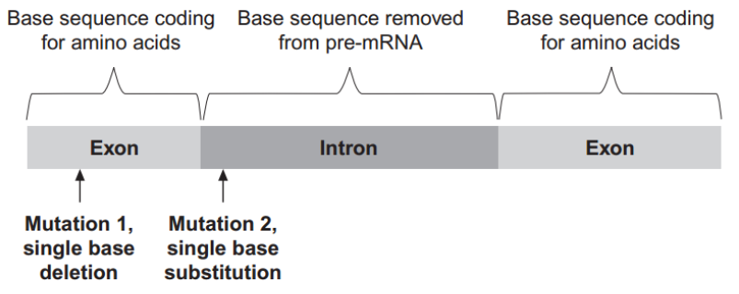
- Figure 1 shows part of a pre-mRNA molecule. Geneticists identified two mutations that can affect this pre-mRNA, as shown in Figure 1.

Mutation 1 leads to the production of a non-functional protein. Explain why.
(Mutation) changes triplets/codons after that point/causes frame shift; Changes amino acid sequence (after this)/codes for different amino acids (after this); Affects hydrogen/ionic/sulfur bond (not peptide bond); Changes tertiary structure of protein (so nonfunctional);

- What effect might mutation 2 have on the protein produced? Explain your answer.
Intron non-coding (DNA)/only exons coding; (So) not translated / no change in mRNA produced / no effect (on protein) / no effect on amino acid sequence; OR Prevents/changes splicing; (So) faulty mRNA formed; Get different amino acid sequence;

- A biologist investigated the behaviour of a species of worm that lives in soil. He cultured three samples of worms in three separate trays of soil for many days.
Each culture:
- contained a food supply
- was kept at a different temperature.
The temperatures of the cultures were 17 ºC, 20 ºC and 23 ºC.
The biologist then removed food from the trays for several hours. Then he transferred each sample of worms onto a glass surface where there was no food. Each surface had a temperature gradient across it. After 1 hour, the biologist recorded the position of each worm.
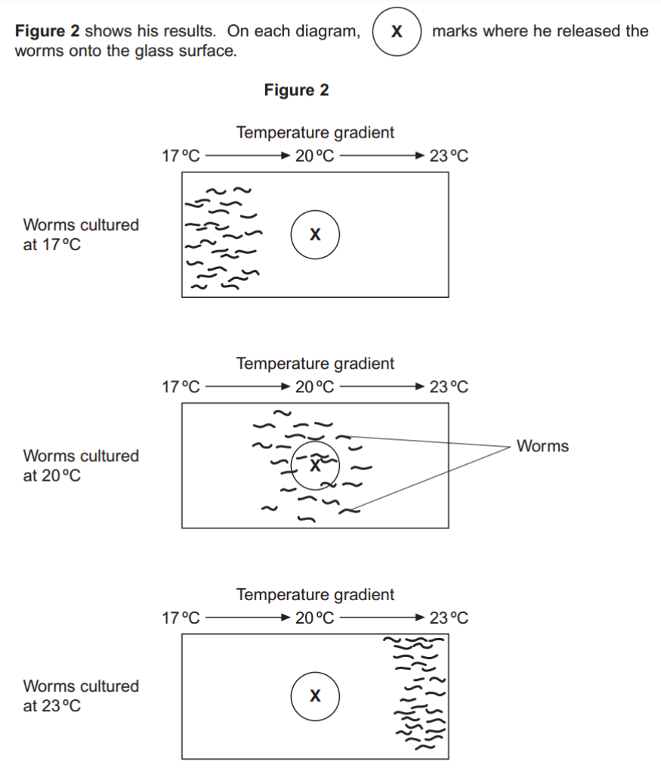

- The biologist concluded that the worms’ behaviour demonstrated taxis. How do these results support this conclusion?
(Taxis is) movement towards/away from a stimulus / a directional response/movement (to a stimulus); (Move towards) temperature they were used to/cultured in;

- Using the information provided, suggest an explanation for the worms’ behaviour on the glass surfaces in the absence of food.
Hungry, so seeking food / in absence of food respond to temperature; Move towards temperature they were used to/cultured in; Associate (this temperature) with food; (Then) stay in this temperature;

- In each experiment, the biologist exposed the surfaces to light that was dim and even, so he could see where the worms went. Apart from seeing where the worms went, suggest two reasons why it was important that the light was dim and even.
(Dim) worms live in soil/dark/ affected by bright light / dim light is like normal environment/what they are used to; 2. (Even) because worms might move towards/away from bright light / to avoid creating light gradient / prevent worms showing phototaxis/ all parts of surface exposed to same light; 3. (Dim light) ensures heat from light not a variable/ heat from lamp could kill/dry out worms;

- A myelinated axon conducts impulses faster than a non-myelinated axon. Explain this difference.
(In myelinated) action potential/depolarisation only at node(s); (In myelinated, nerve impulse) jumps from node to node/saltatory; (In myelinated) action potential/impulse does not travel along whole length

- Doctors investigated the relationship between myelin in brain tissue and different types of dementia. All types of dementia involve loss of mental ability. The doctors measured the mean amount of myelin in samples of brain tissue from:
- a control group of 12 people without dementia
- 20 people with vascular dementia (VaD)
- 19 people with Alzheimer’s dementia (AD)
- 31 people with Lewy body dementia (LD).
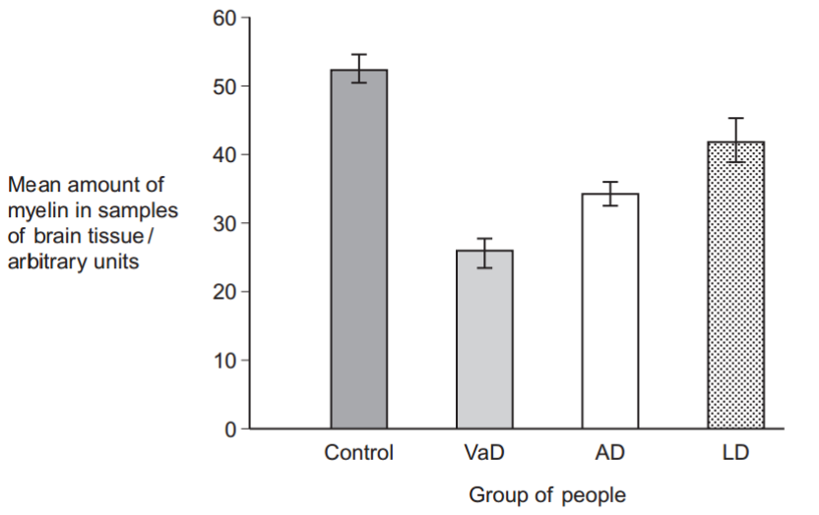
The doctors’ results are shown in Figure 3. The vertical bars show standard errors.

The doctors used a statistical test to compare the results for AD and LD. They obtained a value for P of 0.047. What does this result show about the difference between the means for AD and LD? Use the words probability and chance in your answer
Probability of obtaining this difference by chance; Is less than 5%/less than 0.05/less than one in twenty; Difference is significant;
- A student who read this investigation concluded that there was a relationship between the amount of myelin in a person’s brain and whether or not they had dementia. Do these data support this conclusion? Give reasons for your answer.
(All) dementia results lower (than control group)/non-dementia result higher; Error bars do not overlap so differences are (possibly) significant; Dementia may be due to other factors / not only due to a lack of myelin; (Because) big/significant differences in myelin in different dementia; Only small sample sizes/only one study/ more data required;

- When insulin binds to receptors on liver cells, it leads to the formation of glycogen from glucose. This lowers the concentration of glucose in liver cells. Explain how the formation of glycogen in liver cells leads to a lowering of blood glucose concentration.
(Formation of glycogen) - Glucose concentration in cell/liver falls; Below that in blood (plasma)/ higher in blood; Creates/maintains glucose concentration/diffusion gradient; Glucose enters cell/leaves blood by facilitated diffusion/via carrier(protein)/channel (protein);

- People with type II diabetes have cells with low sensitivity to insulin. About 80% of people with type II diabetes are overweight or obese. Some people who are obese have gastric bypass surgery (GBS) to help them to lose weight. Doctors investigated whether GBS affected sensitivity to insulin. They measured patients’ sensitivity to insulin before and after GBS. About half of the patients had type II diabetes. The other half did not but were considered at high risk of developing the condition.
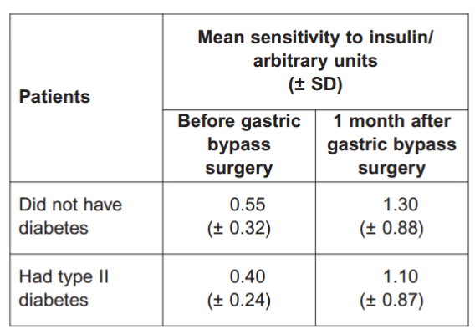
Table 1 shows the doctors’ results. The higher the number, the greater the sensitivity to insulin.

The doctors concluded that many of the patients who did not have type II diabetes were at high risk of developing the condition. Use the data in Table 1 to suggest why they reached this conclusion.
Insulin sensitivity similar to/not (significantly) different from those with diabetes; Overlap of SDs; Their sensitivity (to insulin also) improved by GBS;
- The doctors also concluded that GBS cured many patients’ diabetes but that some were not helped very much. Do these data support this conclusion?
Sensitivity (to insulin) does increase; But large SD/ large variation (after GBS); (So) some showing no/little change/ get worse; Do not know what sensitivity to insulin is of nondiabetics (who are not obese);

- Hodgkin’s lymphoma (HL) is a type of cancer. It is usually treated using chemotherapy. In young female patients with HL, chemotherapy can reduce their ability to have children in later life. This is because some of the drugs used in chemotherapy destroy developing follicles in their ovaries.
Destruction of developing follicles during chemotherapy can lead to a much higher concentration of FSH in the young female patients’ bodies than normal. Use your knowledge of hormonal interactions to explain why.
No/less oestrogen produced (by follicles/ovaries); No/less negative feedback (by oestrogen); On pituitary (gland);

- Some young female patients with HL are given an artificial hormone during chemotherapy. This artificial hormone reduces the release of FSH. Suggest how the artificial hormone helps to prevent a reduction in their ability to have children in later life.
(Less FSH so) fewer/no follicles develop; (So) fewer follicles (will be) destroyed (by chemotherapy); (So) more follicles left for later in life/after treatment; (So) more eggs;

- Figure 4 shows the structures of the artificial hormone and the hormone that normally causes the release of FSH.
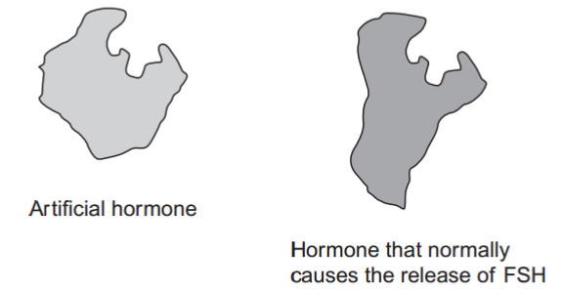

Suggest how the artificial hormone reduces the release of FSH
(Artificial hormone,) - Similar shape/structure/binding site to normal hormone; So binds to (same) receptor and stops normal hormone binding;

- What is the role of phosphocreatine (PC) in providing energy during muscle contraction?
(Phosphocreatine) provides phosphate/phosphorylates; To make ATP

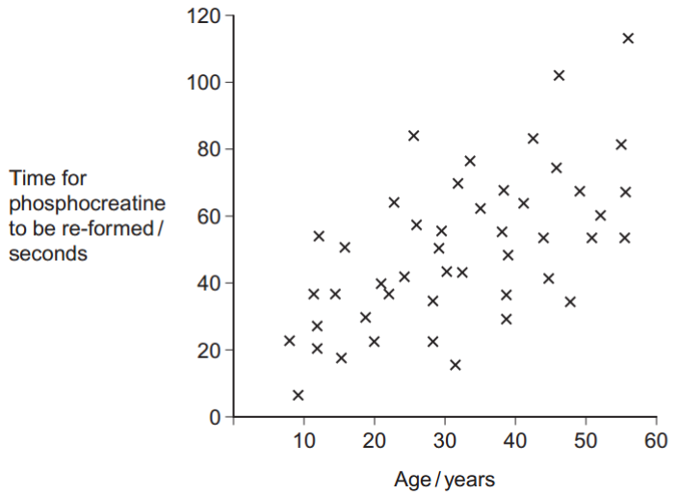
- Scientists investigated the time for phosphocreatine (PC) to be re-formed in arm muscles after the same exercise in healthy people of different ages. The exercise involved brief, rapid contractions of arm muscles.

There is a lot of variation in the time taken for PC to be re-formed in people of a very similar age. Suggest one reason for this variation
Genetic differences; Level of fitness/amount of regular exercise done/mass of muscle; Sex; Ethnicity; Metabolic rate; Number of fast/slow muscle fibres

- Use your knowledge of fast muscle fibres to explain the data in Figure 5.
(From graph, phosphocreatine) takes longer to remake as people get older; Fast muscle fibres used for rapid/brief/powerful/strong contractions; Phosphocreatine used up rapidly during contraction/to make ATP; Anaerobic respiration involved; (As people get older) slower metabolic rate/slower ATP production/slower respiration; ATP used to reform phosphocreatine; Lots of phosphocreatine in fast fibres;

- CREB is a transcription factor in the mitochondria of neurones. What is a transcription factor?
(Protein/molecule) that moves from cytoplasm to DNA; (TF) binds to specific gene/genes/ to specific part of/site on DNA/ binds to promoter/RNA polymerase; Leads to/blocks (pre)mRNA production / allows/blocks binding of RNA polymerase (to DNA)/allows RNA polymerase to work;

- CREB leads to the formation of a protein that removes electrons and protons from reduced NAD in the mitochondrion. Huntington’s disease (HD) causes the death of neurones. People with HD produce a substance called huntingtin. Some scientists have suggested that binding of huntingtin to CREB may lead to the death of neurones. Suggest how binding of huntingtin to CREB may lead to the death of neurones
(Binding to CREB) prevents transcription/mRNA formation; (Binding of huntingtin) prevents production/translation of protein (that removes electrons/protons from NAD); Fewer electrons to electron transport chain/electron transport chain slows/stops/ stops/slower oxidative phosphorylation; Fewer protons for proton gradient; Not enough ATP produced/energy supplied to keep cells alive / anaerobic respiration not enough to keep cell alive;

- CREB is a protein synthesised in the cytoplasm of neurones. Transport of CREB from the cytoplasm into the matrix of a mitochondrion requires two carrier proteins. Use your knowledge of the structure of a mitochondrion to explain why transport of CREB requires two carrier proteins.
CREB/protein is too large/is water soluble so cannot cross membrane/phospholipid bilayer; Mitochondrion has two membranes/inner and outer membranes; For each (different) membrane a (different) carrier required;

- Scientists wanted to measure how much mRNA was transcribed from allele A of a gene in a sample of cells. This gene exists in two forms, A and a. The scientists isolated mRNA from the cells. They added an enzyme to mRNA to produce cDNA. Name the type of enzyme used to produce the cDNA.
Reverse transcriptase

- The scientists used the polymerase chain reaction (PCR) to produce copies of the cDNA. They added a DNA probe for allele A to the cDNA copies. This DNA probe had a dye attached to it. This dye glows with a green light only when the DNA probe is attached to its target cDNA. Explain why this DNA probe will only detect allele A.
Probe (base sequence) complementary (to DNA of allele A/where A is); (Probe) binds by forming base pairs/hydrogen bonds; So (only) this DNA labelled/has green dye/gives out (green) light;

- The scientists used this method with cells from two people, H and G. One person was homozygous, AA, and the other was heterozygous, Aa. The scientists used the PCR and the DNA probe specific for allele A on the cDNA from both people.
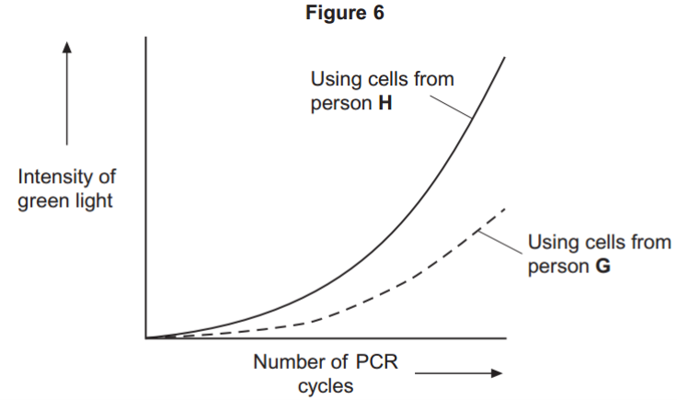
Explain the curve for person H
More probe binding/more cDNA/mRNA/more allele/gene A means more light; DNA (with A) doubles each (PCR) cycle; So light (approximately) doubles/curve steepens more and more (each cycle) /curve goes up exponentially/ increases even faster;

- Which person, H or G, was heterozygous, Aa? Explain your answer
G - (Heterozygous) only has half the amount of probe for A attaching / only half the amount of DNA/allele A (to bind to); (So,) only produced (about) half the light/glow/intensity (of H) (per cycle of PCR);

- Scientists measured the rate of respiration in three parts of an ecosystem. They did this by measuring carbon dioxide released into the air by:
- leaves of plants
- stems and roots of plants
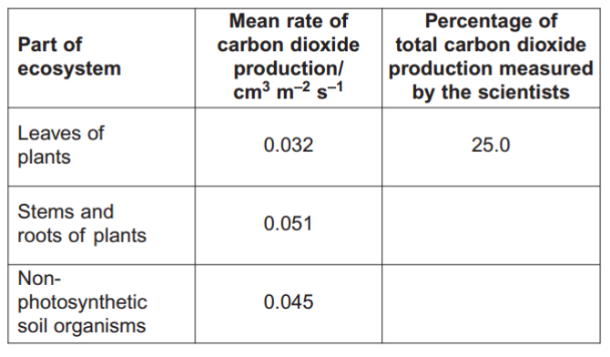
- non-photosynthetic soil organisms.

Complete Table 2 to show the percentage of total carbon dioxide production by each part of the ecosystem.
39.8

35.2

- A student who looked at the data in Table 2 concluded that plants carry out more respiration than non-photosynthetic organisms in the ecosystem. Use the information provided to suggest why these data may not support the student’s conclusion.
Data only include (heterotrophic) soil organisms; Doesn’t include animals (above ground)/other (non-soil) organisms; Doesn’t take into account anaerobic respiration

- What measurements would the scientists have made in order to calculate the rate of carbon dioxide production?
Volume of carbon dioxide given off; (From known) area/ per m2 /m-2 ; In a known/set time

- The scientists calculated the mean rate of carbon dioxide production of the leaves using measurements of carbon dioxide release in the dark. Explain why they did not use measurements taken in the light
(In the light) photosynthesis/in the dark no photosynthesis; (In light,) carbon dioxide (from respiration) being used/taken up (by photosynthesis);

- Another group of scientists measured the mean rate of respiration in soil under trees and soil not under trees in the same wood. They also measured the mean rate of photosynthesis in the trees. They took measurements at different times of day during the summer
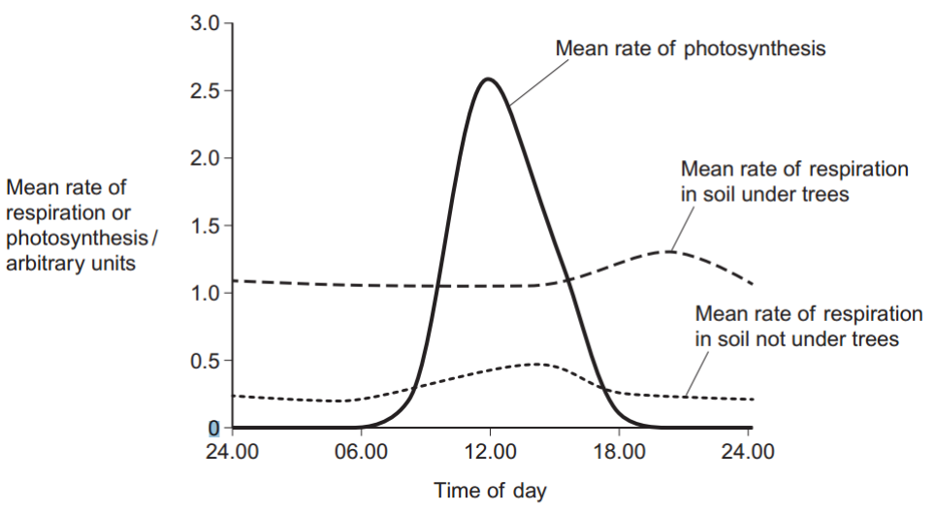

Describe two ways in which the mean rate of respiration in soil under trees is different from soil not under trees.
(Rate of respiration) - In soil under trees (always) higher; In soil under trees does not rise between 06.00 and 12.00 /in the middle of the day/ peaks at 20:00- 21.00/in the evening; In soil not under trees, peaks at about 14:00- 15:00/in middle of day;

- Suggest one explanation for the differences in the mean rate of respiration in soil under trees and soil not under trees between 06.00 and 12.00.
(Between 06.00 and 12.00 Respiration higher in soil under tree) - Tree roots carry out (a lot of) respiration; More/there are roots under tree; OR More food under trees; So more active/greater mass of/more organisms (carrying out respiration); OR Soil not under trees respiration increases (No mark) Soil in sunlight gets warmer; Enzymes (of respiration) work faster;

- The scientists suggested that the rise in the mean rate of photosynthesis was the cause of the rise in the mean rate of respiration in soil under trees. Suggest how the rise in the mean rate of photosynthesis could lead to the rise in the mean rate of respiration in soil under trees.
Photosynthesis produces sugars; Sugars moved to roots; (Sugars) are used/required for respiration;

- Suggest why there is a delay between the rise in the mean rate of photosynthesis and the rise in the mean rate of respiration.
Takes time to move sugars to roots;

- The genetic code is described as being degenerate. What does this mean?
One amino acid can be coded for by more than one triplet

- What is a codon
3 bases on mRNA that code for an amino acid

- What is the role of RNA polymerase during transcription
To join nucleotides together to form mRNA/pre-mRNA/RNA

- mRNA can be converted to cDNA. Name the enzyme used in this process
reverse transcriptase

- use evidence from the diagram to explain what is meant by a palindromic recognition sequence on DNA.

GGATCC same as CCTAGG in opposite direction

- Describe the part played by each of the following in myofibril contraction;
- Tropomyosin
Moves out of the way when calcium ions bind; Allowing myosin to bind (to actin)/crossbridge formation
- Myosin
Head (of myosin) binds to actin and moves/pulls/slides actin past; (Myosin) detaches from actin and re-sets/moves further along (actin) This uses ATP

- Use information from the table to suggest and explain one advantage of;

- The high glycogen content of fast muscle fibres
(Glycogen broken down) gives (lots of) glucose for glycolysis/anaerobic respiration; Glycolysis/anaerobic respiration not very efficient/only yields 2 ATP per glucose

- The number of capillaries supplying slow muscle fibres.
(Many capillaries) give high concentration/lots of oxygen/ shorter diffusion pathway for oxygen/large surface area for oxygen exchange/diffusion; Good glucose supply with little glycogen present; Allows high rate of/more aerobic respiration OR prevents build-up of lactic acid/(muscle) fatigue

- Scientists investigated the response of lateral roots to gravity. Lateral roots grow from the side of main roots. The diagrams show four stages, A to D, in the growth of a lateral root and typical cells from the tip of the lateral root in each stage. All of the cells are drawn with the bottom of the cell towards the bottom of the page

Describe 3 changes in the root tip cells between A and D.
1. Formation/growth of vacuole;
2. Formation of starch grains/amyloplasts;
3. Movement of grains/amyloplasts towards bottom of cell;
4. Cells get longer/wider/larger

- The scientists’ hypothesis was that there was a relationship between the starch grains in the root tip cells and the bending and direction of growth of lateral roots. Does the information in the diagram support this hypothesis? Give reasons for your answer.
Grows sideways before starch grains form; Bending starts when/as grains form; More bending as grains increase in number; More elongation (of cells)/growth (of roots) downwards as starch grains increase/move; Bending starts before grains move down; Could be related to vacuole

- The diagram shows the distribution of IAA in the lateral root at stage B. explain how this distribution of IAA causes the root to bend
Greater (elongation) growth on top of root/less growth on bottom of root; (IAA) at bottom of root/where IAA concentration high inhibits expansion/elongation (of cells); (IAA) at top of root/where IAA concentration low leads to expansion/elongation (of cells)

- The release of a substance called dopamine in some areas of the brain increases the desire to eat. Scientists measured increases in the release of dopamine in the brains of rats given different concentrations of sucrose solution to drink. Sucrose stimulates taste receptors on the tongue. The graph shows their results. Each point is the result for one rat.
The scientists concluded that drinking a sucrose solution had a positive feedback effect on the rats’ desire to eat. How do these data support this conclusion?
Positive correlation between sucrose and dopamine concentrations/higher concentration of sucrose, more dopamine; So (dopamine) makes them want to drink/eat more (sucrose); Positive feedback because drinking/eating leads to wanting to drink/eat (even) more
- In this investigation, the higher the concentration of sucrose in a rat’s mouth, the higher the frequency of nerve impulses from each taste receptor to the brain. If rats are given very high concentrations of sucrose solution to drink, the refractory period makes it impossible for information about the differences in concentration to reach the brain. Explain why.
(Refractory period) leads to discrete/separate nerve impulses/time when another nerve impulse can’t happen; OR (Refractory period) limits number of impulses per second/frequency of nerve impulses; When maximum frequency reached/exceeded, no further increase in information/all (higher) concentrations of sucrose seem the same

- In humans, when the stomach starts to become full of food, receptors in the wall of the stomach are stimulated. This leads to negative feedback on the desire to eat. Suggest why this negative feedback is important.
(Negative feedback) stops desire/wish to eat/appetite; (This) limits amount eaten/stops eating; Prevents/reduces risk of obesity/too much energy intake

- Hyperthermia is a condition in which a person’s body temperature is above 37.5 ºC. This happens when a person’s body produces or absorbs more heat than it loses to the environment. Doctors recruited healthy volunteers. At a room temperature of 20 ºC, the doctors measured each volunteer’s:
body temperature
rate of oxygen consumption
rate of carbon dioxide production.
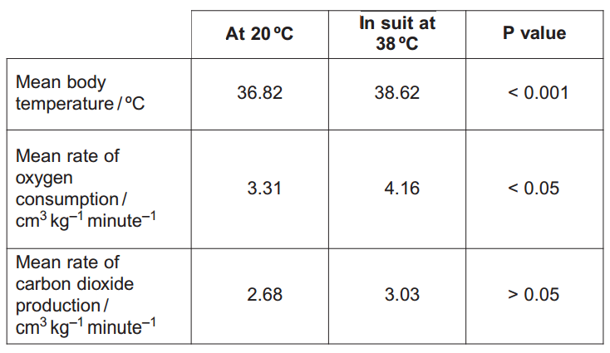
Each volunteer then put on a suit that covered the whole body. Water at 38 ºC was circulated through pipes in the suit. This caused the volunteer to develop hyperthermia. The doctors’ results are shown in the table.
The doctors carried out statistical tests to see whether or not the differences in the results were significant. The P values from these tests are shown in the table. Calculate the percentage increase in mean body temperature
4.9/4.89
(38.62 – 36.82) / 36.82

- Explain one way in which a suit with water circulating in it at 38 ºC causes hyperthermia.
Suit prevents loss of sweat; So heat of evaporation not lost; OR Water (initially) at higher temperature than skin/body/blood; (So) heat gained/less lost (by conduction/convection)

- Were the changes produced by hyperthermia significant? Give reasons for your answer. You should use the P values in your answer.
Yes for temperature and oxygen consumption/no for carbon dioxide; Because P value (equal to, or) less than 0.05 (other than carbon dioxide)/ P value greater than 0.05 (for carbon dioxide)

- Using information from the table, explain the increase in mean rate of oxygen consumption.
Increased temperature leads to faster enzyme activity; Faster rate of respiration (and oxygen consumption)

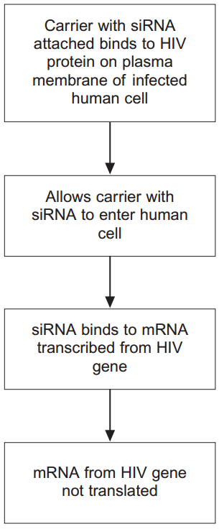
- Human immunodeficiency virus (HIV) particles have a specific protein on their surface. This protein binds to a receptor on the plasma membrane of a human cell and allows HIV to enter. This HIV protein is found on the surface of human cells after they have become infected with HIV. Scientists made siRNA to inhibit expression of a specific HIV gene inside a human cell. They attached this siRNA to a carrier molecule. The flow chart shows what happens when this carrier molecule reaches a human cell infected with HIV

When siRNA binds to mRNA, name the complementary base pairs holding the siRNA and mRNA together. One of the bases is named for you.
cytosine With guanine .
adenine With uracil .

- This siRNA would only affect gene expression in cells infected with HIV. Suggest two reasons why
Only infected cells have HIV protein on surface; So carrier only attaches to/specific to these cells/siRNA can only enter these cells; OR siRNA (base sequence) complementary/specific to one mRNA; Only infected cells contain mRNA of HIV/this gene/ stops translation of this gene/only binds to this mRNA /destroys this mRNA
- The carrier molecule on its own may be able to prevent the infection of cells by HIV. Explain how.
Carrier binds to (protein on) HIV; Prevents HIV/it binding to (receptor on human) cell

- Serotonin is a neurotransmitter released in some synapses in the brain. It is transported back out of the synaptic gap by a transport protein in the pre-synaptic membrane. Serotonin diffuses across the synaptic gap and binds to a receptor on the post-synaptic membrane. Describe how this causes depolarisation of the post-synaptic membrane.
Causes sodium ion channels to open; Sodium ions enter (cell and cause depolarisation)

- It is important that a neurotransmitter such as serotonin is transported back out of synapses. Explain why.
(If not removed) keeps binding (to receptors); Keeps causing action potentials/depolarisation (in postsynaptic membrane); Prevents information being carried across synapse/described consequence

- Scientists investigated the effect of a drug called MDMA on movement of mice. They measured the amount of movement of three groups of mice, K, L and M.
- Group K, mice not given MDMA.
- Group L, mice given MDMA.
- Group M, mutant mice that did not produce a serotonin receptor on their post-synaptic membranes and were given MDMA.
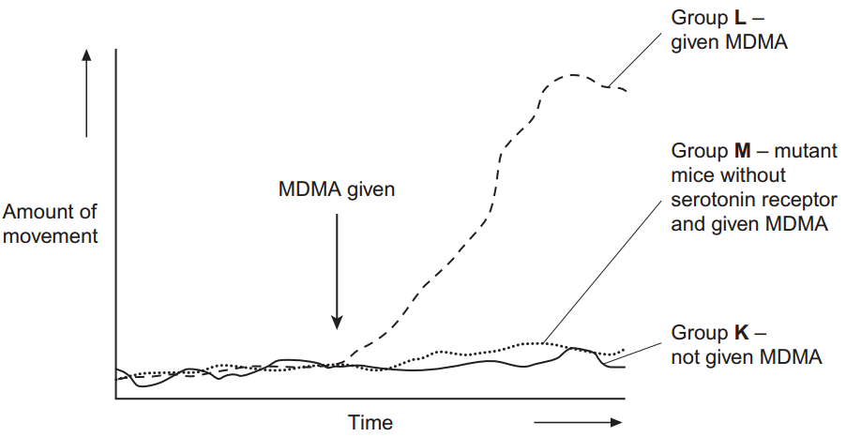
The graph shows their results.

The scientists concluded that MDMA affects movement by binding to serotonin receptors. How do these results support this conclusion?
Movement in all groups (about) same before MDMA; MDMA increases movement in Group L; Group K shows MDMA causes movement; No/little increase in mice without receptor/Group M

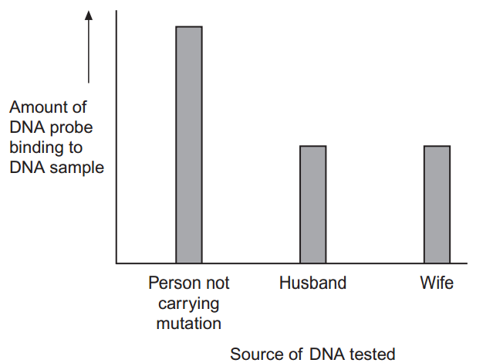
- A husband and wife wanted to know whether they were carriers of the mutated form of a gene. This mutation is a deletion that causes a serious inherited genetic disorder in people who are homozygous. A geneticist took samples of DNA from the husband and the wife. He used a DNA probe to look for the deletion mutation. The DNA probe was specific to a particular base sequence in an exon in the gene. Exons are the coding sequences in a gene. The geneticist compared the couple’s DNA with that of a person known not to carry this mutation. The chart shows the geneticist’s results.
The geneticist told the couple they were both carriers of the mutated gene. Explain how he reached this conclusion.
Carriers are heterozygous/have one normal copy and one mutant copy of gene/have one recessive allele/don’t have the condition; Both have DNA that binds (about) half/50% amount of probe (that non-carrier does); Probe binds to dominant/healthy allele; So only one copy of exon in their DNA/ have one copy of gene without exon/base sequence for probe to bind to

- The DNA probe the geneticist used was for an exon in the DNA, not an intron. Explain why.
Introns not translated/not in mRNA; (Exons) code for amino acids/introns do not code for amino acids; Mutations of these (exons) affect amino acid sequences; (That produce) faulty protein/change tertiary structure of protein; So important to know if parents’ exons affected, rather than any other part of DNA/introns

- To make the DNA probe, the geneticist had to find the base sequence of the normal gene. Once he had copies of the gene, what methods would he use to find the base sequence of the gene?
Restriction mapping/described; DNA/base sequencing (of fragments)/ description/name of method

- Some species of crop plant produce a substance called glycinebetaine (GB). Scientists transferred the gene for GB into a species of crop plant that does not normally produce GB. These genetically modified plants then produced GB. The scientists grew large numbers of the same crop plant with and without the gene at different temperatures. After 3 days, they found the increase in dry mass of the plants. Figure 1 shows their results
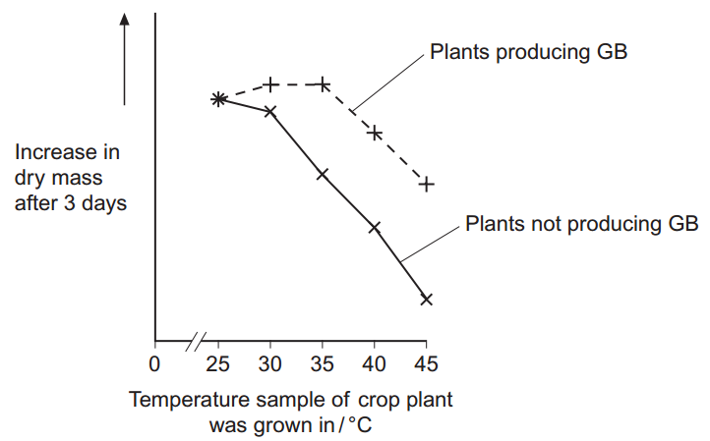
Describe the effect on growth of transferring the gene for GB into this plant.
No effect at 25o C; Keeps growing at 30o C and 35o C/up to 35o C (more than without GB); Above 35o C, falls but grows more than plant without GB

- The scientists measured the rate of photosynthesis in plants that produce GB and plants that do not produce GB at 25 ºC, 35 ºC and 45 ºC. Figure 2 shows their results.
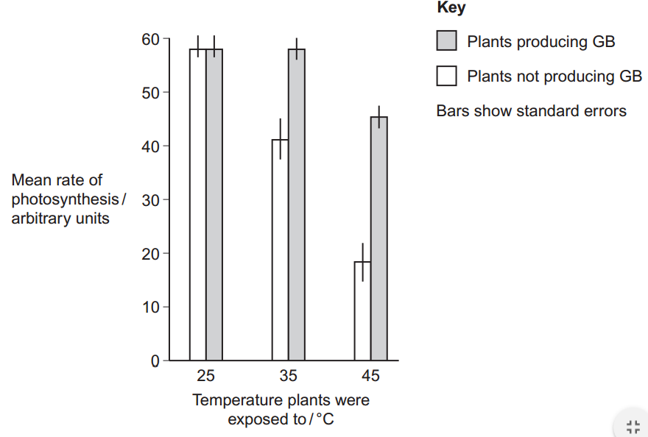
The scientists concluded that the production of GB protects photosynthesis from damage by high temperatures. Use these data to support this conclusion.
Significantly different /SEs do not overlap

- Use the data from Figure 2 for plants that do not produce GB to explain the effect of temperature on changes in dry mass of the plants shown in Figure 1.
(As temperature increases,) Enzyme activity reduced/(some) enzymes denatured; Less photosynthesis, so fewer sugars formed; Less (complex) biological molecules/organic substances made (that add to mass); Less respiration; Less energy/ATP for growth; Less energy for named function associated with growth
- Rubisco activase is an enzyme found in chloroplasts. It activates the light-independent reaction of photosynthesis. The scientists discovered that, as temperature increased from 25 ºC to 45 ºC, rubisco activase began attaching to thylakoid membranes in chloroplasts and this stopped it working. Rubisco activase stops working when it attaches to a thylakoid. Use your knowledge of protein structure to explain why.
(Rubisco activase attaches to thylakoid and) this changes shape/tertiary structure (of enzyme)/blocks active site/changes active site; (This) prevents substrate/RuBP entering active site/binding

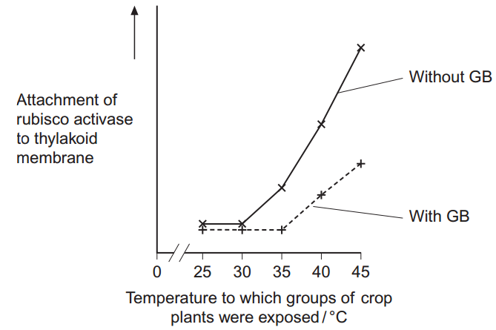
- The scientists investigated the effect of GB on attachment of rubisco activase to thylakoid membranes at different temperatures. Figure 3 shows their results.
Use information from Figure 2 and Figure 3 to suggest how GB protects the crop plant from high temperatures.
GB prevents/reduces binding of rubiscoactivase to (thylakoid membrane); (Prevents it) up to 35o C; (So) rubiscoactivase/enzyme remains active; (So) photosynthesis/lightindependent stage still happens; Above 35o C, some binding still occurs but less than without GB, so less reduction in growth

- The scientists’ hypothesis at the start of the investigation was that crop plants genetically engineered to produce GB would become more resistant to high environmental temperatures. The scientists developed this hypothesis on the basis of previous research on crops that are grown in hot climates. Suggest how the scientists arrived at their hypothesis.
Looked for information/journals, on crop plants that grow at high temperatures; (Crop plants cited in this research) contain/make GB; So assumed making plants produce GB makes them resistant to high temperatures

- The black mamba is a poisonous snake. Its poison contains a toxin. The table shows the base sequence of mRNA that codes for the first two amino acids of this toxin.
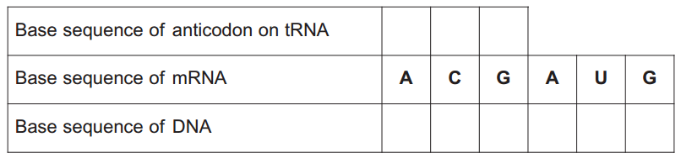
C
A
T
C
G
T
C
G
U

Complete the table to show:
- the base sequence of the anticodon on the first tRNA molecule that would bind to this mRNA sequence
- (ii) the base sequence of the DNA from which this mRNA was transcribed

- The length of the section of DNA that codes for the complete toxin is longer than the mRNA used for translation. Explain why.
(DNA) contains introns/noncoding bases / mRNA only contains exons/coding bases

- A mutation in the base sequence of the DNA that codes for the toxin would change the base sequence of the mRNA. Explain how a change in the base sequence of the mRNA could lead to a change in the tertiary structure of the toxin.
Different primary structure/amino acid sequence/amino acid coded for

- The black mamba’s toxin kills prey by preventing their breathing. It does this by inhibiting the enzyme acetylcholinesterase at neuromuscular junctions. Explain how this prevents breathing.
Acetylcholine not broken down / stays bound to receptor; Na+ ions (continue to) enter / (continued) depolarisation / Na+ channels (kept) open / action potentials/impulses fired (continuously); (Intercostal) muscles stay contracted / cannot relax
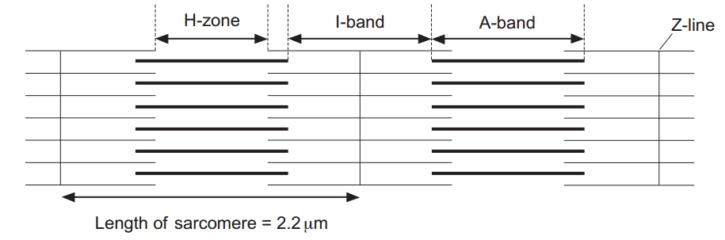
- The diagram shows two relaxed sarcomeres from skeletal muscle.

When the sarcomeres contract, what happens to the length of
- the I-band
Decreases
- the A-band?
Nothing / stays the same length

- The length of each sarcomere in the diagram is 2.2 μm. Use this information to calculate the magnification of the diagram.
29545-30455 (divides measured width by actual width)

- People who have McArdle’s disease produce less ATP than healthy people. As a result, they are not able to maintain strong muscle contraction during exercise. Use your knowledge of the sliding filament theory to suggest why.
ATP is needed for: Attachment/cross bridges between actin and myosin; ‘Power stroke’ / movement of myosin heads / pulling of actin; Detachment of myosin heads; Myosin heads move back/to original position / ‘recovery stroke

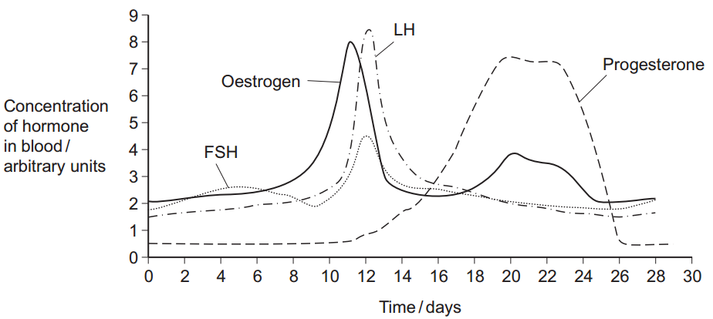
- The graph shows the concentration of four hormones in a woman’s blood during one oestrous cycle.
Explain how the graph supports the following statements.
- Oestrogen causes the release of LH.
LH increases/peaks after oestrogen increases/peaks; OR Oestrogen increases/peaks before LH increases/peaks
- The woman did not become pregnant during this cycle.
Progesterone falls / progesterone returns to start / progesterone not maintained;

- Implanon is a contraceptive device that is inserted under a woman’s skin and prevents pregnancy for up to three years. It is a small rod that continuously releases progesterone into her blood. This progesterone prevents fertilisation from taking place. Explain how Implanon prevents fertilisation from taking place.
FSH inhibited; Follicle not stimulated / ripened / does not grow; LH inhibited; Ovulation prevented / egg/ovum not released

- Suggest one advantage of using Implanon rather than an oral contraceptive.
Will not forget to take Implanon / may forget to take an oral contraceptive / does not have to be taken daily / not affected by illness/vomiting

- Increased intensity of exercise leads to an increased heart rate. Explain how.
(Oxygen/carbon dioxide) detected by chemoreceptors / (pressure) detected by baroreceptors; Medulla/cardiac centre involved; More impulses to SAN/along sympathetic nerve

- Scientists investigated the effect of taking omega-3 fatty acids in fish oil on heart rate during exercise. They recruited two large groups of volunteers, A and B. For each group, they measured the mean heart rates at different intensities of exercise. The volunteers were then given capsules to take for 8 weeks. l Group A was given capsules containing omega-3 fatty acids in fish oil. l Group B was given capsules containing olive oil. After 8 weeks, they repeated the measurements of mean heart rates at different intensities of exercise. The graph shows their results. The bars represent the standard deviations.
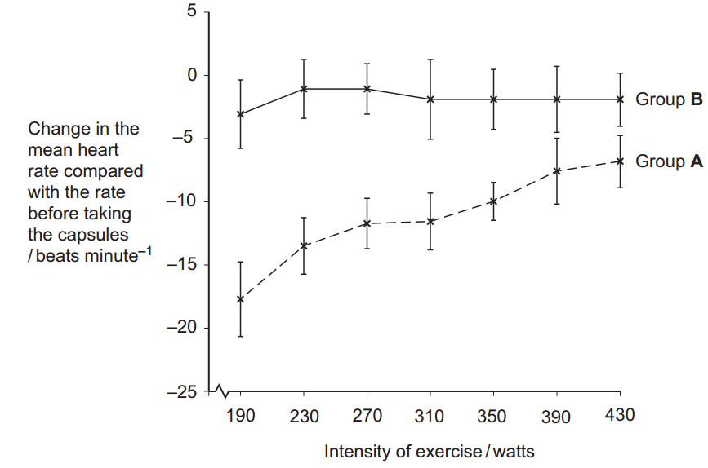

Group B was given capsules containing olive oil. Explain why.
To ensure results are due to omega-3/fatty acids (only) / not due to something else in the oil; Placebo linked to mental/psychological effect

- The scientists concluded that omega-3 fatty acids lower the heart rate during exercise. Explain how the information in the graph supports this conclusion.
Lower/greater change of heart rate for Group A; (Differences) are real / reliable / significant / not due to chance; As bars do not overlap / values are not shared

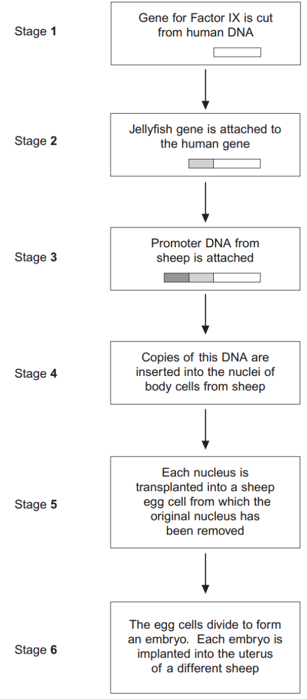
- Haemophilia is a genetic condition in which blood fails to clot. Factor IX is a protein used to treat haemophilia. Sheep can be genetically engineered to produce Factor IX in the milk produced by their mammary glands. The diagram shows the stages involved in this process.

Name the type of enzyme that is used to cut the gene for Factor IX from human DNA (Stage 1) .
Restriction endonuclease

- The jellyfish gene attached to the human Factor IX gene (Stage 2) codes for a protein that glows green under fluorescent light. Explain the purpose of attaching this gene.
(Acts as a) marker gene; Shows that the (human) gene has been taken up/expressed; (Only) implant cells/embryos that show fluorescence / contain the jellyfish gene

- The promoter DNA from sheep (Stage 3) causes transcription of genes coding for proteins found in sheep milk. Suggest the advantage of using this promoter DNA.
Factor IX present in / extracted from milk; Gene only expressed in mammary glands/udder / gene not expressed elsewhere; Do not need to kill sheep (to obtain Factor IX)

- Many attempts to produce transgenic animals have failed. Very few live births result from the many embryos that are implanted. 5 (c) (i) Suggest one reason why very few live births result from the many embryos that are implanted.
Mutation / nucleus/ chromosomes/DNA may be damaged / disrupts genes; May interfere with proteins (produced)/gene expression/ translation; OR Embryo/antigens foreign; Embryo is rejected/attacked by immune system

- It is important that scientists still report the results from failed attempts to produce transgenic animals. Explain why.
Saves time/money for others; Same work is not repeated / methods can be compared/improved/ amended/ same errors are not made

- Adrenaline binds to receptors in the plasma membranes of liver cells. Explain how this causes the blood glucose concentration to increase.
Adenylate cyclase activated / cAMP produced / second messenger produced; Activates enzyme(s) (in cell); (So) glycogenolysis/ gluconeogenesis occurs / glycogenesis inhibited

- Scientists made an artificial gene which codes for insulin. They put the gene into a virus which was then injected into rats with type I diabetes. The virus was harmless to the rats but carried the gene into the cells of the rats. The treated rats produced insulin for up to 8 months and showed no side-effects. The scientists measured the blood glucose concentrations of the rats at regular intervals. While the rats were producing the insulin, their blood glucose concentrations were normal. The rats were not fed for at least 6 hours before their blood glucose concentration was measured. Explain why.
Glucose/sugar in food would affect the results; Food/eating would affect blood glucose (level); (Allows time for) blood glucose (level) to return to normal

- The rats used in the investigation had type I diabetes. This form of gene therapy may be less effective in treating rats that have type II diabetes. Explain why.
Type 2 diabetes is a failure to respond to insulin / still produces insulin / is not insulin-dependent

- Research workers have suggested that treating diabetes in humans by this method of gene therapy would be better than injecting insulin. Evaluate this suggestion.
(For) –Avoids injections / pain of injections; Long(er) lasting / permanent / (new) cells will contain/ express gene; Less need to measure blood sugar / avoids the highs and lows in blood sugar; Less restriction on diet; (Against) – Rats are different to humans; May have side effects on humans; Long(er) term effects (of treatment) not known / may have caused effects after 8 months; (Substitute) insulin may be rejected by the body

- Scientists investigated the response of the roots of pea seedlings to gravity. They took three samples of seedlings, A, B, and C, and placed them so that their roots were growing horizontally. The root tips of each sample had been given different treatments. After a set time, the scientists recorded whether the roots of the seedlings had grown upwards or downwards and the amount of curvature. The table shows the treatment they gave to each sample and their results
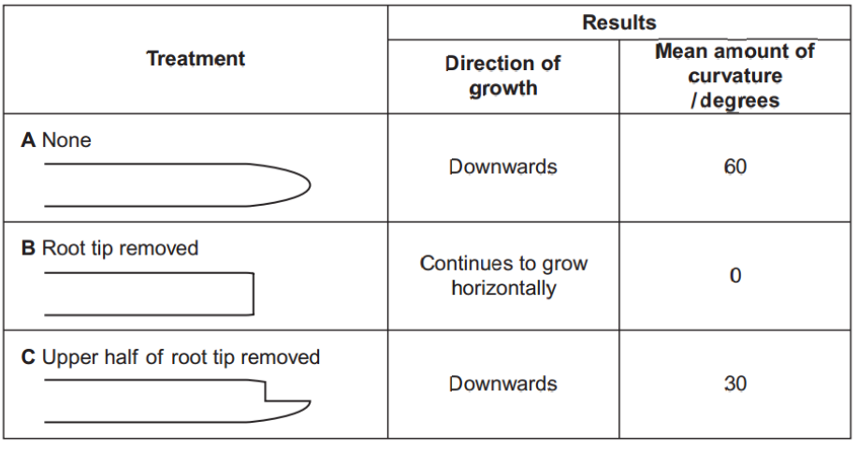

The pea seedlings were kept in the dark after each treatment. Explain why this was necessary.
(Seedlings) respond to light / are phototropic; OR (Only) measuring the effect of gravity / response to gravity

- What conclusion can be made from the results for treatment B?
(Cells in) root tip detect gravity / respond to gravity; OR IAA/auxin is produced in the root tip

- Suggest how indoleacetic acid (IAA) could have caused the results for
- treatment A
IAA/auxin moves to lower side / more IAA/auxin on lower side; Lower side grows less/slower / upper side grows more /faster / inhibits growth on lower side
- treatment C.
Less IAA/auxin (produced); Lower side grows more/faster / less inhibition of growth on lower side

- Huntington’s disease is a genetic condition that leads to a loss in brain function. The gene involved contains a section of DNA with many repeats of the base sequence CAG. The number of these repeats determines whether or not an allele of this gene will cause Huntington’s disease. l An allele with 40 or more CAG repeats will cause Huntington’s disease. l An allele with 36 – 39 CAG repeats may cause Huntington’s disease. l An allele with fewer than 36 CAG repeats will not cause Huntington’s disease. The graph shows the age at which a sample of patients with Huntington’s disease first developed symptoms and the number of CAG repeats in the allele causing Huntington’s disease in each patient.
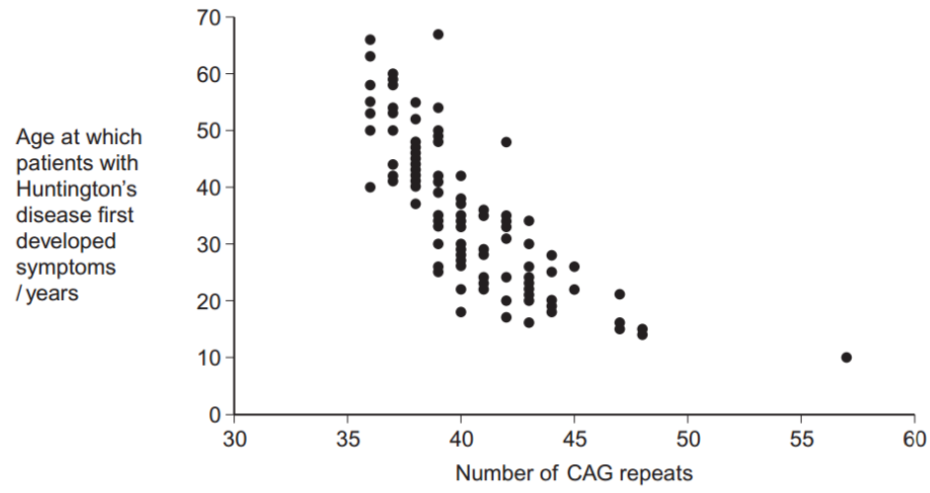

People can be tested to see whether they have an allele for this gene with more than 36 CAG repeats. Some doctors suggest that the results can be used to predict the age at which someone will develop Huntington’s disease. Use information in the graph to evaluate this suggestion.
Negative correlation; Wide range; Overlap; (Graph suggests that) other factors may be involved (in age of onset)

- Huntington’s disease is always fatal. Despite this, the allele is passed on in human populations. Use information in the graph to suggest why.
Age of onset can be high / symptoms appear later in life; (So) individuals have already had children / allele has been passed on; O Individuals have passed on the allele / already had children; Before symptoms occur

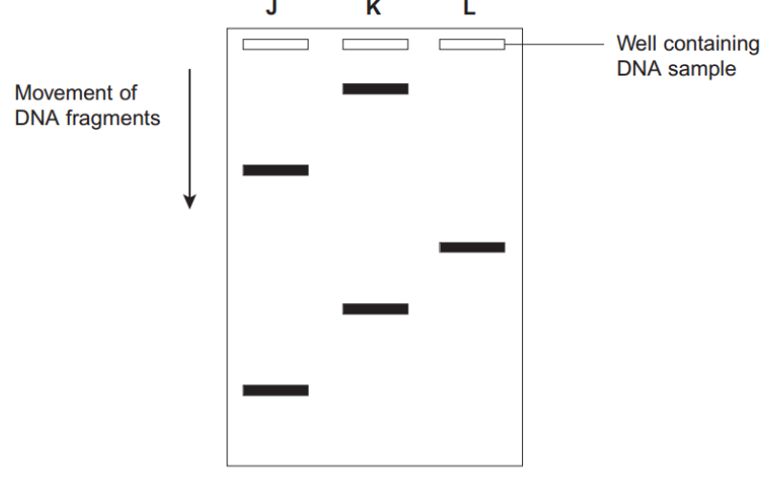
- Scientists took DNA samples from three people, J, K and L. They used the polymerase chain reaction (PCR) to produce many copies of the piece of DNA containing the CAG repeats obtained from each person. They separated the DNA fragments by gel electrophoresis. A radioactively labelled probe was then used to detect the fragments. The diagram shows the appearance of part of the gel after an X-ray was taken. The bands show the DNA fragments that contain the CAG repeats.

Only one of these people tested positive for Huntington’s disease. Which person was this? Explain your answer.
Person K; (As has) high(est) band/band that travelled a short(est) distance/slow(er) so has large(st) fragment/number of CAG repeats

- The diagram only shows part of the gel. Suggest how the scientists found the number of CAG repeats in the bands shown on the gel.
Run fragments of known length / CAG repeats (at the same time)

- Two bands are usually seen for each person tested. Suggest why only one band was seen for Person L.
Homozygous / (CAG) fragments are the same length/size/mass

- Cows suffer from heat stress when the environmental temperature is too high. Heat stress occurs when their core body temperature rises above 39.4 C. The table shows how environmental temperature affects the food intake, water intake and milk production of cows in a fixed period of time.
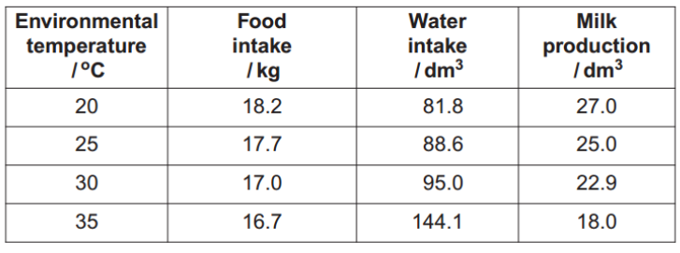

Calculate the percentage decrease in milk production between the temperatures of 30C and 35C.
21 or 21.4%

- Suggest how each of the following responses helps to maintain core body temperature.
- The change in water intake as environmental temperature increases.
Water intake linked to sweating / panting

- The change in food intake as environmental temperature decreases.
Food intake linked to (increased) respiration; Food intake linked to heat/energy release / maintaining body temperature

- Explain the change in milk production as environmental temperature increases.
Increased sweating so less water available (for milk production); Less food so less energy/nutrients available (for milk production); Enzymes not working at optimum temperature

- The rectal temperatures of cows are recorded to monitor heat stress. This is a better measurement of core body temperature than measuring the temperature of the skin. Explain why.
(Skin temperature) Varies/fluctuates more / more heat lost/gained / (can be) further from core; (As) more affected by environment / sweating / conduction / convection / radiation

- Selective breeding can be used to produce cows with desirable features. This involves mating cows with bulls. Suggest how a bull is selected to increase the probability of producing cows with a high milk yield.
Select a bull whose mother/offspring produced a high milk yield

- Milk contains lactose. Human babies produce the enzyme lactase, which digests lactose. Many human adults do not produce lactase and are lactose intolerant. People who are lactose intolerant can become very ill if they drink milk or eat dairy products, such as butter and cheese. Scientists have recorded the percentage of adults who are lactose intolerant in different countries. Explain the advantage of using percentages in this type of study.
Allows comparison; (As) different countries have different population/ sample sizes

- The scientists found that the percentage of people who can tolerate lactose is much higher in populations that drink a lot of milk and eat a lot of dairy products. Use your knowledge of natural selection to explain this finding.
(Selective) advantage producing lactase/ being lactose tolerant/able to digest milk/able to eat dairy foods; People (producing lactase) reproduce; (And) pass on gene/allele; Allele frequency increases

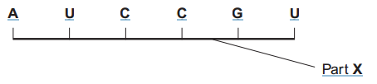
- The diagram shows part of a pre-mRNA molecule.
Name the two substances that make up part X.
Phosphate and ribose

- Give the sequence of bases on the DNA strand from which this pre-mRNA has been transcribed.
TAGGCA

- Give one way in which the structure of an mRNA molecule is different from the structure of a tRNA molecule.
Does not contain hydrogen bonds/base pairs /contains codons / does not contain anticodon / straight/not folded / no amino acid binding site/longer

- Explain the difference between pre-mRNA and mRNA.
(pre-mRNA) contains introns / mRNA contains only exons

- The table shows the percentage of different bases in two pre-mRNA molecules. The molecules were transcribed from the DNA in different parts of a chromosome. Complete the table by writing the percentage of uracil (U) in the appropriate boxes.
21
18
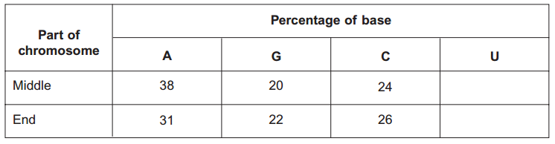
- Explain why the percentages of bases from the middle part of the chromosome and the end part are different.
Different genes; Have different (base) sequences / combinations of (bases); (Pre-mRNA) transcribed from different DNA/codes for different proteins

- Different substances are involved in coordinating responses in animals. Hormones are different from local chemical mediators such as histamine in the cells they affect. Describe how hormones are different in the cells they affect.
Hormones have widespread effect / affect different organs / affect different parts of the body / affect distant organs / only affect cells with right receptor

- Describe how hormones and local chemical mediators reach the cells they affect.
Hormones in blood;Local chemical mediators spread by diffusion / spread directly
- Synapses are unidirectional. Explain how acetylcholine contributes to a synapse being unidirectional.
. (Acetylcholine) released from/in presynaptic side; Diffusion from higher concentration/to lower concentration; Receptors in postsynaptic (side) / binds on postsynaptic (side)

- Cells in the stomach wall release gastric juice after a meal. The graph shows how the volumes of gastric juice produced by nervous stimulation and by hormonal stimulation change after a meal.
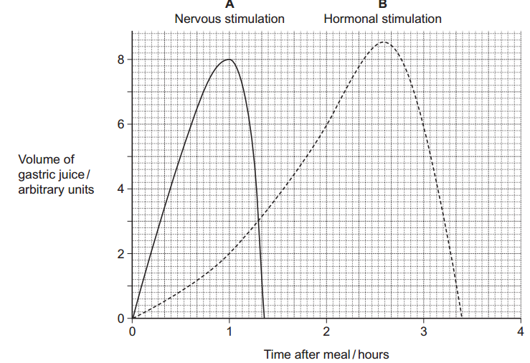
Describe the evidence from the graph that curve A represents the volume of gastric juice produced by nervous stimulation.
Rapid response; Short duration

- Complete the table to show the percentage of gastric juice produced by nervous stimulation at the times shown.
0
0
80
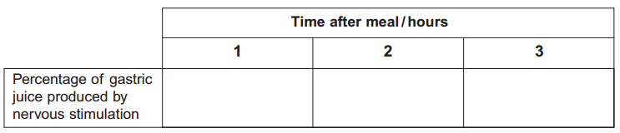
- IAA is a specific growth factor. Name the process by which IAA moves from the growing regions of a plant shoot to other tissues.
Diffusion
- When a young shoot is illuminated from one side, IAA stimulates growth on the shaded side. Explain why growth on the shaded side helps to maintain the leaves in a favourable environment.
Causes plant to bend/grow towards light / positive phototropism; (Light) required for photosynthesis
- NAA is a similar substance to IAA. It is used to control the growth of cultivated plants. Plant physiologists investigated the effect of temperature on the uptake of NAA by leaves. They sprayed a solution containing NAA on the upper and lower surfaces of a leaf. The graph shows their results.
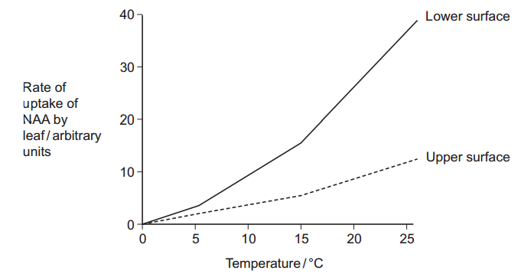

- Explain the effect of temperature on the rate at which NAA is taken up by the lower surface of the leaf.
More kinetic energy; Faster movement of molecules; More diffusion

- There are differences in the properties of the cuticle on the upper and lower surfaces of leaves. Suggest how these differences in the cuticle might explain the differences in rates of uptake of NAA by the two surfaces.
Thick cuticle on upper surface / thin cuticle on lower surface / few stomata on upper surface / no stomata on upper surface; More diffusion / shorter diffusion pathway (on lower surface)

- In this investigation, the physiologists investigated the leaves of pear trees. Explain why the results might be different for other species.
Different species have different (qualified) properties;

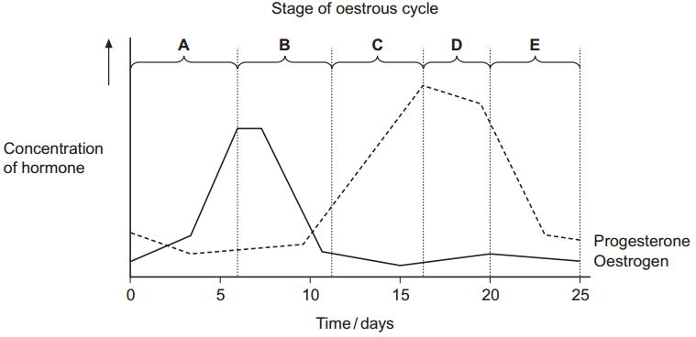
- The graph shows the concentrations of two hormones in the blood of an adult female pig over 25 days.

Use the graph to give the letter of the stage where ovulation occurred.
B

- Give one piece of evidence from the graph that this pig was not pregnant at 25 days.
Fall in progesterone / progesterone same as at start / progesterone low at 25 days

- The relationship between oestrogen and LH is an example of positive feedback. Explain how.
Answer showing understanding of positive feedback i.e. more produces more / differs further; Answer showing understanding of positive feedback correctly linked to oestrogen and LH i.e. more oestrogen produces more LH

- Farmers sometimes give progesterone to sheep to prevent ovulation. Explain how progesterone prevents ovulation.
Progesterone has negative feedback effect / inhibits secretion of FSH/LH; (FSH) stimulates follicle development / ( LH) stimulates ovulation

- Scientists used restriction mapping to investigate some aspects of the base sequence of an unknown piece of DNA. This piece of DNA was 3 000 base pairs (bp) long. The scientists took plasmids that had one restriction site for the enzyme Kpn1 and one restriction site for the enzyme BamH1. They inserted copies of the unknown piece of DNA into the plasmids. This produced recombinant plasmids. The diagram shows a recombinant plasmid.
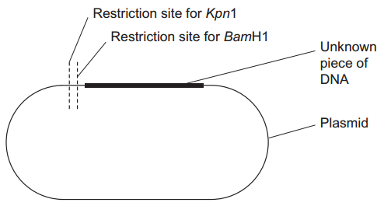
When the scientists digested one of the recombinant plasmids with Kpn1, they obtained two fragments. One fragment was measured as 1 000 bp. The other fragment was described as "very large". What does this show about the base sequence of the unknown piece of DNA?
Has the restriction site (cut by Kpn1); Once; 3. 1000bp from Kpn1 on site of plasmid / ⅓ way along

- One of the fragments that the scientists obtained was described as "very large". What is represented by this very large fragment?
(Most of) plasmid and rest of unknown DNA / rest of recombinant plasmid / rest of plasmid but not 1000 bp part

- When the scientists digested another of the recombinant plasmids with BamH1, they obtained three fragments. How many BamH1 restriction sites are there in the unknown piece of DNA?
2

- Scientists can separate fragments of DNA using electrophoresis. Suggest how they can use electrophoresis to estimate the number of base pairs in the separated fragments.
Give one mark for answer confined to smaller fragments move further/faster; Give two marks for comparing with distance/speed moved by fragments of known size/markers / DNA ladder

- Scientists need to take precautions when they carry out restriction mapping. They need to make sure that the enzyme they have used has completely digested the DNA. One check they may carry out is to add the sizes of the fragments together. How could scientists use this information to show that the DNA has not been completely digested? Explain your answer.
Large pieces of DNA present; Add up to more than total length of original DNA / plasmid plus inserted DNA; Because this would add undigested to total (original) length

- Plant physiologists attempted to produce papaya plants using tissue culture. They investigated the effects of different concentrations of two plant growth factors on small pieces of the stem tip from a papaya plant. Their results are shown in the table.
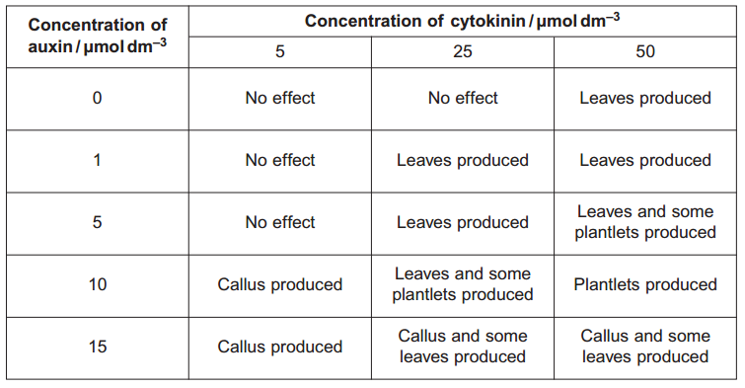

Callus is a mass of undifferentiated plant cells. Plantlets are small plants. Explain the evidence from the table that cells from the stem tip are totipotent.
Gives rise to new plants/plantlets; So must be able to develop into different tissues / other specialised cell types / differentiate

- Calculate the ratio of cytokinin : auxin that you would recommend to grow papaya plants by this method.
5 : 1 / 50 :10 / 1 : 0.2

- Papaya plants reproduce sexually by means of seeds. Papaya plants grown from seeds are very variable in their yield. Explain why.
Meiosis; Independent assortment / crossing over; (Fusion of) genetically different gametes / random fertilisation

- Explain the advantage of growing papaya plants from tissue culture rather than from seeds.
Will be clones / produced by mitosis / will be genetically identical / less variation / all plants will have desired characteristics;

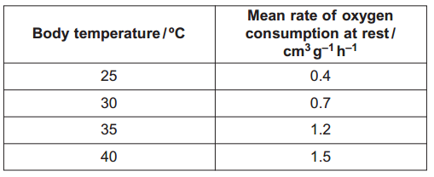
- Desert iguanas are lizards that live in hot, dry conditions. Scientists measured the rate of oxygen consumption of desert iguanas at different body temperatures. Some of their results are shown in the table.
Explain how an increase in the iguana’s body temperature affects its oxygen consumption when it is at rest.
(Increased temperature) increases rate of reactions / increases kinetic energy / increases metabolism; 2. More energy/more ATP; 3. Oxygen consumption linked to respiration

- The units in the table allowed the scientists to compare the oxygen consumptions of different iguanas. Explain how.
Units given per gram / per unit mass / mass is standardised / variation in mass taken into account

- The scientists then investigated how body temperature affected the behaviour of desert iguanas. They kept the iguanas in cages. Half of each cage was in the sun and half was covered to provide shade. The scientists continuously measured the body temperature of each iguana. They also recorded the body temperature when the iguana moved between sun and shade. Their results are shown in the graph.
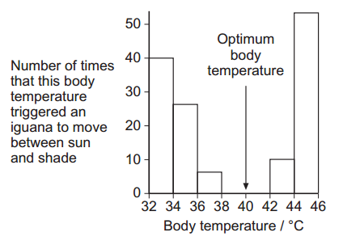
Describe how the movements of the iguanas between sun and shade are related to body temperature.
Further away from the optimum, the greater the movement/least/no movement at optimum

- The behaviour of the desert iguanas keeps their body temperatures within a narrow range. Explain how.
(Outside optimum temperature) moves (between sun and shade); Warm up or cool down

- At high temperatures, a desert iguana keeps its mouth wide open and breathes in and out rapidly. This is called panting. Explain how panting helps to reduce the body temperature of an iguana.
Evaporation (of water from lining of mouth); 2. Heat transferred from blood

- Transcriptional factors are important in the synthesis of particular proteins. Describe how.
Bind to DNA/gene; At specific region/base sequence/promoter sequence; Stimulate transcription / prevents transcription / turn on gene / turn off gene

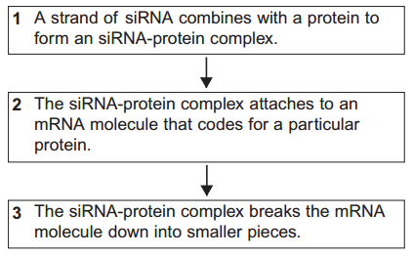
- The flowchart shows how small interfering RNA (siRNA) affects the expression of a particular target gene
The siRNA-protein complex attaches to an mRNA molecule coding for a particular protein (step 2). Explain what causes the siRNA to attach only to one sort of mRNA molecule.
Has complementary base sequence

- Describe and explain how expression of the target gene is affected by siRNA.
No longer able to make specific protein / cannot make whole protein / mRNA cannot be translated; Because mRNA has been cut into pieces

- Scientists have suggested that siRNA may be useful in treating some diseases. Suggest why siRNA may be useful in treating disease.
Some diseases are genetic / caused by mutations; siRNA will stop product of this gene / the protein being produced / stops translation;

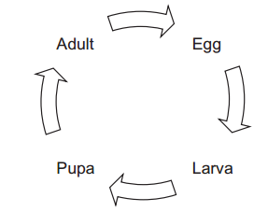
- The diagram shows the life cycle of a fly.
When the larva is fully grown, it changes into a pupa. The pupa does not feed. In the pupa, the tissues that made up the body of the larva are broken down. New adult tissues are formed from substances obtained from these broken-down tissues and from substances that were stored in the body of the larva. Hydrolysis and condensation are important in the formation of new adult proteins. Explain how.
Hydrolysis breaks proteins / hydrolyses proteins / produces amino acids (from proteins); Protein synthesis involves condensation; Hydrolysis of polysaccharides/lipids linked to energy source (for synthesising proteins)

- Most of the protein stored in the body of a fly larva is a protein called calliphorin. Explain why different adult proteins can be made using calliphorin.
Amino acids (from calliphorin) can be joined in different sequences/rearranged

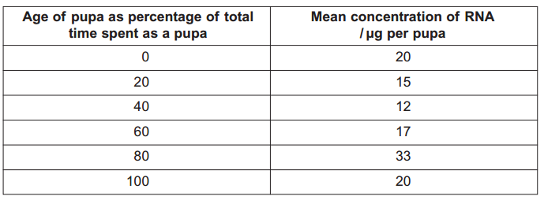
- The table shows the mean concentration of RNA in fly pupae at different ages.
Describe how the concentration of RNA changes during the time spent as a pupa.
Fall, rise and fall; Rise after 40 and fall after 80

- Describe how you would expect the number of lysosomes in a pupa to change with the age of the pupa. Give a reason for your answer.
Fall / increase then fall ; Lysosomes associated with tissue breakdown

- Suggest an explanation for the change in RNA concentration in the first 40 % of the time spent as a pupa.
Tissues/cells are being broken down; RNA is digested/hydrolysed/broken down; By enzymes from lysosomes; New proteins not made / no new RNA made

- Suggest an explanation for the change in RNA concentration between 60 and 80 % of the time spent as a pupa.
(RNA) associated with making protein; New / adult tissues are forming

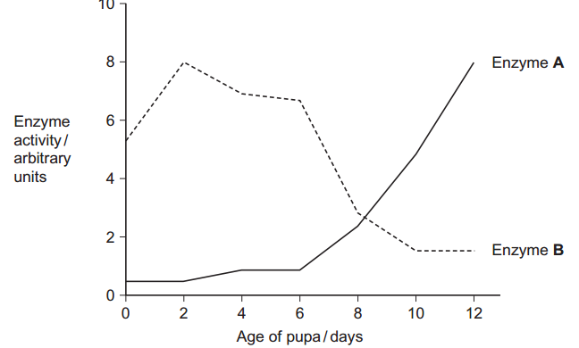
- The graph shows changes in the activity of two respiratory enzymes in a fly pupa. Enzyme A catalyses a reaction in the Krebs cycle. Enzyme B catalyses the formation of lactate from pyruvate
During the first 6 days as a pupa, the tracheae break down. New tracheae are formed after 6 days. Use this information to explain the change in activity of the two enzymes.
In the first 6 days no/little oxygen supplied / with breakdown of tracheae, no/little oxygen supplied; (Without tracheae) respire anaerobically; Anaerobic respiration involves reactions catalysed by enzyme B / conversion of pyruvate to lactate/involves lactate production; Enzyme A/Krebs cycle is part of aerobic respiration

- Termites are insects. Some species live in colonies in the soil. Although most termites are wingless, winged termites are sometimes produced. The winged termites fly from the soil, mate and start new colonies. A scientist studied the behaviour of winged termites. He divided these termites into three groups.
● Group A had their eyes covered.
● Group B had their antennae removed.
● Group C was the control group.
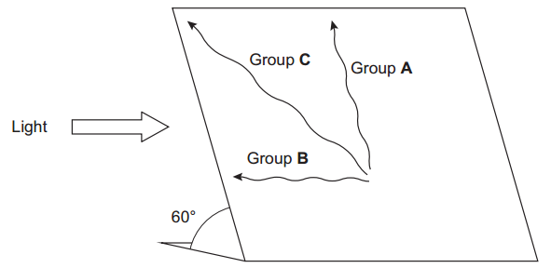
He put individual winged termites on a sloping board that was illuminated from one side. The diagram shows the direction of movement of a typical termite from each of the three groups.

What type of behaviour was shown by the termite from group B? Taxis
- Give the evidence for your answer.
Moves towards stimulus/towards light

- Explain what the results from group A suggest about the factors controlling the behaviour of winged termites.
Gravity; Antennae involved; Doesn’t show light is involved/doesn’t respond to light as they are unable to see/as eyes are covered

- Suggest one advantage to the termites from group C of the behaviour shown in the investigation.
Helps them to leave the soil/ground/reach the surface; Disperse/produce new colonies; Avoid competition

- Complete the table to show the differences between DNA, mRNA and tRNA.
1

1
2
X

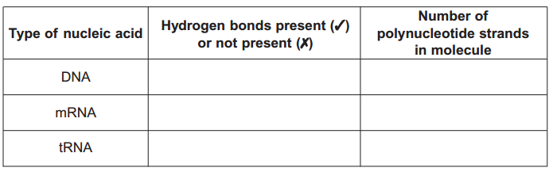
- The diagram shows the bases on one strand of a piece of DNA.
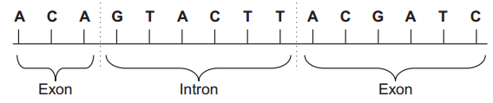

Give the sequence of bases on the pre-mRNA transcribed from this strand.
UGU CAU GAA UGC UAG

- Give the sequence of bases on the mRNA produced by splicing this piece of pre-mRNA.
UGU UGC UAG
- During an action potential, the permeability of the cell-surface membrane of an axon changes. The graph shows changes in permeability of the membrane to sodium ions (Na+) and to potassium ions (K+) during a single action potential.
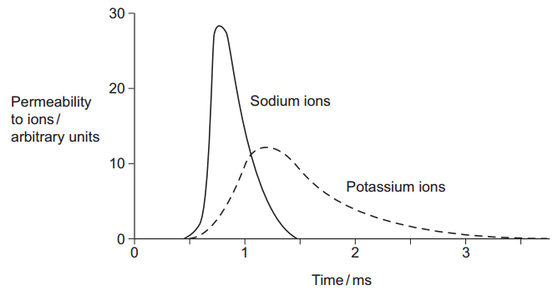
- Explain the shape of the curve for sodium ions between 0.5 ms and 0.7 ms.
(Ion) channel proteins open; Sodium in; Changes membrane potential/makes inside of axon less negative/positive/depolarisation/ reaches threshold; More channels open/positive feedback

- During an action potential, the membrane potential rises to +40 mV and then falls. Use information from the graph to explain the fall in membrane potential.
Potassium channels open; Potassium out; Sodium channels close

- After exercise, some ATP is used to re-establish the resting potential in axons. Explain how the resting potential is re-established.
Pump/active transport/transport against concentration gradient; Of sodium from axon/sodium out/of potassium in;

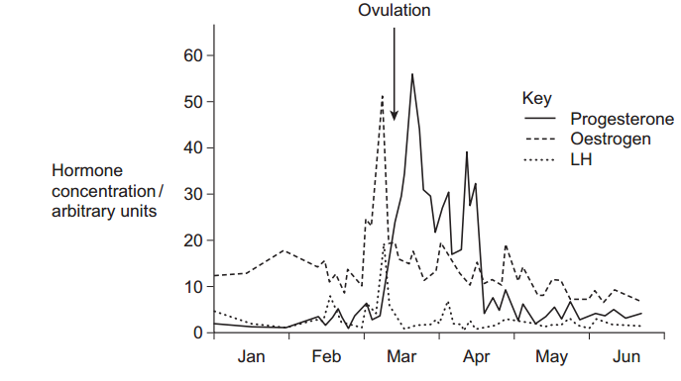
- Scientists investigated control of ovulation in a species of mammal. They measured the concentration of some hormones in the blood of females between January and June. The graph shows the results for one animal.
The concentration of LH in the blood is controlled by negative feedback. Use the curves for progesterone and LH to explain how.
LH rises; Increase in progesterone; Progesterone inhibits LH; (Then) LH fall

- Explain how the change in progesterone concentration in March shows that ovulation took place at the time indicated.
Corpus luteum; Progesterone produced

- Two pieces of information from the graph, other than the change in progesterone concentration, show that ovulation took place at the time indicated. Explain how.
A lot of/ rise in oestrogen; Associated with follicle growth/development/ LH surge; OR Fall in oestrogen; Follice breaks down; Surge in LH (before ovulation); (LH) stimulates ovulation/release of egg; OR Fall in LH (after ovulation); Inhibited by progesterone

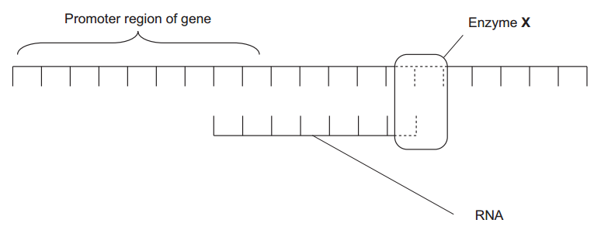
- Figure 1 shows part of a gene that is being transcribed.
Name enzyme X.
RNA polymerase

- Oestrogen is a hormone that affects transcription. It forms a complex with a receptor in the cytoplasm of target cells. Explain how an activated oestrogen receptor affects the target cell.
(Receptor/transcription factor) binds to promoter; Stimulates RNA polymerase/enzyme X; Transcribes gene/increase transcription

- Oestrogen only affects target cells. Explain why oestrogen does not affect other cells in the body.
Other cells do not have the/oestrogen/ ERα receptors

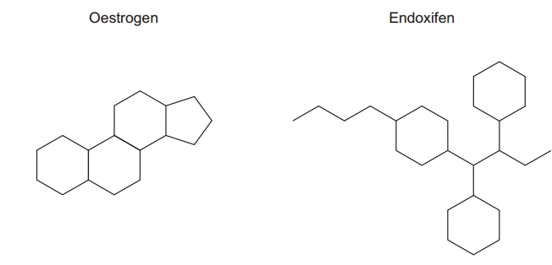
- Some breast tumours are stimulated to grow by oestrogen. Tamoxifen is used to treat these breast tumours. In the liver, tamoxifen is converted into an active substance called endoxifen. Figure 2 shows a molecule of oestrogen and a molecule of endoxifen.
Use Figure 2 to suggest how endoxifen reduces the growth rate of these breast tumours.
Similar shape to oestrogen; Binds receptor/prevents oestrogen binding; Receptor not activated/will not attach to promoter/no transcription

- SCID is a severe inherited disease. People who are affected have no immunity. Doctors carried out a trial using gene therapy to treat children with SCID. The doctors who carried out the trial obtained stem cells from each child’s umbilical cord. Give two characteristic features of stem cells.
Will replace themselves/keep dividing/replicate; Undifferentiated/can differentiate/develop into other cells/totipotent/multipotent/pluripotent

- The doctors mixed the stem cells with viruses. The viruses had been genetically modified to contain alleles of a gene producing full immunity. The doctors then injected this mixture into the child’s bone marrow. The viruses that the doctors used had RNA as their genetic material. When these viruses infect cells, they pass their RNA and two viral enzymes into the host cells. One of the viral enzymes makes a DNA copy of the virus RNA. Name this enzyme.
Reverse transcriptase

- The other viral enzyme is called integrase. Integrase inserts the DNA copy anywhere in the DNA of the host cell. It may even insert the DNA copy in one of the host cell’s genes. The insertion of the DNA copy in one of the host cell’s genes may cause the cell to make a non-functional protein. Explain how.
Alters base/nucleotide sequence/causes frame shift; Different sequence of amino acids in polypeptide/protein/primary structure; Alters tertiary structure

- Some of the children in the trial developed cancer. How might the insertion of the DNA have caused cancer?
Affects tumour suppressor gene; Inactivates (tumour suppressor) gene; Rate of cell division increased/tumour cells continue to divide;
- Five out of the 20 children in the trial developed cancer. Although the cancer was treated successfully, the doctors decided to stop the trial in its early stages. They then reviewed the situation and decided to continue. Do you agree with their decision to continue? Explain your answer.
Yes SCID patients unlikely to survive/quality of life poor unless treated; Cancer that develops is treatable/only affects 25%/five children; No Risk of developing cancer is high/25%; Cancer may recur/may not be treated successfully in future/only short time scale so more may develop cance

- The drawing is a tracing of a cross-section through skeletal muscle tissue. This muscle contains fast muscle fibres and slow muscle fibres. The section has been stained to show the distribution of the enzyme succinate dehydrogenase. This enzyme is found in mitochondria.
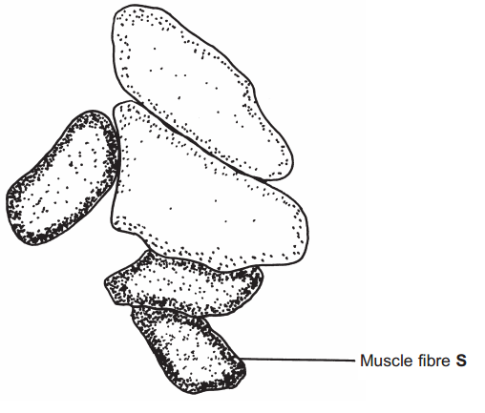
Succinate dehydrogenase catalyses one of the reactions in the Krebs cycle. What is the evidence from the drawing that muscle fibre S is a slow muscle fibre? Explain your answer.
Contains more/large amount of succinic dehydrogenase; (Slow fibres) have lots of mitochondria/ (slow fibres) respire aerobically

- Use evidence from the diagram to describe the distribution of mitochondria inside the slow muscle fibres. Explain the importance of this distribution.
Near edge/outside; Short distance for diffusion of oxygen/Allows rapid diffusion/more diffusion of oxygen; Oxygen used by mitochondria/electron transfer system in mitochondria;

- You could use an optical microscope and a slide of stained muscle tissue to find the diameter of one of the muscle fibres. Explain how.
Measure with graticule/eyepiece scale; Calibrate against something of known size: OR Estimate/measure field diameter with a scale; Estimate number of fibres to cover diameter

- A student found the mean diameter for the slow muscle fibres in a section. Give two precautions that she should have taken when sampling the fibres. Give a reason for each precaution.
Equivalent measurements taken; At random to avoid bias/avoid choice of particular fibres; Large number to be representative/minimise effect of extremes/of anomalies

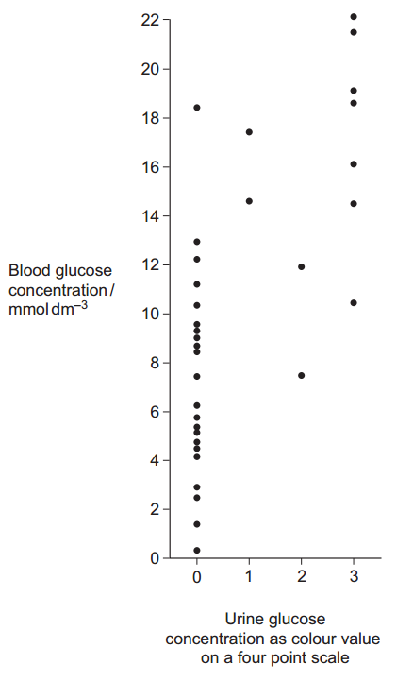
- Technicians in a hospital laboratory tested urine and blood samples from a girl with diabetes at intervals over a one-year period. Each time the technicians tested her urine, they also measured her blood glucose concentration. Their results are shown in the graph.
The girl who took part in this investigation was being successfully treated with insulin. The graph shows that on some occasions, the concentration of glucose in her blood was very high. Suggest why.
Eaten; Containing carbohydrate/sugar; Glucose absorbed from intestine/into blood; Long time after insulin injection/needs more insulin/has not taken insulin; Does not convert glucose to glycogen/glucose not taken up from blood

- Use the graph to evaluate the use of the urine test as a measure of blood glucose concentration.
Shows positive correlation/directly proportional; A range of results for a particular value/values (for different colours) overlap; Urine test only an arbitrary scale/not directly related to concentration/colour is subjective/few colour values;

- Diabetic people who do not control their blood glucose concentration may become unconscious and go into a coma. A doctor may inject a diabetic person who is in a coma with glucagon. Explain how the glucagon would affect the person’s blood glucose concentration.
Glycogen to glucose/glycogenolysis; By activating enzymes; Gluconeogenesis

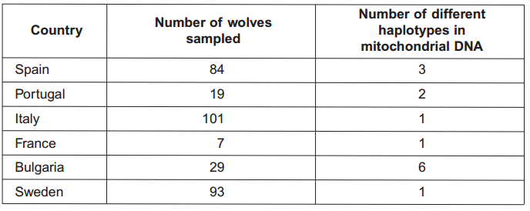
- There are wolves in many European countries. Scientists investigated the genetic diversity of these wolves. They collected samples of DNA from the mitochondria of wolves from different countries. For each sample they identified which haplotypes were present in the DNA. A haplotype is a particular sequence of bases on DNA. Mutations can produce new haplotypes.

The scientists wanted to find out whether one of the haplotypes in the Portuguese wolves was the same as one of those in the Spanish wolves. They used a restriction endonuclease, electrophoresis and a labelled DNA probe. For what purpose did they use
- the restriction endonuclease
To cut the DNA;
- electrophoresis?
To separate the (pieces of) DNA

- Explain why the labelled DNA probe could be used to find out whether the haplotypes were the same.
Complimentary base sequence/complementary DNA; Binds to both (haplotypes); Label would show up in both

- Two hundred years ago there were many wolves in Italy. By the 1970s there were fewer than 100 wolves left. Since 1980, wolves have increased in number and have spread to France. Use this information to explain the number of haplotypes in the Italian wolves.
Bottleneck; Present population descended from small number/fewer than 100/1970 population; With small number few haplotypes/little genetic variation /little genetic diversity/few base sequences

- Suggest an explanation for the number of haplotypes in the wolves that have spread to France.
All descended from Italian wolves/founder effec

- The scientists analysed the DNA on the Y chromosome and the DNA in the mitochondria of the Swedish wolves. They concluded that the Swedish wolf population descended from one male wolf from Finland and one female wolf from Russia. Explain why DNA on the Y chromosome helped them to reach this conclusion.
Y chromosome inherited/comes from male parents/only found in males;

- Suggest why DNA in the mitochondria helped them to reach this conclusion.
Mitochondria in egg/female gamete/no mitochondria come from sperm/male gamete;

- Wolves eat different mammals. An ecologist investigated factors that affect wolf numbers in North America. He collected data from different field studies carried out in different places. The graph shows his results.
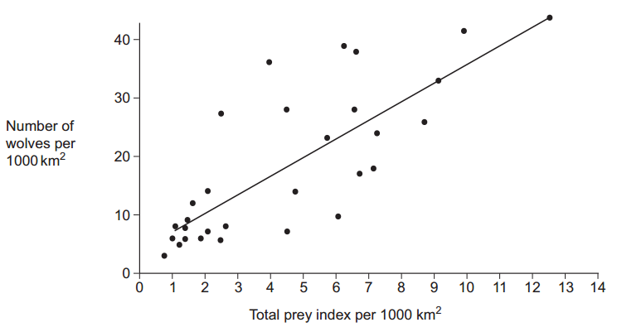
The wolf numbers are given per unit area. Explain why.
Allows comparison; Different (sized) areas covered

- The ecologist calculated the total prey index for each of the places that had been studied. In order to do this, he gave each prey species a value based on how much food was available to wolves from the prey animal concerned. He called this value the prey index. The ecologist considered that the prey index gave a better idea of the food available than the prey biomass in kg. Suggest why the prey index gives a better idea of food available.
Wolves do not eat all of prey animal/do not eat (large) bones/skin; Inedible parts make up different proportions/wolf eats different proportions;

- The ecologist calculated the total prey index by combining the prey indices and the total number of animals of each species present in 1000 km2 . He plotted this information on the graph. What does the graph suggest about the factors that determine wolf numbers in North America? Explain your answer
Limited by food/prey; As prey increases so do wolf numbers/positive correlation; Large range so other factors involved;
PAST PAPER ESSAYS:
- Carbon dioxide may affect organisms directly or indirectly. Describe and explain these effects
Breadth Sections:
Carbon dioxide affects the physiology of organisms - Pulmonary ventilation and the mechanism of breathing / Light-independent reaction of photosynthesis. Limiting factors / Role of chemoreceptors in controlling heart rate
The direct effects of increasing carbon dioxide concentration - Respiration, photosynthesis and human activity giving rise to short-term fluctuations and long-term change / Yield of crop plants / Carbon cycle
Indirect effects of increasing carbon dioxide concentration - Role of carbon dioxide in producing global warming / Life cycles and number of insect pests / Distribution of animals and plants / Effect of temperature on enzymes;

- The causes of disease in humans.
Breadth sections:
Pathogens - Pathogens include bacteria, viruses and fungi / Pathogens cause disease by damaging cells and producing toxins / Cholera bacteria produce toxins resulting in diarrhoea / Symptoms and transmission of pulmonary tuberculosis / Horizontal gene transmission and MRSA
Lifestyle - Risk factors associated with cancer and coronary heart disease / The effects of fibrosis, asthma and emphysema on lung function / The biological basis of heart disease
Genetics - Differences in bases may lead to non-functional enzymes / Relationship between the cell cycle and cancer / Proto-oncogenes and tumour suppressor genes / Gene mutations

- Using DNA in science and technology
Breadth sections:
DNA and classification - Structure of DNA / Differences in DNA lead to genetic diversity / Comparison of DNA base sequences / DNA hybridisation
Genetic engineering and making useful substances – Plasmids / The use of recombinant DNA to produce transformed organisms that benefit humans
Other uses of DNA - Cell cycle and treatment of cancer / Gene therapy; Medical diagnosis and the treatment of human disease; The use of DNA probes to screen patients for clinically important genes

- A cycle is a biological pathway or process in which the end product of one cycle becomes the starting point for the next cycle. Write an essay about cycles in biology.
Breadth sections:
Ecological cycles - Nutrient cycles / Carbon cycle / Nitrogen cycle
Biochemical cycles - Enzyme action / Synthesis of ATP from ADP / Light-independent reaction / The Krebs cycle
Physiological and genetic cycles - The mechanism of breathing / The cardiac cycle / The cell cycle / Muscle contraction / Oestrous cycle

- The importance of shapes fitting together in cells and organisms.
Breadth sections:
Proteins & Enzymes - Enzyme properties and digestion / Protein structure / Plasma membrane structure and cell transport / Antigens, antibodies, B cells & T cells / Vaccines
Nucleic Acids - Structure of DNA / DNA Replication (not PCR) / Transcription & translation / Transcriptional factors, oestrogen, siRNA / Restriction enzymes
Physiology - Haemoglobin / Action potentials & synaptic transmission / Muscle contraction / Control of blood glucose concentration / Control of mammalian oestrous cycle

- How bacteria can affect the lives of humans and other organisms.
Breadth sections:
Bacteria & Disease - Pathogens / Lactose intolerance / Cholera /Tuberculosis / Resistance to antibiotics
Ecological Importance - Carbon cycle / Nitrogen cycle / Eutrophication
Making Use of Bacteria - Use of bacterial enzymes e.g. restriction endonuclease, DNA polymerase for PCR / Use of bacterial plasmids e.g. in vivo gene cloning, genetically-modified crops, gene therapy / Use of bacteria to produce useful chemicals

- The membranes of different types of cells are involved in many different functions.
- The emphasis in answers should be on the involvement of membranes in processes, not just the processes themselves
- Breadth should include Membranes – basic functions / Organelle membranes / Cell surface membranes/ Processes – eg protein secretion, synaptic transmission, cell division
Breadth sections:
Membrane function as selectively permeable / Transport mechanisms across membranes / Absorption and co-transport of sodium ions and glucose / Photosynthesis, chloroplast, thylakoids / Respiration, mitochondrion and cristae / Protein secretion, RER, SER and Golgi / Surface receptors and antigen and immune response / Cell division / Vertical and horizontal transmission – membranes and bacteria / Pacinian corpuscle / Tropisms – movement of IAA / Nerve impulses/action potentials / Synaptic transmission / Muscle contraction, calcium ion movement/storage / Hormones - eg Blood glucose regulation – insulin and glucagon / Osmosis, including water movement in plants

- There are many different types of relationships and interactions between organisms.
- The emphasis in answers should be on the relationships and interactions between organisms not just the topics themselves
- Breadth should include - Pathogen and host / Evolution (related topics) / Ecological / Human intervention in relationships
Breadth topics:
Pathogens and effects on host / Cholera / Taxonomy / Classification and evolution / Inheritance and evolution / Genetic code, universal / Behaviour / Populations and evolution, variation between individuals within a species / Relationships within ecosystems – eg predator-prey / Energy transfer in ecosystems / Nutrient cycles, the organisms involved / Succession, biodiversity, species and individuals in a community / Human impacts on the environment and its effect on relationships between organisms – including farming / Gene technology and GMO and selective breeding / Antibiotic resistance

- How cells and organisms carry out exchanges with their external environment to maintain their internal environment.
Breadth topics:
Homeostasis / Digestion and absorption / Cells / Lung function / Gas exchange / Passage of water through plant / Nutrient cycles / Response to stimuli / Neurones / Temperature control / tissue fluid and its formation / Control of blood glucose concentration / Negative feedback /Gene expression

- How energy is transferred within and between organisms.
Breadth topics:
Photosynthesis / Energy transfer through ecosystems / Food production / Digestion (as in fuel) / Absorption (by cells) / Mass transport / Respiration / ATP / Stimuli and responses / Muscle contraction / Nerve impulses

