UNIT 5 NERVOUS SYSTEM SUMMARY NOTES

RESPONSE TO STIMULI

STIMULUS – a detectable change in the internal or external environment of an organism that produces a response
RESPONSE – something that aids survival which includes movement, secretion from glands and behaviours such as stalking, prey, communication and reproducing
RECEPTORS – cells or organisms that detect stimuli. They transfer the energy of a stimulus into a form that can be processed by the organism and leads to a response
EFFECTOR – the cells, tissues, organs and organ systems that bring about a response
COORDINATOR – interneurons connecting the sensory and motor systems. They connect information from each receptor with its appropriate effector.

Taxis – A simple response that’s direction is determined by the direction of the stimulus
An organism can respond directly to a change in the environment by moving its body either:
- Toward the stimulus (positive taxis)
- Away from the stimulus (negative taxis)

Kinesis – A response which results in an increase of random movements (instead of the direct movement towards a stimulus) which ultimately brings the organism back into favourable conditions.

Tropism – a growth movement of part of a plant in response to a directional stimulus

Nervous Control
The nervous system has two main divisions:
- The central nervous system (CNS) – brain and spinal cord
- The peripheral nervous system (PNS) – Made up of pairs of nerves that originate either from the brain or the spinal cord

The peripheral nervous system
This is divided into:
- Sensory neurons which carry impulses away from receptors to the CNS
- Motor neurons which carry nervous impulses from the CNS to effectors (either under voluntary or autonomic control)

REFLEX ARC
A reflex – involuntary response to a stimulus
Reflec arc - The pathway of neurons involved in a reflex

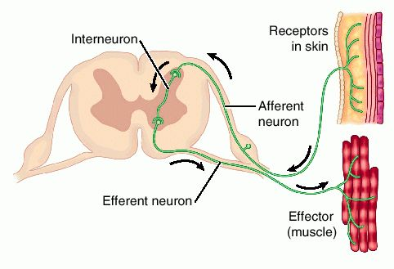
Reflex arcs contain just 3 neurons:
Think; Sam Reads Mice
- A sensory neuron
- An intermediate neuron
- A motor neuron
Think; Smooth Rain Slips In My Ear Roughly
There are several stages of a reflex arc:
- Stimulus
- Receptor
- Sensory neuron
- Coordinator (intermediate neuron)
- Motor neuron
- Effecter
- Response

Importance of the reflex arc
- Involuntary – does not require the decision making power of the brains
- Brain can override the response if necessary
- Protects the body from harmful stimuli
- Effective from birth – does not need to be learnt
- Short pathway – fewer synapses

The Autonomic nervous system
The autonomic nervous system Controls subconscious activities of muscles and glands
Has two main divisions:
- The sympathetic nervous system – Speeds up activities and thus allows us to cope with stressful situations (fight or flight response)
- The parasympathetic nervous system – Inhibits effects and slows down activities. This allows energy to be conserved. Controls under normal resting conditions

The two divisions are antagonistic meaning that their effects oppose one another

Control of heart rate
Changes of the heart rate are controlled by the medulla oblongata which has two main divisions:
- One INCREASES heart rate – it’s connected to the sinoatrial node via the sympathetic nervous system
- One DECREASES heart rate – it’s connected to the sinoatrial node via the parasympathetic nervous system

Control of heart rate by chemoreceptors
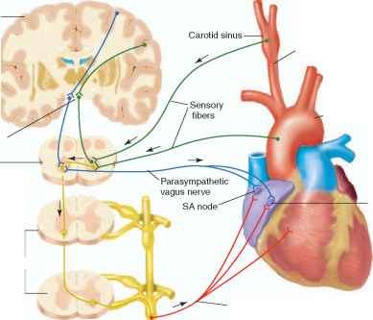
Chemoreceptors are found in the wall of the carotid arteries and detect changes in pH as a result of CO₂ concentration
- When CO₂ concentration in the blood is too low, chemoreceptors detect this and send impulses to the section of the medulla oblongata responsible for increasing heart rate
- This section then increases the number of impulses sent to the S.A node via the sympathetic nervous system
- This results in an increase in heart rate which then causes blood pH to return to normal.

Control of heart rate by pressure receptors
Pressure receptors occur in the wall of the carotid arteries and the aorta
When blood pressure is too high – impulses are sent to the medulla oblongata which then sends impulses to the S.A node via the parasympathetic nervous system decreasing the heart rate
When blood pressure is too low – impulses are sent to the medulla oblongata which then sends impulses to the S.A node via the sympathetic nervous system, increasing the heart rate

ALL THE DIFFERENT NERVOUS SYSTEMS:

RECEPTORS
A sensory receptor will:
- Only respond to a specific type of stimulus (e.g. light, pressure, etc)
- Produce a generator potential by acting as a transducer. This means that it can convert the information to a form that the human body can interpret. This is achieved by using the energy of a stimulus into a nerve impulse called a generator potential.

A Pacinian corpuscle
Responds to mechanical pressure
Found in deep skin, ligaments and joints so that the organism can tell which direction a joint is changing
The neuron of a pacinian corpuscle is in the centre of layers of tissue, each separated by gel
The sensory neuron of a Pacinian corpuscle has stretch-mediated sodium channels in its plasma membrane which can change shape when the channel’s permeability to sodium changes.
- During its resting state, stretch-mediated sodium channels are too narrow to allow sodium through. The corpuscle therefore has a resting potential

- When pressure is applied, the membrane of the neuron is stretched causing sodium channels to widen therefore allowing sodium to diffuse into the neuron

- The influx of sodium ions causes a change in the polarity of the neuron, creating a generator potential

- The generator potential creates an action potential which moves along the neuron to the CNS

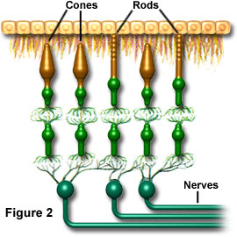

RECEPTORS IN THE EYE
The two light receptors in the eye (the rod and cone cells) both convert light energy into a nervous impulse and are therefore acting as transducers

ROD CELLS | CONE CELLS
Share a SINGLE NEURON = respond to LOW light intensity as many weak generator potentials combine to reach the threshold to trigger an action potential | Have their OWN BIPOLAR CELL = need a HIGH light intensity to create a generator potential and trigger an action potential
Low visual acuity as only one impulse is generated – because they share a single neuron so hard to tell apart points that are close together as the brain cannot distinguish between 2 separate sources of light and stimulated different rod cells. | Good visual acuity as brain receives separate impulses due to the separate connections so can distinguish between different points of light.
Breakdown the pigment rhodopsin to create an action potential (and pigment is broken down in low light intensity) | Breakdown the pigment iodopsin to create an action potential (iodopsin only broken down by a high light intensity)
Only in black or white (cannot distinguish between different wavelengths of light) | Three types, each responding to a different wavelength of light so images in colour depending on proportion of each type that’s stimulated.
Found at the peripheries of retina (as light intensities are lowest) | Found on the Fovea (it receives highest light intensity)

COORDINATION
Two main forms of coordination:
- The nervous system – Uses nerve cells that can pass electrical impulses along their length to secrete neurotransmitters to stimulate the target cells. The response is quick, yet short lived and only acts on a localised region of the body.
- The hormonal system – Chemicals (hormones) are transported in the blood plasma which then reach target certain cells, thus stimulating them. The responses often act over a longer period of time, yet are slower to act.

Hormonal system | Nervous system
Communication by chemicals | Communication by nervous impulses
Transmission takes place in the blood | Transmission is by neurons
Transmission is generally slow | Transmission is very rapid
Hormones travel to all areas of the body, but target only certain tissues/organs | Nerve impulses travel to specific areas of the body
Response is widespread | Response is localised
Effect may be permanent/long lasting/ irreversible | Effect is temporary and reversible

Chemical mediators
Nervous and hormonal forms of communication are only useful at coordinating the activities of the whole organism. At the cellular level they are complimented by chemical mediators they are secreted by individual cells and affect other cells in the immediate vicinity.

EXAMPLES:
- Histamine – Stored in white blood cells and is secreted due to presence of antigens. It causes dilation of blood vessels, increased permeability of capillaries and therefore swelling the infected area.
- Prostaglandins – Found in cell membranes and cause dilation of small arteries and arterioles. They’re released due to injuries and increase the permeability of capillaries. They also affect blood pressure and neurotransmitters; in doing so they relieve pain.

Plant growth factors
Plants respond to external stimuli by means of plant growth factors (plant hormones)
Plant growth factors:
- Exert their influence by affecting growth
- Are not produced by a particular organ, but are instead produced by all cells
- affect the tissues that actually produce them, rather than other tissues in a different area of the plant.

One plant hormone called indoleacetic acid (IAA) causes plant cells to elongate

Control of tropisms by IAA
TROPISM = a growth movement of a plant in response to a directional stimulus.

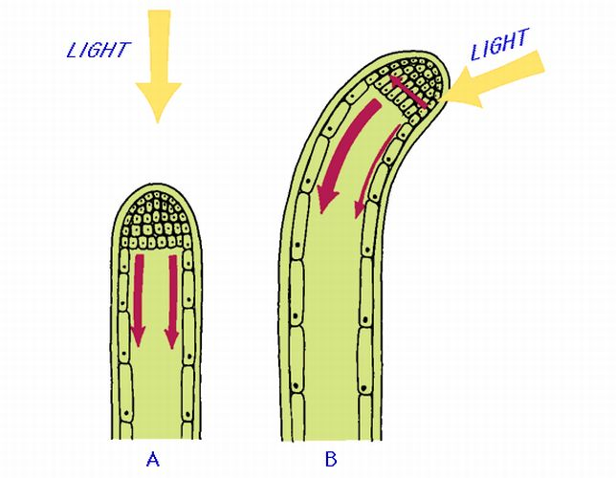
RESPONSE TO LIGHT:
- Cells in the tip of the shoot produce IAA, which is then transported down the shoot.
- The IAA is initial transported to all sides as it begins to move down the shoot
- Light causes the movement of IAA from the light side to the shaded side of the shoot.
- A greater concentration of IAA builds up on the shaded side of the shoot
- The cells on the shaded side elongate more due to the higher concentration of IAA
- The shaded side of the root therefore grows faster, causing the shoot to bend towards the source of light

IAA can also effect the bending of roots towards gravity. However in this case it slows down growth rather than speeds it up and so collects on the opposite side to gravity.

Neurons
Specialised cells adapted to rapidly carry electrochemical changes (nerve impulses) from part of the body to another

Neuron structure
- Cell body - Large amounts of rough endoplasmic reticulum to produce neurotransmitters
- Dendrons - Carry nervous impulses to the cell body
- Axon - A single long fibre that carries nerve impulses away from the cell body
- Schwann cell - Surrounds the axon, protecting it and providing insulation or carrying out phagocytosis.
- Myelin sheath - made up from the Schwann membrane which produces myelin (a lipid)
- Nodes of Ranvier - The gaps between myelinated areas
TYPES:
Sensory Neuron
- Transmit impulses from a receptor to an intermediate neuron or motor neuron
- One Dendron towards the cell body, one axon away from the cell body

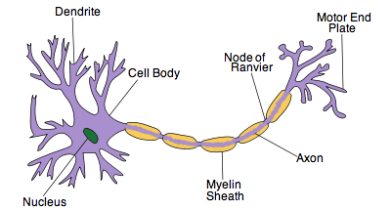
Motor neuron
- Transmit impulses from the sensory/intermediate neuron to an effector
- Long axon, many short dendrites

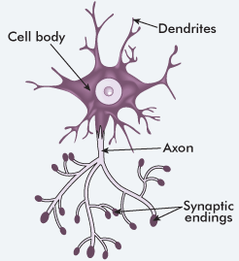

Intermediate neuron
- Transmit impulses between neurons
- Numerous short processes

The nerve impulse
It is a self-propagating wave of electrical disturbance that travels along the surface of an axon membrane. It is the temporary reversal of the electrical potential difference across an axon membrane
The reversal is between two states
- The resting potential - no nerve impulse transmitted
- The action potential – nerve impulse transmitted

Resting potential (the difference in electrical charge across the axon when NOT stimulated – the inside is negatively charged relative to the outside)
- Sodium out of axon by SODIUM-POTASSIUM PUMP
- Potassium into axon
- More sodium out than potassium in = creates chemical gradient (relatively more positive outside)
- Sodium naturally diffuses back into axon and potassium out
- Potassium diffuse out faster than sodium diffuses in, further increasing potential difference (in charge) and creating an electrical gradient.
- Eventually an equilibrium is established as potassium is attracted to the negative inside.
- OVERALL THERE IS A POSITIVE OUTSIDE AND A NEGATIVE INSIDE WHEN RESTING (polarised)

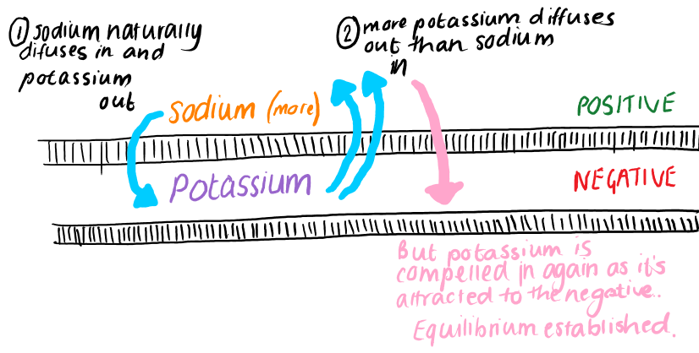

The action potential (the change/reversal in electrical charge across the membrane when stimulated and a nerve impulse passes, so the inside becomes positive and the outside negative - depolarisation)
Depolarisation = the temporary reversal of charges when a nerve impulse is transmitted.
- Temporary reversal of the charge of the membrane from -65mV to +65mV (depolarisation) because the ion channels open/close depending upon the voltage across the membrane.

- Energy from stimulus = SODIUM voltage-gated channels open = sodium into axon
- This triggers a reversal in the potential difference as sodium is positively charged = depolarisation

- Once action potential of around +40Mv reached gates close and POTASSIUM ones open = potassium out of axon. With the potassium channels having had open, the membrane begins to repolarise back to its resting potential

- Flood of potassium out = temporary overshoot with inside being more negative than usual = hyperpolarisation. Part of the importance of hyperpolarization is in preventing any stimulus already sent up an axon from triggering another action potential in the opposite direction to that the signal is proceeding in one direction.

- Potassium gates close = sodium-potassium pumps start = repolarisation as resting potential re-established.

Refractory period
After an action potential, sodium voltage-gated channels are closed and sodium cannot move into the axon. It is therefore impossible during this time for a further action potential to be generated.

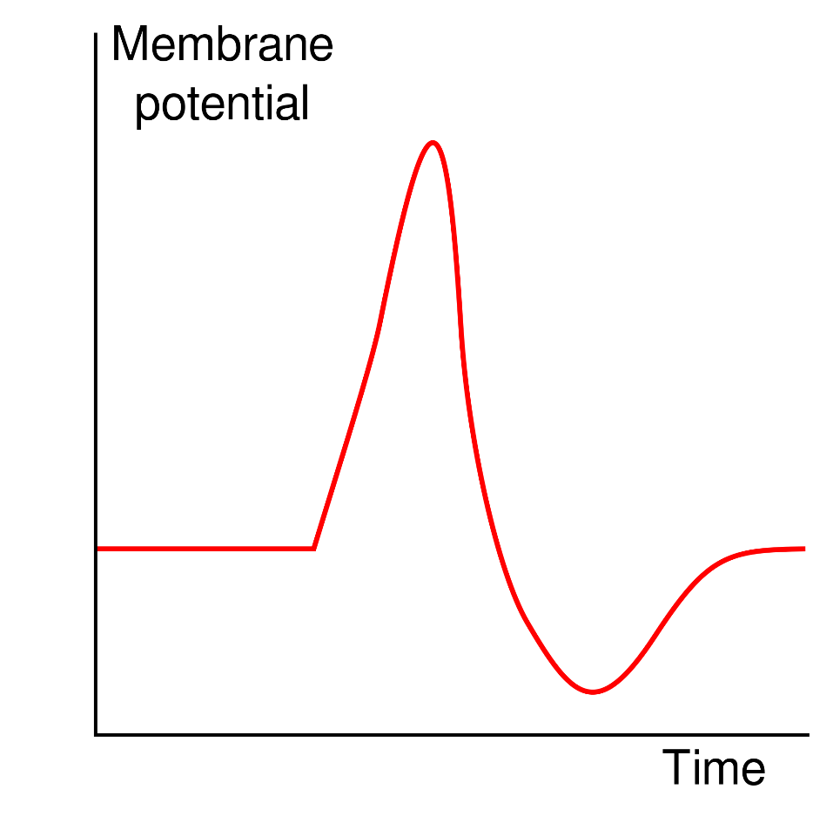

POLARISED – resting potential. Inside negative, outside positive (more sodium outside than potassium inside)

REPOLARISATION – sodium potassium pump bring membrane back to its resting state.

DEPOLARISED – action potential. Sodium into axon, potassium out. Positive inside, negative outside.
REPOLARISATION – with the potassium channels having had open, the membrane begins to repolarise back to its resting potential
HYPER-POLARISED – repolarisation overshoots rest potential and goes into the refractory period to prevent the neuron from to prevent the neuron from receiving information from another stimulus.

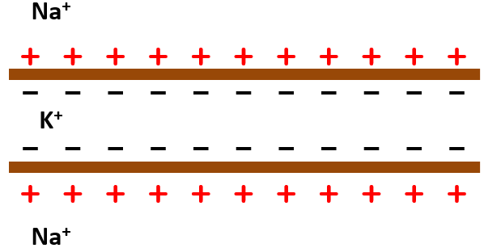
The passage of an action potential along an unmyelinated axon

RESTING POTENTIAL – overall positive outside, negative inside = polarised.

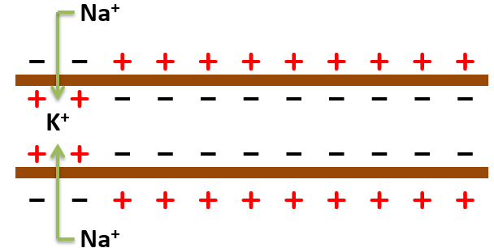
FIRST ACTION POTENTIAL INITIATED – stimulus causes influx of sodium = reversal of charge at start of axon = depolarised.

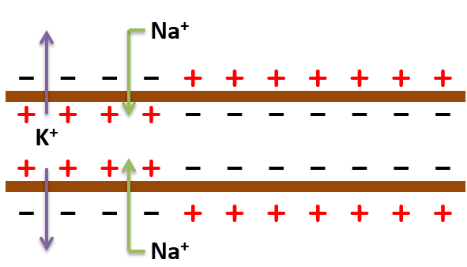
Further along axon sodium voltage-gated channels open, so this later region becomes depolarised (charges reversed). Behind this part, the sodium gates close and potassium ones open (so potassium goes out)

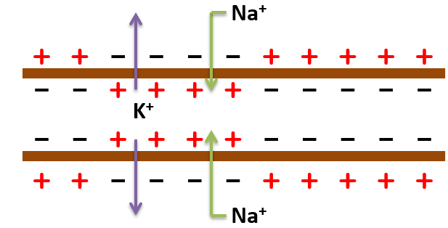

Action potential continues along, the first region becomes REPOLARISED to its original charge as potassium’s keep leaving.

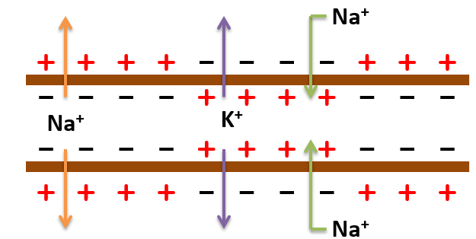

The first region now pumps sodium out, repolarising neuron to its resting potential.

The passage of an action potential along a myelinated axon
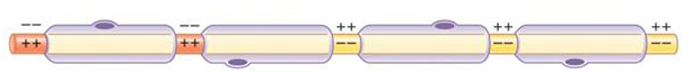
Using SALATORY CONDUCTION, action potentials “jump” from node to node as the myelin layer is an insulator. This makes passage faster.

The speed of a nerve impulse

Factors affecting speed:
- The myelin sheath – Prevents the action potential forming in myelinated areas of the axon, so action potential jumps (salutatory conduction) – this increases the speed of the impulse as less action potentials need to occur

- The greater the diameter of the axon - the greater the speed of conductance due to less leakage of ions from the axon

- Higher the Temperature – the faster nerve impulse. Energy for the ions diffusing by active transport comes from respiration. Respiration like the sodium potassium pump is controlled by enzymes.

Purpose of the refractory period:
- It ensures that an action potential can only be propagated in one direction – An action potential can only move from an active region to a resting region.

- It produces discrete impulses – A new action potential cannot be generated directly after the first. It ensures action potentials are separated from one another.

- It limits the number of action potentials – action potentials are separated from one another, therefore there is a limited amount that can pass along a neuron in a given time

All or nothing principle
- A stimulus must exceed a certain threshold value to trigger an action potential
- A stimulus that exceeds the threshold value by a significant amount, will produce the same strength of action potential as if it has only just overcome the threshold value
- A stimulus can therefore only produce one action potential

An organism can perceive different types of stimulus in two ways:
- The number of impulses in a given time (larger stimulus, more impulses per second)
- Having neurons with different threshold values – depending on which neurons are sending impulses, and how frequently impulses are sent, the brain can interpret the strength of the stimulus

SYNAPSES
A synapse is the point where a dendrite of one neuron connects to the axon of another

Structure
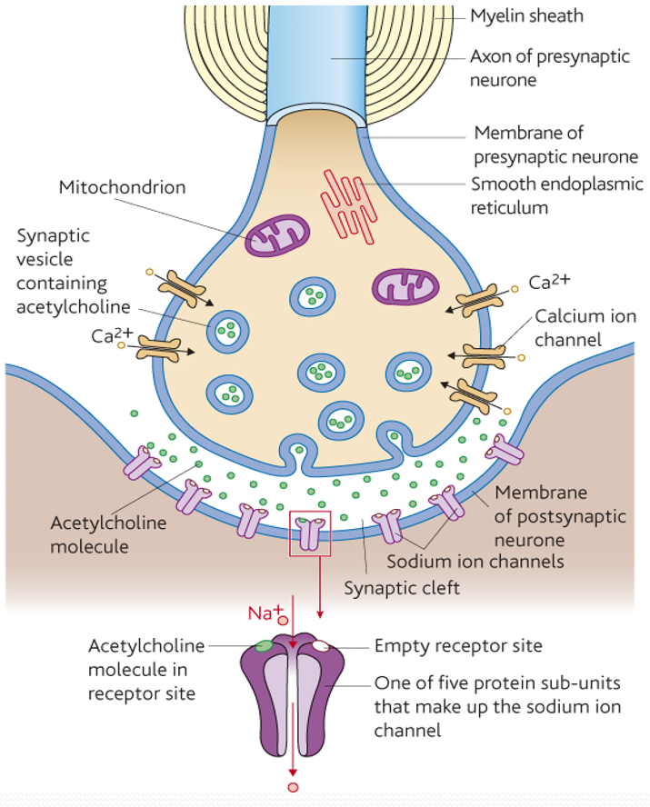

Functions of synapses
- A single impulse from one neuron can be transmitted to several other neurons at a synapse so one impulse can create a number of simultaneous responses
- A number of different impulses can be combined at a synapse so several responses from different stimuli can be combined to give one single response

Process:
- Neurotransmitters are made in the presynaptic cleft only
- When an action potential reaches the presynaptic knob, it causes vesicles containing the neurotransmitter to fuse with the presynaptic membrane
- The neurotransmitter will the diffuse across the synaptic cleft
- The neurotransmitter then bind with receptors on the postsynaptic membrane, in doing so generating a new action potential in the postsynaptic neuron

Features
Unidirectionality
Impulses can only be sent from the presynaptic membrane to the postsynaptic membrane

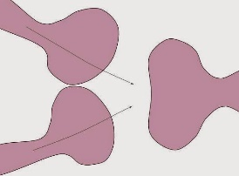
Summation
A new action potential can still be made with a weak, low-frequency stimulus:
- Spatial summation - Different presynaptic neurons together will release enough neurotransmitter to exceed the threshold value to form an action potential

- Temporal summation – One neuron releasing neurotransmitter many times over a short period. Eventually the neurotransmitter will accumulate so as to overcome the threshold value of the postsynaptic membrane.

Inhibition
Some postsynaptic membranes have protein channels that allow chloride ions to diffuse into the axon making it more negative than usual at resting potential. This causes hyperpolarisation which inhibits the postsynaptic neuron from generating a new action potential. Therefore impulses can be controlled or stopped if necessary.

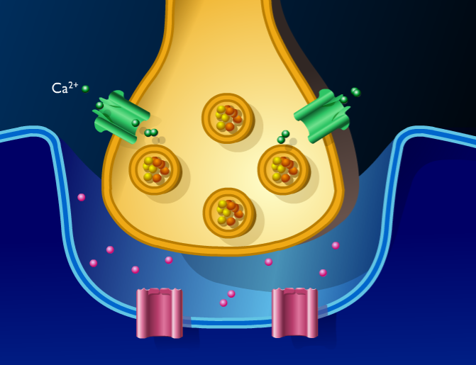
Transmission across a cholinergic synapse (The neurotransmitter Acetylcholine is made up of acetyl (ethanoic acid) and choline and occurs in the central nervous system and at neuromuscular junctions)
- Action potential reaches the presynaptic knob calcium ion channels OPEN letting calcium in

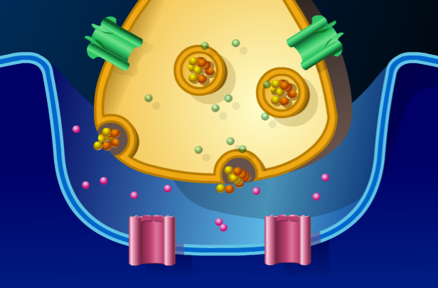

2. calcium cases the vesicles containing acetylcholine to fuse with the membrane and release it into the synaptic cleft

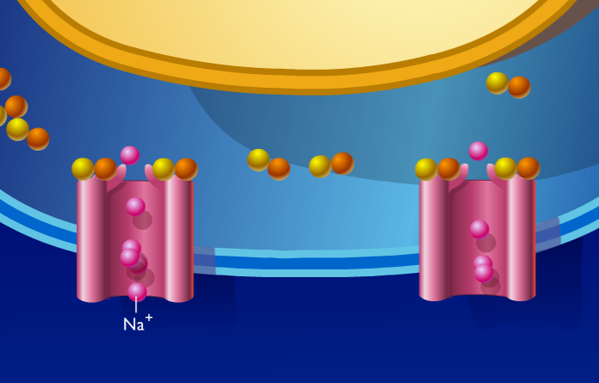
3. Acetylcholine fuses with receptor sites on sodium channels, opening them so sodium diffuses into postsynaptic neuron, causing a new ACTION POTENTIAL.

4. An enzyme (Acetylcholinesterase) hydrolyses acetylcholine back into acetyl and choline which diffuses back into pre-synaptic knob.

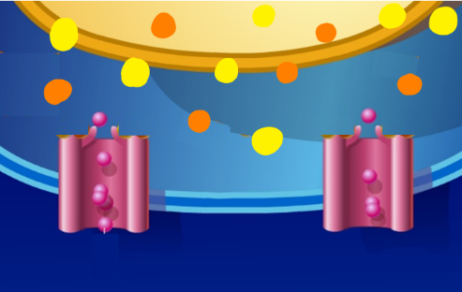

5. Acetyl and choline diffuses back into pre-synaptic knob.
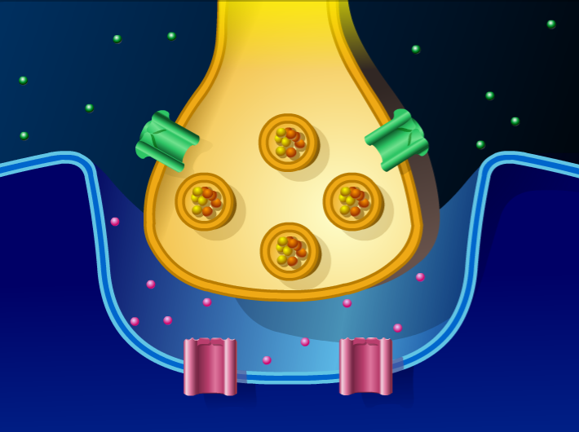

6. Mitochondria release ATP to give the energy to recombine acetyl and choline (which is stored again in vesicles) whilst the sodium channels close

EFFECT OF DRUGS

Drugs can act on synapses to:
- STIMULATE more action potentials to enhance body’s response to impulses (done by stimulating release of more neurotransmitter or inhibiting enzyme that breaks down the neurotransmitter)
- INHIBIT by producing fewer action potentials to reduce body’s response (by inhibiting release of neurotransmitter or blocking receptors on sodium/potassium ion channels)

