UNIT 5 MUSCLES SUMMARY NOTES
MUSCLE = effector organs that respond to nervous stimulation by contracting and so brign about movement.
Three types:
Cardiac muscle - found only in the heart
Smooth muscle - found in the walls of blood vessels
Skeletal muscle - attached to bone - only type under conscious control

- Muscles are made up of many muscle fibres called myofibrils because if the cells of muscles were joined together from the end of one cell to another, the point between cells would be a point of weakness
- Cells of the same myofibrils share the same nuclei as well as cytoplasm (sarcosplasm).
- Within the sacroplasm are many mitochondria as well as endoplasmic reticulum

The myofibrils are made up of 2 protein filaments:
- ACTIN thinner (2 strands twisted)
- MYOSIN thicker (long rod-shaped fibres with bulbous heads

skeletal muscle

Myofibrils have coloured bands:
- The isotropic (I) bands appears lighter since it consists only of actin (no overlap)
- The anisotropic (A) bands are darker since this is where acting and myosin overlap
- The H zone is the region in the centre of the sarcomere that is lighter in colour since there is only myosin
- The z line lies at the centre of the I bands
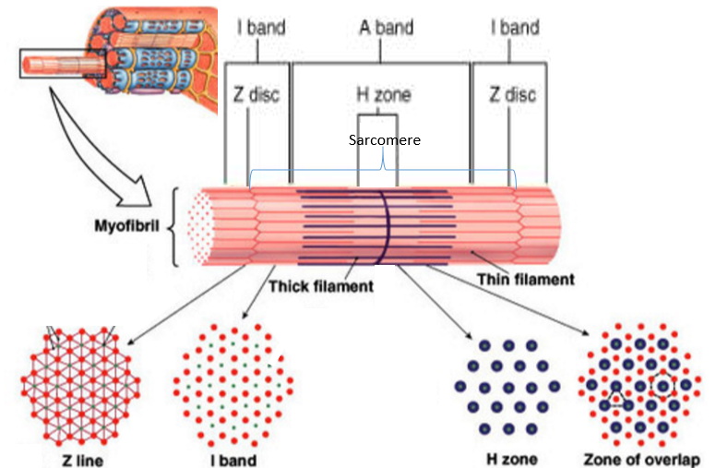
- The distance between two z lines = Sarcomere
The advantage of having parallel sarcomeres = all the force is generated in one direction and even if only 1 contracts a little, the whole line will contract a lot.

Types of muscle fibre

Slow-twitch
- Contract more slowly, less powerful.
- Adapted for endurance/aerobic respiration so less lactic acid forms as energy is released slowly
- Work for long period without tiring
- Rich in myoglobin (to store oxygen)
- Has a supply of glycogen for metabolic energy
- Rich supply of blood vessels
- Numerous mitochondria

Fast-twitch
- Contracts more rapidly with more power but only for a short period of time.
- Adapted for intense exercise as energy is released quickly through anaerobic respiration using glycogen
- Tire easily
- Many enzymes used for anaerobic respiration
- Large store of phosphocreatine to provide phosphate to make ATP
- Thicker and more myosin filaments.

Neuromuscular junctions

It is the point where a MOTOR neuron meets a skeletal muscle fibre.

- There’s many along the muscle to enable rapid & simultaneous contraction (simultaneously contracting enables more power and faster contractions)

- Each muscle fibre has one motor neuron associated with it. The muscle fibre and the neuron make up one motor unit

- When only a small force is needed only a few motor units are stimulated

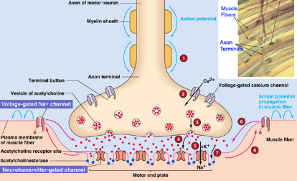
PROCESS:
- A nerve impulse reaches the junction and synaptic vesicles join with presynaptic membrane and release acetylcholine.
- Acetylcholine diffuses to post synaptic membrane and alters its permeability to sodium ions
- Sodium ions enter, DEPOLARISING the membrane
- Acetylcholine is broken down by acetylcholinesterase (so muscle isn’t over-stimulated)
- Acetyl and choline diffuse back into presynaptic neurone where they use energy from mitochondria to recombine.

Contraction of skeletal muscle

THE SLIDING FILAMENT MECHANISM
Actin and myosin slide past each other to make sarcomeres contract.

Evidence for the sliding filament mechanism:
When a muscle contract, the following changes occur to the sarcomere:
- The I band becomes narrower
- The z lines move close to one another
- The h band becomes narrower
- The a band does not change as this band is determined by the width of the myosin and this is proof that the bands don’t shorten

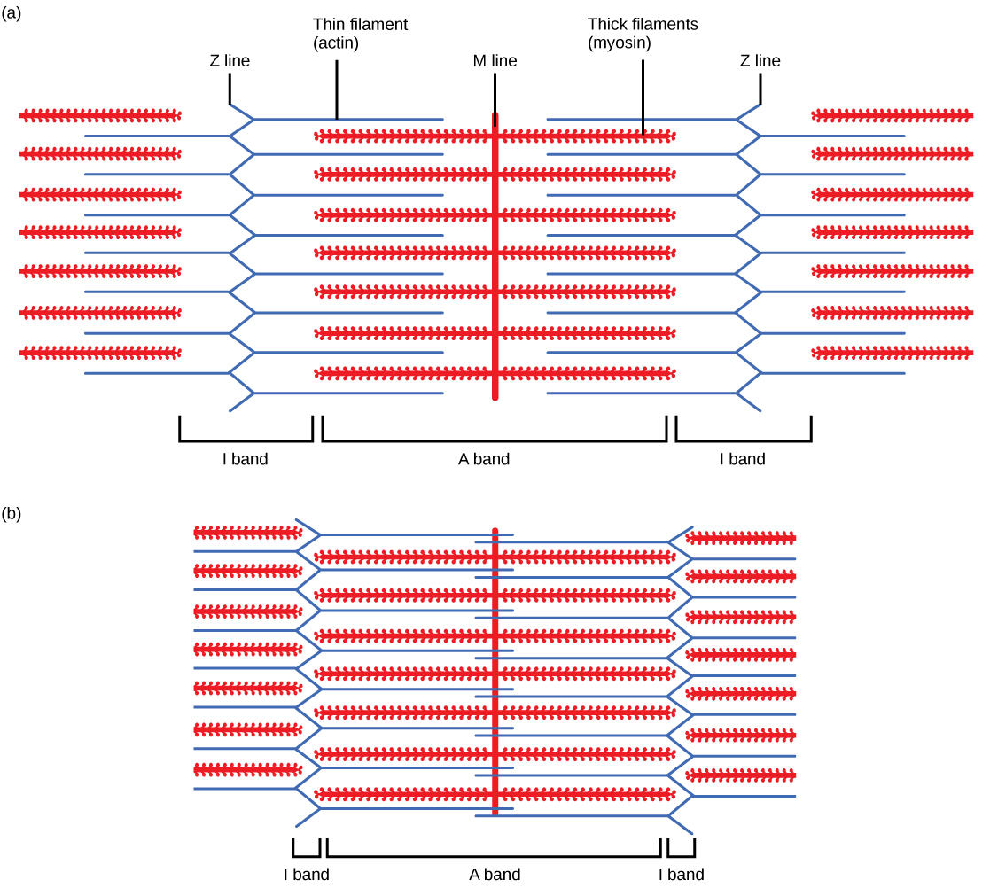

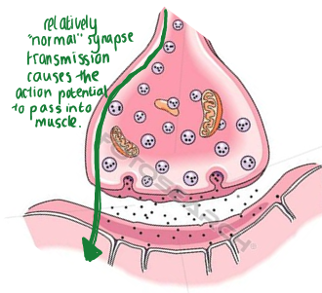
PROCESS:

- Muscle stimulation
- An action potential (due to depolarisation) reaches the neuromuscular junctions
- Calcium ion channels open = calcium into the synaptic knob
- This causes synaptic vesicles to fuse with the presynaptic membrane and release acetylcholine
- Acetylcholine binds with receptors on the sodium voltage gated channels on the postsynaptic membrane causing it to depolarise

- Muscle contraction
- The action potential movies through the fibres by travelling through tubules that branch through the sarcoplasm
- The action potential moves through the tubules until it reach the sarcoplasmic reticulum and opens calcium ions in the sarcoplasmic reticulum
- Calcium ions diffuse into the muscle and cause tropomyosin (which is bound around actin) to change shape and so that the binding sites on the actin filament is exposed
- The myosin heads form a cross bridge with actin by binding with the receptor site
- Once attached, the myosin head changes shape and slides the actin across. In doing so it loses the ADP attached to the myosin head
- An ATP molecule attaches to the myosin head and thus causes it to detach
- Calcium ions activate the enzyme ATPase which hydrolyses ATP to ADP and releases energy that allows the myosin head to resume its original shape.
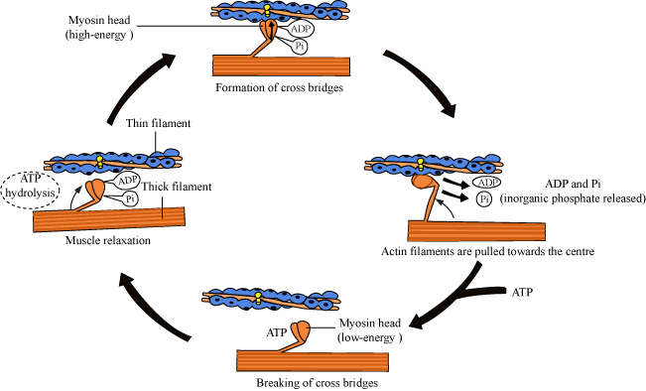
- The myosin head now has a new ADP molecule that will allow it to bind with a new receptor site somewhere along the actin filament

- Muscle relaxation
- When the muscle is not being stimulated, the sarcoplasmic reticulum actively transport calcium ions back into it
- The lack of calcium ions means that tropomyosin can establish its original position (blocking the actin filament) so myosin cannot bind to actin.

SUMMARY OF MUSCLE CONTRACTION:
- Action potential in synapse opens calcium channels so acetylcholine is released and sodium goes into the muscle, passing the action potential across
- Action potential travels through tubules to open calcium channels in sarcoplasmic reticulum so calcium goes into muscle
- Tropomyosin changes shape to expose actin binding site.
- Myosin head binds with actin and releases its ADP
- ATP attaches to myosin, detaching it
- Calcium actives ATPase to hydrolyse ATP and allow myosin to go resume its original shape
- Calcium goes back into sarcoplasmic reticulum so tropomyosin blocks the receptor site again.

Energy supply for muscle contraction

Energy is needed for the movement of myosin heads & the active transport of calcium ions into sarcoplasmic reticulum.

Generated 2 ways:
- From the hydrolysis of ATP to ADP and Pi during the respiration of pyruvate in the mitochondria (BUT THIS NEEDS OXYGEN WHICH IS QUICKLY USED UP IN MUSCLES!!)
- ATP is anaerobically generated using phosphocreatine (it regenerated ATP and acts as a reserve supply of phosphate)

