UNIT 5 HOMEOSTASIS SUMMARY NOTES
= The maintenance of a constant internal environment

Homeostasis involves maintaining the volume, chemical make up and other factors of blood and tissue fluid within restricted limits and set-points.

The importance of homeostasis
- Enzymes and other proteins are sensitive to changes in pH and temperature
- Water potential of blood and tissue fluid should be kept constant to ensure cells do not burst or shrink due to osmosis (this is achieved by maintaining constant glucose levels)
- Independence of the external environment – a wider geographical range and therefore a greater chance of finding food shelter, etc. Homeostasis allows them to tolerate a wide range of conditions

Control mechanisms
The set point is monitored by:

Thermoregulation (regulation of body temp)

How to gain heat:
- Metabolism of food during respiration
- Heat gain from the environment – Conduction, convection & radiation

How to lose heat:
- Evaporation of water
- Heat loss to environment – conduction, convection & radiation

Endotherms – (birds/mammals) - derive most heat energy from metabolic activities INSIDE their body
Ectotherms – obtain most heat from the external environment
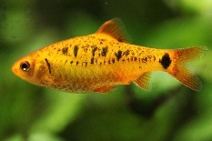
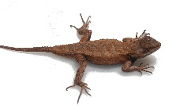
Regulation of body temperature in Ectotherms
Body temp fluctuates with the environment
Controlled by;
- exposure to the sun
- shelter
- heat from the ground
- metabolic heat from respiration
- colour variations (to alter heat radiation)
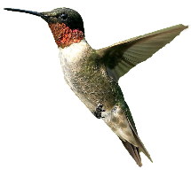
Regulation of body temperature in Endotherms
Most heat gained through internal metabolic activities

CONSERVING HEAT IN COLD ENVIRONMENTS
- Small surface area to volume ratio = relatively large
- Smaller extremities
- thick fur/feathers/fat
- Vasoconstriction – reducing the diameter of arterioles near skin’s surface so blood stays below the layer of fat
- Shivering – in voluntary rapid movements that produce metabolic heat energy from respiration
- Raising hair – enables a thick layer of still air to build up which acts as a good insulator.
- Increased metabolic rate – more hormones that increase metabolic rate are produced so higher metabolic and respiration rate
- Behavioural mechanisms – bathing in the sun
- Decreased sweating

LOSING HEAT IN WARM ENVIRONMENTS
- Large surface area to volume ratio = smaller animals
- Larger extremities
- Light coloured fur to reflect heat
- Vasodilation – Arterioles increase in diameter so warm blood passes close to skin’s surface and radiates heat
- Lower body hair – Hair erector muscles relax. Hairs flatten, reduces the insulating layer of air
- Behavioural mechanisms – seeking shade, burrows, etc
- Increased sweating – Heat energy is required to evaporate sweat. The energy comes from the body. Therefore, removes heat energy to evaporate water

Control of body temperature
The hypothalamus measures the INTERNAL temperature of blood passing through it
Thermoreceptors in the skin measure the EXTERNAL temperature

- Impulses are sent to the hypothalamus via the autonomic nervous system from the thermoreceptors.
- Impulses are sent along motor neurones to effectors to conserve/lose heat.

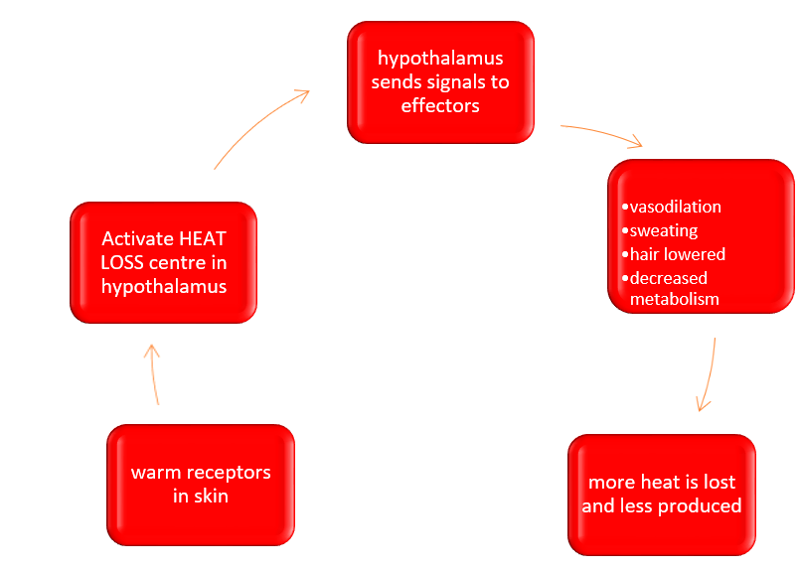

INCREASE
DECREASE

Hormones and Glucose regulation
- Hormones are produced by endocrine glands which secrete the hormones into the blood
- The hormones are carried in the blood plasma to the target cells to which they act.
- The target cells have complementary receptors on the cell surface membrane

The second messenger model:
Adrenaline (as an example)
- The first hormone (Adrenaline) binds to specific receptors on the surface membrane of target cells, forming a hormone-receptor complex.
- This activates an enzyme inside the cell membrane which produces a response (converts ATP to cyclic AMP - which acts as the secondary messenger
- Cyclic AMP then activates several other enzymes that can convert glycogen to glucose
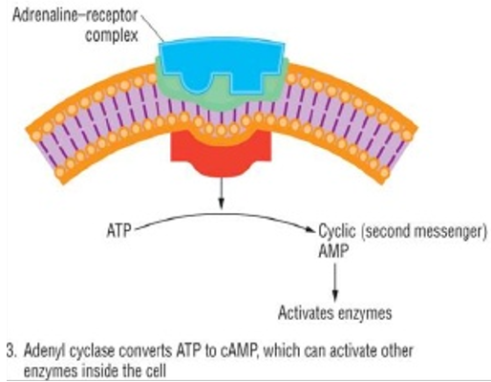

REGULATION OF BLOOD GLUCOSE
too much glucose = lower blood water too little glucose = cells deprived of
potential = dehydration energy

Blood glucose comes from:
Directly from the diet – from the breakdown of carbohydrate
Glycogenolysis – glucose coming from the breakdown of glycogen that is stored in the liver and in muscle cells
Gluconeogenesis – production of new glucose from sources other than carbohydrate and glycogen. E.g. from amino acids and glycerol

As glucose levels fluctuate, levels can be maintained with the help of 3 hormones:
- Insulin and beta cells in the pancreas
The ‘hormone producing’ cells in the pancreas are known as the islets of Langerhans

- Beta cells in the pancreas can detect an increase in glucose and release insulin
- Insulin binds to receptors on the plasma membrane of cells.
- This causes a change in the tertiary structure of the glucose transport protein channels
- These channels change shape and open causing them to change shape so more glucose goes into the cell
- Insulin binding also increases the number of carrier molecules in the membrane
- And activates enzymes involved in converting glucose to glycogen & fat (so less glucose is left in blood)

By increasing the amount of glucose entering cells, the cells respire more (which needs more glucose) so the cells take in even more glucose leaving less to be in the blood.

- Glucagon and alpha cells in the pancreas
- Alpha cells in pancreas detect a decrease in glucose and release glucagon
- Glucagon binds to receptors on liver cells and activate an enzyme converting glucagon glucose
- Liver cells also increases gluconeogenesis – conversion of amino acids & glycerol to glucose
- Respiration decreases so cells use up less glucose.

- Adrenaline
- It activates an enzyme causing glycogenolysis (converting glycogen to glucose)
- Inhibiting enzyme for glycogenesis (creating glycogen from glucose)

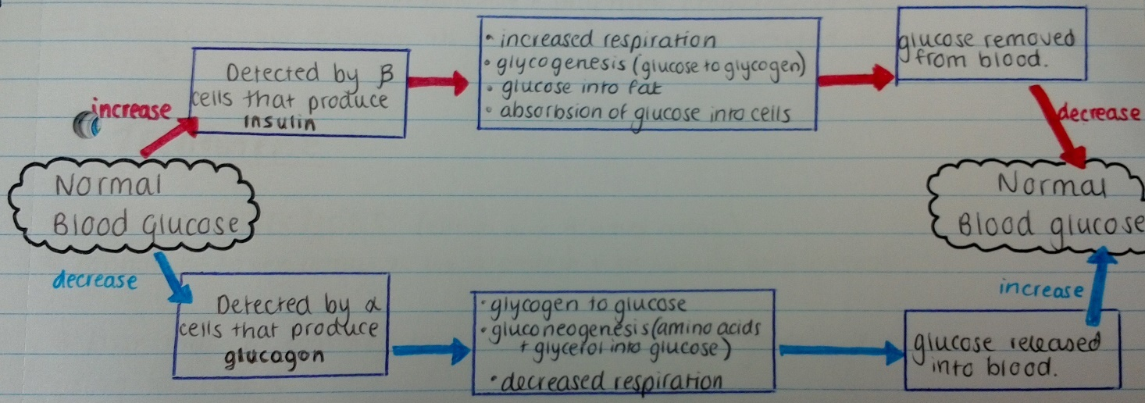
Hormones interact using NEGATIVE FEEDBACK:

DIABETES
Symptoms of diabetes
- High blood glucose level
- Presence of glucose in the urine
- Increased thirst/hunger
- Excessive urination
- Tiredness
- Weight loss
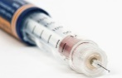
- Blurred vision

- Type 1 (insulin dependent) - Often due to an autoimmune response where the body attacks beta cells = person cannot produce insulin
INSULIN
- Develops during childhood
- After eating, glucose levels will remain high and kidneys cannot reabsorb it all so will secrete glucose in the urine

Helped with INSULIN INJECTIONS (not orally as, being a protein, insulin would be digested)

- Type 2 (insulin independent) – Glycoprotein receptors on cells lose their responsiveness to insulin or beta cells don’t produce ENOUGH insulin (so cells don’t take up enough glucose)

- Developed later (usually with obesity)
INSULIN
Helped by regulating carbohydrates and exercise (sometimes drugs to stimulate insulin or to slow down absorbs ion of glucose)

Feedback mechanisms

Feedback loops inform the receptor of changes brought about by the effector

Negative feedback
= corrective measures being turned off (to return to set point)
EXAMPLE:
- Temperature
Once our body goes through motions to increase/decrease body temperature and it has returned to normal, negative feedback turns off the corrective measures (such as turning off the effector) so you don’t go too far in the other direction!
- Glucose
Once hormones from islets of Langerhans cause gluconeogenesis/glyconeolysis and glucose goes back to normal, the “normal” blood circulates back to the pancreas to turn off the corrective measures (the production of the hormone)

Positive feedback
= causes corrective measures to remain turned on (to move further away from set point)
EXAMPLE:
- stimulus causing sodium ions to enter the axon.
When more sodium ions enter, the potential across the membrane increases and causes other sodium-gated channels to open thus causing an even greater amount of sodium ions to move into the axon

THE OESTROUS CYCLE

HORMONES INVOLVED:
The pituitary gland releases:
- FSH – Stimulates follicles to grow and mature and so start producing oestrogen
- LH) – causes ovulation and stimulates the ovary to produce progesterone from the corpus leuteum

The ovaries produce:
- Oestrogen – produced from growing follicle and causes the rebuilding of the uterus lining. Stimulates the production of LH
- Progesterone – Maintains the lining of the uterus and inhibits the production of FSH

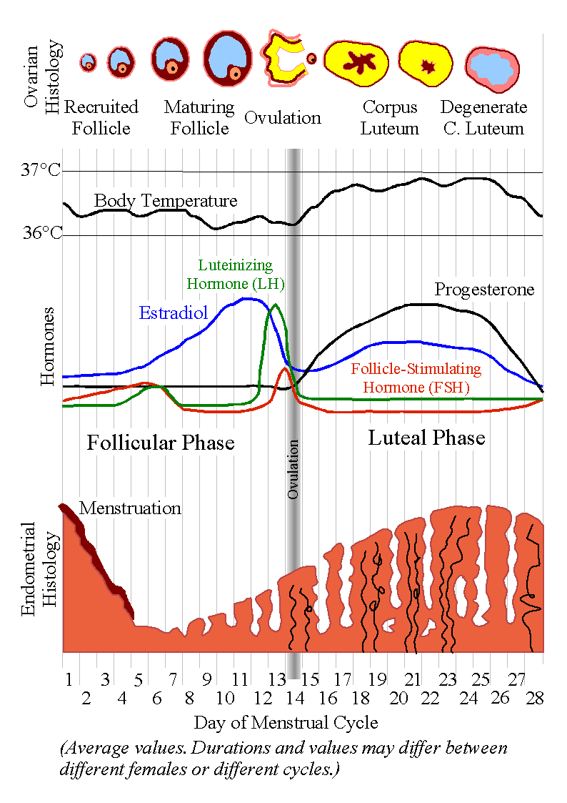
The menstrual cycle
- Pituitary gland produces FSH
- FSH stimulates follicles to grow and mature
- The follicles secrete oestrogen which causes the rebuilding of the uterus lining and inhibits the production of FSH and LH
- The follicle grows and produces more oestrogen until reaching a critical point it begins to stimulate the FSH and LH
- There is a surge in FSH and LH production causing ovulation (matured follicle releases its egg)
- LH then stimulates the empty follicle to develop into a corpus luteum which secretes progesterone (and small amount of oestrogen)
- The progesterone maintains the lining of the uterus and inhibits the production of FSH and LH
- If the egg is not fertilised the corpus luteum will degenerate and no longer produce progesterone and so the uterus lining breaks down
- Since there is less progesterone produced, FSH is no longer inhibited and so the cycle resumes

