UNIT 5 GENETICS SUMMARY NOTES
The genetic code
The genetic code = the sequence of bases on mRNA that code for specific amino acids.

Features of the genetic code:
- Each amino acid is coded for by a sequence of 3 bases on the mRNA strand
- A few amino acids have only one codon
- The code is degenerate (some amino acids can be coded for by different codons)
- Stop codons mark the end of the polypeptide chain (& they don’t code for amino acids)
- There is no overlapping
- It is a universal code for all organisms

Ribonucleic acid (RNA)

RNA = a single strand in which each nucleotide is made up of:
- Ribose sugar
- Bases - adenine, guanine, cytosine, and uracil
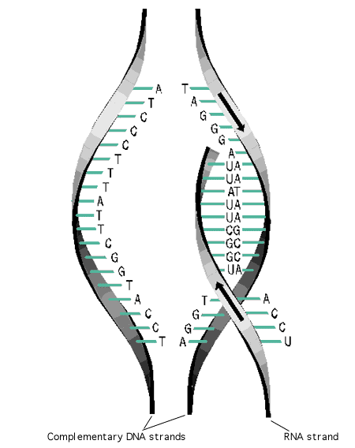
- A phosphate group

- Messenger RNA (mRNA)
A long strand that is arranged into a single helix
It is a mirror image of the copied DNA strand
It leaves the nucleus through the nuclear pores and associates with the ribosomes and acts as a template onto which proteins are built
Can be easily broken down

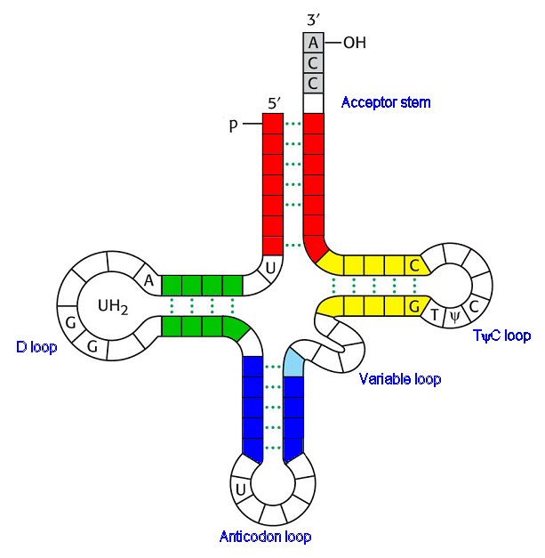

- Transfer RNA (tRNA)
Short single stranded chain folded into a clover shape
One end extends out to attach amino acids
The other end is an “anticodon” – 3 bases that will pair the 3 bases on the mRNA molecule

TRANSCRIPTION

Making pre–mRNA from DNA as a template

PROCESS:
- DNA helicase breaks the hydrogen bond in a specific region of DNA to expose unpaired bases
- RNA polymerase moves along a one of the DNA strands, causing nucleotides to join with free nucleotides
- C links to G // T links to A // A links to U!
- Behind RNA polymerase, the DNA molecule recombines
- RNA polymerase reaches a stop codon on the DNA molecule and detaches
- Pre-mRNA is made
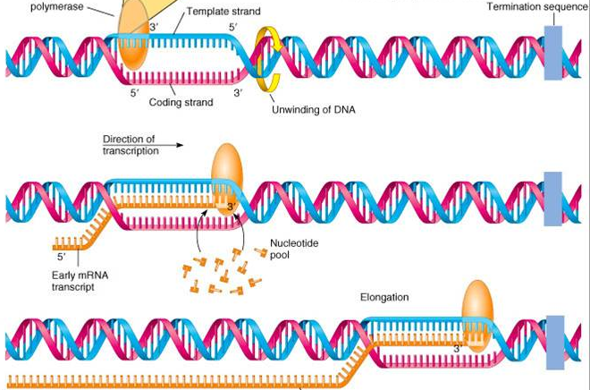

Splicing of pre–mRNA

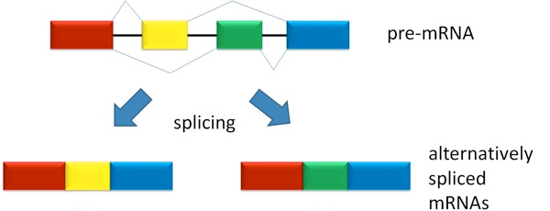
Exons code for proteins
Introns don’t code for proteins

Splicing – removal of interfering introns and combining of exons

Exon’s can be combined in a number of different ways so that one section of DNA (a gene) can code for a variety of different proteins

TRANSLATION

Each amino acid has a corresponding tRNA molecule with its own anticodon bases. These will join up depending on the mRNA sequence to make a chain of amino acids.

PROCESS:
- A ribosome attaches to the starting codon of mRNA

- The tRNA, with an amino acid attached and with the complementary anticodon sequence binds with the mRNA

- Another tRNA binds to the next codon on the mRNA whilst carrying another amino acid

- The ribosome moves along the mRNA, bringing together the two tRNA molecules

- Enzymes and ATP join together the amino acids on adjacent tRNA molecules

- The ribosome moves along to the third codon whilst releasing the first tRNA (which goes to collect another amino acid)

- The process continues until a ribosome reaches a stop codon where everything is released, leaving the polypeptide chain.

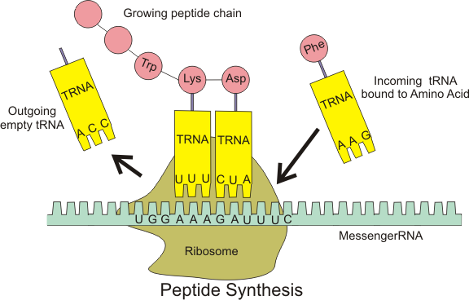

GENE MUTATIONS

GENE MUTATION = a change to the nucleotide bases in DNA (as it the mRNA will be different so there will be a different amino acid sequence)
It can be inherited if they occur in the gametes

HOW CAN DNA BASES CHANGE?:

- Substitution of bases

When one nucleotide is replaced by another

OUTCOMES:
- A nonsense mutation –base substitution results in a stop codon being transcribed on to mRNA so polypeptide chain is stopped prematurely and will often not function

- A mis-sense mutation –base substitution results in a different amino acid being coded for which could change the tertiary structure

- A Silent mutation – base substitution does not result in a different amino acid being coded for as the genetic code is degenerate

- Deletion of bases

Occurs when a nucleotide is lost
It causes a frame shift so bases are read in different sets of three

Causes of mutation

Can arise spontaneously in DNA replication but is increased by mutagenic agents (like high energy radiation or chemicals)

CANCER

The rate of cell division is controlled by two genes and mutations in these can cause cancer;
- Proto-oncogenes
- Stimulate cell division
- Mutations turn proto-oncogenes into oncogenes.

With cell division rowth factors attach to a protein on the cell surface membrane and Relay proteins in the cytoplasm then “switch on” the genes necessary for DNA replication

Mutations into Oncogenes:
- cause the receptor protein in the cell surface membrane to permanently activated and cell division occurs without growth factors
- may code for excessive amount of growth factor

- Tumour suppressor genes
Inhibit cell division

Mutations make tumour suppressor genes inactivated so cell division is not inhibited and mutated cells that do not die can clone themselves and form a tumour

Totipotency
TOTIPOTENT CELLS = cells that can differentiate into any cell in the body

They become specialised because, during cell specialisation, only some of the genes are expressed

Genes are prevented from expressing themselves by:
- Preventing transcription and hence the production of mRNA and polypeptides
- Breaking down mRNA before translation

Adult stem cells are totipotent and may be found in the inner lining of the intestine, bone marrow and in the skin.

Regulation of transcription and translation

Preventing gene expression:

- For transcription to start, the gene needs to be stimulated by a transcriptional factor that moves from the cytoplasm into the nucleus
- Each type of transcription factor has a site capable of binding to a specific region of DNA
- When it binds, transcription can begin and so mRNA forms and thus a polypeptide is synthesised
- An inhibitor molecule can bind to a transcription factor where it would bind to DNA to block it so transcription cannot occur

Effect of oestrogen on transcription:
- Oestrogen is lipid soluble and can pass through the phospholipid bi-layer of the plasma membrane and bind to a complementary receptor site on the transcriptional factor so the transcriptional factor changes shape and releases the inhibitor molecule from the DNA binding site

- The transcriptional factor can now enter the nucleus and bind to a specific region of DNA where it will stimulation transcription

The effect of siRNA on gene expression

They break down mRNA before it’s genetic code can be translated into a polypeptide.
PROCESS:
- An enzyme cuts the large double stranded RNA into two smaller sections called siRNA
- One of the two strands of siRNA combines with an enzyme
- Since the siRNA molecule has complementary bases to a region of mRNA, it can “guide” the enzyme to the complementary section of mRNA
- Once the enzyme is in the correct position it cuts the mRNA into smaller sections that can no longer be translated = no gene is expressed

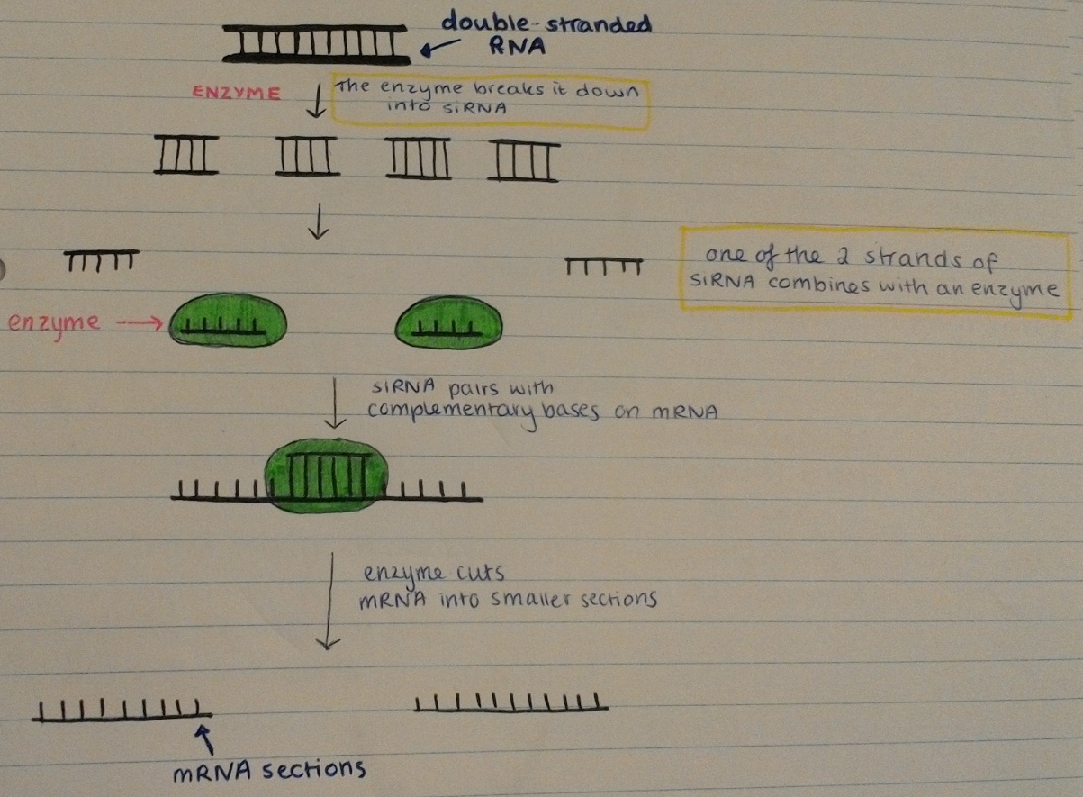

The uses of siRNA

- Identify genes in a biological pathway
- By adding siRNA that can block a particular gene, the affects of the gene can be reduced as a certain function will no longer take place
- siRNA may also be used to block genes that are causing diseases

