UNIT 5 end of chapter questions
- Below shows part of the retina of a human eye

- Explain each of the following observations;
- When light falls on cells 1 and 2, only one spot of light is seen. But, when light falls on cells 2 and 3, two spots of light are seen
1 and 2 share a neurone but 2 and 3 have separate neurones to the brain

- When one unit of light energy falls on cell 3, no light is seen. But, when one unit of light energy falls on cell 3, one unit falls on cell 4 and one unit falls on cell 5, light is seen.
One unit is sub-threshold and three units is above the threshold to cause depolarisation. One unit causes no impulses or action potential in the sensory neurone so the sensory neurone is not stimulated. Whereas with three units impulses are fired. Spatial summation leads to sufficient neurotransmitter being released from three receptors.

- Cells of the same type as cells 6 and 7 are found in large numbers at the fovea. This results in high visual acuity. Explain what causes high visual acuity at the fovea.
Impulses travel along separate neurones from each receptor cells as each receptor cell connects to a separate neurone.
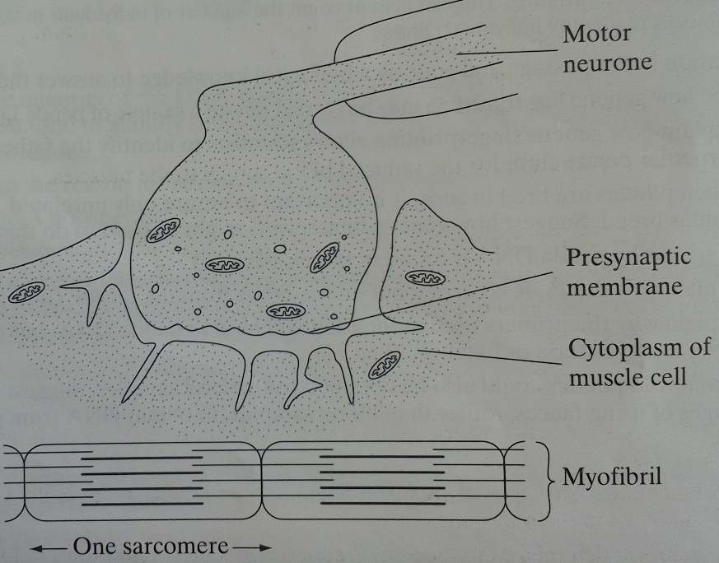
- Below shows a neuromuscular junction
- (i) label the myelin sheath
(ii) the myelin sheath is not formed in new-born babies. Explain how this leads to slower reflexes in babies.
no salutatory conduction so depolarisation has to occur along the whole length of the axon so there is slower transmission of impulses to the muscle.

- Nerve impulses arriving at the presynaptic membrane at the neuromuscular junction in shortening of myofibrils. Describe how
The action potential causes calcium ions to enter the presynaptic membrane and vesicles fuse with the membrane to release their acetylcholine into the cleft which then binds to receptors in the post-synaptic membrane to depolarise it. the action potential opens calcium channels on the endoplasmic reticulum so calcium floods into the muscle and causes tropomyosin to pull away and stop blocking the actin filament. The myosin head can now bind to actin and form cross-bridges. The myosin then changes angle to pull the actin along and this releases ADP. ATP then attaches to the myosin head so it can detach from actin. Calcium then activated ATPase to hydrolyse ATP to ADP and this conversion provides the energy for the myosin to return to its original position.

- Myofibrils are made up of many sarcomeres. The sarcomeres in a myofibril are always the same length as each other. However, this length changes with the state of contraction of the muscle. The table shows the force produced by a myofibril in relation to the length of its sarcomeres.
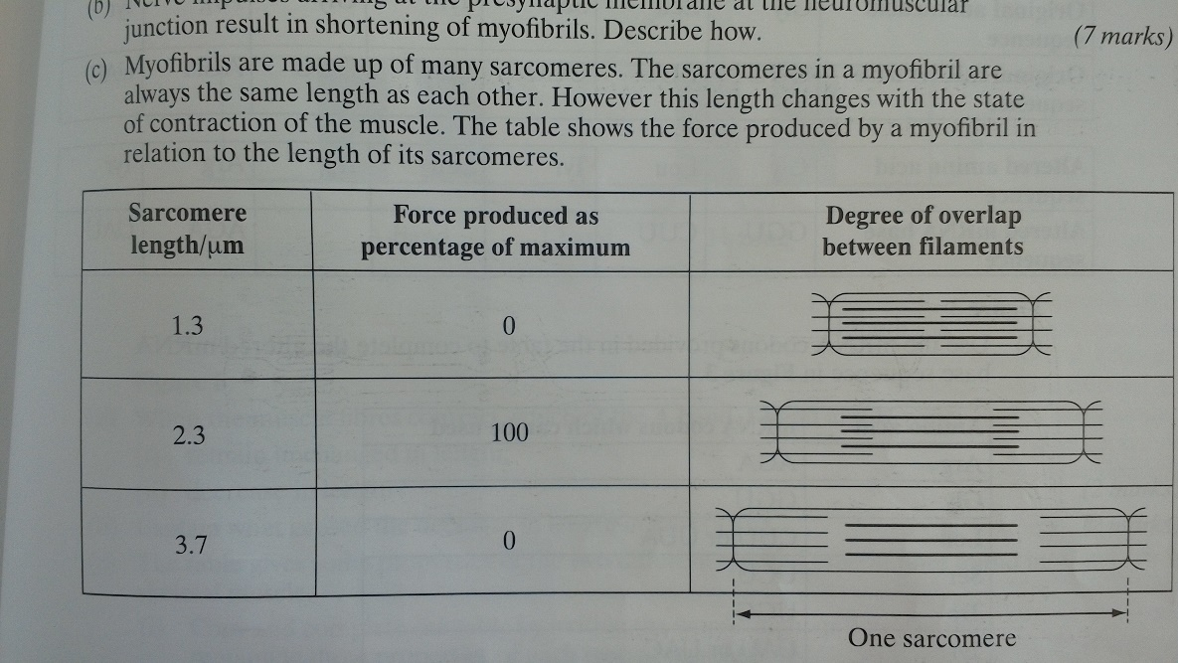
- Give the sarcomere length at which the H-zone will be at its minimum length
1.3$μ$m as it is the maximum overlap so the muscle is fully contracted and all actin sites are occupied to no further cross bridges can be formed.

- Explain why no force is generated when the sarcomere length is 3.7$μ$m
Actin and myosin is not overlapping so no cross bridges are formed and thus the muscle cannot contract

- Explain why the maximum force is produced when the sarcomere length is 2.3$μ$m
The muscle is contracting because binding sites are available so interactions can occur

- (a) one effect of getting into a cold shower is a reduction in the amount of blood flowing through the capillaries near the surface of the skin. Explain how the cold causes this response.
Thermoreceptors in the skin sends impulses via neurones to or from the hypothalamus. The heat gain centre in the hypothalamus causes constriction of arterioles by the diversion through shunt vessels.

(b) (i) when exercising at 30C, the body is more likely to overheat in humid conditions than in dry conditions. Explain why
There would be reduced evaporation of sweat due to a reduced gradient so there’s less heat loss by latent heat of evaporation.

(ii) strenuous exercise leads to exhaustion more quickly in hot conditions than in cool conditions. One reason for this is a reduced blood supply to the muscles, which means that they receive less oxygen. Suggest an explanation for the reduced blood supply to the muscles.
Skin vessels open (vasodilatation) causes blood to be diverted from muscles.

- Lysosome is an enzyme consisting of a single polypeptide chain of 129 amino acids.
- What is the minimum number of nucleotide bases needed to code for this enzyme?
387

- The diagram below shows the sequence of bases in a section of the mRNA strand used to synthesise this enzyme
G G U C U U U C U U A U G G U A G A U A U
- Give the DNA sequence which would be complementary to the first four bases in this section of mRNA
CCAG
- how many different types of tRNA molecule would attach to the section of mRNA shown in the diagram?
5
- Give two factors which might increase the frequency at which mutation in DNA occurs.
High-energy radiation/x-rays – high-energy particles/alpha or beta particles – chemical mutagens such as benzene, caffeine, pesticides, mustard gas, tobacco tar and free radicles – the length of time of exposure to a mutagen – the dosage of a mutagen.

- Two single base mutations occurred in the DNA coding for this section of mRNA. These mutations caused an alteration in the sequence of amino acids in the enzyme. The tables below show the original and altered sequence of amino acids.
UAC UUA UGG
- Use the mRNA codons provided in the table to complete the altered mRNA base sequence

- Use the information provided to determine to precise nature of the two single base mutations in the DNA
Addition and deletion of bases – thymine added, adenine deleted.

- Read the following passage;
Scientists discovered a protein in milk. This protein had antibacterial properties. They extracted the protein and determine its amino acid sequence. This information allowed them to make the gene for the protein. A vector was used to insert this gene into rice cells, together with a marker gene. The scientists hope to use the genetically modified rice to make drinks that would combat diarrhoea. Diarrhoea is often caused by bacterial infections, and is a major killer of children worldwide. Many tests, however, would need to be carried out before the rice drinks could be sold to consumers. The scientists had been given permission to plant a trial field of the genetically modified rice. They were told, however, that the field had to be a long way from any commercial rice farm.
- Scientists know the order of amino acids in milk protein. Explain how they can use this information to obtain a gene that codes for this protein
Three bases code from one amino acid so they could look up the genetic code using the table and synthesise DNA with the correct base sequence
- (i) a vector was used to insert the new gene into rice cells. Explain what is meant by a vector.
the means of getting new DNA into a cell or host

(ii) a marker gene was used in genetically modifying rice. Explain why
It codes for characteristics that are easy to detect so allows identification of modified cells that have taken up the gene/vector.

- Many test would be needed before the rice drinks could be sold to consumers. Give two reasons why these tests would be needed.
To ensure that the antibacterial protein is produced and to show that the antibacterial protein is effective. To check that no by-products or toxins are produced so that people do not become allergic and to ensure its safe.

- The genetically modified rice will be grown a long way from any commercial rice farms. Why is this important?
To prevent cross-breeding with other rice crops so to prevent the new gene transferring to other plants.

- Describe how the rice cells produce the milk protein from the inserted gene
DNA’s hydrogen bonds break so DNA splits to make mRNA using RNA nucleotides via RNA polymerase. Complementary pairing and introns removed. mRNA joins to the ribosome and tRNA carries a specific amino acid so that eventually peptide bonds are formed between amino acids.

- Below shows part of a myofibril form a relaxed muscle fibre

- When the muscle fibres contract, which of the A-band, I-band and H-zone will:
- Remain unchanged in length
The A-band – it will remain the same as its length is determined by the length of the myosin filaments which do not change

- Decrease in length
H-zone and I-band

- Explain what caused the decrease in length
Actin filaments slide in between myosin and actin filaments entering the H-zone reduces its width as Z lines are pulled closer together. Overall, as the actin filaments are pulled in between the myosin filaments the width of the H-zone and I-band decreases

- The table below gives some properties of the two different types of muscle fibre found in skeletal muscle.
Low high
Low high
High low
- Complete the table by writing the words ‘high’ or ‘low’ for the remaining three properties of each type of muscle fibre

- The myosin-ATPase of fast muscle fibres has a faster rate of reaction than in slow fibres. Use your knowledge of this mechanism of muscle contraction to explain how this will help fast muscle fibres to contract faster than slow fibres.
The overall rate of contraction is limited by the rate of ATPase hydrolyses ATP to provide energy for myosin-actin interaction, myosin head movement and to ‘re-cock’ the myosin head.

- The blood leaving an active muscle with a high percentage of fast muscle fibres contained a higher concentrate of lactate than that leaving a muscle with a high percentage of slow muscle fibres. Why
Lactate is a produce of anaerobic respiration. fast fibres have higher activity of glycolytic enzymes and have lower activity of krebs cycle enzymes and have fewer mitochondria.

- Scientist believe that the tendency to develop cancer can be inherited. It is thought that some people possess cancer-causing genes. These genes only become functional when activated by an environmental factor. The functional genes then cause the production of abnormal cells. The abnormal cells multiply and spread, causing cancer.
- Explain why medical screening of people for the presence of these cancer-causing genes is recommended
To identify those at risk of developing cancer so as to avoid relevant environmental factors and to enable early diagnosis and identify risk in families.
- Cells contain suppressor genes, which code for protein that control cell division and growth. Describe what is meant by a mutation, and explain how a mutation in a suppressor gene might lead to the development of a malignant tumour.
MUTATION OF A SUPPRESSOR GENE mutation is a change in DNA by altering the base sequence. Suppressor genes therefor will produce the wrong instruction by having a different code and so it will have a different amino acid sequence and a different protein structure and this protein may be non functional
MALIGNANT TUMOUR cell division by mitosis leads to tumour cells growing abnormally uncontrollable. Tumour cells spread and invade other tissues to form secondary tumours via blood/lymph system

