ALL UNIT 4 BIOLOGY PAST PAPER QUESTIONS

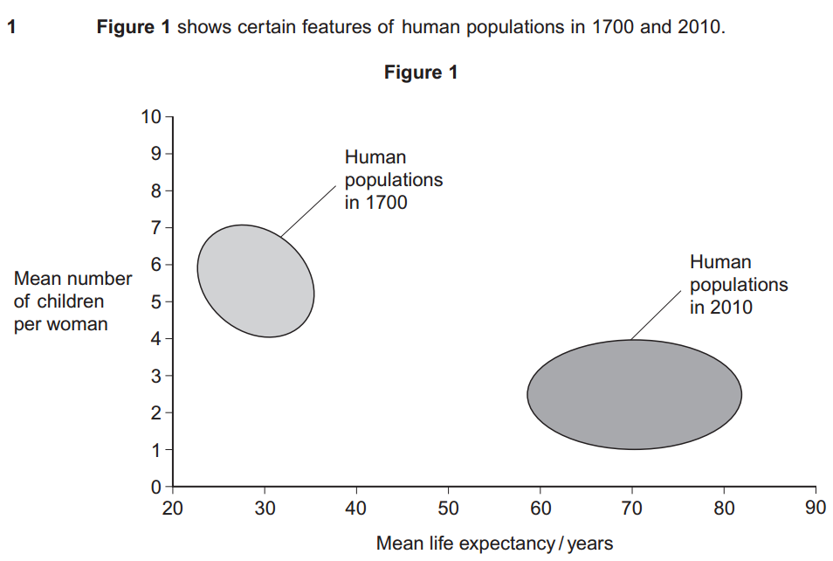
- Give two differences between the populations in 1700 and 2010.
Higher mean/average number of children per female in 1700
Higher life expectancy/percentage of older people in 2010
Greater range/spread/variation of life expectancies in 2010

- Suggest two reasons for the differences between the populations in 1700 and 2010.
Medical/health care/vaccination/antibiotics/lower infant mortality
Diet / nutrition / food availability
Sanitation / water supply / sewage treatment
Contraception / birth control
Work related example / occupation / education
Financial considerations of having children
Government/state policy
War

- Table 1 shows some features relating to the human population in Italy in 2010.
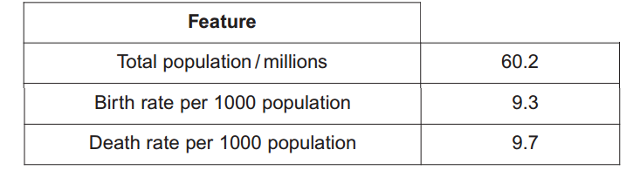

Use the information in Table 1 to calculate the size of the population of Italy in 2011.
60.18 million

- Upwelling is a process where water moves from deeper parts of the sea to the surface. This water contains a lot of nutrients from the remains of dead organisms.
Nitrates and phosphates are two of these nutrients. They provide a source of nitrogen and phosphorus for cells.
Give a biological molecule that contains:
nitrogen – Amino acid/protein/enzyme/urea/nucleic acid/chlorophyll/DNA/RNA/ATP/ NAD/NADP
phosphorus -- DNA/RNA/nucleic acid/ATP/ NADP/TP /GP/ RuBP /phospholipids;

Describe the role of microorganisms in producing nitrates from the remains of dead organisms.
Saprobiotic microorganisms break down the dead remains into ammonia. Ammonium ions are then reduced into nitrites and then into nitrates by Nitrifying bacteria during nitrification

Upwelling often results in high primary productivity in coastal waters. Explain why some of the most productive fishing areas are found in coastal waters.
Nitrate is needed to be absorbed by plants/algae so they can use it for growth. As they grow, there will therefore be more plants (producers) and so more food for the consumers (fish) so there will be an increase in number of fish.

- Farmland previously used for growing crops was left for 30 years and developed into woodland. During this period, ecologists recorded an increase in the diversity of birds in the area.
Name the process that resulted in the development of woodland from farmland.
Succession.

Explain the increase in the diversity of birds as the woodland developed.
Greater variety/diversity of plants and insects so more food sources which will lead to a greater variety and greater number of more habitats/niches

The ecologists also investigated photosynthesis in two species of plant found in the woodland. One of the species was adapted to growing in bright sunlight (sun plant) and the other was adapted to growing in the shade (shade plant). The ecologists’ results are shown below.

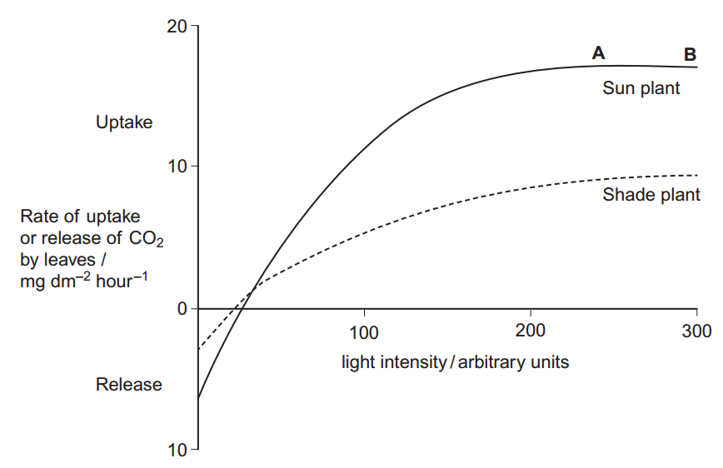

Give two factors which could be limiting the rate of photosynthesis in the sun plant between points A and B
Temperature and carbon dioxide

Explain why CO2 uptake is a measure of net productivity
Because it shows photosynthesis (gross productivity) minus respiration. More carbon dioxide is used in photosynthesis than produced in respiration

Use the information in Figure 2 to explain how the shade plant is better adapted than the sun plant to growing at low light intensities.
The shade plant has a lower rate of respiration (more respiratory losses) and less CO2 is released at 0 light intensity (in the dark) so there is a greater net productivity - less sugars are used so more sugars are available

- In birds, males are XX and females are XY.
Use this information to explain why recessive, sex-linked characteristics are more common in female birds than in male birds.
Recessive allele is always expressed in females as they have one recessive allele and males would need two recessive alleles (need to be homozygous recessive). Males could have dominant and recessive alleles and thus just be carriers

In chickens, a gene on the X chromosome controls the rate of feather production. The allele for slow feather production, F, is dominant to the allele for rapid feather production, f. Figure 3 shows the results produced from crosses carried out by a farmer.
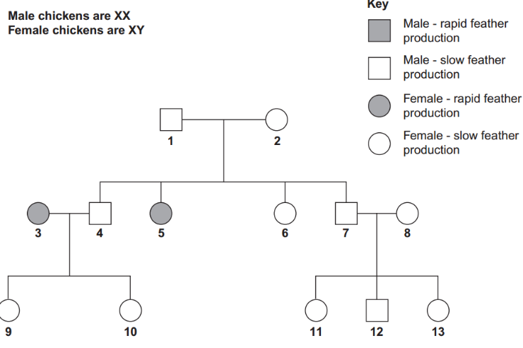

Explain one piece of evidence from Figure 3 which shows that the allele for rapid feather production is recessive.
The evidence lies in 1 and 5.
1 must possess and pass on the recessive allele (it’s a carrier) if slow feather production is recessive all offspring of 1 would be slow feather production. If rapid production was dominant, 1 would have rapid feather production.
In essence, 1 and 2 have slow production but produce one offspring with rapid production. S

Give all the possible genotypes of..
Chicken 5 – Xf Y
Chicken 7 – XF Xf and XF XF or Xf XF and XF XF or XF Xf and XF XF

A cross between two chickens produced four offspring. Two of these were males with rapid feather production and two were females with slow feather production. Give the genotypes of the parents.
XF Xf and Xf Y or
Xf XF and Xf Y or
XF Xf and X fY or
Xf XF and Xf Y or
Ff and fY or
Ff and fY

Feather colour in one species of chicken is controlled by a pair of codominant alleles which are not sex-linked. The allele CB codes for black feathers and the allele CW codes for white feathers. Heterozygous chickens are blue-feathered. On a farm, 4% of the chickens were black-feathered. Use the Hardy–Weinberg equation to calculate the percentage of this population that you would expect to be blue-feathered. Show your working.
32 %

Malaria is a disease that destroys red blood cells. Scientists investigated whether certain red blood cell phenotypes were associated with developing severe or mild malaria. They compared the red blood cell phenotypes of hospital patients suffering from severe malaria with the red blood cell phenotypes of patients suffering from mild malaria. The results are shown
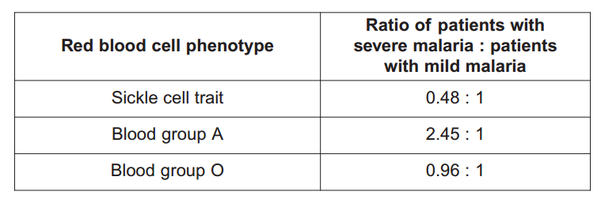
Explain the advantage of presenting the results as a ratio.
Allows valid comparison and helps as the Number or sample size may vary

What do these data show about the effect of red blood cell phenotypes on the chance of developing severe malaria rather than mild malaria?
Increased chance of severe malaria with blood group A and a decreased chance of severe malaria with sickle cell
There is an almost equal chance with blood group O of mild malaria and a slightly lower chance of severe malaria with group O
More than twice the chance of severe malaria with blood group A
Half the chance of severe malaria with sickle cell and twice the chance of mild malaria with sickle cell

- The allele for normal haemoglobin in red blood cells is HbA. In some parts of Africa where malaria occurs there is a high frequency in the population of the allele HbC. Individuals possessing the HbC allele have a lower chance of developing severe malaria. Severe malaria causes a large number of deaths in Africa. Explain the high frequency of the HbC allele in areas where malaria occurs
Individuals with the HbC allele reproduce and pass on the HbC allele which increases in frequency. HbA individuals are less likely to survive and reproduce and the frequency of HbA allele decreases

- A student investigated the rate of anaerobic respiration in yeast. She put 5 g of yeast into a glucose solution and placed this mixture in the apparatus shown in Figure 4. She then recorded the total volume of gas collected every 10 minutes for 1 hour.

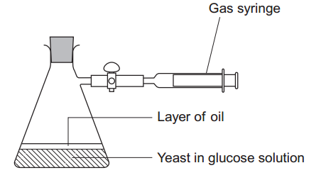

Explain why a layer of oil is required in this investigation.
To prevents oxygen being taken up or entering/being absorbed

The student’s results are shown. Calculate the rate of gas production in cm3 g–1 min–1 during the first 40 minutes of this investigation.
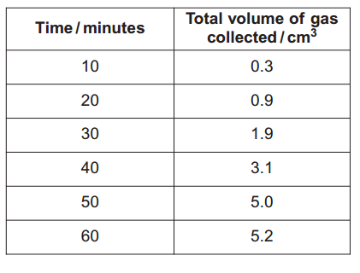
0.016

Suggest why the rate of gas production decreased between 50 and 60 minutes
Glucose decreases (it is a limiting factor and it is also used up) and ethanol increases.

Yeast can also respire aerobically. The student repeated the investigation with a fresh sample of yeast in glucose solution, but without the oil. All other conditions remained the same. Explain what would happen to the volume of gas in the syringe if the yeast were only respiring aerobically.
It would stay the same (relatively constant) as there is the same oxygen uptake and carbon dioxide release

Respiration produces more ATP per molecule of glucose in the presence of oxygen than it does when oxygen is absent. Explain why
Oxygen is the final electron acceptor as it combines with electrons and protons. Oxidative phosphorylation during the electron transport chain provides the ATP. However, only glycolysis occurs without oxygen (there is no Krebs or link reaction)

- Hydrilla (Hydrilla verticillata) is an aquatic plant which has become a major pest of waterways in parts of the USA. Hydrilla is not a native species of the USA. It was introduced into natural habitats from aquariums. In many freshwater habitats it has rapidly become the dominant plant species.
In many freshwater habitats Hydrilla has rapidly become the dominant plant species. Suggest two reasons why
There is no/few consumers or pests so Hydrilla outcompetes for all resources needed for their ideal niche

The spread of Hydrilla has had economic consequences for commercial activities and for the government’s environmental agency. Suggest two economic consequences of the spread of Hydrilla
Cost of control and removal and the cost of restoring and conserving the habitat.
Loss of income from fishing, boating, tourism or recreation
Scientists investigated the effect of the chemical fluridone as a method of controlling Hydrilla. The study was carried out using samples of Hydrilla grown under controlled laboratory conditions. Several samples of the plant were grown at different concentrations of fluridone. The results are shown in Table 4

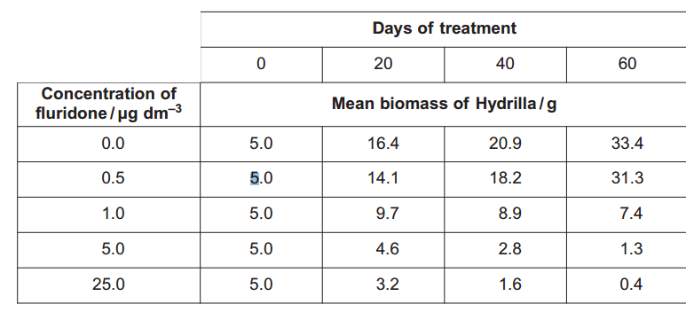
The scientists obtained the biomass of each sample by heating it at 75 ºC for 2 hours. They then weighed the sample, reheated it for 15 minutes and weighed it again. They continued this cycle of reheating and weighing until they found the sample had a constant mass.
Explain how this method helped to provide a reliable measurement of the biomass
It removes water as the water content can vary in sample of plant

A scientist reviewed the results of this investigation. He suggested that fluridone should be used in the habitat at a concentration of 5.0 µg dm–3 rather than at the other concentrations tested. Use the information provided and your knowledge of chemical control to explain why he made this suggestion
0.5 has little effect and 1.0 is less effective than 5.0 (concentrations below 5.0 are less effective). At 5.0 biomass, growth is reduced. There is a small difference between using 5.0 and 25.0; using 5.0 is cost effective and using 25.0 is expensive. 25.0 (high concentrations) may affect the environment or other organisms as the chemical may remain in habitat or bioaccumulation may occur.

- Scientists have also investigated the use of an integrated system to control Hydrilla. This involved using fluridone and a fungus as a biological control agent. They set up four different experiments.
Experiment 1 – Hydrilla left untreated
Experiment 2 – Hydrilla treated with the fungus
Experiment 3 – Hydrilla treated with fluridone
Experiment 4 – Hydrilla treated with both fluridone and the fungus.
The scientists determined the biomass of Hydrilla at the end of each experiment.
Experiment 1 acted as a control. Explain why the scientists carried out experiment 1
To compare and see effect with and without fungus, fluridone, control agents

The scientists isolated the fungus from the tissue of Hydrilla growing in its country of origin. Suggest two possible advantages of using this fungus as the biological control agent.
It is specific - it grows and survives in Hydrilla
It can reproduce so only one application required
It does not become a pest

The treatment in experiment 4 was the most effective. Use your knowledge of integrated pest control systems to suggest why the treatment in experiment 4 was the most effective.
Fluridone acts quickly and quickly reduces Hydrilla. Fungus/biological control keeps Hydrilla in low numbers and this works over a long time and can reproduce. Resistance does not develop against fungus/biological control

- During the light-independent reaction of photosynthesis, carbon dioxide is converted into organic substances. Describe how
Carbon dioxide combines with ribulose bisphosphate to produce two glycerate 3-phosphate. This is then reduced to triose phosphate using reduced NADP. Using energy from ATP, Triose phosphate is converted to glucose and other organic substances.

- Explain how human activities have contributed to global warming.
Carbon dioxide is a greenhouse gas. Deforestation leads to less carbon dioxide being removed by photosynthesis. Additionally, combustion releases carbon dioxide. Methane is a greenhouse gas too which is released from, for example, cattle’s intestines.

- The bluebell is a flowering plant found in woodlands. Global warming has been associated with a change in the population of bluebells. Describe how you could estimate the number of bluebells in a small woodland.
Use a grid that has a split area into squares. Random coordinates are obtained using a random number generator. The count number (frequency) of plants in a quadrat is gained and the mean number per quadrat is calculated and then the total number of bluebells is calculated by finding the mean number of plants per quadrat and multiplying it by the number of quadrats in the wood.

- What information is required in order to calculate the growth rate of a population?
Birth rate and death rate

- The diagram shows an age population pyramid for humans in a country.
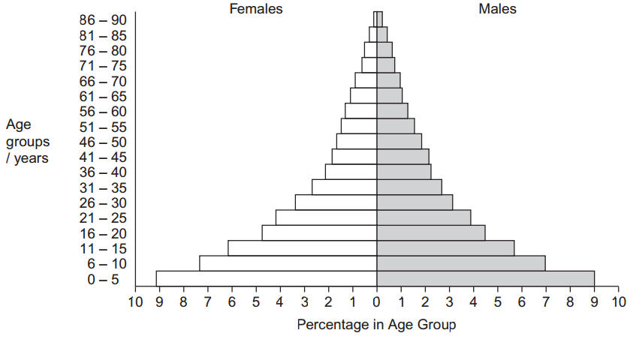
This country is at an early stage of demographic transition. Describe the evidence for this.
High birth rate - high percentage of young children. High death rate - low percentage of elderly people who have a low life expectancy

- Algae are photosynthesising organisms. Some algae grow on rocky shores. A scientist investigated succession involving different species of algae. He placed concrete blocks on a rocky shore. At regular intervals over 2 years, he recorded the percentage cover of algal species on the blocks. His results are shown in the graph.
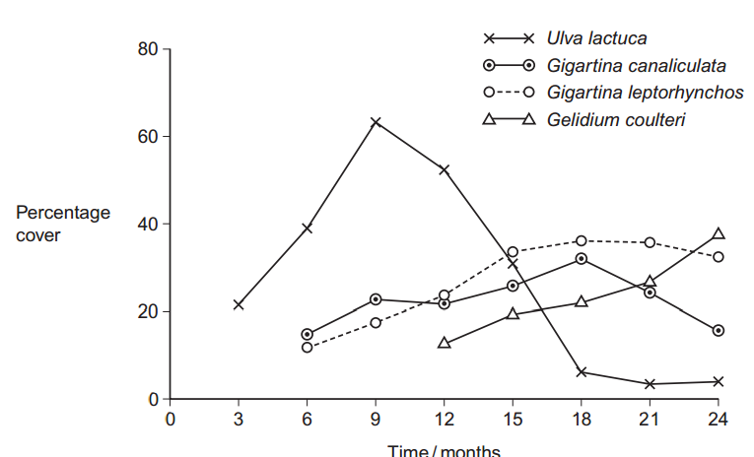
Name the pioneer species
Ulva lactuca

The scientist used percentage cover rather than frequency to record the abundance of algae present. Suggest why.
Difficult as there is too many to count - individual organisms are not identifiable as they are too small and grow in clumps.

Some scientists reviewing this investigation were concerned about the validity of the results because of the use of concrete blocks. Suggest one reason why these scientists were concerned about using concrete blocks for the growth of algae.
Because of the texture, flatness, composition of chemicals in concrete.

Use the results of this investigation to describe and explain the process of succession
Pioneer species (Ulva) increases then decreases. They change the conditions to make them less hostile. New species arrived that are better competitors than the pioneer species and so they outcompete the pioneer species. Coulteri/Gelidium increases and other species decreases

- Explain what is meant by the term phenotype.
The appearance of a characteristic due to the genotype and is expressed depending on the environment.

- Tay-Sachs disease is a human inherited disorder. Sufferers of this disease often die during childhood. The allele for Tay-Sachs disease t, is recessive to allele T, present in unaffected individuals. The diagram shows the inheritance of Tay-Sachs in one family.
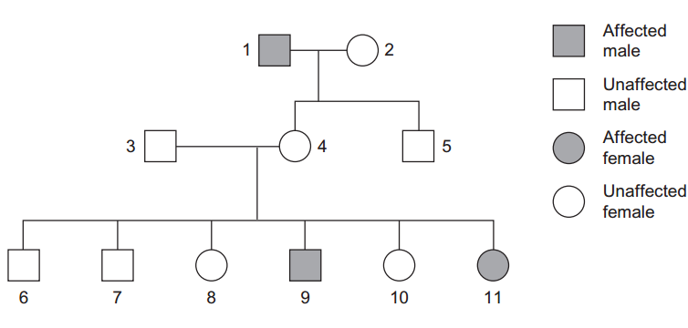
Explain one piece of evidence from the diagram which proves that the allele for Tay-Sachs disease is recessive.
3 and 4 have an affected child (9, 11) as they are both carriers (heterozygous). If it was dominant at least one of 3 and 4 would be affected

Explain one piece of evidence from the diagram which proves that the allele for Tay-Sachs disease is not on the X chromosome
11 is affected, 3 is not. The father (3) of 11 does not have a recessive allele on his X chromosome. If it was on the X, 11 (affected female) would not receive the recessive allele on the X chromosome from her father (3). If it was on the X then 3 (the father of 11) would pass on the dominant allele on his X chromosome.

In a human population, one in every 1000 children born had Tay-Sachs disease. Use the Hardy-Weinberg equation to calculate the percentage of this population you would expect to be heterozygous for this gene.
5.8 (to 6.2) %

The actual percentage of heterozygotes is likely to be lower in future generations than the answer. Explain why
Affected individuals usually do not reproduce as they die during childhood and so do not pass on allele

- The following reaction occurs in the Krebs cycle.
A scientist investigated the effect of the enzyme inhibitor malonate on this reaction. The structure of malonate is very similar to the structure of succinate. The scientist added malonate and the respiratory substrate, pyruvate, to a suspension of isolated mitochondria. She also bubbled oxygen through the suspension.
Explain why the scientist did not use glucose as the respiratory substrate for these isolated mitochondria.
Glucose is used (broken down) during glycolysis which is in the cytoplasm but glucose cannot cross mitochondrial membrane but pyruvate can

Explain how malonate inhibits the formation of fumarate from succinate
Is a competitive inhibitor so attaches to active site and prevents enzyme-substrate complex forming

The scientist measured the uptake of oxygen by the mitochondria during the investigation. The uptake of oxygen decreased when malonate was added. Explain why
Krebs cycle inhibited so there is less NAD and hydrogens are not passed to the electron transport chain and oxygen is used in the chain as the final electron acceptor

- Scientists investigated the effect of iron deficiency on the production of triose phosphate in sugar beet plants. They grew the plants under the same conditions with their roots in a liquid growth medium containing all the necessary nutrients. Ten days before the experiments, they transferred half the plants to a liquid growth medium containing no iron. The scientists measured the concentration of triose phosphate produced in these plants and in the control plants:
at the end of 6 hours in the dark
Then for 16 hours in the light.
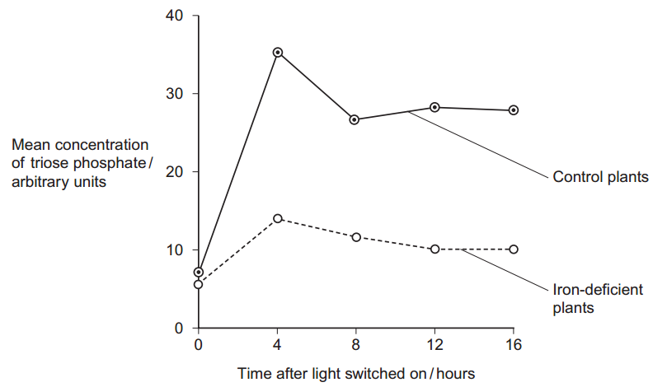

The experiments were carried out at a high carbon dioxide concentration. Explain why
So CO2 is not a limiting factor on growth and photosynthesis

Explain why it was important to grow the plants under the same conditions up to ten days before the experiment.
So any difference is due to iron deficiency

The plants were left in the dark for 6 hours before the experiment. Explain why
Amount of triose phosphate will be similar/the same at start

Iron deficiency reduces electron transport. Use this information and your knowledge of photosynthesis to explain the decrease in production of triose phosphate in the iron-deficient plants.
Less ATP produced so less reduced NADP produced and ATP and reduced NADP are produced during the light-dependent reaction so less GP converted to triose phosphate.

Iron deficiency results in a decrease in the uptake of carbon dioxide. Explain why
Less triose phosphate converted to RuBP and CO2 combines with RuBP

- The Amazonian forest today contains a very high diversity of bird species.
- Over the last 2 000 000 years, long periods of dry climate caused this forest to separate into a number of smaller forests.
- Different plant communities developed in each of these smaller forests.
- Each time the climate became wetter again, the smaller forests grew in size and merged to reform the Amazonian forest.
Use the information provided to explain how a very high diversity of bird species has developed in the Amazonian forest.
No interbreeding as they have separate gene pools due to geographical isolation. Mutation occurs. There are also different selection pressures due to different foods/niches/habitats and so the adapted organisms survive and breed, leading to a change in allele frequency

Speciation is far less frequent in the reformed Amazonian forest. Suggest one reason for this.
There is the same environmental/abiotic/biotic factors and so have similar selection pressures. There is no isolation so gene flow can occur within a species

- Malaria is a disease caused by a parasite. Scientists investigated the effect of malaria on competition between two species of Anolis lizard on a small Caribbean island. They sampled both populations by collecting lizards from a large number of sites on the island.
Explain the importance of collecting lizards from a large number of sites.
Reliable / representative / for statistical tests

Describe one method the scientists could have used to ensure that the sites were chosen without bias
Find coordinates on a grid, split the area into squares and count the number of sites OR using a random number generator.

The population number of both species of lizard varied at different times of the year. Suggest two reasons why.
Breeding of lizards / Food source / Predator / Variation in malarial infection / Temperature variation / Availability of water eg drought or rainy season

- The scientists investigated the percentage of lizards of both species that were infected with malaria at different sites on the island. They collected samples of both lizards at intervals of 3 months for 1 year. They also recorded the elevation (height above sea level) of each site. Some of their results are shown in the table.
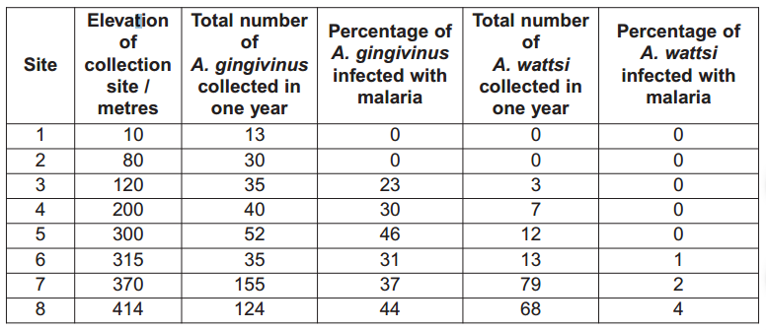
When analysing their results, the scientists used the percentage of lizards infected at each site, rather than the number of lizards infected. Explain why.
Number in sample varies. Allows a valid comparison

A preliminary study suggested that malarial infections were more common at higher elevations. Use the information provided to evaluate this suggestion.
Overall positive correlation for both species. Limited results for A.wattsi due to a small sample

As a result of this investigation, the scientists concluded that the presence of malaria provided a competitive advantage to A. wattsi. Use the information provided to explain how they reached this conclusion.
Fewer A.wattsi infected and more A.gingivinus infected. Higher number of A.wattsi present when higher percentage of A.gingivinus infected. No A.wattsi present when A.gingivinus has zero infection

The malarial parasite of Anolis lizards destroys both red and white blood cells. Suggest how an increase in the percentage of A. gingivinus infected with malaria could result in A. wattsi having a competitive advantage.
Reduced immunity to disease. Reduced oxygen transport and uptake. Reduced respiration, activity and movement.

The scientists carried out a statistical test to determine whether the correlation between the number of A. wattsi collected and the percentage of A. gingivinus infected was significant. They obtained a value for P of < 0.01. Use the terms probability and chance to help explain what this means.
There is a probability of less than 1% (0.01) that results are due to chance OR There is a probability of more than 99% (0.99) that result are not due to chance

- Rather than use chemical pesticides or biological agents, farmers often use an integrated system of chemical pesticides and biological agents to control agricultural pests. Explain the advantages of using an integrated system to control agricultural pests.
(Biological Agents) - Only needs one application as it reproduces / Specific / Keeps and maintains a low population / Pests do not develop resistance / no bioaccumulation
(Chemical pesticides) - Acts quickly / Can apply to specific area / Kills most pests

- Nitrate from fertiliser applied to crops may enter ponds and lakes. Explain how nitrate may cause the death of fish in fresh water.
Growth of algae on the surface (algal bloom) blocks light so the lower plants cannot photosynthesise and they then die. Saprobiotic microorganisms/bacteria, decompose these dead plants and aerobically respire as they do so. This uses oxygen so less oxygen is available for fish to respire and they die

- Explain how the intensive rearing of domestic livestock increases net productivity
They’re slaughtered when young and still growing so more energy is transferred to biomass. They’re fed on concentrated and controlled diets so higher proportion of food is absorbed and used for biomass as a lower proportion lost in faeces. Movement restricted so less heat and energy is lost. They’re kept warm inside so less heat is lost and body temperature in maintained. They’re genetically selected (selective breeding) for high productivity

- The diagram shows the nitrogen cycle.
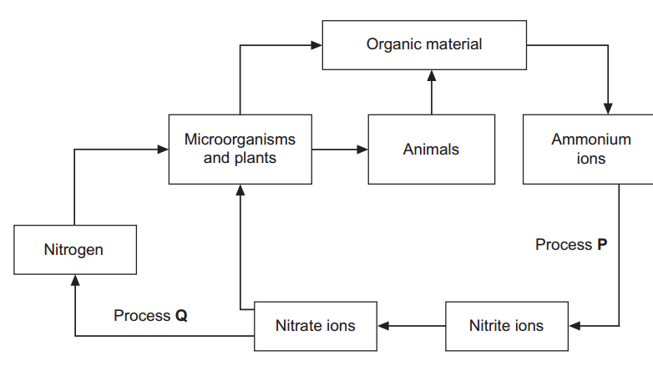

Name process P. Nitrification
Name process Q. Denitrification
Leguminous crop plants have nitrogen-fixing bacteria in nodules on their roots. On soils with a low concentration of nitrate ions, leguminous crops often grow better than other types of crop. Explain why.
The nitrogen is converted to ammonia and produces amino acids which helps the crop grow.

Applying very high concentrations of fertiliser to the soil can reduce plant growth. Use your knowledge of water potential to explain why.
The fertiliser will make the soil have a lower water potential and so the plant roots have a higher water potential, leading to osmosis occurring with water moving out of the plant and into the soil.

- What is meant by the term population?
All the individuals of one species in a habitat.

- Give two factors which could lead to a decrease in the death rate in a human population.
Improved medical care, improved nutrition, more food, improved sanitation, less disease, improved living conditions, improved economy, war ends

- The graph shows survival curves for human populations of the same country in different years.
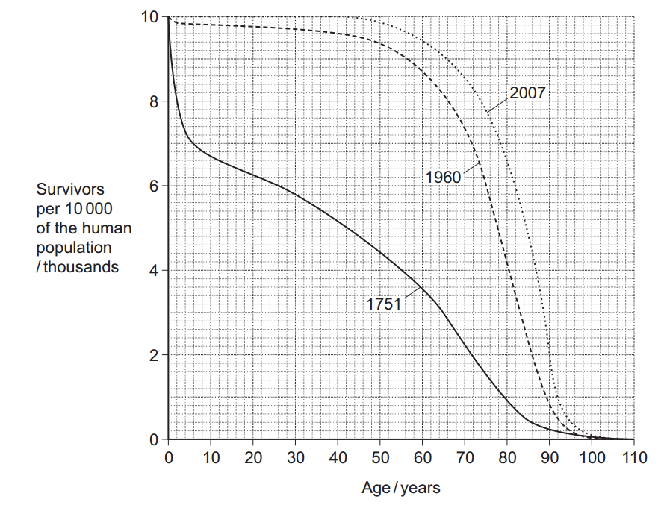
Calculate the percentage increase from 1751 to 2007 in the number of people who survived to 70 years of age.
8.6-2.2x100 = 290 %

The changes in the survival curves between 1751 and 1960 show that a demographic transition has taken place in this country. Explain how the changes show this.
Increase in average life expectancy. Low (decrease in) death rate and fewer babies.

- The fruit fly is a useful organism for studying genetic crosses. Female fruit flies are approximately 2.5 mm long. Males are smaller and possess a distinct black patch on their bodies. Females lay up to 400 eggs which develop into adults in 7 to 14 days. Fruit flies will survive and breed in small flasks containing a simple nutrient medium consisting mainly of sugars.
Use this information to explain two reasons why the fruit fly is a useful organism for studying genetic crosses.
Large number of eggs/offspring so it improves reliability due to the large sample size. They are of a small size and breed in small flasks and this will reduce costs and allow them to be easily stored. Their markings (phenotypes) make it easy to identify males and females. Reproduce quickly therefore results obtained quickly which saves times

Male fruit flies have the sex chromosomes XY and the females have XX. In the fruit fly, a gene for eye colour is carried on the X chromosome. The allele for red eyes, R, is dominant to the allele for white eyes, r. The genetic diagram shows a cross between two fruit flies. Complete the genetic diagram for this cross.
Phenotypes of parents red-eyed female × white-eyed male
Genotype of parents ............... XR XR................... .............Xr Y...................
Gametes ........XR...and...XR................ .......XR...and....Y..................
Phenotypes of offspring red-eyed females and red-eyed males
Genotype of offspring .........XR Xr......................... ..........XR Y....................

The number of red-eyed females and red-eyed males in the offspring was counted. The observed ratio of red-eyed females to red-eyed males was similar to, but not the same as, the expected ratio. Suggest one reason why observed ratios are often not the same as expected ratios.
Fertilisation is random. Small sample was used. Selection advantage.

Male fruit flies are more likely than female fruit flies to show a phenotype produced by a recessive allele carried on the X chromosome. Explain why
Males have one allele. Females need two recessive alleles (must be homozygous recessive). They could have dominant and recessive alleles and so be carriers

- A student investigated an area of moorland where succession was occurring. She used quadrats to measure the percentage cover of plant species, bare ground and surface water every 10 metres along a transect. She also recorded the depth of soil at each quadrat.
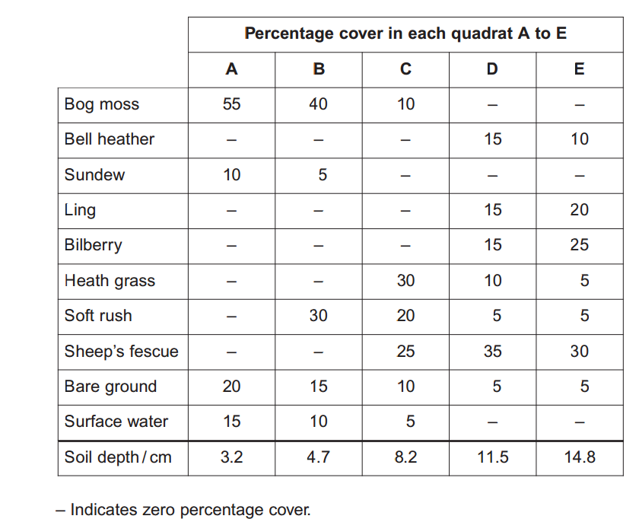
Her results are shown in the table.

Explain how these data suggest that succession has occurred from points A to E along the transect.
Decrease in percentage cover of bare ground. Water is linked to more plants and an increase in plant coverage. Change in diversity and number of plants as abiotic conditions altered due to making conditions less hostile. Increase in depth of soil as plants die

The diversity of animal species is higher at E than A. Explain why
Greater variety of food and more food sources. More habitats/niches

The student used the mark-release-recapture technique to estimate the size of the population of sand lizards on an area of moorland. She collected 17 lizards and marked them before releasing them back into the same area. Later, she collected 20 lizards, 10 of which were marked.
Give two conditions for results from mark-release-recapture investigations to be valid
Marking is not removed. marking does not affect predation. No immigration/emigration. Sufficient time for marked individuals to mix within the population. No/little births or deaths. Sampling method is the same

Calculate the number of sand lizards on this area of moorland.
17x20/10 = 34

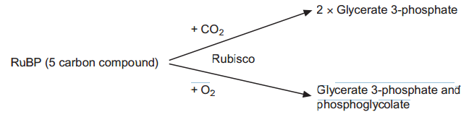
- During photosynthesis, carbon dioxide reacts with ribulose bisphosphate (RuBP) to form two molecules of glycerate 3-phosphate (GP). This reaction is catalysed by the enzyme Rubisco. Rubisco can also catalyse a reaction between RuBP and oxygen to form one molecule of GP and one molecule of phosphoglycolate. Both the reactions catalysed by Rubisco are shown in Figure 1.

Where exactly in a cell is the enzyme Rubisco found?
Stroma

Use the information provided to give the number of carbon atoms in one molecule of phosphoglycolate.
2

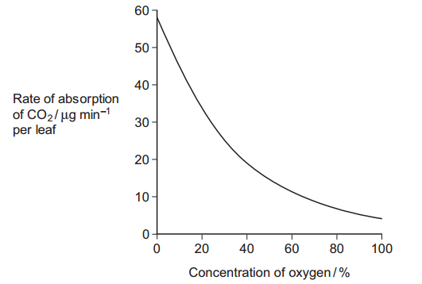
Scientists investigated the effect of different concentrations of oxygen on the rate of absorption of carbon dioxide by leaves of soya bean plants. Their results are shown in Figure 2.
Use Figure 1 to explain the results obtained in Figure 2.
As oxygen (concentration) increases less Rubisco/RuBP reacts/binds with carbon dioxide; 2. Competitive inhibition / competition between oxygen and carbon dioxide for rubisco/enzyme/active site; 3. Less RuBP formed/regenerated (to join with carbon dioxide)

Use the information provided and your knowledge of the light-independent reaction to explain why the yield from soya bean plants is decreased at higher concentrations of oxygen. Phosphoglycolate is not used in the light-independent reaction.
Less glycerate 3-phosphate/GP produced; (Less) triose phosphate to form sugars/protein/organic (product)/any named photosynthetic product; Less RuBP formed/regenerated

- Yeast is a single-celled organism. A student investigated respiration in a population of yeast growing in a sealed container. His results are shown in the graph
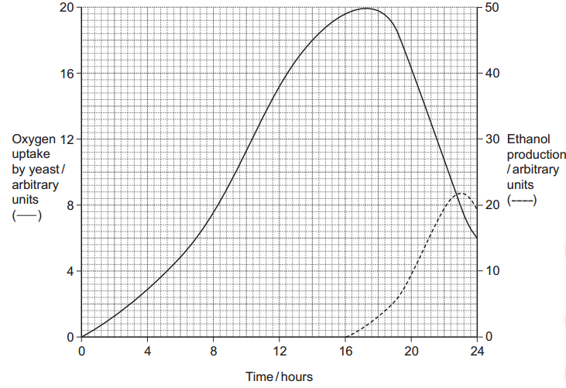
Calculate the rate of oxygen uptake in arbitrary units per hour between 2 and 4 hours.
0.8

Use the information provided to explain the changes in oxygen uptake during this investigation.
Aerobic respiration; Increase in uptake (of oxygen) with growth/reproduction/division of yeast cells; Glucose/nutrients/oxygen decreases/becomes limiting / cells die / ethanol/toxins form / heat produced / anaerobic respiration occurs;

Use the information provided to explain the changes in production of ethanol during this investigation.
(Ethanol produced) by anaerobic respiration / from pyruvate in anaerobic conditions; (Ethanol / anaerobic respiration) increases as oxygen (uptake/concentration) decreased; Decreases as glucose is used up / ethanol kills cells

Sodium azide is a substance that inhibits the electron transport chain in respiration. The student repeated the investigation but added sodium azide after 4 hours. Suggest and explain how the addition of sodium azide would affect oxygen uptake and the production of ethanol.
Oxygen uptake decreases/stopped; Oxygen is final (electron) acceptor/combines with electrons (and protons); Ethanol produced sooner / more ethanol produced

- Scientists investigated the effect of a pesticide called malathion on the survival of tadpoles of species of toads found in the USA. The scientists determined the LC50 for the tadpoles of each species over a 16-day period in an aquarium. The LC50 is the concentration of malathion that killed 50 percent of a population of tadpoles. The scientists also investigated whether the presence of a predator of tadpoles changed the effect of malathion. Suggest two advantages of using the LC50 to determine the effect of a pesticide.
Provides a standard/benchmark; Can compare (different pesticides/chemicals); Does not kill all the tadpoles/organisms/population

The scientists looked at previous studies on the effects of various pesticides on tadpoles. They found that most of these studies were carried out on tadpoles of the African clawed toad and measured the LC50 of each pesticide over 1 to 4 days in the absence of any biotic factor. The scientists concluded that these previous studies were of limited use when trying to assess the effects of malathion on the tadpoles of toads found in the USA. Suggest why the scientists reached this conclusion.
Only carried out on one species of toad/African toad / not carried out on USA toads/tadpoles/species; Only tested for 1-4 days/short term / not 16 days/long term; Did not look at effect of predator/predation; Used various pesticides / may not have used malathion;

Malathion affects the nervous system of tadpoles. The scientists investigated whether the stress caused by the presence of a predator changed the effect of malathion on the tadpoles. The scientists used newts which are predators of tadpoles. They carried out two experiments, as shown in the diagram. Explain why the scientists carried out experiment 1.
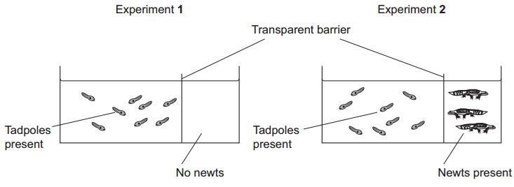

Explain why the scientists used a transparent barrier in experiment 2.
(See) effect of pesticide/malathion; Without predator/newts/stress / to compare/see effect with predator/newts/stress present (in experiment 2)

Adult toads spend most of their time on land but lay their eggs in water. These eggs hatch into tadpoles, which live in water and develop into adults. The tadpoles are much smaller than adult toads. Use this information to explain why the tadpoles are affected more rapidly by pesticides in water than adult toads.
Tadpoles not killed/eaten; Newts are seen/detected

When malathion is used as a pesticide, it is often sprayed onto aquatic habitats at concentrations of 0.1 to 1.6 mg dm–3. The scientists tested the effect of malathion at concentrations of 0.001 to 10 mg dm–3. Suggest why.
Large surface area to volume ratio; Rapid/more diffusion / shorter diffusion pathway; Longer time exposure to pesticide / adults/toads live in and out of water / tadpoles remain/stay in water

As a result of this investigation, the scientists concluded that more studies on pesticides should be carried out in natural habitats rather than under laboratory conditions. Suggest two advantages of carrying out such investigations in natural habitats.
Link between using less (pesticide) and cost/less effect on environment/organisms; Pesticide/malathion diluted (in water); Concentrated due to evaporation; Concentrated in food chains/webs/tadpoles/habitat

- Energy enters most ecosystems through the light-dependent reaction of photosynthesis. Describe what happens during the light-dependent reaction.
Chlorophyll absorbs light energy; Excites electrons / electrons removed (from chlorophyll); Electrons move along carriers/electron transport chain releasing energy; Energy used to join ADP and Pi to form ATP; Photolysis of water produces protons, electrons and oxygen; NADP reduced by electrons / electrons and protons / hydrogen

- Describe the reasons for the low efficiency of energy transfer through ecosystems.
Some light is reflected / not of appropriate wavelength; Some light misses leaves/ photosynthetic tissue/chloroplasts/chlorophyll; Heat loss; 4. (Energy loss via) respiration; Loss via faeces/undigested food/part of organism not eaten; Excretion/named excretory product;

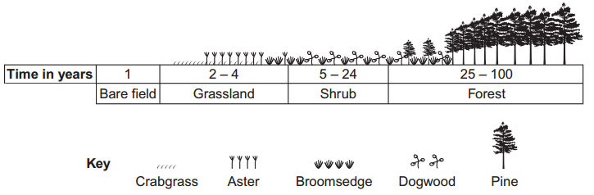
- The diagram shows the dominant plants in communities formed during a succession from bare soil to pine forest.

Name the pioneer species shown in the diagram.
Crabgrass

The species that are present change during succession. Explain why.
Species/plants/animals change the environment/conditions/add humus/nutrients etc.; Less hostile (habitat); Species/plants better competitors

The pine trees in the forest have leaves all year. Explain how this results in a low species diversity of plants in the forest
(Only) plants which can photosynthesise with less light (remain)

- In a species of snail, shell colour is controlled by a gene with three alleles. The shell may be brown, pink or yellow. The allele for brown, CB, is dominant to the other two alleles. The allele for pink, CP, is dominant to the allele for yellow, CY. Explain what is meant by a dominant allele.
Is always expressed/shown (in the phenotype)

Give all the genotypes which would result in a brown-shelled snail.
CB CB , CB CP and CB CY ; Or CB CB , CP CB and CY CB

A cross between two pink-shelled snails produced only pink-shelled and yellow-shelled snails. Use a genetic diagram to explain why.
Two genotypes (as parents) shown as CP CY Or Two sets of gametes shown as CP and CY ; Genotypes of offspring shown as CP CY , CP CP and CY CY ; Above genotypes of offspring correctly linked to phenotypes i.e. pink and yellow

The shells of this snail may be unbanded or banded. The absence or presence of bands is controlled by a single gene with two alleles. The allele for unbanded, B, is dominant to the allele for banded, b. A population of snails contained 51 % unbanded snails. Use the Hardy-Weinberg equation to calculate the percentage of this population that you would expect to be heterozygous for this gene.
42%
2pq = heterozygotes. q² = 0.49 (49%). q= 0.7(70%)

- Explain what is meant by the ecological term community.
All/group of species / all/group of populations / all the organisms;

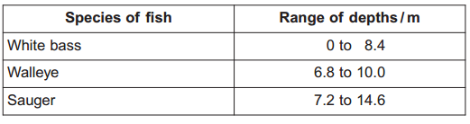
Scientists investigated the distribution of three species of fish in a lake. They recorded the range of depths where each species was found. The table shows their results
Use information from the table to give the range of depths at which all three species of fish may be found living together.
7.2 to 8.4
Suggest and explain one advantage to the fish of occupying different depths in the lake.
Food / prey / oxygen; Less/no competition

The graph shows the relationship between the depth and the temperature of the water in the lake.
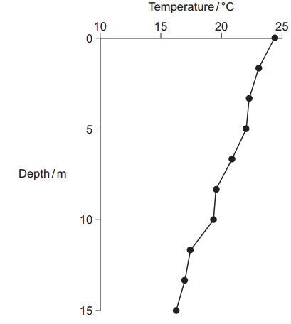
A student concluded that the temperature of the water in the lake determined the depth at which the species of fish were found. Use the table and the graph to evaluate this conclusion.
Increase in depth linked to decrease in temperature / decrease in depth linked to increase in temperature; Correlation/relationship between temperature and fish distribution does not indicate a causal effect; Overlap in ranges / different fish/species occupy same depth; Other abiotic/biotic/named factor involved

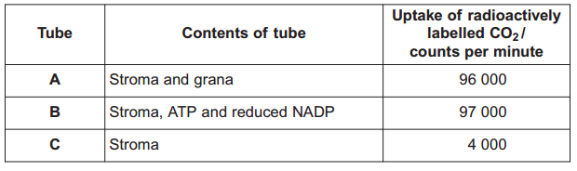
- A scientist investigated the uptake of radioactively labelled carbon dioxide in chloroplasts. She used three tubes, each containing different components of chloroplasts. She measured the uptake of carbon dioxide in each of these tubes. Her results are shown in the table.
Name the substance which combines with carbon dioxide in a chloroplast.
RuBP

Explain why the results in tube B are similar to those in tube A.
ATP and reduced NADP are produced in grana/thylakoids/ present in A/both tubes

Use the information in the table to predict the uptake of radioactively labelled carbon dioxide if tube A was placed in the dark. Explain your answer.
4000 - Light-dependent reaction does not occur /ATP and reduced NADP are not produced;

Use your knowledge of the light-independent reaction to explain why the uptake of carbon dioxide in tube C was less than the uptake in tube B.
(Less) GP converted to TP; (Less) TP converted to RuBP

DCMU is used as a weed killer. It inhibits electron transfer during photosynthesis. The addition of DCMU to tube A decreased the uptake of carbon dioxide. Explain why.
No/less ATP / ATP produced (during electron transport); No/less reduced NADP / reduced NADP produced (during electron transport);

- Insect pests of crop plants can be controlled by chemical pesticides or biological agents. Give two advantages of using biological agents.
Specific (to one pest); Only needs one application/ reproduces; Keeps population low; Pests do not develop resistance; Does not leave chemical in environment/on crop / no bioaccumulation; Can be used in organic farming

Two-spotted mites are pests of strawberry plants. Ecologists investigated the use of predatory mites to control two-spotted mites. They released predatory mites on strawberry plants infested with two-spotted mites. They then recorded the percentage of strawberry leaves occupied by two-spotted mites and by predatory mites over a 16-week period. The results are shown on the graph.
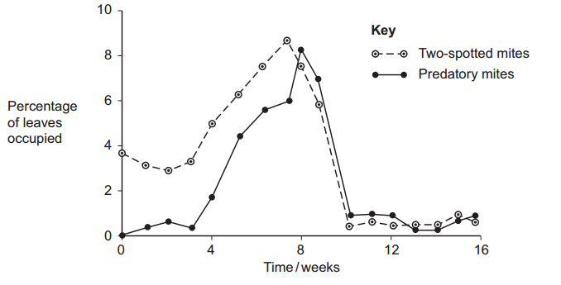
Describe how the percentage of leaves occupied by predatory mites changed during the period of this investigation.
Increases, rapid decrease, constant/level/fluctuates; Accept any one of increases at 3/4 weeks / increases to 8 weeks / peaks at 8 weeks / levels at 10 weeks

The ecologists concluded that in this investigation control of the two-spotted mite by a biological agent was effective. Explain how the results support this conclusion.
Decrease number of pests / (two-spotted) mite / decrease in % (of leaves occupied); Remains at low numbers / remains below 2%

Farmers who grow strawberry plants and read about this investigation might decide not to use these predatory mites. Suggest two reasons why.
Cost of treatment/biological control; Takes (a long) time to act; Pest/two-spotted mite is not completely removed; May become a pest/damage/eat crop;

The ecologists repeated the investigation but sprayed chemical pesticide on the strawberry plants after 10 weeks. After 16 weeks no predatory mites were found but the population of two-spotted mites had risen significantly. Suggest an explanation for the rise in the two-spotted mite population.
Pesticide kills predatory mites / other predators / two-spotted mites are resistant; Two-spotted mite reproduces

- A student investigated the rate of gas exchange in aerobically respiring seeds using the apparatus shown in the diagram. She carried out two experiments.
In Experiment 1, she put potassium hydroxide solution in the beaker. Potassium hydroxide solution absorbs carbon dioxide.
In Experiment 2, she put water in the beaker.

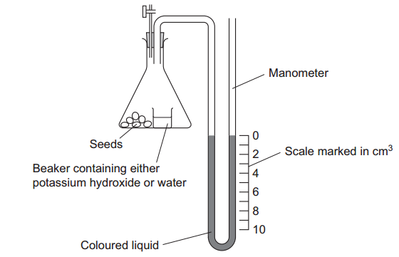
Both experiments were carried out at the same temperature. Explain why.
Respiration involved enzymes - Affects enzymes; Affects respiration; Or Affects volume/pressure of gases; Affects readings;

The level of coloured liquid in the right-hand side of the manometer tube went down during Experiment 1. Explain why.
Oxygen taken up/used (by seeds); Carbon dioxide (given out) is absorbed by solution/potassium hydroxide; Decrease in volume / pressure (inside flask)

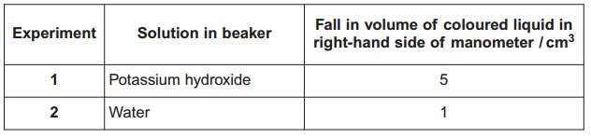
The results from both experiments are shown in the table.
Use these results to calculate the volume of carbon dioxide produced during Experiment 1
4

The student repeated Experiment 1 using seeds which were respiring anaerobically. What would happen to the level of coloured liquid in the right-hand side of the manometer tube?
Remains the same; No oxygen uptake/used

- Biofuels are fuels which can be produced from plants. Scientists have developed a standard method called net life-cycle carbon dioxide production (NLP) to find the overall effect of producing and using particular biofuels on carbon dioxide production. Petroleum is used as a comparison when evaluating NLPs of biofuels. Suggest two reasons why.
Is widely/commonly used; Provides a standard/benchmark/reference; Produces large amount of carbon dioxide; Is a decreasing resource / could be replaced by biofuel;

Biofuels are produced by a variety of different companies. The scientists who developed the method of calculating NLPs are funded by the government’s environmental agency. Suggest two advantages of this method being developed by these scientists.
Independent / no bias / trustworthy; Non-profit making; (Focused on) effect on environment/climate;

Scientists compared the percentage change in carbon dioxide production if different biofuels replaced petroleum. Their results are shown in the table.
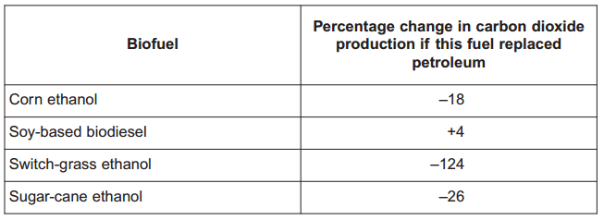
The scientists suggested that using biofuels would have a great effect on limiting climate change. Use the data in the table to evaluate this suggestion.
Most/3 biofuels show reduction in CO2/negative % change in CO2; (But) soy-based biodiesel is positive/ shows an increase in CO2; CO2 is a greenhouse gas; Global warming (affected); Other ‘greenhouse gases’/ methane/nitrous oxide/water vapour etc. (affect climate)

Producing and using biofuels from corn ethanol results in a negative percentage change in carbon dioxide production. Explain why.
CO2 taken up in photosynthesis; More taken up than produced (when it is used); Less CO2 produced than petro

Ethanol can be produced from cellulose. It is produced by anaerobic respiration of cellulose-based biomass by microorganisms. The cellulose is pre-treated by adding cellulose-digesting enzymes before it is used in anaerobic respiration. Suggest why pre-treatment is necessary.
(These microorganisms) don’t have (cellulose-digesting) enzymes; (Cellulose) is a polysaccharide/polymer/long (molecule/chain); (Cellulose) is insoluble / glucose/product of digestion is soluble; Broken down into glucose/monomers /monosaccharides; Sugars/glucose used in glycolysis / glucose can be converted to pyruvate; Produces more ethanol/fuel produces ethanol/fuel quicker

Large areas of land have to be used to grow the plants to make biofuels. Ecologists have suggested that changes in land use could lead to a decrease in biodiversity. Suggest how changes in land use could lead to a decrease in biodiversity.
Removes species / fewer species / growth of single crop / single plant species / monoculture; Removes habitats / fewer habitats/niches /only one habitat; Removes variety of food sources / fewer food sources / only one food source;

- Explain how farming practices increase the productivity of agricultural crops.
Fertilisers/minerals/named ion (added to soil); Role of named nutrient or element e.g. nitrate/nitrogen for proteins / phosphate/phosphorus for ATP/DNA; Pesticides/biological control prevents damage/consumption of crop; Pesticides/weed killers /herbicides/weeding remove competition; Selective breeding / genetic modification (of crops); Glass/greenhouses enhance temp/CO2/ light; Ploughing aerates soil/improves drainage; Ploughing/aeration allows nitrification/decreases denitrification; Benefit of crop rotation in terms of soil nutrients/fertility/pest reduction; Irrigation/watering to remove limiting factor; Protection of crops from birds/pests/frost by covers/netting etc.;

Describe how the action of microorganisms in the soil produces a source of nitrates for crop plants.
Protein/amino acids/DNA into ammonium compounds / ammonia; By saprobionts; Ammonium/ammonia into nitrite; Nitrite into nitrate; By nitrifying bacteria/microorganisms; Nitrogen to ammonia/ammonium; By nitrogen-fixing bacteria/microorganisms in soil

Explain how the use of pesticides can result in resistant strains of insect pests.
Variation/variety in pest population; Due to mutation; Allele for resistance; Reference to selection; Pests with resistance (survive and) breed / differential reproductive success; Increase in frequency of allele

- Ecologists studied a community of fish in a lake. Explain what is meant by a community.
All the fish/all the species/all the populations/all the organisms;

The ecologists could have used the mark-release-recapture method to estimate the number of one species of fish in the lake. Describe how.
Capture sample, mark and release; Appropriate method of marking suggested / method of marking does not harm fish; Take second sample and count marked organisms; Population = number in sample1 × number in sample2 / Number marked in sample2

This species of fish breeds at a certain time of the year. During this fish-breeding season, the mark-release-recapture technique might not give a reliable estimate. Suggest one reason why.
population increases/changes (between first and second sample)

The ecologists found that each species of fish had adaptations to its niche. One of these adaptations was the shape of its mouth. Suggest how the shape of mouth is an adaptation to its niche.
With different mouth eats different food / has different way of feeding / specific mouth shape for specific food; Competition between species/interspecific competition is reduced;

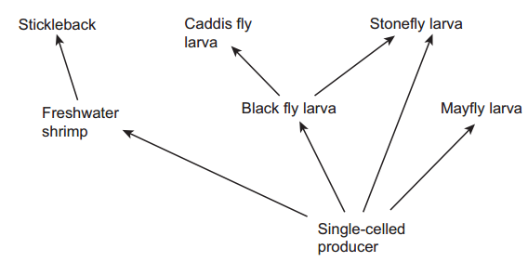
- The diagram shows organisms in a food web.
Name all the secondary consumers in this food web.
Stickleback + caddis fly (larva) + stonefly (larva);

Use the diagram to explain the likely effect of a sudden decrease in the stickleback population on the population of mayfly larvae.
(With fewer fish) reduced predation / not being eaten results in more freshwater shrimps; Increased competition for food/resources / more producers eaten by shrimps / more shrimps eating producers; Less food/resources for mayfly

A pyramid of energy for this food web is shown below. The bars are drawn to the same scale.
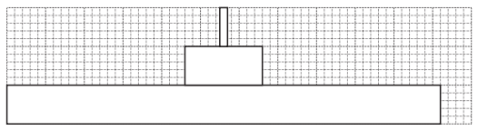
Use the pyramid of energy to calculate the percentage efficiency of energy transfer between producers and primary consumers.
16.8 to 18.9

The average efficiency of energy transfer between producers and primary consumers in pyramids of energy is around 10 %. Suggest why the efficiency of energy transfer from producers to primary consumers in this food web is higher than 10 %.
Single-celled producers are more digestible / contain less cellulose (than plants) / less energy lost in faeces; All of producer eaten/parts of plant not eaten; Less heat/energy lost / less respiration

Energy from the sun may ultimately end up in dead plant matter. Describe how.
Photosynthesis/light dependent reaction/light independent reaction; Carbon-containing substances

- marram grass grows on a sand dune. Describe how you would investigate the distribution of marram grass from one side of the dune to the other.
Transect/lay line/tape measure (from one side of the dune to the other); Place quadrats at regular intervals along the line; Count plants/percentage cover/abundance scale (in quadrats) OR Count plants and record where they touch line/transec

Marram grass is a pioneer species that grows on sand dunes. It has long roots and a vertically growing stem that grows up through the sand. Sand dunes are easily damaged by visitors and are blown by the wind. Planting marram grass is useful in helping sand dune ecosystems to recover from damage. Use your knowledge of succession to explain how.
Stabilises sand / stops sand shifting; Forms/improves soil / makes conditions less hostile

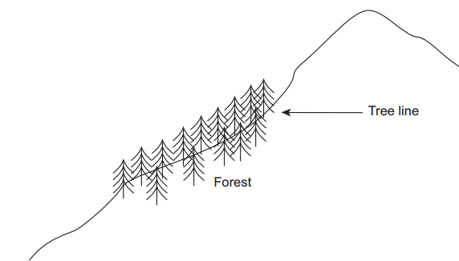
- Mountains are harsh environments. The higher up the mountain, the lower the temperature becomes. The diagram shows a forest growing on the side of a mountain. The upper boundary of the forest is called the tree line. Trees do not grow above the tree line.
The position of the tree line is determined by abiotic factors. What is meant by an abiotic factor?
Non-living/physical/chemical factor/non biologica

Other than temperature, suggest one abiotic factor that is likely to affect the position of the tree line on the mountain.
Water / Named soil factor / Light / Carbon dioxide / Wind (speed)

Scientists measured the concentration of carbon dioxide in the air in one part of the forest. They took measurements at different times of day and at two different heights above the ground. Their results are shown in the bar chart.
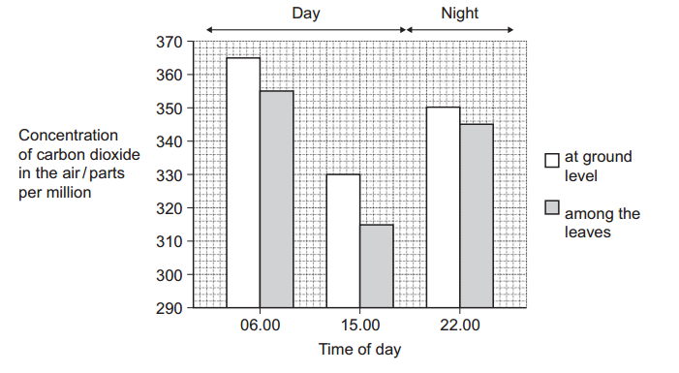
Use your knowledge of photosynthesis and respiration to explain the data in the bar chart.
photosynthesises only during the daytime / no photosynthesis/only respiration at night; Net carbon dioxide uptake during the day/in light OR No carbon dioxide taken up at night/in dark / carbon dioxide released at night/in dark; At ground level more respiration / in leaves more photosynthesis; Carbon dioxide produced at ground level/carbon dioxide taken up in leaves;

The population of trees in the forest evolved adaptations to the mountain environment. Use your knowledge of selection to explain how.
Variation in original colonisers / mutations took place; Some better (adapted for) survival (in mountains); Greater reproductive success; allele frequencies change

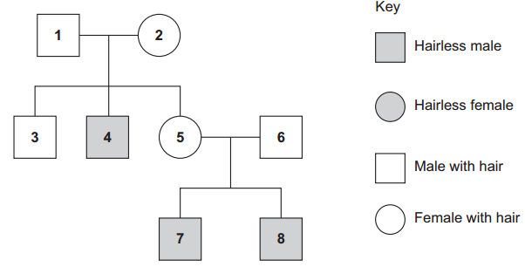
- A single gene controls the presence of hair on the skin of cattle. The gene is carried on the X chromosome. Its dominant allele causes hair to be present on the skin and its recessive allele causes hairlessness. The diagram shows the pattern of inheritance of these alleles in a group of cattle.
Use evidence from the diagram to explain that hairlessness is caused by a recessive allele
Animal 2 / 5 has hair but offspring do not; So 2 / 5 parents must be heterozygous/carriers; OR 4/7/8 are hairless but parents have hair; So 2 / 5 must be heterozygous/carriers
Use evidence from the diagram to show that hairlessness is caused by a gene on the X chromosome.
Hairless males have fathers with hair / 4 is hairless but 1 is hairy / 7 and/or 8 are hairless but 6 is hairy / only males are hairless

What is the probability of the next calf born to animals 5 and 6 being hairless? Complete the genetic diagram to show how you arrived at your answer.
Phenotypes of parents Female with hair Male with hair
Genotypes of parents XHXh XHY
Gametes XH Xh XH Y
Genotypes of offspring XHXH, XHY, XHXh, XhY
Phenotypes of offspring Females with hair, males with hair, male hairless
Probability of next calf being hairless 0.25 or 1 in 4 or 25%

- Name the process by which some bacteria oxidise ammonia to nitrate.
Nitrification

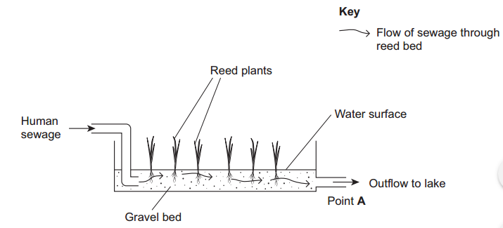
Reeds are plants that grow with their roots under water. A reed bed contains a large number of growing reeds. Reed beds may be used to absorb nitrates produced when bacteria break down human sewage. The diagram shows a reed bed.
Reeds have hollow, air-filled tissue in their stems which supplies oxygen to their roots. Explain how this enables the roots to take up nitrogen-containing substances.
Uptake (by roots) involves active transport; Requires ATP/ aerobic respiration;

There is an optimum rate at which human sewage should flow through the reed bed. If the flow of human sewage is too fast, the nitrate concentration at point A falls. Explain why.
Not enough time / fast flow washes bacteria away; (Not all/less) ammonia converted to nitrate/less nitrification

An increase in nitrate concentration in the water entering the lake could affect algae and fish in the lake. Explain how.
Algal bloom / increase in algae; Algae block light / plants/algae die; Decomposers/saprobionts/bact eria break down dead plant materials; Bacteria/decomposers/saprobionts use up oxygen in respiration / increase BOD; Fish die due to lack of oxygen

- In some countries, pigs are reared in intensive units in which the temperature is controlled. Agricultural scientists investigated the effect of temperature on pig growth and on the efficiency with which the pigs converted food to biomass. In the investigation, the scientists used pigs of the same breed, with similar genotypes. Explain why.
Same breed so similar alleles; Controls/removes variable/so genes not a factor / only temperature affects results / rate of growth affected by genes;

The pigs were allowed to eat as much food as they wanted. How could this have decreased the reliability of any conclusions drawn from the investigation?
Different growth rates / gained different biomass / grew different amount; Not due to temperature / the independent variable

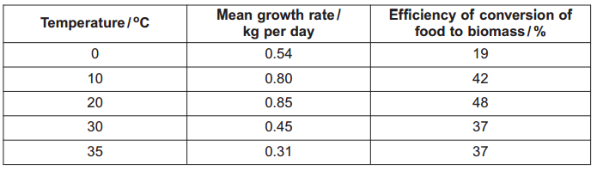
The table shows the results of this investigation
Describe the effect of temperature on mean growth rate.
Rise then fall with peak at 20 C

A student concluded from these data that the mean growth rate of the pigs was fastest at 20C. Do you agree with this conclusion? Explain your answer.
Temperature may be between 10 and 30/10 and 20/20 and 30; Intervals are 10 C/large/not small/should be smaller/should be intermediates

Pigs can survive at temperatures above 35 o C. Use the data to suggest why scientists did not carry out any investigations at temperatures higher than 35 C.
Growth rate decreasing / conversion staying same/ decreasing; (Scientists would be) looking for high growth rate/ conversion / data shows unlikely to improve growth/yield; Wastes time/resources/would not relate to farming conditions

The efficiency of conversion of food to biomass is lower at 0 C than it is at 20 C. Suggest an explanation for the lower efficiency.
Will lose more heat / not as much energy used to maintain body temperature; Heat resulting from respiration/more respiration; More food used in respiration

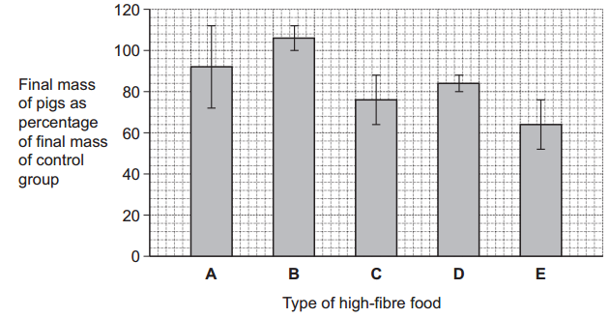
- Pigs require a mixture of fibre and protein in their food. The greater the ratio of fibre to protein, the less the food costs. Scientists took five large groups of pigs. They fed each group a different high-fibre food. Each of the foods contained fibre from different plant species, but they all had the same energy content. The scientists fed a control group of pigs a low-fibre food with the same energy content. After 10 days, the scientists compared the masses of the pigs fed on high-fibre food to those fed on low-fibre food. The graph shows the results of the investigation. The bars represent ±2 standard errors of the mean.

A farmer saw these results and concluded that he should replace his pigs’ usual food with food B. Evaluate this conclusion.
In support - Food B produces greater mass than control/greater than 100%; BUT Error bars for B mean B could be no better / not different from control; Overlap of error bars for B and A; A no better than/not different from B; Experimental limitations - Experiment only ran for 10 days; Experimental conditions /breed of pig may not be the same as on the farm; No information about cost

- ATP is useful in many biological processes. Explain why.
Releases energy in small / manageable amounts; (Broken down) in a one step / single bond broken; Immediate energy compound/makes energy available rapidly; Phosphorylates/adds phosphate; Makes (phosphorylated substances) more reactive / lowers activation energy; Reformed/made again

Describe how ATP is made in mitochondria.
Substrate level phosphorylation / ATP produced in Krebs cycle; Krebs cycle/link reaction produces reduced coenzyme/reduced NAD/reduced FAD; Electrons released from reduced /coenzymes/ NAD/FAD; (Electrons) pass along carriers/through electron transport chain/through series of redox reactions; Energy released; ADP/ADP + Pi; Protons move into intermembrane space; ATP synthase;

Plants produce ATP in their chloroplasts during photosynthesis. They also produce ATP during respiration. Explain why it is important for plants to produce ATP during respiration in addition to during photosynthesis.
In the dark no ATP production in photosynthesis; Some tissues unable to photosynthesise/produce ATP; ATP cannot be moved from cell to cell/stored; Plant uses more ATP than produced in photosynthesis; ATP for active transport; ATP for synthesis (of named substance)

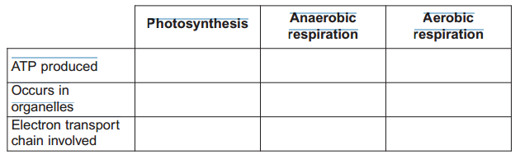
- The table contains statements about three biological processes. Complete the table with a tick if the statement in the first column is true, for each process.

Write a simple equation to show how ATP is synthesised from ADP.
ADP + Pi ATP

Give two ways in which the properties of ATP make it a suitable source of energy in biological processes.
Energy released in small/suitable amounts; Soluble; Involves a single/simple reaction;

Humans synthesise more than their body mass of ATP each day. Explain why it is necessary for them to synthesise such a large amount of ATP.
ATP is unstable; ATP cannot be stored / is an immediate source of energy; Named process uses ATP ; ATP only releases a small amount of energy at a time

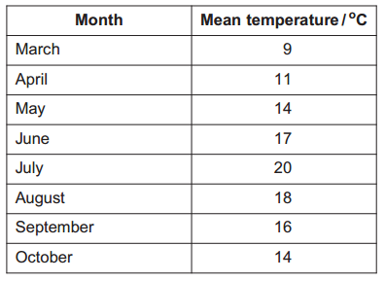
- Scientists measured the mean temperature in a field each month between March and October. The table shows their results
The gross productivity of the plants in the field was highest in July. Use the data in the table to explain why.
High temperature allows enzymes to work faster/allows more collisions/ allows more e-s complexes to be formed OR A lot of light so light not limiting; Photosynthesis reactions are faster/more photosynthesis

Give the equation that links gross productivity and net productivity.
Gross productivity = net productivity + respiratory loss/respiration

The net productivity of the plants in the field was higher in August than in July. Use the equation and your knowledge of photosynthesis and respiration to suggest why.
. Respiration slower /less respiration; Light-dependent reaction/photosynthesis less affected by temperature increase; Lower (energy) loss;

- A horse was kept in the field from March to October. During the summer months, the horse was able to eat more than it needed to meet its minimum daily requirements. Suggest how the horse used the extra nutrients absorbed.
Stored as fat/glycogen/biomass; Used for growth/movement/reproduction / process involved in growth/movement/reproduction

The horse’s mean energy expenditure was higher in March than it was in August. Use information in the table to suggest why.
More heat/energy is lost (in March)/colder (in March); Maintain/regulate body temperature/more heat generated; By respiration/metabolism;

- Intensive rearing of livestock produces large quantities of waste. Some farmers use an anaerobic digester to get rid of the waste. In an anaerobic digester, microorganisms break down the large, organic molecules in the waste. This produces methane, which is a useful fuel. It also produces organic substances that can be used as a natural fertiliser. The diagram shows an anaerobic digester.

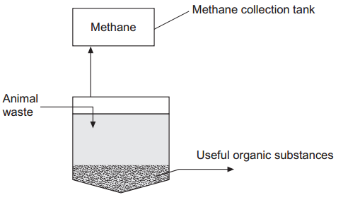
Suggest two advantages of processing waste in anaerobic digesters rather than in open ponds.
Gases / correct named gas not released; conditions (in digester) can be controlled; Products/named product can be collected; Open ponds associated with health risk/environmental damage/eutrophication;
The anaerobic digester has a cooling system, which is not shown in the diagram. Without this cooling system the digester would soon stop working. Explain why.
Respiration causes temperature increase/release of heat; Enzymes would be denatured/microorganisms killed;

The over-application of fertiliser increases the rate of leaching. Explain the consequences of leaching of fertiliser into ponds and lakes.
. Increase algae/algal bloom; Light blocked out; Plants can’t photosynthesise / plants and/or algae die; Bacteria/saprobionts/EW feed off/breakdown dead organisms; Bacteria/saprobionts/EW use up oxygen/bacteria respire/BOD rises;

Give one advantage of using natural fertiliser produced in the digester rather than an artificial fertiliser.
Acts as soil conditioner/improves drainage/ aerates soil/increases organic content of soil; Contains other elements/named element/wider range of elements; Production of artificial fertiliser energy-consuming; Less leaching / slow release (of nutrient);

- Explain what is meant by birth rate.
Births per thousand/given number of the population and per year/given period of time

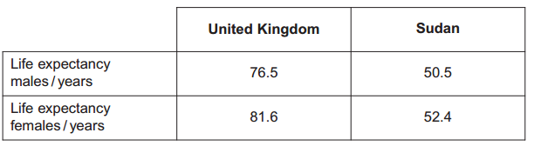
The table shows life expectancies for babies born in the United Kingdom and in the Sudan in 2009.
Describe the patterns shown by these data.
Females have higher life expectancies; UK has higher life expectancies

Suggest reasons for the differences in the life expectancy shown by these data.
Females tend to outlive males linked to reason e.g. male risk of CVD more males smoke/drink to excess males involved in fighting / war; Medical care/vaccination programmes better in UK/infectious disease common in Sudan; More food/better diet in UK; Food preservation/sanitation/clean water supply better in UK

- A breeder crossed a black male cat with a black female cat on a number of occasions. The female cat produced 8 black kittens and 4 white kittens. Explain the evidence that the allele for white fur is recessive.
Parents are heterozygous; Kittens receive white allele from parents /black cat;

Predict the likely ratio of colours of kittens born to a cross between this black male and a white female.
1:1

The gene controlling coat colour has three alleles. The allele B gives black fur, the allele b gives chocolate fur and the allele b^{i} gives cinnamon fur.
● Allele B is dominant to both allele b and b^{i}
● Allele b is dominant to allele b^{i}
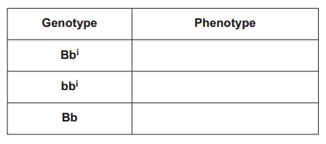
Complete the table to show the phenotypes of cats with each of the genotypes shown

black

chocolate
Black

A chocolate male was crossed several times with a black female. They produced
● 11 black kittens
● 2 chocolate kittens
● 5 cinnamon kittens.
Complete the genetic diagram to show the results of this cross.
Parental phenotypes Chocolate male Black female
Parental genotypes b b^{i} Bb^{i}
Gametes b b^{i} B b^{i}
Offspring genotypes Bb, Bb^{i} bb^{i} b^{i}b^{i}
Offspring phenotypes Black Chocolate Cinnamon

The breeder had expected equal numbers of chocolate and cinnamon kittens from the cross between the chocolate male and black female. Explain why the actual numbers were different from those expected.
Offspring ratios are a probability/not fixed/arise by chance/ gametes may not be produced in equal numbers/ fertilisation/fusion of gametes is random/ small sample

The breeder wanted to produce a population of cats that would all have chocolate fur. Is this possible? Explain your answer.
Possible if parents homozygous/ bb; Don’t know genotype of chocolate cat / chocolate cat could be homo- or heterozygous / chocolate cat could be bb or bb^{i}; Two chocolate cats could give cinnamon kittens

- Sea otters were close to extinction at the start of the 20th century. Following a ban on hunting sea otters, the sizes of their populations began to increase. Scientists studied the frequencies of two alleles of a gene in one population of sea otters. The dominant allele, T, codes for an enzyme. The other allele, t, is recessive and does not produce a functional enzyme. In a population of sea otters, the allele frequency for the recessive allele, t, was found to be 0.2.
Use the Hardy-Weinberg equation to calculate the percentage of homozygous recessive sea otters in this population.
4 (0.2x0.2 x100)

What does the Hardy-Weinberg principle predict about the frequency of the t allele after another 10 generations?
It will remain the same/ stay 0.2

Several years later, scientists repeated their study on this population. They found that the frequency of the recessive allele had decreased. A statistical test showed that the difference between the two frequencies of the t allele was significant at the P = 0.05 level. Use the terms probability and chance to help explain what this means.
There is a probability of 5%/0.05; That difference in frequencies / difference in results are due to chance;

What type of natural selection appears to have occurred in this population of sea otters? Explain how this type of selection led to a decrease in the frequency of the recessive allele.
Directional; The recessive allele confers disadvantage/ the dominant allele confers advantage/more likely to survive / reproduce

- Parasites are organisms that live on or in host organisms. The populations of many organisms may be reduced by the effects of parasites. Feather mites are small parasites found on the wing feathers of many birds. The mites feed on the oil that the birds produce. This oil keeps the feathers in good condition. Birds unable to oil their feathers properly use more energy in maintaining their body temperature. This results in less energy being available for other processes. Scientists investigated the relationship between the numbers of feather mites and the breeding success of one species of bird, the great tit. Use the information above to suggest how feather mites could affect breeding in great tits.
Breeding less successful; Feathers in poor condition; Less energy for breeding/reproduction/ stated aspect of reproduction

The scientists located a large number of great tit nests. They sampled these at random. For each nest they recorded
• the total number of eggs laid
• the number of chicks that hatched from the eggs
• the number of chicks that survived to leave the nest
• the total number of feather mites on the two parent birds.
Explain why the scientists sampled the nests at random.
Avoids bias;Data representative/choice of nest not influencing results; Allows use of statistical tests/named statistical test

The scientists calculated the percentage of each pair’s eggs from which chicks survived to leave the nest. They called this ‘breeding success per pair’. The table shows some of the data that the scientists obtained.
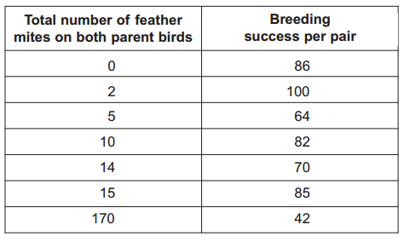
Do these data support the hypothesis that the presence of feather mites reduces the ability of great tits to reproduce successfully? Give reasons for your answer.
Accept general statements or statements based on data that make the required points - Correct statement about range of 0 – 15 / Correct statement about 0 / Correct statement about 170 / Correct statement about gap between 15 and 170
The scientists calculated a correlation coefficient for these data. State a null hypothesis that would be appropriate for this investigation.
There is no correlation between the number of feather mites and breeding success /the number of feather mites does not affect breeding success

The correlation coefficient that they obtained had a negative value. What does a negative value indicate about these data?
Breeding success decreases as feather mites increases/ negative correlation between feather mites and breeding success

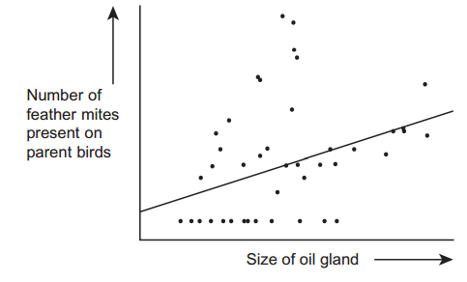
The oil that a great tit puts on its feathers is made in an oil gland at the base of the tail. The bird uses its beak to spread the oil over its feathers. This is called preening. Preening takes place in early morning and evening and empties the oil gland each time. After preening, the oil gland is considerably smaller. At the same time that the scientists recorded the number of feather mites on each great tit, they also measured the size of the oil gland. The graph shows their results and includes the scientist’s line of best fit.
Describe the relationship between the number of feather mites present on each great tit and the size of the oil gland.
The larger the size of the oil gland the larger the number of feather mites; Positive correlation; (Wide) scatter of points / points not on line

Explain how measuring the oil gland at the same time as counting the feather mites may have affected the reliability of the data.
No mark for effect on reliability, marks are for explanation. Oil gland size/number of mites could vary; At different times of the day/due to preening

Feather mites eat pathogenic bacteria and fungi as well as oil. Explain how this may affect the breeding success of the birds.
Improve health of birds/reduces disease/reduces harm; Healthier birds may find more food for young/do not pass on disease/ have greater specified aspect of breeding success

- Much of Indonesia is covered with forest. Large areas of forest have been cleared and planted with oil-palm trees to be used in the production of fuel. In these forests, nitrogen in dead leaves is made available to growing plants by the action of bacteria. Describe the role of bacteria in making the nitrogen in dead leaves available to growing plants.
Saprobionts/saprophytes; Digest/break down proteins/DNA/nitrogen-containing substances; Extracellular digestion/release of enzymes; Ammonia/ammonium produced; Ammonia converted to nitrite to nitrate/ammonia to nitrate; Nitrifying (bacteria)/ nitrification; Oxidation

Clearing the forests and burning the vegetation affects the carbon dioxide concentration in the atmosphere. Describe how and explain why.
Carbon dioxide concentration increases; Clearing - No/Less vegetation so no/less photosynthesis / photosynthetic organisms; No/Less carbon dioxide removed (from the atmosphere); Burning -Burning/combustion releases / produces carbon dioxide

During photosynthesis, oil-palm trees convert carbon dioxide into organic substances. Describe how.
Carbon dioxide combines with ribulose bisphosphate/RuBP; Produces two molecules of glycerate (3-)phosphate/GP; Reduced to triose phosphate/TP; Using reduced NADP; Using energy from ATP; Triose phosphate converted to other organic substances/ named organic substances/ribulose bisphosphate; In light independent reaction/Calvin cycle

- Explain what is meant by the ecological term population.
(Number of) organisms of one species in a habitat / same place

Four factors may affect the size of a human population. They are
- Birth rate (B)
- Death rate (D)
- Emigration rate (E)
- Immigration rate (I).
Use all the letters B, D, E and I to write a formula showing
- a population that stays the same size
B+I=D+E or (B+I)-(D+E)=0 or (B-D)+(I-E)=0
- a population that is increasing in size.
B + I > D + E or (B - D) +(I - E) > 0 or (B + I) - (D + E) > 0
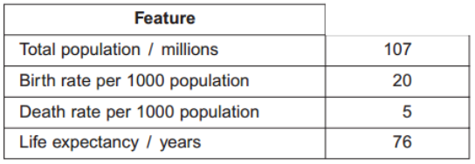
The table shows some features relating to the human population of Mexico in 2007.
In 1990 the life expectancy was 70 years. Suggest one reason for the change in life expectancy since 1990.
Improved medical care / improved nutrition / improved sanitation/water treatment / lower infection rates / less disease
Use the information in the table to calculate the size of the population of Mexico in 2008.
108,605000

- Explain what is meant by a recessive allele.
Only expressed/shown (in the phenotype) when homozygous / two (alleles) are present / when no dominant allele / is not expressed when heterozygous

Explain what is meant by codominant alleles.
Both alleles are expressed/shown (in the phenotype);

The Rhesus blood group is genetically controlled. The gene for the Rhesus blood group has two alleles. The allele for Rhesus positive, R, is dominant to that for Rhesus negative, r. The diagram shows the inheritance of the Rhesus blood group in one family.
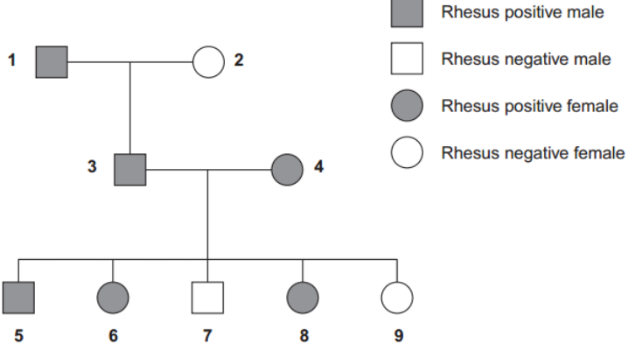
Explain one piece of evidence from the diagram which shows that the allele for Rhesus positive is dominant.
3 and 4 / two Rhesus positives produce Rhesus negative child/children / 7 / 9; - Both Rhesus positives/3 and 4 carry recessive (allele)/ are heterozygous / if Rhesus positive was recessive, all children (of 3 and 4) would be Rhesus positive/recessive

Explain one piece of evidence from the diagram which shows that the gene is not on the X chromosome.
3 would not be/is Rhesus positive / would be Rhesus negative- 3 would receive Rhesus negative (allele) on X (chromosome) from mother / 3 could not receive Rhesus positive (allele) from mother / 3 would not receive Rhesus positive (allele)/X (chromosome) from father/1 / 3 will receive Y (chromosome) from father/1; OR
9 would be Rhesus positive / would not be/is Rhesus negative / 8 and 9/all daughters of 3 and 4 would be Rhesus positive; - As 9 would receive X chromosome/dominant allele from father/3

Sixteen percent of the population of Europe is Rhesus negative. Use the Hardy-Weinberg equation to calculate the percentage of this population that you would expect to be heterozygous for the Rhesus gene.
48%

- Urea from animal waste can be used as a fertiliser. Some bacteria in the soil secrete the enzyme urease which hydrolyses urea into ammonia. Some of this ammonia is released into the atmosphere. NBPT is an inhibitor of urease and can be added to urea fertiliser to reduce the loss of ammonia to the atmosphere. A molecule of NBPT has a similar structure to a molecule of urea. Use this information to suggest how NBPT inhibits the enzyme urease.
Complementary to / fits / binds to active site; Competitive / competes / ‘prevents’ enzyme-substrate complexes / ‘prevents’ urea attaching;

Scientists investigated the effect of NBPT on the release of ammonia from urea fertiliser added to the soil. A control experiment was carried out. This involved adding urea fertiliser only. The graph shows their results
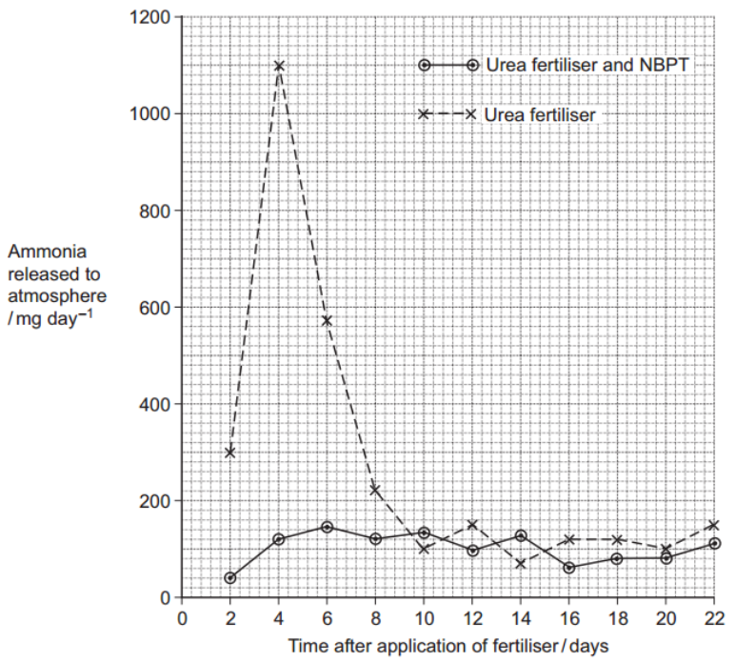
Describe how NBPT affected the loss of ammonia from urea fertiliser.
Reduces loss of ammonia up to day8/9

Suggest an explanation for the increase in mass of ammonia released over the first four days in the control experiment.
Increase in urease / temperature; More enzyme-substrate complexes; More bacteria;

Suggest how the addition of NBPT to urea fertiliser could result in increased growth of crop plants.
Less urea/ammonia lost (from soil) / less urea broken down; Urea/ammonia converted to nitrite/nitrate; Used to produce protein / amino acids / DNA / bases / nucleotides

- The young of frogs and toads are called tadpoles. Ecologists investigated the effect of predation on three species of tadpole. They set up four artificial pond communities. Each community contained 200 spadefoot toad tadpoles, 300 spring peeper frog tadpoles and 300 southern toad tadpoles.
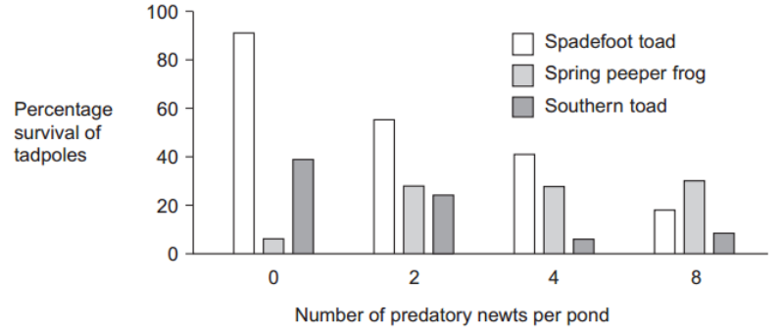
The ecologists then added a different number of newts to each pond. Newts are predators. Figure 1 shows the effect of increasing the number of newts on the percentage survival of the tadpoles of each species.
Describe the effect of an increase in the number of newts on the percentage survival of the tadpoles of each of the toad species.
Decrease in spadefoot toad; Decrease in southern toad up to 4 newts per pond, then increase (at 8 newts per pond)

Suggest an explanation for the effect of an increase in the number of newts on the percentage survival of the tadpoles of spring peeper frogs.
Predators/newts eat/feed/prey on toad (tadpoles); Less competition more food/resources / fewer toads feeding on frogs
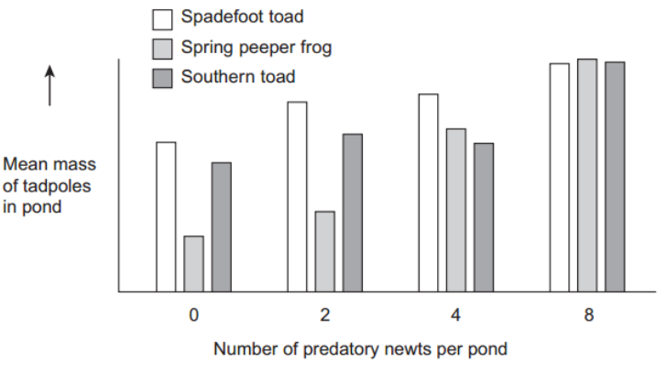
Figure 2 shows how the masses of the tadpoles were affected in each pond during the investigation.
Using the information provided in Figure 1 explain the results obtained in Figure 2.
Fewer toads/tadpoles (as number of predators increases in Figure 1); More food, so are larger / grow more / increase in mass

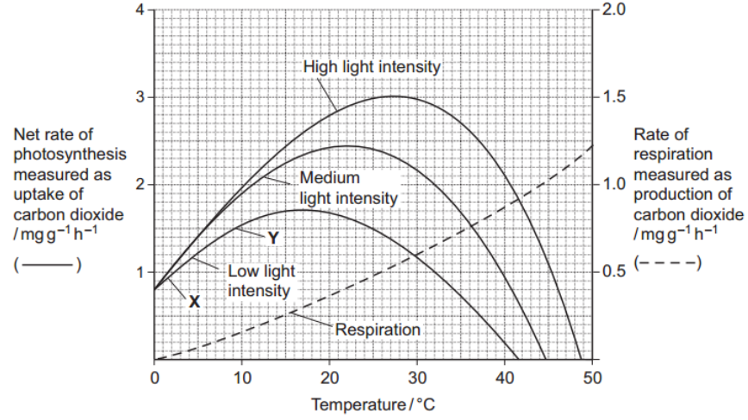
- Scientists investigated the effects of temperature and light intensity on the rate of photosynthesis in creeping azalea. They investigated the effect of temperature on the net rate of photosynthesis at three different light intensities. They also investigated the effect of temperature on the rate of respiration. The graph shows the results.
Name the factors that limited the rate of photosynthesis between X and Y.
Temperature and light;

Use information from the graph to explain your answer.
Increase in temperature causes increase in rate of photosynthesis / uptake of carbon dioxide; Increase in light/ more/medium/high light (intensity) causes increase in rate of photosynthesis / uptake of carbon dioxide;

Use information from the graph to find the gross rate of photosynthesis at 20°C and medium light intensity.
2.75 - 2.81 (mg g-1 hr-1 )

Creeping azalea is a plant which grows on mountains. Scientists predict that in the area where this plant grows the mean summer temperature is likely to rise from 20°C to 23°C. It is also likely to become much cloudier. Describe and explain how these changes are likely to affect the growth of creeping azalea.
Growth will decrease (at higher temperature); 2. Rate of respiration will increase at higher temperature; 3. Photosynthesis decreases as limited by light/ as there is less light

- A student measured the rate of aerobic respiration of a woodlouse using the apparatus shown in the diagram
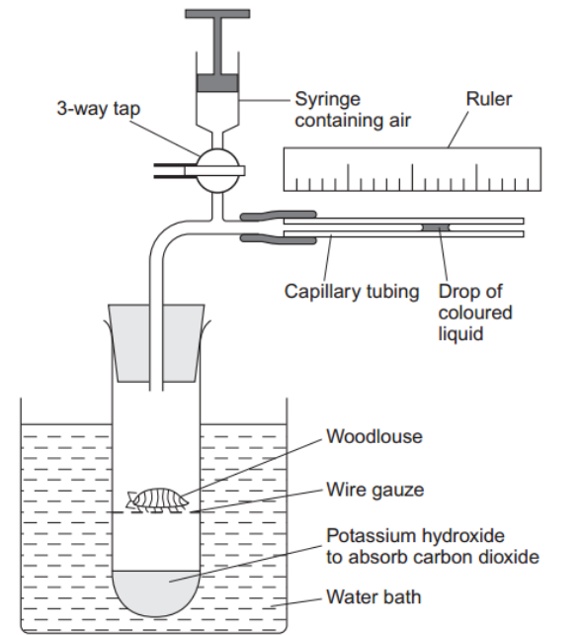
The student closed the tap. After thirty minutes the drop of coloured liquid had moved to the left. Explain why the drop of coloured liquid moved to the left.
Oxygen taken up/used (by woodlouse); Carbon dioxide (given out) is absorbed by solution/potassium hydroxide; Decrease/change in pressure

What measurements should the student have taken to calculate the rate of aerobic respiration in mm3 of oxygen g–1 h–1?
Distance (drop moves) and time; Mass of woodlouse; Diameter/radius/bore of tubing/lumen / cross-sectional area;

DNP inhibits respiration by preventing a proton gradient being maintained across membranes. When DNP was added to isolated mitochondria the following changes were observed
- less ATP was produced
- more heat was produced
- the uptake of oxygen remained constant.
Explain how DNP caused these changes.
Less/no proton/H+ movement so less/no ATP produced; Heat released from electron transport/redox reactions / / energy not used to produce ATP is released as heat; Oxygen used as final electron acceptor/combines with electrons (and protons);

- Residual food intake (RFI) is the difference between the amount of food an animal actually eats and its expected food intake based on its size and growth rate. Scientists have selectively bred cattle for low RFI. Explain the advantage to farmers of having cattle with a low RFI.
Reduced cost; Less feed / less land use / more growth rate with same amount of food;

When RFI is calculated, low values are negative. Explain why they are negative.
Amount of food taken in less than expected

Scientists have developed a standard procedure for comparing RFI in cattle. They control two factors. These are type of food and environmental temperature. Explain why each of these factors needs to be controlled.
- Type of food
May vary in protein/fat/carbohydrate/fibre/roughage/ vitamins/minerals; 2. May affect absorption / digestibility / energy value / tastiness / growth / overall food intake;
- Environmental temperature
Will affect heat loss/gain/respiration/metabolism; 4. (Need) to maintain/regulate body temperature; 5. More food/energy can be used for growth;

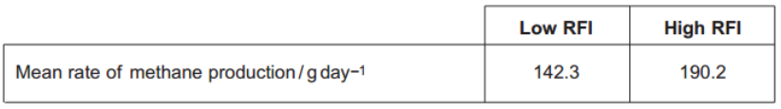
- Bacteria in the digestive systems of cattle break down food and produce methane. Scientists investigated the relationship between RFI and methane production. They measured the rate of methane production of 76 cattle over a fifteen-day period. Some of the results are shown in Figure 3.
Suggest a null hypothesis for this investigation.
RFI does not affect methane production / There is no difference in the rate of methane production for low and high RFI values / The difference between the rates of methane production is due to chance / No correlation/relationship/link between RFI and methane production;

Selectively breeding cattle with a low RFI may help to limit global warming. Use the information in Figure 3 to explain how.
(Cattle with low RFI) produce less methane; Methane linked to greenhouse effect

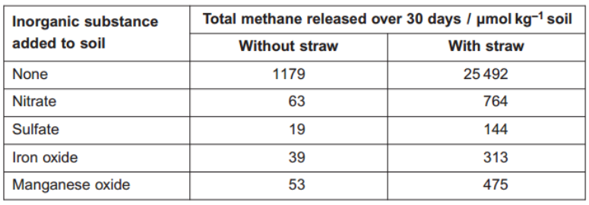
- Other scientists investigated the release of methane from rice fields. They investigated the effect of adding organic material (straw) and inorganic substances on the release of methane from rice fields. The results are shown in Figure 4.

Which treatment is most effective in reducing release of methane from rice fields?
Sulfate without straw

Research findings are not always of direct use to farmers. What else would rice farmers need to know before acting on the results of this investigation?
May affect yield / damages rice crop; Substance/treatment may affect other organisms/ environment; Cost of substance/application/labour; Method/frequency/timing of application / amount of substance required

Methane is produced by anaerobic microorganisms in the soil. The scientists found that rice fields that are not flooded do not produce large amounts of methane. Suggest why.
Not flooded aerobic conditions/more oxygen / with flooding anaerobic conditions/less oxygen; Not flooded fewer/less active anaerobic microorganisms/respiration / not flooded more/more active aerobic microorganisms/respiration

- Succession occurs in natural ecosystems. Describe and explain how succession occurs.
(Colonisation by) pioneer (species); Change in environment / example of change caused by organisms present; Enables other species to colonise/survive; Change in diversity/biodiversity; Stability increases / less hostile environment; Climax community

Managed ecosystems such as wheat fields are prone to pest infestations. Describe the advantages and disadvantages of using biological agents to control pests.
Advantages - Specific (to one pest); Only needs one application/ reproduces; Keeps/maintains low population; Pests do not develop resistance; Does not leave chemical in environment/on crop / no bioaccumulation; Can be used in organic farming; Disadvantages - Does not get rid of pest completely; May become a pest itself; Slow acting/ lag phase/ takes time to reduce pest population

Changes in ecosystems can lead to speciation. In Southern California 10 000 years ago a number of interconnecting lakes contained a single species of pupfish. Increasing temperatures caused evaporation and the formation of separate, smaller lakes and streams. This led to the formation of a number of different species of pupfish. Explain how these different species evolved.
Geographical isolation; Separate gene pools / no interbreeding (between populations); Variation due to mutation; Different environmental/abiotic/biotic conditions / selection pressures; Selection for different/advantageous, features/characteristics/mutation/ /allele; Differential reproductive success / (selected) organisms survive and reproduce; Leads to change in allele frequency; Occurs over a long period of time;

- Nitrogenase catalyses the reduction of nitrogen during nitrogen fixation. The reaction requires 16 molecules of ATP for each molecule of nitrogen that is reduced. Nitrogen gas is the usual substrate for this enzyme. Name the product.
ammonia

Nitrogenase also catalyses reactions involving other substances. Explain what this suggests about the shapes of the molecules of these other substances.
Will have similar shape/tertiary structure (as substrate) / complementary shape (to active site); Fit/bind with active site / forms enzyme-substrate complex

Azotobacter is a nitrogen-fixing bacterium. It produces the enzyme nitrogenase. The enzyme only works in the absence of oxygen. Azotobacter has a very high rate of aerobic respiration compared with bacteria that do not fix nitrogen. Suggest two advantages of the very high rate of aerobic respiration.
Provides ATP for the reaction/nitrogen fixation/reduction of nitrogen/formation of ammonia; Enzyme/nitrogenase produced quicker/more enzyme produced; Uses/removes oxygen (so nitrogenase works);

If scientists could transfer the gene that codes for nitrogenase to cereal plants, these cereal plants would be able to fix nitrogen. However, the scientists would expect these genetically engineered cereal plants to grow more slowly than cereal plants that get their nitrogen from fertiliser. Explain why they would grow more slowly.
ATP used for/needed for nitrogen fixation/reduction of nitrogen/formation of ammonia/production of enzyme/nitrogenase; (So less ATP) available for growth/protein synthesis/production of new cells/production of biomass

- Blue tits are small birds that live in woods. An ecologist estimated the size of the blue tit population visiting gardens near a wood in November.
• She trapped 28 blue tits. She marked all of these birds with small metal rings on their legs.
• Two weeks later, she trapped another sample of blue tits. Of these birds, 18 were marked and 20 were not marked.
Use the data to estimate the size of the blue tit population.
59 or 60

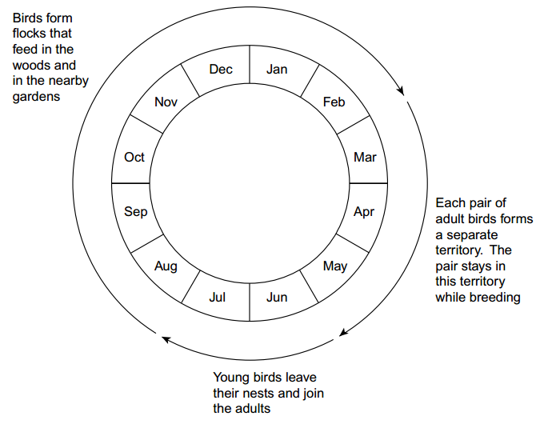
The diagram shows some features of blue tit behaviour at different times of the year.
Using mark-release-recapture to estimate the size of a blue tit population in June would not give reliable results. Explain why.
Population changes; As young birds leave nest/join population

Using mark-release-recapture to estimate the size of a blue tit population in March would not give reliable results. Explain why.
(Would be likely to) catch all birds (again) in second sample / sample sizes are the same; Birds (in territories and) not mixing with population; Only estimates number of birds in territories sampled / territory sample not representative (of population)

Whales spend most of their time deep in the sea but they come to the surface to breathe. When they are at the surface, scientists obtain small samples of their skin. The scientists find the base sequence in some of the DNA from these samples. The base sequence is different in each whale. You could use the information about the base sequence to estimate the size of the whale population by using mark-release-recapture. Explain why.
(Recording) DNA / base sequence is like marking (animal)/wouldn’t need to mark; (Finding identical/same base sequence) would show animal has been caught/recorded before

- What does the Hardy–Weinberg principle predict?
The frequency/proportion of alleles (of a particular gene); Will stay constant from one generation to the next/over generations / no genetic change over time; Providing no mutation/no selection/population large/population genetically isolated/mating at random/no migration

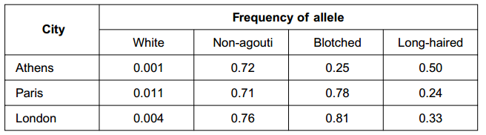
The table shows the frequencies of some alleles in the population of cats in three cities.

White cats are deaf. Would the Hardy–Weinberg principle hold true for white cats? Explain your answer.
White/deaf cats unlikely to survive/selected against; Will not pass on allele (for deafness/white fur) (to next generation)/will reduce frequency of allele

What is the evidence from the table that non-agouti and blotched are alleles of different genes?
In Paris/London frequencies (of these alleles) add up to more than 1

Hair length in cats is determined by a single gene with two alleles. The allele for long hair (h) is recessive. The allele for short hair (H) is dominant. Use the information in the table and the Hardy–Weinberg equation to estimate the percentage of cats in London that are heterozygous for hair length.
44.22

- Scientists constructed a mathematical model. They used this model to estimate the transfer of energy through consumers in a natural grassland ecosystem. The table shows their results.
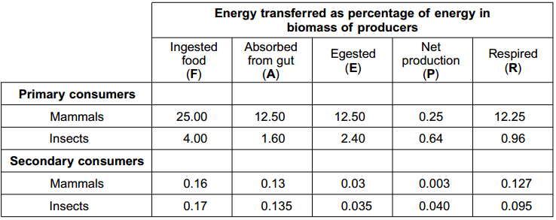

Complete the equation to show how net production is calculated from the energy in ingested food.
P = F-E-R OR F-(E+R)

Describe and explain how intensive rearing of domestic livestock would affect
- the figure for A in the first row of the table
Increase because fed concentrates/food with high nutritive value/food with high digestibility/food with little waste/because less egested
- the figure for R in the first row of the table
Decrease because movement restricted/heat loss reduced;
Calculate the ratio of R : A for mammalian primary consumers.
0.98:1 or 98:100

The R : A ratio is higher in mammalian primary consumers than in insect primary consumers. Suggest a reason for this higher value.
Mammals maintain (body) temperature/have high (body) temperature

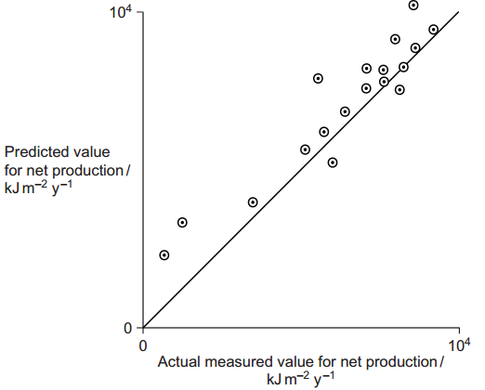
The scientists tested their model by comparing the values it predicted with actual measured values. The graph shows their results.
Are the values predicted by the model supported by the actual measured values? Evaluate the evidence in the graph.
(Results show) positive correlation/positive correlation described; Most/higher values close to line / curve shows good agreement; Lower values less close to line/less correlation; (Generally) predicted values are higher / actual values lower

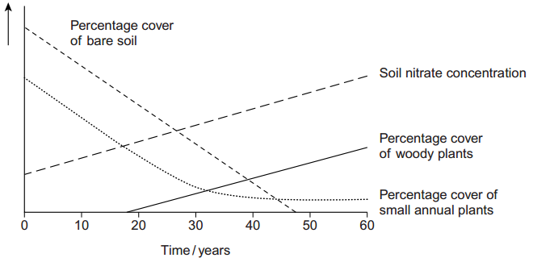
- Ecologists investigated succession in some abandoned crop fields. The data that they collected are shown in the graph. The curves show the trends that occurred over a period of 60 years.

Explain the change in soil nitrate concentration shown on the graph.
(Increase in) dead organisms/humus/decomposition; Leading to (increase in) nitrification/ammonia to nitrate/activity of nitrifying bacteria; Nitrogen fixation

The pioneer plants had different characteristics from the plants that colonised the fields after 50 years. The pioneer plants had seeds that germinate better when the temperature fluctuates. Explain the advantage of this to these pioneer plants.
Bare soil temperatures fluctuate; More bare soil, early/at start of succession/when few plants

Explain the advantage to a plant that colonises after 50 years of having a high rate of photosynthesis at low light intensities.
Plant will grow/survive in the shade/when overshadowed (by taller plants)/when receiving less light

Conservation of grassland habitats involves management of succession. Use the data in the graph to explain why.
(Grassland consists of) small/annual plants; Will be replaced by/outcompeted by woody plants; So these (woody plants) must be removed/have growth checked/grazed;

Describe the part played by the inner membrane of a mitochondrion in producing ATP.
Electrons transferred down electron transport chain; Provide energy to take protons/H+ into space between membranes; Protons/H+ pass back, through membrane/into matrix/through ATPase; Energy used to combine ADP and phosphate/to produce ATP;

A scientist investigated ATP production in a preparation of isolated mitochondria. He suspended the mitochondria in an isotonic solution and added a suitable respiratory substrate together with ADP and phosphate. He bubbled oxygen through the preparation. Why was the solution in which the mitochondria were suspended isotonic?
Prevent damage to mitochondria caused by water/osmosis/differences in water potential;

Explain why the scientist did not use glucose as the respiratory substrate.
Glucose is used/broken down during glycolysis; Breakdown of glucose/glycolysis in cytoplasm/not in mitochondria; Glucose cannot cross mitochondrial membrane/does not enter mitochondria

Explain why the oxygen concentration would change during this investigation.
Terminal/final acceptor (in electron transport chain) / used to make water

- A Sri Lankan scientist investigated the effect of human disturbance on the organisms living on a rocky seashore. He chose three areas for the study. These areas had different amounts of human disturbance. The scientist measured human disturbance by walking from one end of the beach to the other. He recorded the number of people he encountered. Figure 1 shows his results.
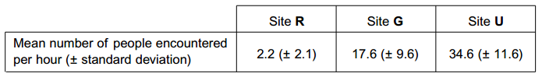
What conclusions can you draw about the number of people visiting Site R compared with the number of people visiting the other two sites? Give evidence from Figure 1 to support your answer.
Fewest people at site R as mean is lowest; Standard deviations do not overlap so significant/not due to chance

The scientist reported that the difference between the number of people visiting Site R and the number visiting the other two sites differed significantly (p < 0.05). Use the words probability and chance to explain the meaning of differed significantly (p < 0.05).
There was a probability of less than 0.05/ 5 in a hundred/5%; That the difference was due to chance

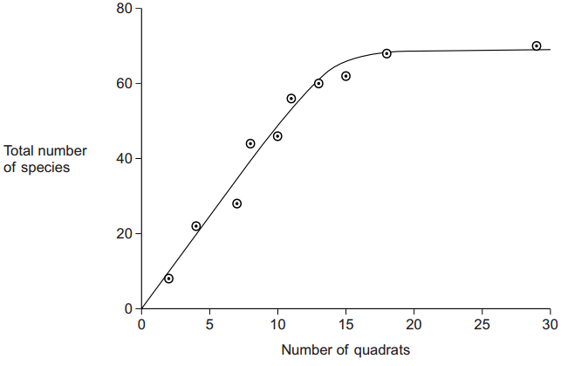
The scientist used quadrats to find the number of species at each of the three sites. He carried out a preliminary investigation and recorded the total number of species in an increasing number of quadrats. Figure 2 shows the results. Figure 2
Use Figure 2 to explain why 10 would not be an appropriate number of quadrats to use.
(Would not be reliable as) number of species is still increasing

Use Figure 2 to explain why 25 would not be an appropriate number of quadrats to use.
Idea of curve has flattened/no more species found so no benefit/no point/takes unnecessary time/takes unnecessary effort / can get same results with fewer quadrats

The scientist measured the dry biomass of seaweeds at each of sites R, G and U. He collected all the organisms of a particular species in a quadrat and incubated them in an oven at a temperature of 80°C. The scientist incubated the seaweeds at 80°C. Suggest why incubating them at a higher temperature would not produce valid results.
Combustion/ would burn/cause loss of substances (other than water)/named substance/cause loss of dry mass

As well as measuring the dry biomass of the seaweeds, the scientist measured the dry mass of the animals present. He also measured the abundance of each species. Figure 3 shows the data he collected.
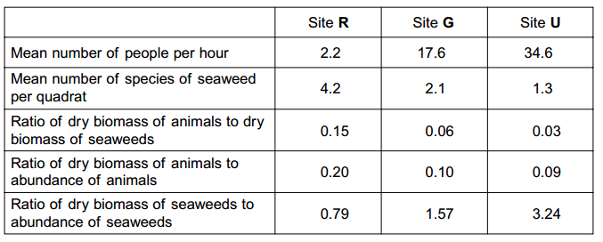
The ratio of the dry biomass of animals to the dry biomass of seaweeds is always a lot less than one. Explain why.
Seaweeds/plants are producers/lower/first trophic level / animals are consumers/higher trophic level/feed on seaweeds; Loss of energy between trophic levels; As a result of respiration/ as heat

Conservation officers were working on the beaches used in this investigation. They noticed that there were fewer larger seaweeds on beaches used by a large number of people than on beaches visited by only a few people. Explain how the data in Figure 3 support this.
The site/site U with most people/34.6 has the largest ratio/3.24; (Large value of ratio due to) large biomass ÷ small number / large size ÷ small number/biomass greater than abundance

What conclusions can you draw from the data in Figure 3 about the effect of human disturbance on the animals living on the seashore? Explain your answer.
Fewer larger animals/more smaller animals where more people/more disturbance; 0.09 linked to 34.6/appropriate link between row 4 and row 1; Larger animals affected by human activity; Smaller animals are young animals; Fewer species of seaweed (with disturbance); (So) fewer niches /habitats (for large animals)

- The concentrations of carbon dioxide in the air at different heights above ground in a forest changes over a period of 24 hours. Use your knowledge of photosynthesis to describe these changes and explain why they occur.
High concentration of carbon dioxide linked with night/darkness; No photosynthesis in dark/night / light required for photosynthesis/light-dependent reaction; (In dark) plants (and other organisms) respire; In light net uptake of carbon dioxide by plants/plants use more carbon dioxide than they produce/ rate of photosynthesis greater than rate of respiration; Decrease in carbon dioxide concentration with height; At ground level fewer leaves/less photosynthesising tissue/more animals/less light

In the light-independent reaction of photosynthesis, the carbon in carbon dioxide becomes carbon in triose phosphate. Describe how.
Carbon dioxide combines with ribulose bisphosphate/RuBP; To produce two molecules of glycerate 3-phosphate/GP; Reduced to triose phosphate/TP; Requires reduced NADP; Energy from ATP

Microorganisms make the carbon in polymers in a dead worm available to cells in a leaf. Describe how.
Microorganisms are saprobionts/saprophytes; Secrete enzymes (onto dead tissue) / extracellular digestion; Absorb products of digestion/smaller molecules/named relevant substance; Respiration (by microorganisms) produces carbon dioxide; Carbon dioxide taken into leaves; Through stomata

- Snow geese fly north to the Arctic in the spring and form breeding colonies. Different colonies form at different latitudes. The greater the latitude, the further north is the colony. The further north a breeding colony forms, the colder the temperature and the greater the risk of snow. There is a positive correlation between the size of snow geese and how far north they breed. A large size results in snow geese being adapted for breeding in colder conditions. Explain how.
Small surface area to volume ratio / more fat; Lose less heat (to the environment) / for insulation; When they are sitting on eggs

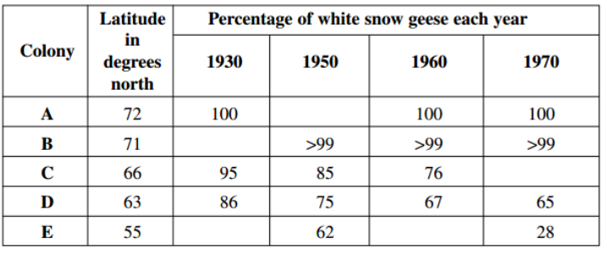
Snow geese are either white or blue in colour. The table shows the percentage of white snow geese in colonies at different latitudes at different times over a 40-year period. The blank cells in the table are years for which no figures are available.
Describe how the percentage of white snow geese varies with distance north.
The further north/higher the latitude, the higher the percentage (of white snow geese)

The further north, the greater the risk of snow. Use this information to explain how natural selection might have accounted for the effect of latitude on the percentage of white snow geese.
Snow lying longer/melts slower further north/at greater latitudes; White geese better camouflaged (further north); Predation linked to survival/reproductive success;

The percentage of white snow geese in these colonies changed over the period shown in the table. Use your knowledge of climate change to suggest an explanation. .
Snow melts earlier/snow melts further north / less snow; White geese decreasing as less well camouflaged/at disadvantage/blue geese increasing as better camouflaged/at an advantage;

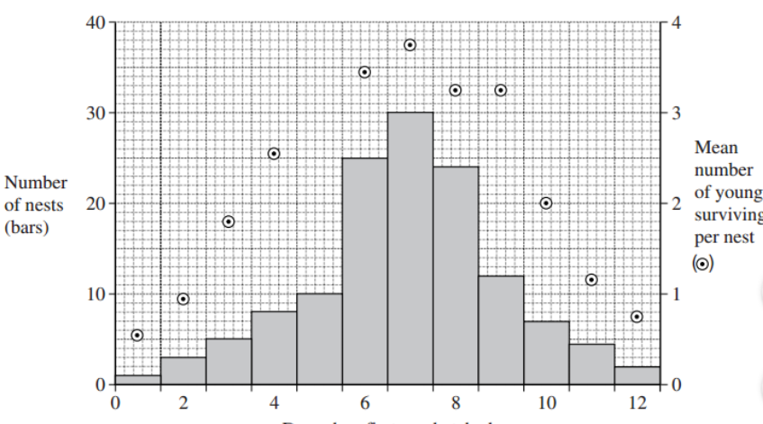
Snow geese breed in large colonies. Scientists studied the nests in one colony. For each nest, they recorded the day on which the first egg hatched. They also recorded the number of young that survived from the nest. They used the data to plot a graph.
What type of natural selection is shown in the graph?
Stabilising

Describe the evidence for your answer.
Few geese survive at the extremes/most survive from the middle of the range;

- Dead leaves contain starch. Describe how microorganisms make carbon in starch available to plants.
Extracellular digestion / releases enzymes; Starch to monosaccharides /glucose/sugars/smaller molecules ; Respire product of digestion; Produce carbon dioxide from respiration

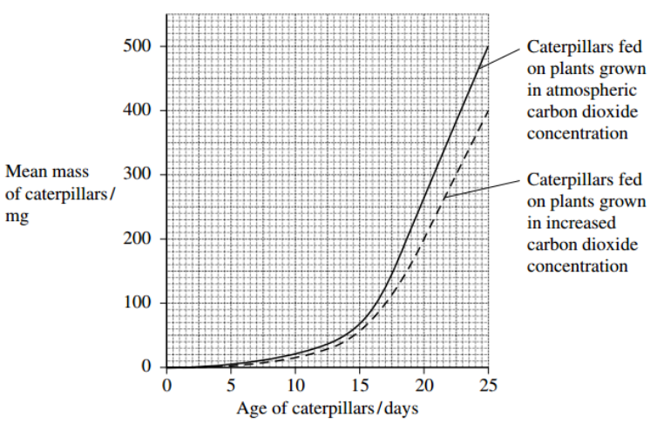
Scientists grew groups of the same species of crop plant in a greenhouse in two different concentrations of carbon dioxide. They fed caterpillars on plants from each group and measured the growth of the caterpillars. The results of their investigation are shown in the graph.
Calculate the maximum rate of growth of the caterpillars on the plants grown in the increased carbon dioxide concentration.
40

Other scientists showed that plants grown in an increased concentration of carbon dioxide have a higher carbon : nitrogen ratio than plants grown in atmospheric carbon dioxide concentration. What does this suggest about the protein concentration in the plants grown in the increased
Lower as plants contain a lower proportion of nitrogen/higher proportion of carbon/ higher C:N ratio; Nitrogen found (mainly) in protein/amino acids / nitrogen used to make protein;

It would not be valid to conclude from the investigations described in this question that an increase in carbon dioxide concentration would reduce crop losses due to caterpillars. Give two reasons why this conclusion might not be valid in field conditions.
Investigation refers to a single species and other species might not respond in the same way; Investigation carried out in greenhouse where conditions controlled; Accept any other valid answers relating to how an increase in carbon dioxide concentration might increase caterpillar damage, e.g.: Caterpillars may eat more to compensate (for low nitrogen/ protein); Increased temperature (resulting from higher carbon dioxide concentration will increase rate of growth /reduce generation time; Other organisms interfere with results

- Explain what is meant by the ecological term, population.
All organisms of one species in a habitat/area/place/at one time;

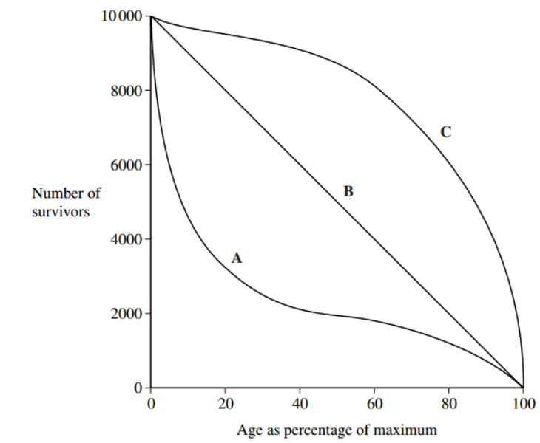
The diagram shows three survival curves, A, B and C.
Assume that the maximum age of a person living in a developed country is 95 years. The diagram can be used to find the average life expectancy of people living in developed countries. Explain how.
From curve C; Find age as a percentage of a maximum/find value when 5000/50% still alive; (Use to) calculate as a percentage of 95/ Answer = 85 years

Curve A is a survival curve for people living in the UK in 1750. Explain why the curve is this shape.
More disease/poor food supplies/poor sanitation/poor medical care; High death rate among the young/in childhood / curve drops steeply at first/in first 40

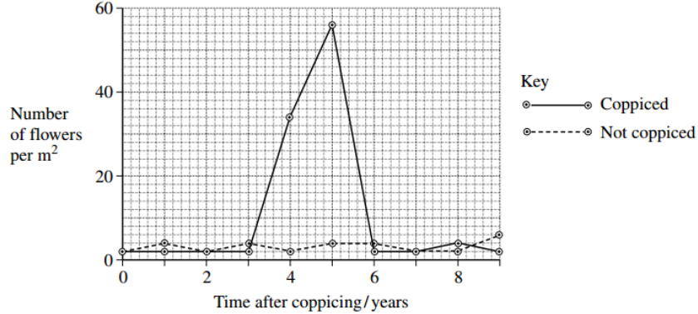
- Woods can be coppiced to provide a continuous supply of useful logs and poles. Coppicing involves cutting down some trees in a wood to leave stumps. New shoots grow from the stumps. After about 15 years, these trees can be coppiced again. Because coppicing produces a wood with patches of light and shade, the diversity of plants and animals in a coppiced wood is high. Ecologists investigated the effect of coppicing on the flowering of wild daffodils growing in a wood in Cumbria. Some areas of the wood were coppiced and some areas were not. The graph shows some results from this investigation

You could collect data for the coppiced plots by using quadrats. Describe how you would place the quadrats at random.
Marking Guidance Mark Comments 4 (a)(i) Method of positioning quadrats, E.g. Find direction and distance from specified point/ find coordinates on a grid / split area into squares; Method of generating random numbers; E.g. From calculator/telephone directory/numbers drawn from a ha

Describe how you would decide the number of quadrats to use in order to collect representative data.
Calculate running mean/description of running mean; When enough quadrats, this shows little change/levels out (if plotted as a graph); Enough to carry out a statistical test; A large number to make sure results are reliable; Need to make sure work can be carried out in the time available;

Members of the public visit this wood to see wild daffodils in flower. Explain how the information in the graph could help the owners to manage the wood so that there were many wild daffodils in flower every year.
Coppice different parts of the wood at different times; As data show many daffodils flowering 4/5 years after coppicing

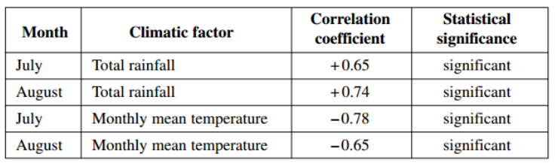
The ecologists analysed the relationship between the number of daffodils in flower in the whole wood and data collected from a nearby weather station for the previous year. They used the Spearman rank correlation test. The table shows their results.
The ecologists concluded that a wet, cool summer produces good flowering the following spring. Do you support this conclusion? Use the data in the table to explain your answer.
Positive correlation between rainfall and flowering/the higher the rainfall, the more daffodil flowers; Negative correlation/the higher the temperature the fewer daffodils in flower; All statistically significant so not likely to be/not due to chance;

- The biochemical pathway of aerobic respiration involves a number of different steps. Name one step in which carbon dioxide is produced.
Krebs cycle/link reaction/pyruvate to acetylcoenzyme A;

In an investigation, scientists transferred slices of apple from air to anaerobic conditions in pure nitrogen gas. They measured the rate of carbon dioxide production. The scientists kept the temperature constant throughout the investigation. Explain how a decrease in temperature would affect the rate of carbon dioxide production.
(Respiratory reactions controlled by) enzymes; Rate decreases as less kinetic energy/fewer collisions (between substrate and active site) fewer E-S complexes formed;

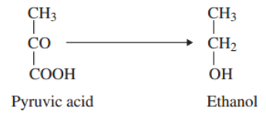
When the apple slices were transferred to nitrogen, the following biochemical pathway took place.
Use this pathway to explain the part played by reduced NAD when the apple slices were transferred to nitrogen.
Requires hydrogen/electrons / is reduction; Hydrogens from reduced NAD/reduced NAD reduces (pyruvic acid) / reduced NAD oxidised

The rate of carbon dioxide production was higher when the apple slices were in nitrogen than when they were in the air. Explain why.
Respiring anaerobically; (Anaerobic respiration/respiration with nitrogen) less efficient/produces less ATP; More anaerobic respiration/ more glucose/substrate must be respired to produce same amount of ATP (so more carbon dioxide produced);

- The graph shows the effects of light intensity on the rate of photosynthesis of three species of tree, X, Y and Z. Each of these species occurs at a different stage in succession.
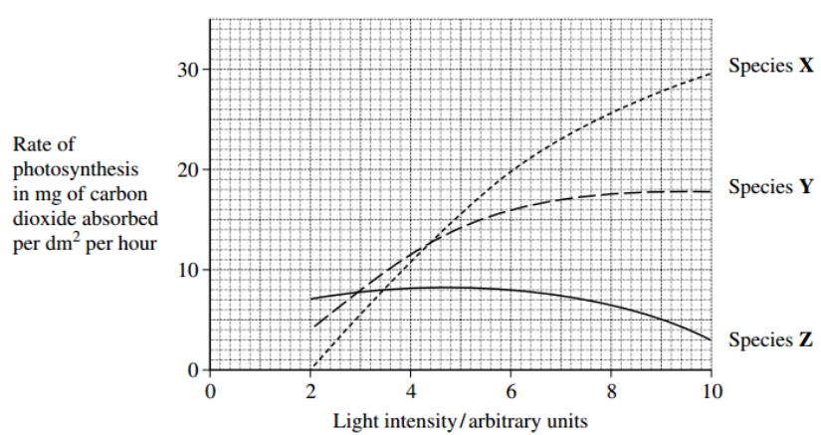
Species X is the first tree to become established in the succession. Use the graph to explain why it is likely to become established earlier in the succession than Y or Z.
Vegetation consists mainly of low growing species/herbs/annuals/ no/few tress; Species X has high rate of photosynthesis at high light intensity; Species X grow fastest at high rate of photosynthesis / at high light intensities; Will outcompete other species Y/Z

Species X may change the environment so that it becomes more suitable for species Z. Use the graph to explain why.
Produces shade/reduces light intensity; Species Z grows best/photosynthesis best/ in low light intensity / Species Z does not grow well / low rate of photosynthesis in high light intensity;

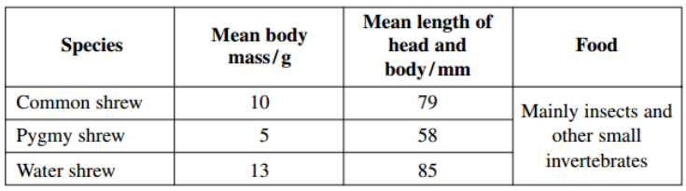
- Shrews are small mammals. Three species of shrew live in mainland Britain. The table shows some features of these shrews.

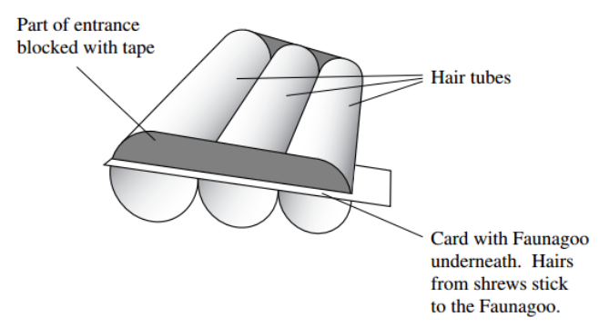
A team of biologists investigated a method of estimating the abundance of shrews. They used plastic tubes, called hair tubes. Some of the hairs from a shrew that enters one of these tubes stick to glue in the tube. These hairs can be used to identify the species of shrew. The diagram shows a set of these hair tubes.
Faunagoo is a glue that remains sticky after wetting and drying. Explain the advantage of using Faunagoo in these hair tubes.
Will work in all weather conditions/hairs will stick to it even if shrew/animal is wet/ withstand rain

The diagram shows that the biologists partly blocked the entrances to the tubes with tape. Suggest why they partly blocked the entrances.
So shrews come into contact with glue

The biologists needed to find a way of distinguishing between the hairs of the three species of shrew. They collected hairs from shrews of each species. For each species, they selected hairs at random and made different measurements. Explain why the biologists selected the hairs at random.
Avoids bias/allows statistical tests to be carried out;

Repeatable measurements are measurements of the same feature that are very similar. In this investigation, each measurement was made by two observers. This helped the team to check the repeatability of these measurements. Explain why it was important to check the repeatability of the measurements.
Increases the reliability of the measurements; If measurements are repeatable, differences less likely to be due to measurement/personal error/ anomalies unlikely

You could use a scatter diagram to check the repeatability of measurements made by two observers. Describe how.
Plot graph/scatter diagram of one set of results against the other; Expect to see points lying close to line / Line should slope upwards/show positive correlation; OR Plot measurement against hair number; Look for overlying / corresponding points

The biologists used hair tubes to find the abundance of shrews along the edges of some fields. They also used traps that caught shrews without harming them. They selected areas where all three species of shrew were present.
• They put sets of hair tubes at 5 m intervals along the edges of the fields. They inspected the tubes one week later and recorded the number of sets of tubes that contained shrew hairs. They called this the hair tube index.
• At each site where they used hair tubes, they set traps immediately after using the hair tubes. They recorded the number of different shrews caught in these traps.
The research team found the hair tube index. Explain why they could not use the hair tubes to find the total number of shrews present.
One mark for a valid explanation based on individual shrews entering more than one hair tube / many hairs from same shrew/ shrews enter without leaving hair

The research team set the traps immediately after using the hair tubes. Explain why setting the traps immediately after using the hair tubes would make comparisons between the two methods more reliable.
Rules out differences due to changes in population / changes in environmental conditions; That could be produced by births/deaths/migration/specific example of environmental conditions affects results

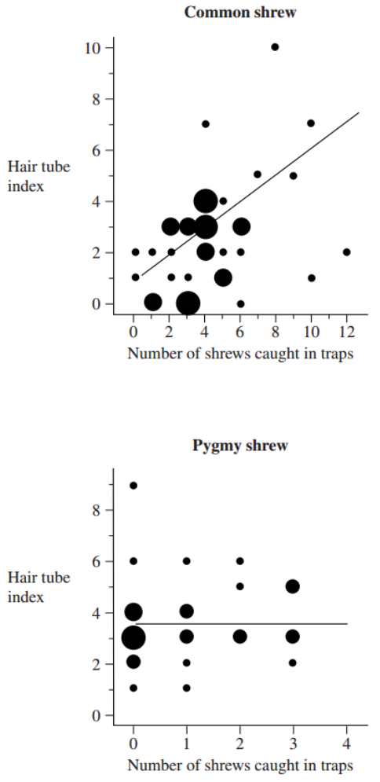
The graphs are types of scatter diagram called bubble plots. They show hair tube index plotted against the number of shrews caught in traps. The area of the bubble is proportional to the number of records plotted.
Explain why a statistical test was necessary in analysing the results for the common shrew. Use the terms chance and probability in your answer.
(A statistical test) determines the probability of results being due to chance; Enables null hypothesis/description of null hypothesis to be accepted/rejected; Determines whether correlation/result is significant;

The biologists concluded that hair tubes were a reliable way of measuring the abundance of common shrews. Give evidence from the graph to support this conclusion.
(Curve/line of best fit shows) positive correlation/ description of positive correlation

Use information in this question to evaluate the use of hair tubes as a way of measuring the abundance of pygmy shrews.
Curve/line of best fit (almost) parallel to x-axis/horizontal / level/ no correlation / index is independent of number of shrews; Hair tubes with positive results when no shrews trapped; Small size of shrews means shrews may not trigger traps

- In the light-dependent reaction of photosynthesis, light energy generates ATP. Describe how.
Light (energy) excites/raises energy level of electrons in chlorophyll;Electrons pass down electron transfer chain; (Electrons) reduce carriers/passage involves redox reactions; Electron transfer chain / role of chain associated with chloroplast membranes / in thylakoids / grana; Energy released / carriers at decreasing energy levels; ATP generated from ADP and phosphate/Pi / phosphorylation of ATP

Energy is transferred through an ecosystem. Describe how and explain why the efficiency of energy transfer is different at different stages in the transfer.
Some light energy fails to strike/is reflected/not of appropriate wavelength; Efficiency of photosynthesis in plants is low/approximately 2% efficient; Respiratory loss / excretion / faeces / not eaten; Loss as heat; Efficiency of transfer to consumers greater than transfer to producers/approximately 10%; Efficiency lower in older animals/herbivores/ primary consumers/warm blooded animals/homoiotherms; Carnivores use more of their food than herbivores;

Explain how the intensive rearing of domestic livestock increases net productivity
Slaughtered when still growing/before maturity/while young so more energy transferred to biomass/tissue/production; Fed on concentrate /controlled diet /controlled conditions/so higher proportion of (digested) food absorbed/lower proportion lost in faeces / valid reason for addition; Movement restricted so less respiratory loss / less energy used; Kept inside/heating/shelter / confined so less heat loss / no predators; Genetically selected for high productivity;

