**RESPIRATION SUMMARY NOTES**



1. **GLYCOLOSIS**

* Glucose is phosphorylated by adding 2 phosphates (from 2 molecules of ATP)
* This phosphorylated glucose is split into 2 TP’s
* TP is oxidised (removed hydrogen – the hydrogen goes to NAD to produced REDUCED NAD) and uses an enzyme to be converted into pyruvate. ATP is produced here too.

1. **LINK REACTION**

* Pyruvate is actively transported into the matrix.
* Pyruvate is decarbonised (loses a carbon that goes on to form Co2)
* 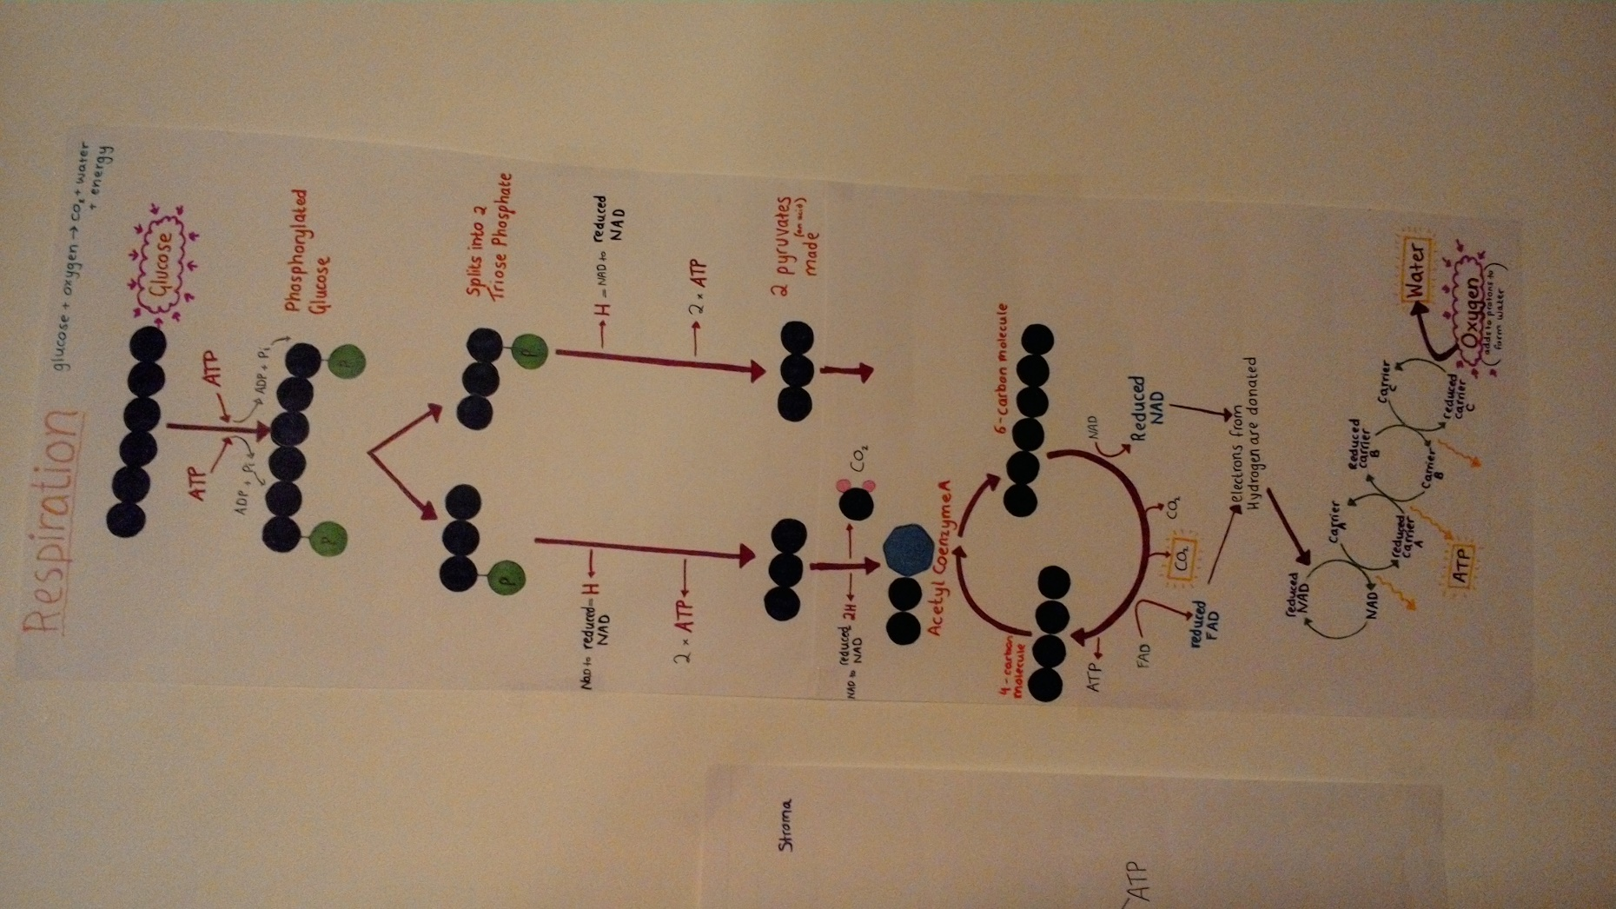It is oxidised (by removing hydrogen – the hydrogen is again used to form REDUCED NAD) to form acetylcoenzyme A.

1. **KREBS CYCLE**

* Acetylcoenzyme A combined with a 4 carbon molecule to form a 6 carbon molecule.
* The 6 carbon molecule loses carbon dioxide and hydrogen (which is used to make REDUCED NAD) to give a single ATP, REDUCED FAD and a 4 carbon molecule (which can then again go on to combine with acetylecoenzyme A).

1. **ELECTRON TRANSPORT CHAIN**

* In the mitochondrial membrane, REDUCED NAD and REDUCED FAD are oxidised and so release their hydrogen atoms.
* The electron from the hydrogen is taken up by an electron carrier to reduce it.
* This electron from the reduced carrier is oxidised again by passing to a new carrier (which in turn becomes reduced)
* It passes through the chain in a series of oxidisation/reduction reactions (this loses energy in the process and this is used to form ATP)
* At the end, electrons combine with protons and oxygen to form water.

**ANAEROBIC RESPIRATION**



In plants:



**Pyruvate (3C) + reduced NAD 🡪 ethanol (2C) + carbon dioxide (1C) + NAD**

In animals:



**Pyruvate (3C) + reduced NAD 🡪lactate (3C) + NAD**