**PHOTOSYNTHESIS SUMMARY NOTES**



1. ***LIGHT DEPENDANT REACTION***

In Thylakoid membranes



1. Light energy is absorbed by chlorophyll



1. This boosts the electrons’ energy level so they escape chlorophyll and are taken up by an electron carrier



1. Electrons are passed along the carrier (by oxidisation-reduction reactions), losing energy as they do so and this lost energy helps produce ATP.



1. Meanwhile water undergoes photolysis to give rise to hydrogen ions (plus electrons and oxygen)



1. These hydrogen ions are taken up by NADP to form REDUCED NADP.

2. ***LIGHT INDEPENDANT REACTION***

In the stroma of chloroplasts



1. Co2 diffuses into leaf and into the stroma
2. Co2 combines with RuBP using an enzyme to produce two molecules of GP
3. GP is reduced to TP using ATP and REDUCED NADP
4. The TP has taken the hydrogen to NADP is reformed
5. Some TP molecules are converted into useful substances or are regenerated into RuBP.

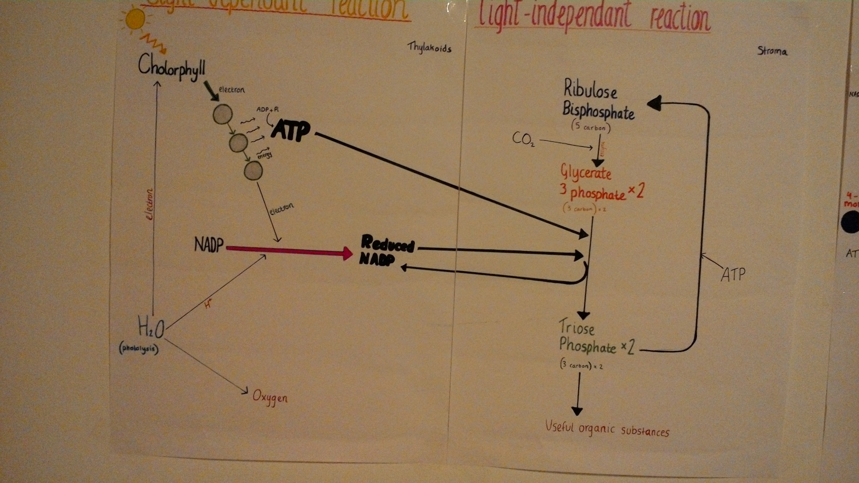

LIMITING FACTORS:

***The effect of light intensity***

* As light intensity increases there comes a “light compensation point” (where the volume of oxygen produced and carbon dioxide absorbed will increase to a point where it is balanced by the oxygen absorbed and carbon dioxide produced by respiration)
* When light is a limiting factor, the rate of photosynthesis is proportional to light intensity.

***The effect of carbon dioxide on the rate of photosynthesis***

* High CO2 concentrations can affect the enzyme catalysed reactions that combine ribulose biphosphate with CO2.

***The effect of temperature on the rate of photosynthesis***

* Higher temperatures often cause the rate of photosynthesis to decrease since enzymes become denatured.