BIOLOGY UNIT TWO PAST PAPER QUESTIONS AND ANSWERS

1. 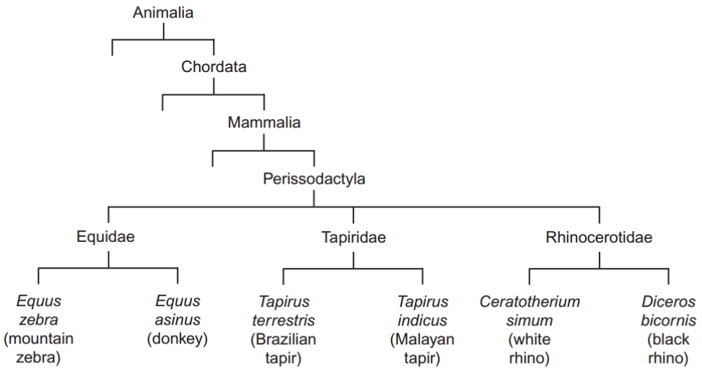**Figure 1 shows how some animals with hooves are classified.**

**This type of classification can be described as a phylogenetic hierarchy. What is meant by a hierarchy?**

Groups within groups; No overlap (between groups)

**How many different families are shown in Figure 1?**

3

**To which phylum does the white rhino belong?**

Chordata

**Explain the role of independent segregation in meiosis.**

(To provide) genetic variation; (Allows) different combinations of maternal and paternal chromosomes/ alleles; (To produce) haploid cells/half the chromosome number; (Allows) homologous chromosomes/ homologous pairs to arrange randomly (at equator/middle of cell)/separate;

**A zeedonk is the offspring produced from breeding a mountain zebra with a donkey. The body cells of a mountain zebra contain 32 chromosomes. The body cells of a donkey contain 62 chromosomes. Use this information to suggest why zeedonks are usually infertile.**

(Zeedonk has) 47/odd/uneven number of chromosomes; Chromosomes cannot pair/are not homologous/ chromosome number cannot be halved / meiosis cannot occur / sex cells/haploid cells are not produced

1. **What is selective breeding?**

(Humans breed) organisms with certain/chosen characteristics/alleles;

**Explain one potential problem that can be caused by selective breeding.**

Inbreeding / breed closely related organisms; (So higher probability of) mutations being passed on / recessive alleles being expressed / health problems/example given / increase in genetic disease;. Reduced genetic variation/diversity / smaller gene pool / less variety of alleles (So) can be killed by/susceptible to the same/a disease / reduces ability to adapt/survive (future) environmental changes / may not be beneficial to future breeding programmes;

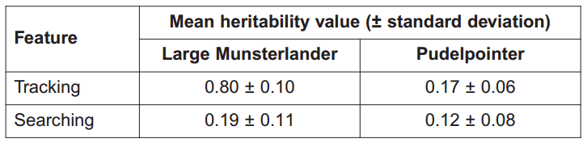**Heritability is a measure of how much of the variation in a population is due to genetic factors. Values for the heritability of a feature range from 0 to 1. A value of 0 means that there is no influence of genetic factors. A value of 1 means that the feature is completely due to genetic factors. The Large Munsterlander and Pudelpointer are two breeds of hunting dog. Table 1 shows the mean heritability values and standard deviations for two features of these two breeds of hunting dog.**

**If a dog breeder wishes to use selective breeding for one of these features, which one should he choose? Use information in Table 1 to explain your answer.**

Select tracking/(Large) Munsterlander; (As) high (heritability) value/0.8/ closer to 1/ mainly due to genetic factors

**What do the standard deviations suggest about the differences in heritability values for searching between the two breeds of hunting dog?**

(SDs) overlap / values shared; (So difference between means) is not significant/is due to chance;

1. **The oxygen dissociation curve for haemoglobin shifts to the right during vigorous exercise. Explain the advantage of this shift.**

Lower affinity for oxygen / releases more oxygen / oxygen is released quicker / oxygen dissociates/unloads more readily; (To) muscles/tissues/cells; (For) high/rapid respiration

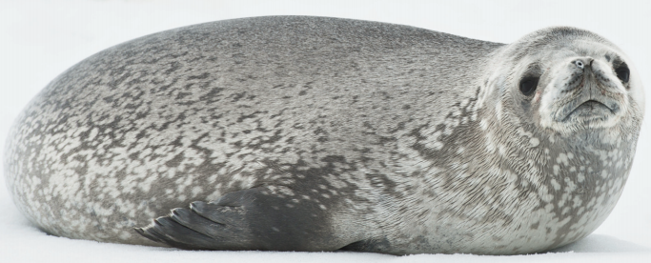**Weddell seals are diving mammals that live in cold environments. A Weddell seal is shown in Figure 2.**

**Explain how the body shape of a Weddell seal is an adaptation to living in a cold environment.**

Small Surface area to volume ratio (So) reduces heat loss / (more) heat retained

**Weddell seals can remain underwater for long periods of time. Figure 3 shows the rate of blood flow to different organs of a Weddell seal before a dive and during a long dive.**

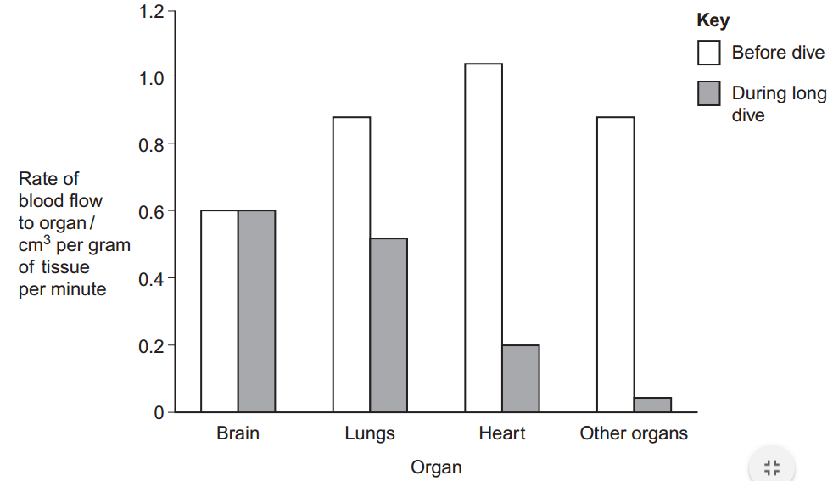**Describe and explain the changes in the rate of blood flow to the different organs during a long dive.**

Brain is the same, others fall;Brain controls other organs/remains active/ needs constant supply of oxygen; Lungs not used/are used less / seal is not breathing; Heart rate decreases / heart pumps less; Blood diverted to muscles; Oxygen (in blood) will last longer / less oxygen used / oxygen is conserved

1. **Describe and explain how the countercurrent system leads to efficient gas exchange across the gills of a fish**

Water and blood flow in opposite directions; Maintains concentration/diffusion gradient / equilibrium not reached / water always next to blood with a lower concentration of oxygen; Along whole/length of gill/lamellae;

**Amoebic gill disease (AGD) is caused by a parasite that lives on the gills of some species of fish. The disease causes the lamellae to become thicker and to fuse together. AGD reduces the efficiency of gas exchange in fish. Give two reasons why.**

(Thicker lamellae so) greater/longer diffusion distance/pathway; (Lamellae fuse so) reduced surface area;

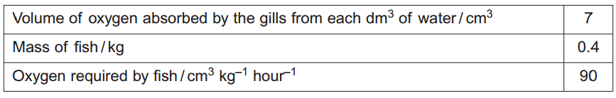**Table 2 shows some features of gas exchange of a fish at rest.**

**Calculate the volume of water that would have to pass over the gills each hour to supply the oxygen required by the fish.**

5.1

**The volume of water passing over the gills increases if the temperature of the water increases. Suggest why.**

Increased metabolism/respiration/enzyme activity; Less oxygen (dissolved in water);

1. 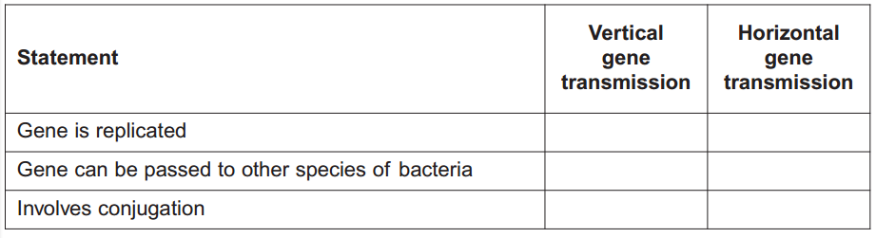**Genes for antibiotic resistance can be transmitted between bacteria. Table 3 shows features of gene transmission. Complete Table 3 by putting a tick in the box if the statement is correct for vertical or horizontal gene transmission**

**The antibiotic tetracycline binds to ribosomes in bacterial cells. Explain how this causes the death of bacterial cells.**

Prevents protein synthesis; (So) enzymes not produced / any named process involving proteins/enzymes is inhibited

**Scientists determined the amino acid sequences of two forms of a protein, A and B, found in two types of the same species of bacterium. They used these amino acid sequences to find the DNA base sequences that code for these proteins. Table 4 shows their results for the same region of proteins A and B. Table 5 shows DNA triplets that code for different amino acids.**

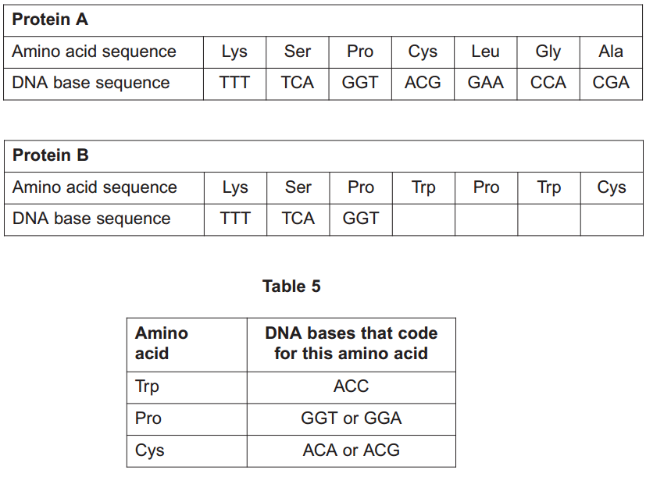

**The amino acid sequence of protein B was the result of a mutation. A single base was added within the DNA sequence coding for protein A. Use the information provided to complete the DNA base sequence that codes for protein B.**

ACC GGA ACC ACG

**Which DNA base was added?**

C

**Tetracycline can enter a bacterium through protein A. This protein is found in the plasma membrane. Suggest how a change in the amino acid sequence of this protein could make a bacterium resistant to tetracycline.**

Different tertiary structure/tertiary shape; (So tetracycline) does not fit/bind/ is not complementary / does not enter/pass through (protein/into cell)

1. **Evolutionary relationships between different primates can be found by comparing their proteins and DNA. All primates produce a species-specific type of haemoglobin. An antibody against human haemoglobin could be used to compare the evolutionary relationships between different primates. Describe and explain how.**

Antibody and haemoglobin/blood (of different primates) mixed/added/bind; Precipitate/complex/band formed; Amount of precipitate/complex/ thickness of band shows relationship/similarity (in protein/DNA)

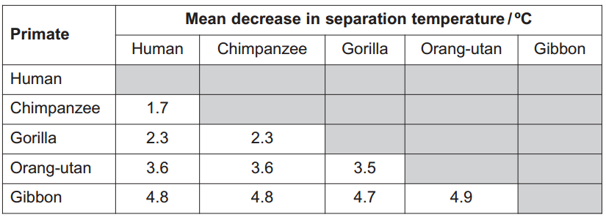**Scientists used DNA hybridisation to determine the evolutionary relationships between five species of primate. The temperature at which a molecule of double-stranded DNA separates into two single strands is the separation temperature. The scientists recorded the mean separation temperature of DNA in which both strands were from the same species. The scientists then recorded the mean decrease in separation temperature of DNA in which one of the strands was from another species. Their results are shown in Table 6.**

**These data suggest that gibbons are the most distantly related to humans. Explain how.**

(Largest decrease in separation temperature) – (So) few(er) hydrogen/H bonds; (So) few(er) complementary bases/ few(er) base pairs

**There were differences in separation temperature of DNA formed from single-stranded DNA of the same species of primate. Suggest why.**

(Same species) have different alleles/different base sequences/ (different) mutations/introns/ non-coding DNA/multiple repeats

**The scientists assumed that the decreases in separation temperatures are directly proportional to the time since the evolutionary lines of these primates separated. Gorillas are thought to have separated from orang-utans 20 million years ago. Use this information to calculate how long ago the evolutionary lines of humans and chimpanzees separated.**

Range between 9.69 to 9.71

1. **What two measurements are needed to calculate an index of diversity?**

Number of (individuals of) each species; Total number of individuals / number of species

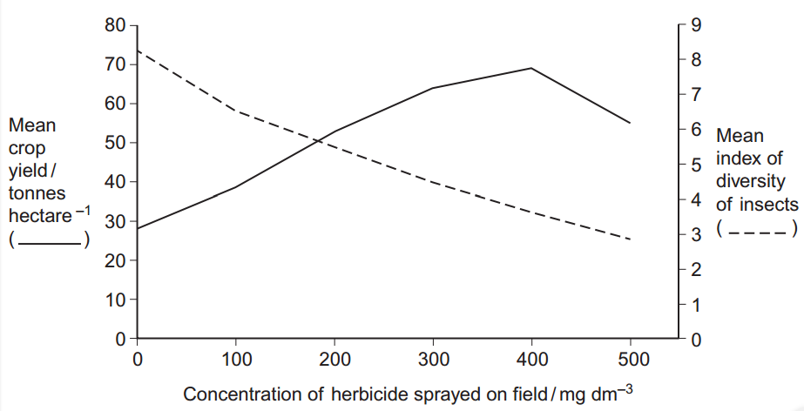**A herbicide is a chemical used to kill weeds. Ecologists investigated the effect of a herbicide on crop yield and the diversity of insects. They sprayed different fields with the same volume of different concentrations of the herbicide. At harvest, the ecologists determined the mean crop yield and the mean index of diversity of insects for fields that had received the same concentration of the herbicide. Figure 4 shows their results.**

**Some fields acted as controls. They were sprayed with a solution that did not contain the herbicide. Explain the purpose of these control fields.**

(Shows) results are due to the herbicide/ are not due to another factor; (To) compare the effect of using and not using the herbicide / shows the effect of adding the herbicide

**Suggest an explanation for the relationship between the concentration of herbicide and the mean crop yield.**

(More) weeds killed so more crops/plants survive/higher yield/less competition; High concentrations (of herbicide) harm/damage/kill/are toxic to crops/plants

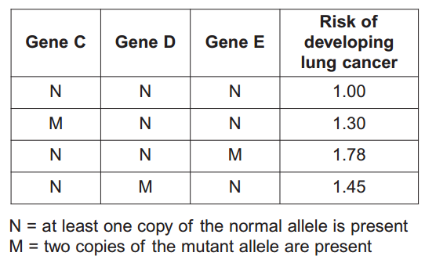**Explain the relationship between the concentration of herbicide and the mean index of diversity of insects.**

Reduced plant diversity / fewer plant species / fewer varieties of plant; Fewer habitats/niches; Fewer food sources/varieties of food

1. **Explain how the structure of DNA is related to its functions.**

Sugar-phosphate (backbone)/double stranded/helix so provides strength/stability /protects bases/protects hydrogen bonds; Long/large molecule so can store lots of information; Helix/coiled so compact; Base sequence allows information to be stored/ base sequence codes for amino acids/protein; Double stranded so replication can occur semi-conservatively/ strands can act as templates; Complementary base pairing / A-T and G-C so accurate replication/identical copies can be made; (Weak) hydrogen bonds for replication/ unzipping/strand separation; 8. Many hydrogen bonds so stable/strong

**Scientists investigated three genes, C, D and E, involved in controlling cell division. They studied the effect of mutations in these genes on the risk of developing lung cancer. The scientists analysed genes C, D and E from healthy people and people with lung cancer. If a person had a normal allele for a gene, they used the symbol N. If a person had two mutant alleles for a gene, they used the symbol M. They used their data to calculate the risk of developing lung cancer for people with different combinations of N and M alleles of the genes. A risk value of 1.00 indicates no increased risk. Table 7 shows the scientists’ results.**

**What do these data suggest about the relative importance of the mutant alleles of genes C, D and E on increasing the risk of developing lung cancer? Explain your answer.**

(Mutation) in E produces highest risk/1.78; 2. (Mutation) in D produces next highest risk/1.45; (Mutation) in C produces least risk/1.30

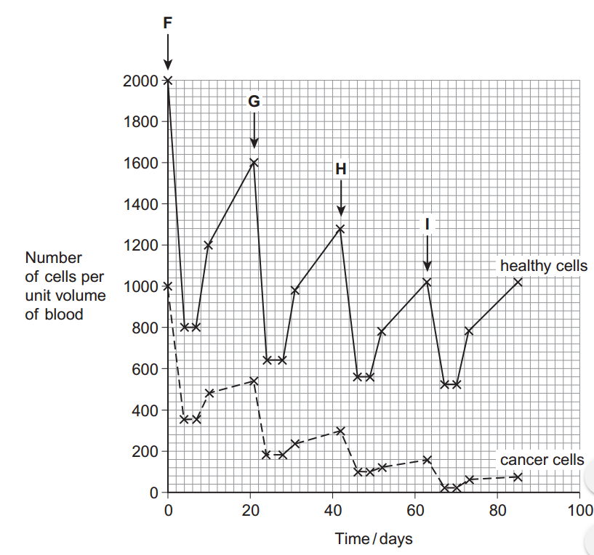**Chemotherapy is the use of a drug to treat cancer. The drug kills dividing cells. Figure 5 shows the number of healthy cells and cancer cells in the blood of a patient receiving chemotherapy. The arrows labelled F to I show when the drug was given to the patient.**

**Calculate the rate at which healthy cells were killed between days 42 and 46.**

**.....**180**......... cells killed per unit volume of blood per day**

**Describe similarities and differences in the response of healthy cells and cancer cells to the drug between times F and G.**

(Similarities): Same/similar pattern / both decrease, stay the same then increase; Number of cells stays the same for same length of time

(Differences): (Per unit volume of blood) Greater/faster decrease in number of healthy cells / more healthy cells killed / healthy cells killed faster; Greater/faster increase in number of healthy cells / more healthy cells replaced/divide / healthy cells replaced/divide faster

**More cancer cells could be destroyed if the drug was given more frequently. Suggest why the drug was not given more frequently.**

More/too many healthy cells killed; (So) will take time to replace/increase in number; Person may die/have side effects

1. **Nicotine is the addictive substance in tobacco. When nicotine reaches the brain, it binds to a specific protein. This causes the release of chemicals that give a feeling of reward to the smoker. This reward is part of the reason why people find it difficult to stop smoking. Scientists have developed a vaccine against nicotine to help people stop smoking. They set up an investigation, which involved a large number of volunteers. Once a month for 5 months, one group of volunteers was given the vaccine and the other group was given a placebo. At regular intervals, the scientists measured the concentration of antibodies to nicotine in the blood of each group of volunteers. They also calculated the percentage of volunteers who had stopped smoking from months 2 to 6 of the investigation.**

**In this investigation, neither the volunteers nor the scientists knew if a particular volunteer was receiving the vaccine or a placebo. Suggest two reasons why this made the scientists’ results more reliable.**

(Scientists) can’t show bias/influence/ may have a vested interest/work for the company developing the vaccine; (Volunteers) can’t show psychological/mental effects/ ‘placebo effect’/expectations

**The scientists measured the concentration of nicotine in the blood of two volunteers who smoked the same number of cigarettes per day. Suggest two reasons why the concentration of nicotine in the blood of these smokers might be different.**

Amount of nicotine in cigarettes; Amount inhaled/absorbed / time since last cigarette; (Different) amounts excreted/ metabolism/rate of binding (of nicotine) to protein; (Different) blood volumes; Nicotine from passive smoking/other smokers/other sources; Some volunteers received the vaccine/placebo

**Suggest how this vaccine could help people to stop smoking.**

Antibodies to nicotine produced / antibodies bind to nicotine; (So) nicotine does not bind to protein/does not reach the brain; (So) cigarettes/smoking does not satisfy addiction/reward smokers/ release (reward) chemicals

**Some people have suggested that this vaccine should not be given free to smokers on the National Health Service (NHS). Evaluate this suggestion**

Agree – people choose to smoke/know the risks; Should spend this money on education/preventing people from starting to smoke/treating other health problems/ vaccines are expensive; (Disagree): Unethical not to treat; Less money needed to treat the effects of smoking/cancer / smokers pay taxes so are entitled to treatment;

**The scientists measured the concentration of antibodies to nicotine in the blood of the volunteers for 12 months after the first vaccination. As a result of these measurements, they divided the volunteers who received the nicotine vaccine into three groups:**

* **high antibody responders**
* **medium antibody responders**
* **low antibody responders.**

**Figure 6 shows their results. The scientists also recorded the number of volunteers who had stopped smoking from months 2 to 6 of the investigation. Table 8 shows these results.**

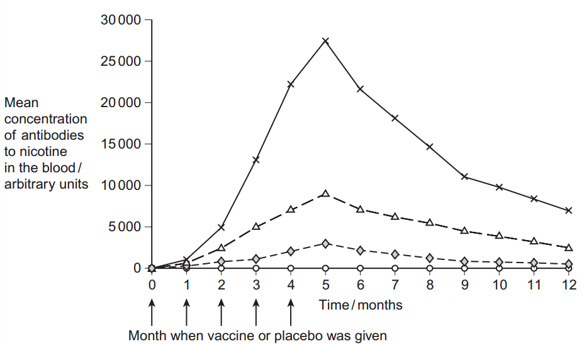

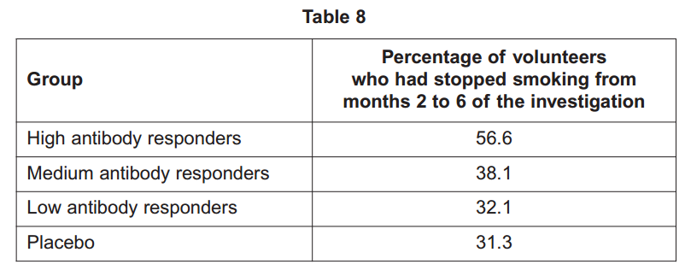

**A journalist reported that this vaccine is a major breakthrough in helping people to stop smoking. Do these data support this statement? Explain your answer.**

High antibody responders have a high % to stop smoking/are more likely to stop smoking; Only a few may be high antibody responders/ no numbers on how many are high/medium/low antibody responders; Percentage who stopped smoking is similar for placebo group and low/medium responders / some/% of placebo group (still) stopped smoking / placebo has the lowest value/% to stop smoking; Large sample size/double blind so reliable/representative; Antibody levels peak at/drop after 5 months / boosters may be needed at/after 5 months; May start smoking again after 5/6 months / do not know the percentage who stopped smoking after 5/6 months; Nicotine is not the only factor responsible for making people smoke

1. 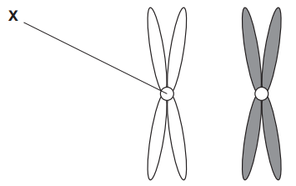**Figure 1 shows one pair of homologous chromosomes.**

**Name X.**

Centromere

**Describe the role of X in mitosis.**

Holds chromatids together; Attaches (chromatids) to spindle; (Allows) chromatids to be separated/move to (opposite) poles / (centromere) divides/splits at metaphase/ anaphase

**Homologous chromosomes carry the same genes but they are not genetically identical. Explain why.**

(Homologous chromosomes) carry different alleles

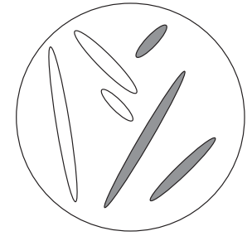**Figure 2 shows three pairs of homologous chromosomes in a cell at the end of cell division.**

**The appearance of each chromosome in Figure 2 is different from those shown in Figure 1. Explain why.**

Chromatids have separated (during anaphase); Chromatids have not replicated; Chromosomes formed from only one chromatid

**Other than independent segregation, give one way in which meiosis allows the production of genetically different cells.**

Crossing over / alleles exchanged between chromosomes or chromatids / chiasmata formation / genetic recombination

1. **What is a species?**

Group of similar organisms / organisms with similar features / / organisms with same genes/chromosomes; Reproduce / produce offspring; That are fertile

**Scientists investigated the diversity of plants in a small area within a forest. The table shows their results.**

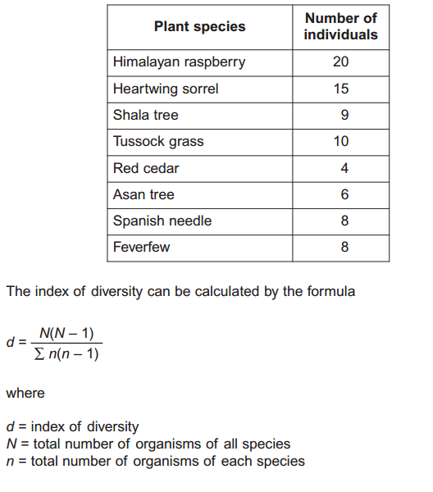**Use the formula to calculate the index of diversity of plants in the forest.** 

6.97 to 7

**The forest was cleared to make more land available for agriculture. After the forest was cleared the species diversity of insects in the area decreased. Explain why.**

Decrease in variety of plants / fewer plant species; Fewer habitats/niches; Decrease in variety of food / fewer food sources; Aspect of clearing forest (killing insects) eg machinery, pesticides

1. **Organisms can be classified using a hierarchy of phylogenetic groups. Explain what is meant by:**
2. **a hierarchy**

Groups within groups; No overlap (between groups);

1. **a phylogenetic group.**

(Grouped according to) evolutionary links/history/relationships / common ancestry

**Cytochrome c is a protein involved in respiration. Scientists determined the amino acid sequence of human cytochrome c. They then:**

* **determined the amino acid sequences in cytochrome c from five other animals**
* **compared these amino acid sequences with that of human cytochrome c**
* **recorded the number of differences in the amino acid sequence compared with human cytochrome c.**

**The table shows their results.**

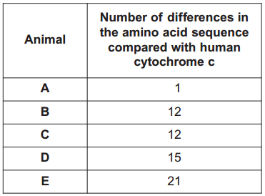**Explain how these results suggest that animal A is the most closely related to humans.**

(Only) one amino acid different / least differences / similar amino acid sequence / similar primary structure; (So) similar DNA sequence/ base sequence

**A student who looked at these results concluded that animals B and C are more closely related to each other than to any of the other animals. Suggest one reason why this might not be a valid conclusion.**

Compared with humans / not compared with each other; Differences may be at different positions / different amino acids affected / does not show where the differences are (in the sequence)

**Cytochrome c is more useful than haemoglobin for studying how closely related different organisms are. Suggest one reason why.**

All organisms respire/have cytochrome c; (Cytochrome c structure) is more conserved / less varied (between organisms)

1. **DNA helicase is important in DNA replication. Explain why.**

Separates/unwinds/unzips strands/helix / breaks H-bonds; (So) nucleotides can attach/are attracted / strands can act as templates

**Scientists investigating DNA replication grew bacteria for several generations in a nutrient solution containing a heavy form of nitrogen (15N). They obtained DNA from a sample of these bacteria. The scientists then transferred the bacteria to a nutrient solution containing a light form of nitrogen (14N). The bacteria were allowed to grow and divide twice. After each division, DNA was obtained from a sample of bacteria. The DNA from each sample of bacteria was suspended in a solution in separate tubes. These were spun in a centrifuge at the same speed and for the same time. The diagram shows the scientists’ results.**

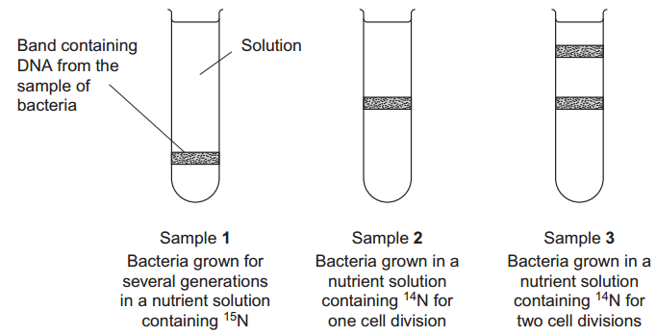

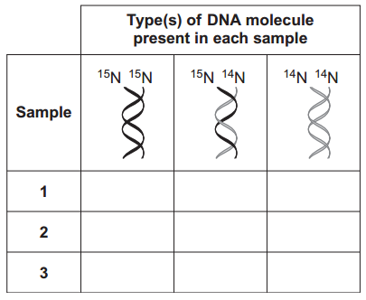**The table shows the types of DNA molecule that could be present in samples 1 to 3. Use your knowledge of semi-conservative replication to complete the table with a tick if the DNA molecule is present in the sample.**

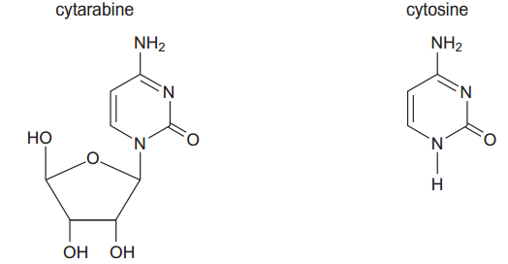**Cytarabine is a drug used to treat certain cancers. It prevents DNA replication. The diagram shows the structures of cytarabine and the DNA base cytosine.**

**Use information in the diagram to suggest how cytarabine prevents DNA replication.**

Similar shape/structure (to cytosine) / added instead of cytosine / binds to guanine; Prevents (complementary) base pairing / prevents H-bonds forming / prevents formation of new strand / prevents strand elongation / inhibits/binds to (DNA) polymerase

**Cytarabine has a greater effect on cancer cells than on healthy cells. Explain why.**

(Cancer cells/DNA) divide/replicate fast(er)/ uncontrollably

1. **Give one way in which antibiotics can prevent the growth of bacteria.**

Prevent cell wall formation / cause (cell) lysis / inhibit ribosomes / inhibit protein synthesis / prevent DNA replication / affect function of cell membrane

**Describe how bacteria can become resistant to antibiotics by vertical gene transmission.**

(Plasmid/genes transmitted through) cell division/reproduction/replication/generations

**Pseudomonas aeruginosa is a bacterium that can cause infections in hospital patients suffering from burns. Disinfectants are substances used to kill bacteria on non-living objects, such as medical equipment. Doctors in one hospital investigated how effective four disinfectants were at killing P. aeruginosa. The doctors: took samples from many patients in the hospital, isolated P. aeruginosa from those samples, suspended the P. aeruginosa in a solution, spread many samples of this solution on nutrient jelly in many Petri dishes. The doctors then placed five small paper discs on the jelly in each dish. Each disc had been soaked in a different disinfectant or sterile water. The doctors left the plates for 24 hours to allow bacteria to grow and divide. The diagram 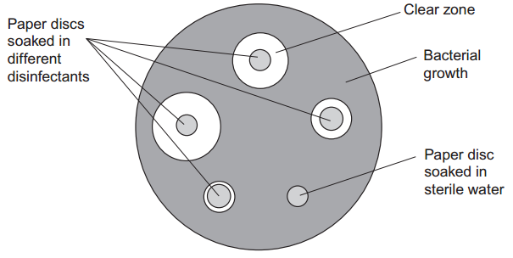shows a typical Petri dish after 24 hours.**

**The doctors used samples of this bacterium taken from many patients in the hospital. Explain why this was important.**

Representative/typical/reliable / different types of bacteria;

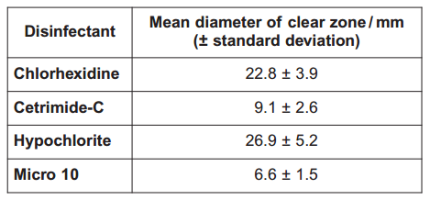**After 24 hours, the doctors measured the diameter of any clear zones around each paper disc. They then calculated the mean diameter of the clear zone for each disinfectant. The table shows their results.**

**Do these data support the conclusion that hypochlorite was the most effective at killing this bacterium? Explain your answer.**

(Yes) Largest clear zone/diameter/mean (so more bacteria killed); (No) Standard deviations of chlorhexidene overlap/share values; (Overlap means difference) is not significant / is due to chance

**Doctors in a different hospital repeated this investigation. They found that hypochlorite had little effect on samples of P. aeruginosa they obtained. Suggest how this different result may have arisen.**

Mutation (in bacterium); Gene/allele for resistance

1. 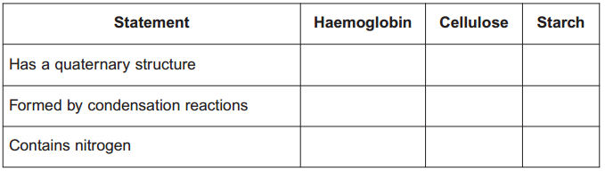**The table shows three statements about some biological molecules. Complete the table with a tick in each box if the statement is true for haemoglobin, cellulose or starch.**

**The graph shows oxygen dissociation curves for the haemoglobin of a mother and her fetus.**

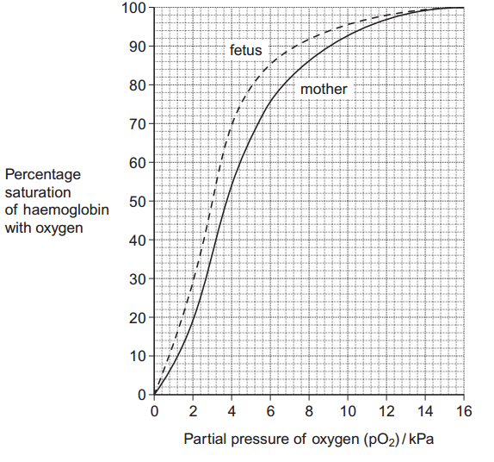**What is the difference in percentage saturation between the haemoglobin of the mother and her fetus at a partial pressure of oxygen (pO2) of 4 kPa?**

16

**The oxygen dissociation curve of the fetus is to the left of that for its mother. Explain the advantage of this for the fetus.**

Higher affinity / loads more oxygen; At low/same/high partial pressure/pO2; Oxygen moves from mother/to fetus

**After birth, fetal haemoglobin is replaced with adult haemoglobin. Use the graph to suggest the advantage of this to the baby.**

Low affinity / oxygen dissociates; (Oxygen) to respiring tissues/muscles/cells

**Hereditary persistence of fetal haemoglobin (HPFH) is a condition in which production of fetal haemoglobin continues into adulthood. Adult haemoglobin is also produced. People with HPFH do not usually show symptoms. Suggest why.**

Enough adult Hb produced / enough oxygen released / idea that curves/affinities/Hb are similar / more red blood cells produced

1. **The Amish are a group of people who live in America. This group was founded by 30 Swiss people, who moved to America many years ago. The Amish do not usually marry people from outside their own group. One of the 30 Swiss founders had a genetic disorder called Ellis-van Creveld syndrome. People with this disorder have heart defects, are short and have extra fingers and toes. Ellis-van Creveld syndrome is caused by a faulty allele. In America today, about 1 in 200 Amish people are born with Ellis-van Creveld syndrome. This disorder is very rare in people in America who are not Amish. Use the information provided and your knowledge of the founder effect to explain why Ellis-van Creveld syndrome occurs at a higher frequency in the Amish population than in people in America who are not Amish.**

Population formed by a small number of founders/people /30 people; (Founders show) less genetic diversity / small(er) gene pool / less variety of alleles. Individuals breed within group / do not breed with outsiders; High(er) chance of inheriting allele (than in non-Amish population)

**In America today, there are approximately 1250 Amish people who have Ellis-van Creveld syndrome. Use the information provided to calculate the current Amish population of America.**

250,000

**The faulty allele that causes Ellis-van Creveld syndrome is the result of a mutation of a gene called EVC. This mutation leads to the production of a protein that has one amino acid missing. Suggest how a mutation can lead to the production of a protein that has one amino acid missing.**

Loss of 3 bases/triplet

**Suggest how the production of a protein with one amino acid missing may lead to a genetic disorder such as Ellis-van Creveld syndrome.**

Change in tertiary structure/ active site; (So) faulty/non-functional protein /enzyme

**Explain how water enters xylem from the endodermis in the root and is then transported to the leaves.**

(In the root) Casparian strip blocks apoplast pathway / only allows symplast pathway; Active transport by endodermis; (Of) ions/salts into xylem; Lower water potential in xylem / water enters xylem by osmosis /down a water potential gradient; (Xylem to leaf) Evaporation / transpiration (from leaves); (Creates) cohesion / tension / H-bonding between water molecules / negative pressure; Adhesion / water molecules bind to xylem; (Creates continuous) water column

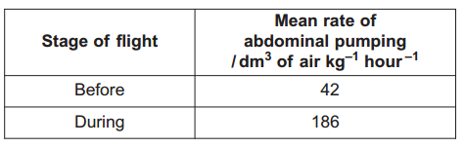**Large insects contract muscles associated with the abdomen to force air in and out of the spiracles. This is known as ‘abdominal pumping’. The table shows the mean rate of abdominal pumping of an insect before and during flight**

**Calculate the percentage increase in the rate of abdominal pumping before and during flight.**

342.8 or 343

**Abdominal pumping increases the efficiency of gas exchange between the tracheoles and muscle tissue of the insect. Explain why.**

More air/oxygen enters / air/oxygen enters quickly/quicker; (So) maintains/greater diffusion or concentration gradient;

**Abdominal pumping is an adaptation not found in many small insects. These small insects obtain sufficient oxygen by diffusion. Explain how their small size enables gas exchange to be efficient without the need for abdominal pumping.**

Large(r) surface area to volume ratio / short(er) diffusion distance (to tissues)

**The graph shows the concentration of oxygen inside the tracheoles of an insect when at rest. It also shows when the spiracles are fully open.**

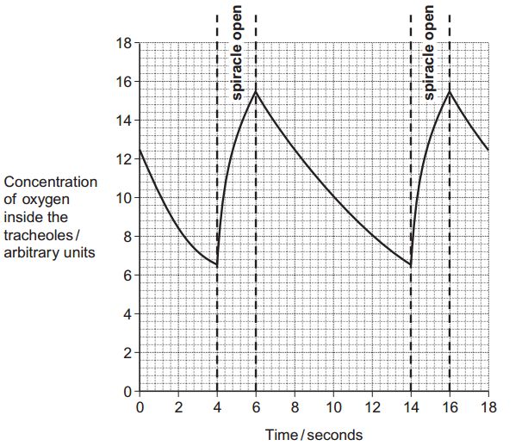**Use the graph to calculate the frequency of spiracle opening.**

6 to 8

**The insect opens its spiracles at a lower frequency in very dry conditions. Suggest one advantage of this.**

Less/no water lost / (more) water retained

**The ends of tracheoles connect directly with the insect’s muscle tissue and are filled with water. When flying, water is absorbed into the muscle tissue. Removal of water from the tracheoles increases the rate of diffusion of oxygen between the tracheoles and muscle tissue. Suggest one reason why.**

Greater surface area exposed to air; Gases move/diffuse faster in air than through water; Increases volume/amount of air

1. **Snakes are predators that lay eggs. Scientists investigated courtship behaviour in male garter snakes in response to: the body length of the female and lipids secreted on the skin of the female. For each trial, the scientists selected 10 male snakes at random. They placed the snakes into a large cage. The scientists then placed one of the following into the cage with the male snakes:**
2. **a short female snake**
3. **a long female snake**
4. **a piece of filter paper containing lipids from the skins of short females**
5. **a piece of filter paper containing lipids from the skins of long females.**

**After 5 minutes, the scientists recorded how many males were showing courtship behaviour. Each trial was repeated several times using different male and female snakes. Apart from the size of the female, suggest two factors that should have been kept constant in order to obtain reliable results.**

Volume/concentration of skin lipid; Age/sexual maturity; Species of snake; Size of male; Colour; Temperature; Light; Time of day/year/breeding season; Duration/length of time observing; Diet; Filter paper; Size of cage

**The male snakes used for each trial were selected at random. Explain why this was important.**

To avoid bias

**The scientists used different male snakes in each trial. Suggest why.**

To avoid change in (courtship) behaviour (due to past experience); To observe a typical/general/representative (response)

**What should the scientists have placed in the cage as a control, to show that males were responding to lipids from females?**

Filter paper without (skin) lipids / untreated filter paper / filter paper with water / (female) snakes with lipids removed

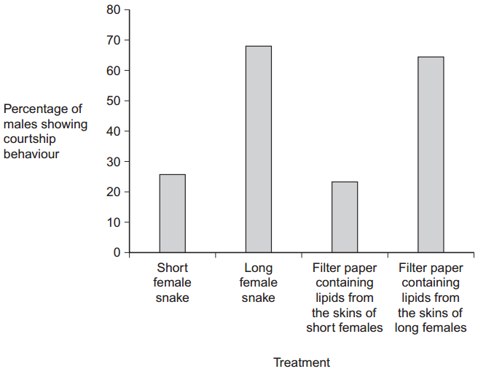**Figure 3 shows the scientists’ results.**

**The scientists concluded that male snakes showed more courtship behaviour towards long female snakes and to lipids from the skins of long females. Explain one other conclusion that can be made from the data.** 

Similar response to lipids and (whole) snakes; (So males are) responding to lipids; (So males are) not responding to (whole) snakes/visual clues



**Suggest two advantages of male snakes courting with longer females.**

(Parent/offspring) Produce more/larger offspring/eggs; Better predators / fitter / more successful at gaining food / less likely to be eaten / more able to protect offspring/eggs; (More) sexually mature / fertile; Have more food stores for offspring/eggs

**The scientists analysed the lipids produced on the skins of females of different lengths. They found the percentage of unsaturated fatty acids present in the lipids. Their results are shown in Figure 4.**

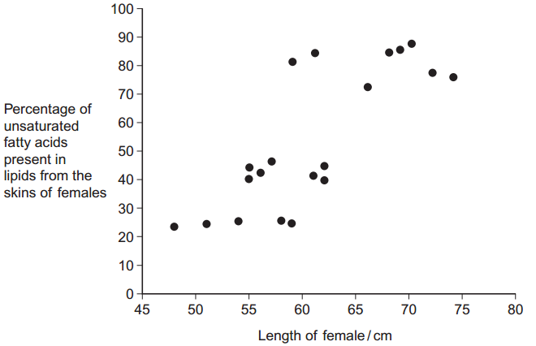**Use Figure 3 and Figure 4 to suggest why male garter snakes show greater courtship behaviour to longer female snakes.**

(Males) respond to/sense (unsaturated) fatty acids; (Long females) produce/have more fatty acids / positive correlation

**Describe how Figure 4 could be used to predict the percentage of unsaturated fatty acids produced by female garter snakes of body length greater than 75 cm.**

Draw a line of best fit; Extrapolation / extend line

**Using Figure 4 to predict the percentage of unsaturated fatty acids produced by female garter snakes of body length greater than 75 cm might not give a true value. Suggest why.**

Results vary for a particular body size/% / values overlap / small sample size / idea of reaching maximum/100%/ a plateau

**The females of other species of snake secrete lipids on their skin. These lipids also contain unsaturated fatty acids. Male garter snakes do not show courtship behaviour towards these females. Suggest why.**

(Other females/species) produce different fatty acids

1. **The table shows some statements about three carbohydrates. Complete the table with a tick in each box if the statement is true.**

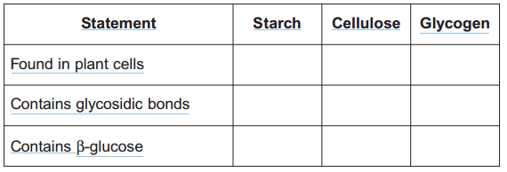

**Name the type of reaction that would break down these carbohydrates into their monomers.**

hydrolysis

**Give one feature of starch and explain how this feature enables it to act as a storage substance.**

Coiled / helical / spiral; (So) compact / tightly packed / can fit (lots) into a small space; Insoluble; (So) no osmotic effect / does not leave cell / does not affect water potential; Large molecule / long chain; (So) does not leave cell / contains large number of glucose units; Branched chains; 8. (So) easy to remove glucose

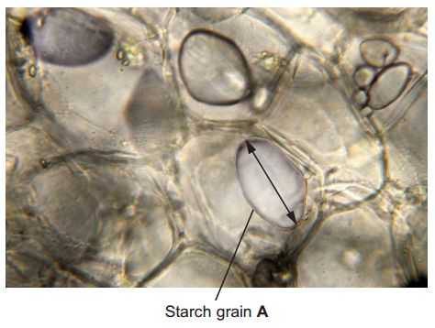**The picture shows starch grains as seen with an optical microscope. The actual length of starch grain A is 48 µm. Use this information and the arrow line to calculate the magnification of the picture.**

479 to 521 (divide measured length by actual length)

1. **An arteriole is described as an organ. Explain why.**

Made of (different) tissues / more than one tissue

**An arteriole contains muscle fibres. Explain how these muscle fibres reduce blood flow to capillaries.**

(Muscle) contracts; (Arteriole) narrows/constricts/reduces size of lumen/vessel / vasoconstriction

**A capillary has a thin wall. This leads to rapid exchange of substances between the blood and tissue fluid. Explain why.**

Short diffusion distance/pathway

**Blood flow in capillaries is slow. Give the advantage of this.**

(More) time for exchange/diffusion (of substances

**Kwashiorkor is a disease caused by a lack of protein in the blood. This leads to a swollen abdomen due to a build up of tissue fluid. Explain why a lack of protein in the blood causes a build up of tissue fluid.**

Water potential (in capillary) not as low/is higher/less negative / water potential gradient is reduced; Less/no water removed (into capillary); 3. By osmosis (into capillary)

1. **The scientific name of the leopard is Panthera pardus. Complete the table to show the classification of the leopard.**

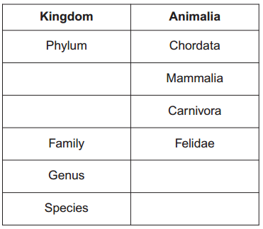**Leopards, cheetahs and pumas are all members of the family Felidae. Biologists used DNA hybridisation to investigate the evolutionary relationships between leopards, cheetahs and pumas. They found that hybrid DNA from a leopard and a cheetah separated into single strands at a higher temperature than hybrid DNA from a leopard and a puma. These results suggest that leopards are more closely related to cheetahs than to pumas. Explain why.**

order

**P**anthera

pardus

class

(For the leopard and cheetah) More hydrogen bonds (form); Similar DNA sequence(s) / similar base sequence(s) / more complementary bases / more base pairs

**All modern cheetahs are thought to have descended from a single female. This female was part of a small population that survived an ice age a long time ago that killed almost all cheetahs. After the ice age, the number of cheetahs increased. Use this information to explain what is meant by a genetic bottleneck.**

Drop in population / many killed / only single female left; Idea of reduced/low genetic variation/diversity / reduction in (variety of) alleles / smaller gene pool

**The fertility of cheetahs is low. The proportion of abnormal sperm cells produced is higher in cheetahs than in other members of the family Felidae. Suggest an explanation for this.**

Mutation affecting sperm cell or production (in small population); Errors during meiosis; Inbreeding / closely related cheetahs breed; High chance of inheriting allele / high frequency of allele (in the population)

1. **What is intraspecific variation?**

Variation / differences within the same/a species;

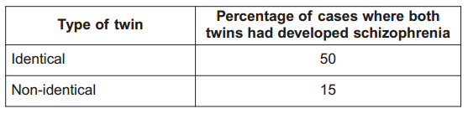**Schizophrenia is a mental illness. Doctors investigated the relative effects of genetic and environmental factors on the development of schizophrenia. They used sets of identical twins and non-identical twins in their investigation. At least one twin in each set had developed schizophrenia. Identical twins are genetically identical. Non-identical twins are not genetically identical. The members of each twin pair were raised together. The table shows the percentage of cases where both twins had developed schizophrenia**

**Explain why both types of twin were used in this investigation.**

Identical twins show genetic influence / differences between them show environmental influence; Non-identical twins (also) show an environmental/non-genetic influence

**What do these data suggest about the relative effects of genetic and environmental factors on the development of schizophrenia?**

Genes play a greater role / environment plays a lesser role;

**Suggest two factors that the scientists should have taken into account when selecting the twins to be used in this study.**

Age; Sex (non-identical twins); Family/medical history (of mental illness); No use of recreational drugs; 5. Ethnic origins

1. 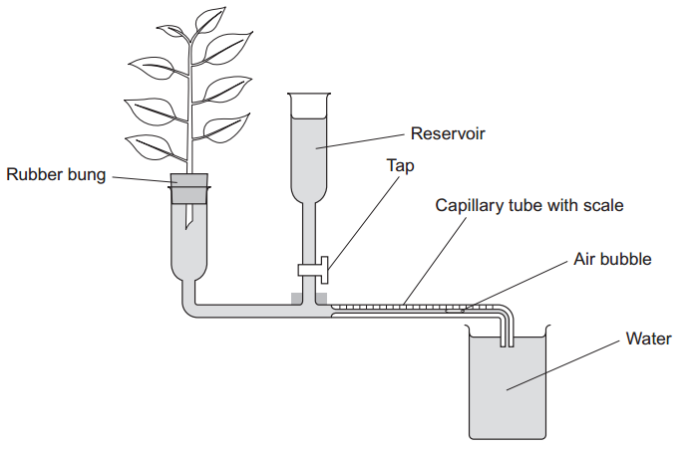**Students investigated the effect of removing leaves from a plant shoot on the rate of water uptake. Each student set up a potometer with a shoot that had eight leaves. All the shoots came from the same plant. The potometer they used is shown in the diagram**

**Describe how the students would have returned the air bubble to the start of the capillary tube in this investigation.**

Open/use tap / add water from reservoir

**Give two precautions the students should have taken when setting up the potometer to obtain reliable measurements of water uptake by the plant shoot.**

Seal joints / ensure airtight / ensure watertight; Cut shoot under water; Cut shoot at a slant; Dry off leaves; Insert into apparatus under water; Ensure no air bubbles are present; Shut tap; Note where bubble is at start / move bubble to the start position

**A potometer measures the rate of water uptake rather than the rate of transpiration. Give two reasons why the potometer does not truly measure the rate of transpiration.**

Water used for support/turgidity; Water used in photosynthesis; Water produced in respiration; Apparatus not sealed/’leaks’

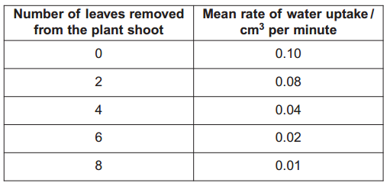**The students’ results are shown in the table.**

**Explain the relationship between the number of leaves removed from the plant shoot and the mean rate of water uptake.**

As number of leaves are reduced (no mark), Less surface area; Fewer stomata; Less evaporation/transpiration; Less cohesion/tension/pulling (force

1. **Mycolic acids are substances that form part of the cell wall of the bacterium that causes tuberculosis. Mycolic acids are made from fatty acids. Isoniazid is an antibiotic that is used to treat tuberculosis. The diagram shows how this antibiotic inhibits the production of mycolic acids in this bacterium.**

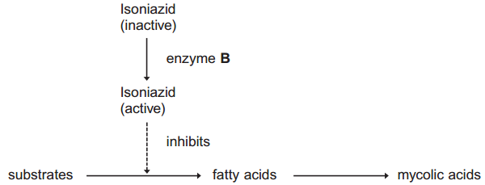**Treatment with isoniazid leads to the osmotic lysis of this bacterium. Use information in the diagram to suggest how.**

Cell wall not formed / production inhibited; Lower water potential in bacterium; Water enters and causes lysis/expansion/pressure

**Human cells also produce fatty acids. Isoniazid does not affect the production of these fatty acids. Use information in the diagram to suggest one reason why isoniazid does not affect the production of fatty acids in human cells.**

Human cells lack enzyme (B)/have a different enzyme/produce different fatty acids/use different substrates

**A mutation in the gene coding for enzyme B could lead to the production of a non-functional enzyme. Explain how.**

Change in base sequence (of DNA/gene); Change in amino acid sequence / primary structure (of enzyme); Change in hydrogen/ionic/ disulphide bonds; Change in the tertiary structure/active site (of enzyme); Substrate not complementary/cannot bind (to enzyme / active site) / no enzyme-substrate complexes form

**Using isoniazid to treat diseases caused by other species of bacteria could increase the chance of the bacterium that causes tuberculosis becoming resistant to isoniazid. Use your knowledge of gene transmission to explain how.**

Resistance gene/allele; On plasmid; (Spread by) horizontal transmission; (Involves) conjugation/pilus

1. **There are ethical and economic arguments for maintaining biodiversity. Suggest one ethical argument for maintaining biodiversity.**

(We should maintain biodiversity to) Prevent extinction /loss of populations/ reduction in populations /loss of habitats / save organisms for future generations (idea of)

**Suggest one economic argument for maintaining biodiversity.**

some species may be important financially e.g. medical / pharmaceutical uses; commercial products / example given; tourism; agriculture; saving local forest communities

**Ecologists calculated the percentage of bird species that have become extinct on six islands in the last one hundred years. They also calculated the percentage of original forest area remaining on each island after the same time period. The graph shows their results.**

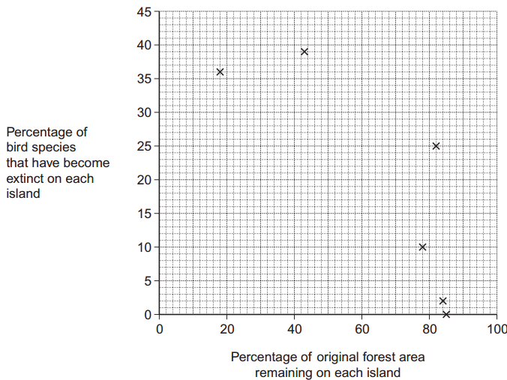**Explain the relationship between the percentage of original forest area remaining and the percentage of bird species that have become extinct.**

Fewer plant species / decrease in plant diversity; Fewer habitats/nesting sites; Fewer niches; Fewer food sources/varieties; Less protection from predators/ hunters/environment

**What two measurements would the ecologists have needed to obtain to calculate the index of diversity of birds on each island?**

Number of (individuals/birds of) each species; Total number of individuals/birds of all species

**The ecologists noted that the species of birds surviving on the coldest islands had a larger body size than those surviving on warmer islands. Explain how a larger body size is an adaptation to a colder climate.**

(Larger birds have) a low(er) surface area to volume ratio (So) less heat loss / more heat retained

1. **Describe how DNA is replicated.**

Strands separate / H-bonds break; DNA helicase (involved); Both strands/each strand act(s) as (a) template(s); (Free) nucleotides attach; Complementary/specific base pairing / AT and GC; DNA polymerase joins nucleotides (on new strand); H-bonds reform; 8. Semi-conservative replication / new DNA molecules contain one old strand and one new strand

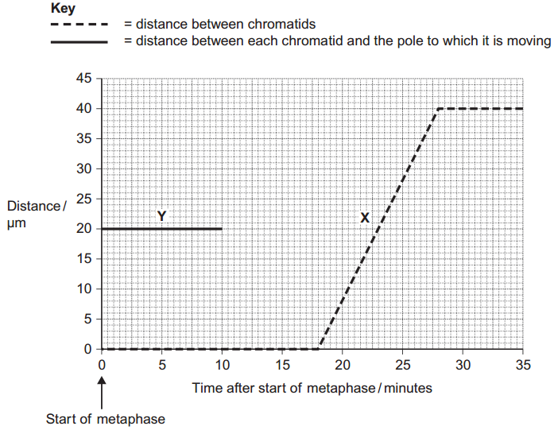**The graph shows information about the movement of chromatids in a cell that has just started metaphase of mitosis.**

**What was the duration of metaphase in this cell?**

18

**Use line X to calculate the duration of anaphase in this cell.**

10

**Complete line Y on the graph.**

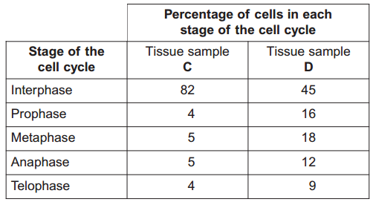**A doctor investigated the number of cells in different stages of the cell cycle in two tissue samples, C and D. One tissue sample was taken from a cancerous tumour. The other was taken from non-cancerous tissue. The table shows his results.**

**In tissue sample C, one cell cycle took 24 hours. Use the data in the table to calculate the time in which these cells were in interphase during one cell cycle.**

19.68

**Explain how the doctor could have recognised which cells were in interphase when looking at the tissue samples.**

No visible chromosomes/chromatids; Visible nucleus

**Which tissue sample, C or D, was taken from a cancerous tumour? Use information in the table to explain your answer.**

D - Lower % (of cells) in interphase / higher % (of cells) in mitosis/named stage of mitosis; (So) more cells dividing / cells are dividing quicker

1. **The ‘placebo effect’ describes the improvement in patients’ symptoms due to psychological effects. Scientists investigated the placebo effect in patients with asthma. They divided a large number of asthma patients into three groups, 1, 2 and 3. Group 1 inhaled a spray containing albuterol every day. Albuterol is a drug used to treat asthma. Group 2 inhaled a placebo spray every day. This was identical to the spray given to group 1 but it did not contain albuterol. Group 3 did not receive any spray treatment. Describe one way the scientists could have allocated the patients to each group.**

Random; Method e.g. number generator / number out of a hat; OR Matched / all the same; For e.g. age / sex

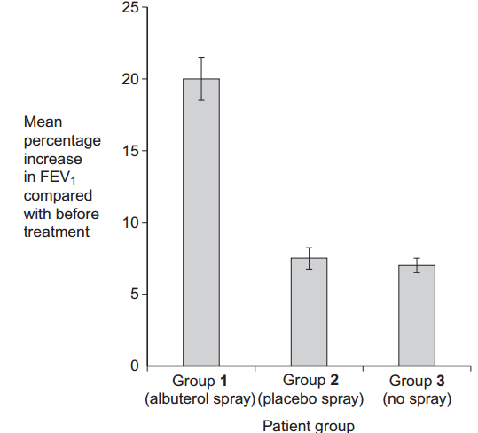**The scientists measured the forced expiratory volume (FEV1) of each patient at regular intervals. The forced expiratory volume (FEV1) is the volume of air forced out of the lungs in the first second when breathing out. The scientists recorded each patient’s FEV1 before treatment started and after 60 days of treatment. They then calculated the mean increase in FEV1 for each group. Their results are shown in the graph. The bars show the standard deviation.**

**What do the standard deviation bars suggest about the difference in the mean increase in FEV1 between Group 1 and the other groups? Explain your answer.**

(Differences) are real/significant/not due to chance; (As) bars/SDs do not overlap;

**What do the data suggest about the ‘placebo effect’ in this investigation? Explain your answer.**

No/slight (placebo) effect; Group 2 and 3 results are similar/the same/ SDs/bars overlap;

**On each occasion that a patient’s FEV1 was measured, a doctor repeated the measurement several times. Explain why.**

(Allows) anomalies to be identified/ ignored/ effect of anomalies to be reduced / effect of variation in data to be minimised / concordant results; (Makes) average/mean (more) reliable

**All the patients continued with their normal treatment for asthma. The normal treatment was the same for all patients and its effects were short-lived. The patients were told to stop this treatment 24 hours before FEV1 measurements were taken. Suggest why all the patients were allowed to continue with their normal asthma treatment in this investigation.**

Unethical/unfair not to treat patients; Dangerous / could cause an asthma attack

**Suggest why the patients were told to stop their normal asthma treatment 24 hours before their FEV1 measurements were taken.**

Ensures normal treatment does not affect results / improvements are only due to the spray; (As) normal treatment is short-lived/ effective for less than 24 hours/ (24h) is long enough for normal treatment to wear off

**After 60 days, the patients in each group were asked to give themselves an Improvement Score from 0 – 10 to show how much they felt their symptoms had improved. This was done before their FEV1 was measured. The scientists calculated the mean Improvement Score for each group. The scientists concluded that the data obtained for the Improvement Scores were less reliable than the data obtained measuring FEV1. Suggest why they concluded this.**

(Improvement scores) are qualitative / subjective/rely on own judgement/ different patients may assess symptoms differently; Some patients may lie/exaggerate/want to please doctors

**Group 3 reported the lowest mean Improvement Score. Suggest one explanation for this.**

Not blind / patients knew they were not receiving treatment/ patients did not receive treatment; (So) more likely to underestimate/give lower scores / did not expect to improve / less improvement;

1. **Flatworms are small animals that live in water. They have no specialised gas exchange or circulatory systems. Flatworm’s are extremely thin and only 6mn long. Name the process by which oxygen reaches the cells inside the body of this flatworm.**

Diffusion

**The body of a flatworm is adapted for efficient gas exchange between the water and the cells inside the body. Using the diagram, explain how two features of the flatworm’s body allow efficient gas exchange.**

(Thin / flat body) so short distance for diffusion / short diffusion pathway; (Thin / flat body so) large surface area to volume ratio;

**A leaf is an organ. What is an organ?**

A group of tissues

**Describe how carbon dioxide in the air outside a leaf reaches mesophyll cells inside the leaf.** (Carbon dioxide enters) via stomata; (Stomata opened by) guard cells; Diffuses through air spaces; Down diffusion gradient

1. 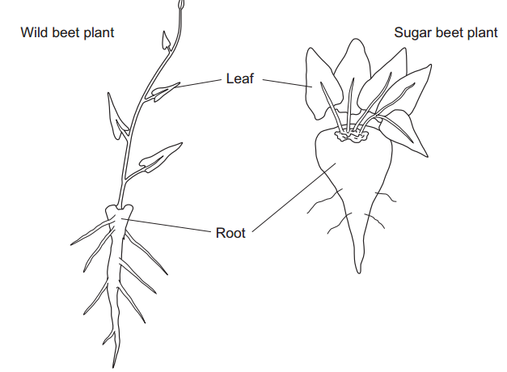**Sugar beet is a crop grown for the sugar stored in its root. The sugar is produced by photosynthesis in the leaves of the plant. Plant breeders selected high-yielding wild beet plants. They used these plants to produce a strain of sugar beet to grow as a crop. The drawings show a wild beet plant and a sugar beet plant. The drawings are to the same scale**

**Use the drawings to describe two ways in which a sugar beet plant is different from a wild beet plant. Explain how each of these differences would give an increased yield of sugar.**

Larger leaves; Photosynthesis; OR Larger/bigger/thicker root; Storage; OR Stem shorter / absent; Less energy used in stem growth / more energy for producing suga

**Sugar beet plants have been selected for a faster rate of growth. Suggest how the faster rate of growth may increase profit for a farmer.**

Beet ready quicker / less time required / allows land to be used again / harvested earlier

**Describe and explain how selection will have affected the genetic diversity of sugar beet.**

(Diversity) reduced / fewer different alleles / less variation / smaller gene pool; As alleles have been chosen / rejected

1. 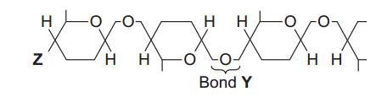**The diagram shows one end of a cellulose molecule.**

**Name the monomers that form a cellulose molecule.**

β/Beta glucose

**Name bond Y.**

Glycosidic

**What chemical group is at position Z?**

OH / hydroxyl / HO;

**Complete the table to show two ways in which the structure of cellulose is different from the structure of starch.**

* Unbranched/straight
* Alternate glucose monomers upside down
* Straight
* Beta glucose
* Fibrils/fibres
* Hydrogen bonds between cellulose molecules
* Branching
* All glucose monomers are the same way up
* Helix/coiled/compact
* Alpha glucose
* No fibrils/fibres
* Hydrogen bonds within starch

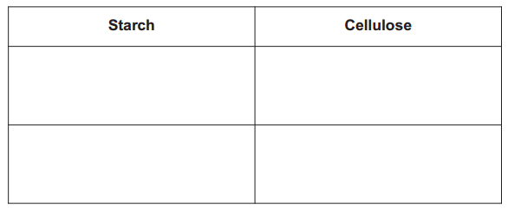

**Explain one way in which the structure of cellulose is linked to its function.**

H-bonds / micro/macro fibrils /fibres; Strength / rigidity / inelasticity

1. **Mitosis is important in the life of an organism. Give two reasons why.**

Growth / increase in cell number; Replace cells / repair tissue / organs /body; Genetically identical cells; Asexual reproduction /cloning

**A biologist used a microscope to investigate plant tissue where some of the cells were dividing by mitosis. She examined 200 cells and counted the number of cells in interphase and in each stage of mitosis. The table shows some of the cells she saw, and the percentage of cells in interphase and in two stages of mitosis, A and B.**

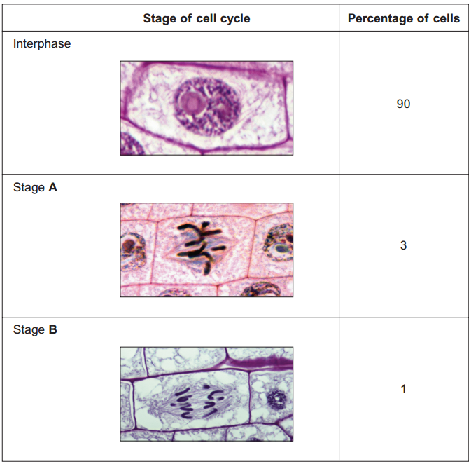**Explain why the biologist chose to examine 200 cells.**

(Ensures) representative (sample)

**Name Stage A and Stage B. Give the evidence from the photograph that you used to identify the stage.**

A = metaphase; Chromosome / chromatids lie on equator; B = anaphase; Chromatids /chromosomes separating / moving apart / moving to poles

**In this tissue one complete cell cycle took 20 hours. Using information from the table, calculate the mean time for these cells to complete mitosis.**

120 minutes (2 hours)

1. 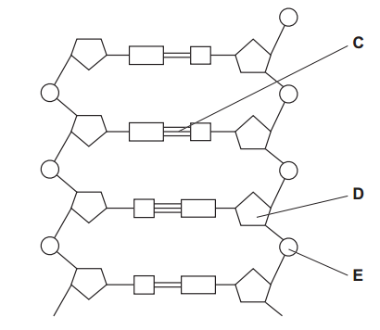**The diagram shows part of a DNA molecule.**

**DNA is a polymer. What is the evidence from the diagram that DNA is a polymer?**

Repeating units / nucleotides / monomer /molecules;

**Name the parts of the diagram labelled C, D and E. Part C**

C = hydrogen bonds

D = deoxyribose

E = phosphate

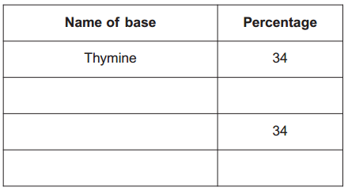**In a piece of DNA, 34% of the bases were thymine. Complete the table to show the names and percentages of the other bases.**

16

Cytosine/Guanine

Adenine 

16

Cytosine/guanine

**A polypeptide has 51 amino acids in its primary structure. What is the minimum number of DNA bases required to code for the amino acids in this polypeptide?**

153

**The gene for this polypeptide contains more than this number of bases. Explain why.**

Some regions of the gene are non-coding / introns / start/stop code/triplet / there are two DNA strands

1. **Hummingbirds belong to the order Apodiformes. One genus in this order is Topaza. Name one other taxonomic group to which all members of the Apodiformes belong.**

Kingdom / phylum / class

**Name the taxonomic group between order and genus.**

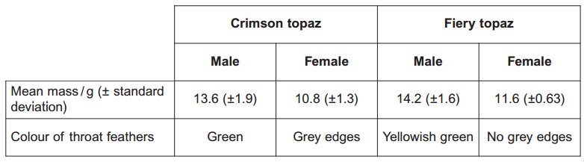Family

**The crimson topaz and the fiery topaz are hummingbirds. Biologists investigated whether the crimson topaz and the fiery topaz are different species of hummingbird, or different forms of the same species. They caught large numbers of each type of hummingbird. For each bird they recorded its sex, recorded its mass, recorded the colour of its throat feathers and took a sample of a blood protein. The table shows some of their results**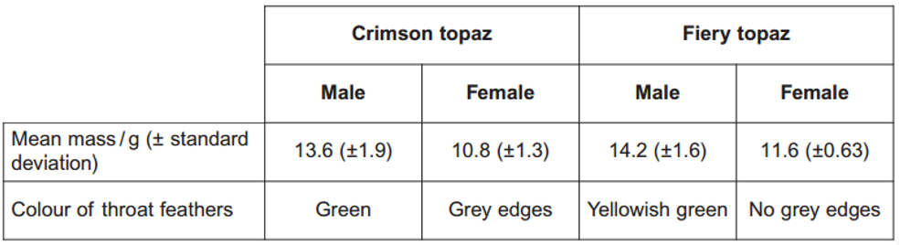

**Explain how the standard deviation helps in the interpretation of these data.**

Shows the spread of the data / how data varies; Overlap = no difference / due to chance / not significant; Low SD means results more reliable / repeatable

**In hummingbirds throat colour is important in courtship. Explain the evidence in the table that shows that the crimson topaz and the fiery topaz may be different species of hummingbird.**

Different colour/different feathers/different throat; Birds don't mate/pair bond with/recognise other species

**The biologists analysed the amino acid sequences of the blood protein samples from these hummingbirds. Explain how these sequences could provide evidence as to whether the crimson topaz and the fiery topaz are different species.**

Different species would have different amino acid sequences; Amino acid sequence is the result of DNA/alleles//base sequence

1. 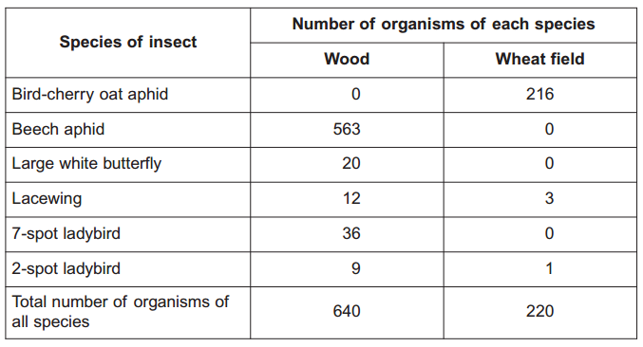**Scientists investigated the species of insects found in a wood and in a nearby wheat field. The scientists collected insects by placing traps at sites chosen at random both in the wood and in the wheat field. The table shows the data collected in the wood and in the wheat field.**

**The scientists collected insects at sites chosen at random. Explain the importance of the sites being chosen at random.**

Removes bias



**Use the formula**

**to calculate the index of diversity for the insects caught in the wood, where d = index of diversity N = total number of organisms of all species n = total number of organisms of each species**

1.28 to 1.3

**Without carrying out any further calculations, estimate whether the index of diversity for the wheat field would be higher or lower than the index of diversity for the wood. Explain how you arrived at your answer.**

Diversity index would be lower (NO MARK) Fewer species / Beech aphid/Large white butterfly/7-spot ladybird absent /only three species / species diversity lower; Mostly one species / mostly birdcherry aphid; Fewer plant species

**A journalist concluded that this investigation showed that farming reduces species diversity. Evaluate this conclusion.**

For: Data support the claim / evidence supports claim; Against: Only wheat field / only comparing with wood / one type of habitat /only insects considered

**Farmers were offered grants by the government to plant hedges around their fields. Explain the effect planting hedges could have on the index of diversity for animals.**

Greater variety of plants; Another habitat / more habitats / places to live / niches; Another food source / more food types

**Scientists measured the rate of water flow and the pressure in the xylem in a small branch. Their results are shown in the graph.**

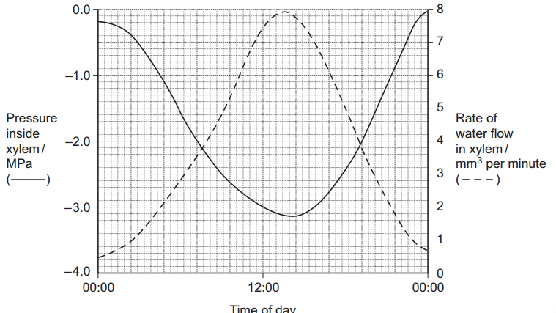**Use your knowledge of transpiration to explain the changes in the rate of flow in the xylem shown in the graph.**

Stomata open; Transpiration highest around midday; Middle of day warmer / lighter; (Increased) tension / water potential gradient; Cohesion (between water molecules)

**Explain why the values for the pressure in the xylem are negative.**

(Inside xylem) lower than atmospheric pressure / (water is under) tension;

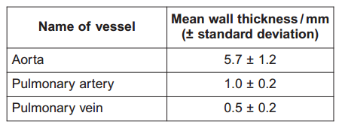**Doctors measured the thickness of the walls of three blood vessels in a large group of people. Their results are given in the table.**

**Explain the difference in thickness between the pulmonary artery and the pulmonary vein.**

High pressure / smoothes out blood flow / artery wall contains more collagen / muscle / elastic (fibres) / connective tissue

**The thickness of the aorta wall changes all the time during each cardiac cycle. Explain why.**

(Aorta wall) stretches; Because ventricle/heart contracts / systole / pressure increases; (Aorta wall) recoils; Because ventricle relaxes / heart relaxes /diastole / pressure falls; Maintain smooth flow / pressure

**Which of the three blood vessels shows the greatest variation in wall thickness? Explain your answer.**

Aorta 1.2 / largest SD

**Describe how tissue fluid is formed and how it is returned to the circulatory system.**

Formation - High blood / hydrostatic pressure / pressure filtration; Forces water / fluid out; Large proteins remain in capillary; Return - Low water potential in capillary / blood; Due to (plasma) proteins; Water enters capillary / blood; (By) osmosis; Correct reference to lymph

1. **Staphylococcus aureus is a bacterium that causes disease in humans. Scientists carried out an investigation to find the most effective concentration of antibiotic to treat this disease. The scientists put equal volumes of a culture of S. aureus in five flasks. They added nothing further to one flask. This was the control. They added different concentrations of antibiotic to the other four flasks. The scientists incubated all the flasks at 35C for 3 hours. They then estimated the number of living bacteria in each flask. The flasks were incubated at 35 oC. Suggest why they were incubated at this temperature.**

Fastest rate of growth/division / enzymes don't denature / optimum temperature for enzymes / at or close to body temperature

**The scientist put the same volume of bacterial culture into each flask. Explain why.**

Same amount / number of bacteria / only one variable in the investigation

**What was the purpose of the control flask?**

To show that only the antibiotic has an effect (on the bacteria)

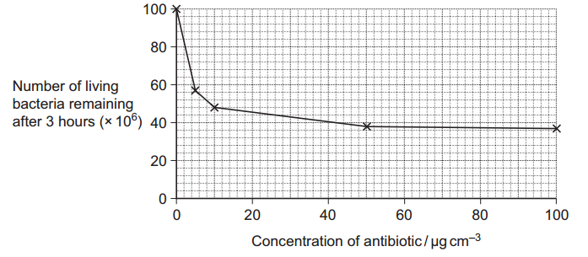**The graph shows the scientists’ results.**

**Describe the pattern of results shown in the graph.**

Falls steeply then levels out / less steep; Fall is less steep after 5-10(µg cm-3 / levels out at / after 50µgcm-3

**A student concluded from these results that an antibiotic dose equivalent to 50 µg cm–3 would be the most effective in treating disease caused by S. aureus. Evaluate his conclusion.**

50 (µg cm-3 ) reduced bacterial growth more (than lower concentrations); Trial did not use people; Very little / no effect after 50 (µg cm-3 ); Other concentrations not tested

**Give two ways in which a bacterium could become resistant to an antibiotic.**

Mutation; Horizontal transmission / conjugation

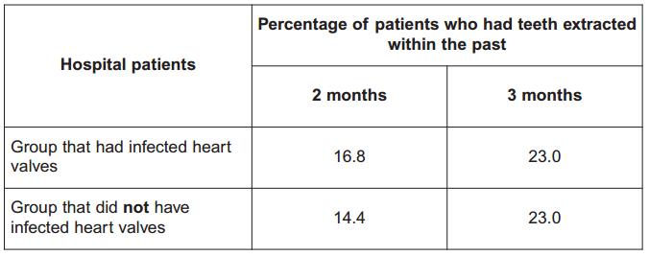**S. aureus lives inside people’s mouths. Some dentists believe that this bacterium can get into the blood of people who have had teeth extracted and infect their heart valves. Doctors carried out a survey to find out whether there was a risk of developing infected heart valves after tooth extraction. They asked patients whether they had had any teeth extracted in the last 2 or 3 months. They collected this information from patients who had infected heart valves. They also collected this information from the same number of other patients who did not have infected heart valves. The information is summarised in the table.**

**The people chosen to be included in the survey were all of a similar age. Suggest why.**

Age affects immune system / heart / teeth

**Some dentists recommend a course of antibiotics when someone has a tooth extracted. Does the information in parts (b), (c) and (d) (the previous three questions) support this recommendation? Explain your answer.**

Antibiotic reduces number of bacteria; (Survivors have) resistant gene/allele; (Resistant bacteria) reproduce/multiply; Valid reference to data at 2 months; (Infection) no difference at 3 months

1. 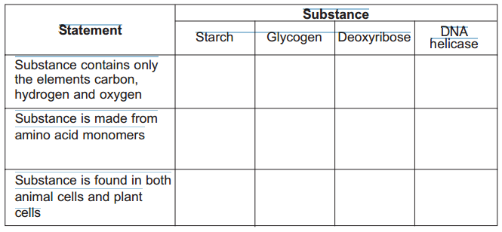**The table shows some substances found in cells. Complete the table to show the properties of these substances. Put a tick in the box if the statement is correct.**

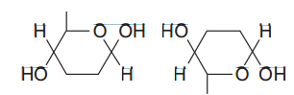**The diagram shows two molecules of β-glucose.**

**On the diagram, draw a box around the atoms that are removed when the two β-glucose molecules are joined by condensation.**

**Hydrogen bonds are important in cellulose molecules. Explain why.**

Holds chains/cellulose molecules together/forms cross links between chains/cellulose molecules/forms microfibrils; Providing strength/rigidity (to cellulose/cell wall); Hydrogen bonds strong in large number

**A starch molecule has a spiral shape. Explain why this shape is important to its function in cells.**

Compact/occupies small space/tightly packed

1. **What is the evidence that haemoglobin has a quaternary structure?**

More that one polypeptide/chain

**A gene codes for the α-polypeptide chain. There are 423 bases in this gene that code for amino acids. How many amino acids are there in the α-polypeptide chain?**

141

**The total number of bases in the DNA of the α-polypeptide gene is more than 423. Give two reasons why there are more than 423 bases.**

Stop/start sequences; Non coding DNA (in the gene)/introns/multiple repeats/junk DNA; Two chains/a non-coding strand/complementary base pairs; Addition of base by mutation

**The haemoglobin in one organism may have a different chemical structure from the haemoglobin in another organism. Describe how.**

Different primary structure/amino acids/different number of polypeptide chains

**The graph shows oxygen dissociation curves for horse haemoglobin and for llama haemoglobin. Horses are adapted to live at sea level and llamas are adapted to live in high mountains.**

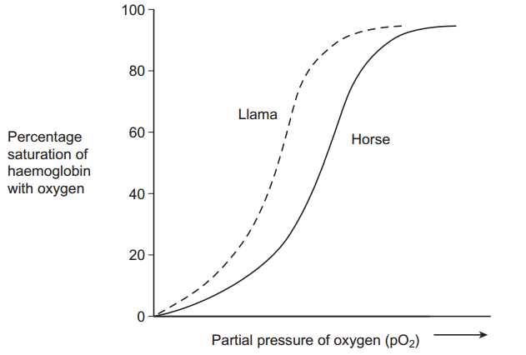**Use the graph to explain why llamas are better adapted to live in high mountains than horses.**

Low partial pressure of oxygen; In lungs; (Llama) haemoglobin able to load more oxygen/(llama) haemoglobin saturated (at low/particular partial pressure of oxygen); Higher affinity for oxygen;

1. **An order is a taxonomic group. Fruit flies and mosquitoes belong to the same order of insects. Name the other three taxonomic groups to which fruit flies and mosquitoes both belong.**

Kingdom, phylum and class

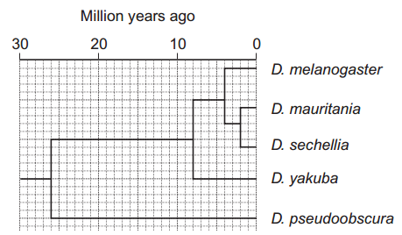**The diagram shows the phylogenetic relationship between five species of fruit fly that belong to the genus Drosophila.**

**Explain what is meant by a phylogenetic relationship.**

Shows evolutionary relationship

**How many million years ago did D. melanogaster and D. pseudoobscura last share a common ancestor?**

26

**Scientists used DNA hybridisation to confirm the relationship between D. mauritania, D. sechellia and D. yakuba. They made samples of hybrid DNA using a gene that was found in all three species. Explain why it was important that they made samples of hybrid DNA from the same gene.**

Base sequence will be similar/some bases in common; These bases will bind together/hydrogen bonds/complementary pairs;

**The hybrid DNA formed between D. mauritania and D. sechellia separated at a higher temperature than the hybrid DNA formed between D. mauritania and D. yakuba. Explain what caused the DNA to separate at a higher temperature.**

Relationship is closer/more complementary bases/more base pairs; More hydrogen bonds; More heat energy needed (to separate bonds);

1. 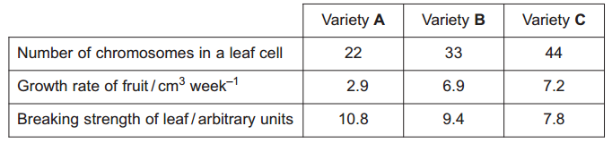**The table shows some differences between three varieties of banana plant**

**How many chromosomes are there in a male gamete from variety C?**

22

**Variety B cannot produce fertile gametes. Use information in the table to explain why.**

Odd number of chromosomes/33 chromosomes (in leaf cell); Chromosomes cannot pair/cannot undergo meiosis/would result in half chromosomes/cannot form haploid cells

**In some countries very strong winds may occur. Banana growers in these countries choose to grow variety B. Use the data in the table to explain why banana growers in these countries choose to grow variety B rather than variety A.**

Fast growth/ produces crop fast/produces large crop

**Use the data in the table to explain why banana growers in these countries choose to grow variety B rather than variety C.**

Leaves less likely to break/higher breaking strength

**Banana growers can only grow new variety B plants from suckers. Suckers grow from cells at the base of the stem of the parent plant. Use your knowledge of cell division to explain how growing variety B on a large scale will affect the genetic diversity of bananas.**

Low genetic diversity because they are produced by mitosis; Will all have the same DNA/genes/alleles/ will be genetically identical/will be clones; OR Low genetic diversity because they are not produced by meiosis; No crossing over/independent segregation/will not be genetically different

1. **What information is required to calculate an index of diversity for a particular community?**

Number of a/each (species)

**Farmers clear tropical forest and grow crops instead. Explain how this causes the diversity of insects in the area to decrease.**

Lower diversity of plants/ few species of plants/less variety of plants/few plant layers; Few sources/types of food/feeding sites; Few habitats/ niches; Fewer (species of) herbivore so few (species of) carnivores; Aspect of agriculture (killing insects)

**Farmers manage the ditches that drain water from their fields. If they do not, the ditches will become blocked by plants. Biologists investigated the effects of two different ways of managing ditches on farmland birds. • Ditch A was cleared of plants on both banks • Ditch B was cleared of plants on one bank. The graph shows the number of breeding birds of all species along the two ditches, before and after management.**

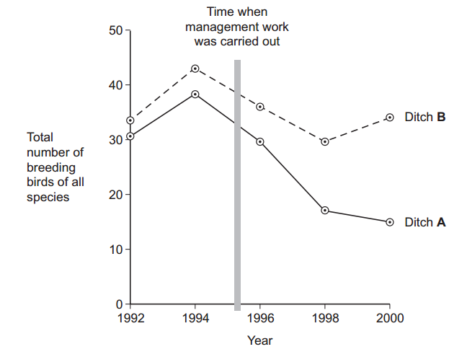**The points on the graph have been joined with straight lines rather than with a smooth curve. Explain why they have been joined with straight lines.**

Cannot predict/ do not know intermediate values

**It would have been useful to have had a control ditch in this investigation. Explain why.**

To see what would happen/ compare with no management work/ to see if numbers fell anyway/ To show that it was not a factor

**A farmer who wanted to increase the diversity of birds on his land read about this investigation. He concluded that clearing the plants from one bank would not decrease diversity as much as clearing the plants from both banks. Evaluate this conclusion.**

Total number of birds along ditch B/ditch with one side cleared greater than along ditch A/ditch with both sides cleared; But only gives data for all birds/does not give data for species/data not about diversity; Single ditch/single occasion/not repeated/no control

1. **Penicillins are antibiotics. Some bacteria produce an enzyme that breaks down one sort of penicillin. The gene that codes for this enzyme may be passed from one species of bacteria to another species. Describe how.**

Horizontal (gene) transmission; Gene passed by) conjugation/through pilus;

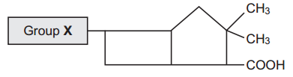**There are different sorts of penicillin. All of these have the same basic chemical structure shown in the diagram but group X is different.**

**A bacterial infection that cannot be treated with one sort of penicillin can be treated with a different sort. Use your knowledge of enzyme action to explain why the different sort of penicillin is effective in treating the infection.**

Shape - Different penicillin has different shape/structure/ enzyme/active site has specific shape/structure; Binding - No longer fits/binds to active site/not complementary to active site/does not form E-S complex; Consequence - (Different) penicillin not broken down

**Farmers often keep large numbers of cattle together. Farmers used to give cattle food which had antibiotics added to it. Suggest how adding antibiotics to the food of the cattle increased profit for the farmers.**

Kills pathogenic/harmful bacteria/pathogens; Disease less likely/improves health/animals healthier/reduces spread of infection; Faster growth/more productive animals/more food converted to meat/greater survival/lower vet’s bills/increased yield/less energy (for “fighting infection‟);

**Adding antibiotics to the food of cattle is now banned in many countries. Use your knowledge of selection to explain why adding antibiotics was banned.**

(Adding antibiotics) selects in favour of antibiotic resistance/resistant bacteria more likely to survive; Increase in numbers/higher proportion of resistant bacteria; May infect humans/may spread resistance to other species/ horizontal transfer

1. 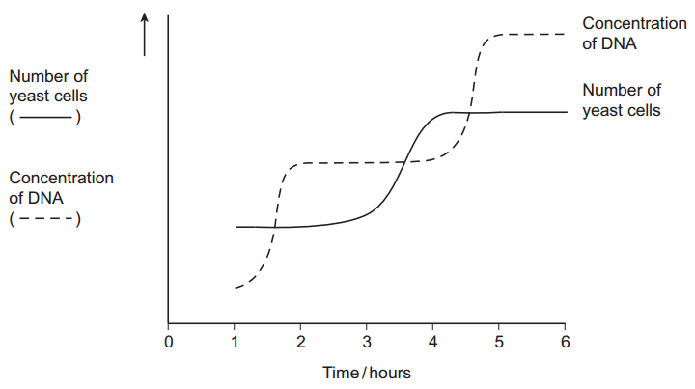**Yeast is a single-celled eukaryotic organism. When yeast cells are grown, each cell forms a bud. This bud grows into a new cell. This allows yeast to multiply because the parent cell is still alive and the new cell has been formed. Scientists grew yeast cells in a culture. They counted the number of cells present and measured the total concentration of DNA in the culture over a period of 6 hours. Their results are shown in the graph.**

**Use your knowledge of the cell cycle to explain the shape of the curve for the number of yeast cells**

1. **between 1 and 2 hours**

Cells are in interphase

1. **between 3 and 4 hours.**

Cells undergoing mitosis/in telophase/cytokinesis

**Use the curve for the concentration of DNA to find the length of a cell cycle in these yeast cells. Explain how you arrived at your answer.**

3 hours; Time between beginnings/endings DNA replication/Increases/levelling outs of DNA concentration/for shape (of curve for replication) to be repeated; (DNA) replication takes place once per cell cycle;

1. **Students measured the rate of transpiration of a plant growing in a pot under different environmental conditions. Their results are shown in the table.**

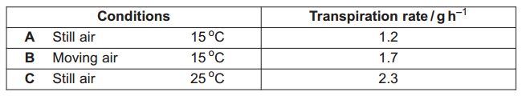**During transpiration, water diffuses from cells to the air surrounding a leaf. Suggest an explanation for the difference in transpiration rate between conditions A and B.**

Removes water vapour/moisture/saturated air; Increases water potential gradient/more diffusion/more evaporation

**Suggest an explanation for the difference in transpiration rate between conditions A and C.**

Increases kinetic energy; Water molecules move faster; Increases diffusion/evaporation

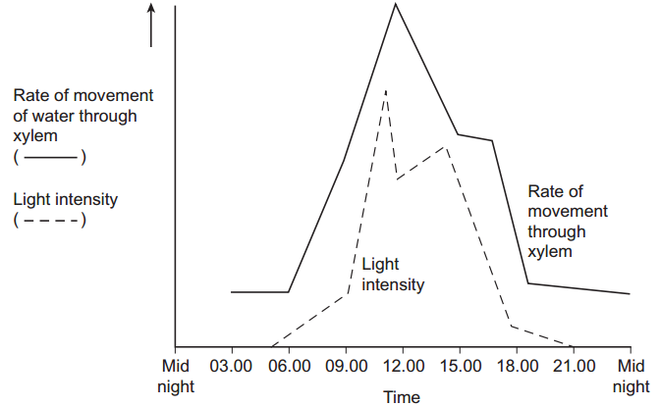**Scientists investigated the rate of water movement through the xylem of a twig from a tree over 24 hours. The graph shows their results. It also shows the light intensity for the same period of time.**

**Describe the relationship between the rate of water movement through the xylem and the light intensity.**

Positive correlation/as light intensity increases so does rate of water movement/follows same pattern/directly proportional;

**Explain the change in the rate of water movement through the xylem between 06.00 and 12.00 hours.**

Stomata open; Photosynthesis increases/transpiration increases; More water pulled up; Cohesion between water molecules/by cohesion tension;

**The scientists also measured the diameter of the trunk of the tree on which the twig had been growing. The diameter was less at 12.00 than it was at 03.00 hours. Explain why the diameter was less at 12.00 hours.**

Water pulled up trunk/moves up at fast rate; (Water column under) tension; Sticking/adhesion (between water and) cells/walls/xylem; Pulls xylem in

**Arteries and arterioles take blood away from the heart. Explain how the structures of the walls of arteries and arterioles are related to their functions.**

Elastic tissue - Elastic tissue stretches under pressure/when heart beats; Recoils/springs back;Evens out pressure/flow; Muscle - Muscle contracts; Reduces diameter of lumen/vasoconstriction/constricts vessel; Changes flow/pressure; Epithelium - Epithelium smooth; 8 Reduces friction/blood clots/less resistance

1. **Figure 1 shows a fresh-water shrimp.**

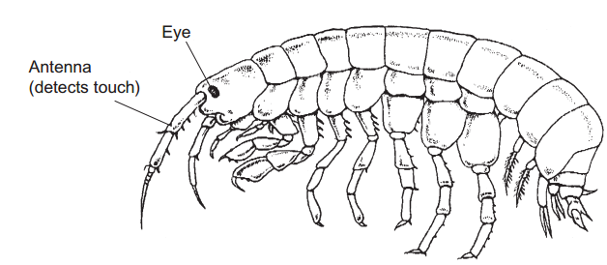**Biologists collected shrimps from a stream inside a cave and from the same stream when it was in the open. They measured the maximum diameter of each shrimp’s eye. They also measured the length of its antenna. From these measurements they calculated the mean values for each site. Figure 2 shows their results.**

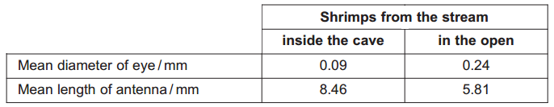**The biologists measured the maximum diameter of each shrimp’s eye. Explain why they measured the maximum diameter.**

(So results) can be compared/so measurement is the same each time/because eye is not perfectly round/uniform

**A scientist working many years earlier suggested that animals which live in caves had similar adaptations. These adaptations included • smaller eyes • greater use of sense organs such as those involved in detecting touch. Do the data in Figure 2 support this scientist’s suggestion? Explain your answer.**

Eye (diameter) is smaller and antennae longer; Antennae detecting touch; Data only refers to shrimps/data may not apply to all animals/only in one area

**The data in Figure 2 are mean values. Explain how standard deviations of these mean values would help you to interpret the data in Figure 2.**

Standard deviation gives a measure of spread/variation; More standard deviations overlap, the less likely it is that differences are real/significant/the more likely they are caused by chance;

**The biologists investigated shrimps living in other streams. They measured the length of the antennae of these shrimps. They also measured their body length. Figure 3 shows the mean antenna length plotted against mean body length for each site**

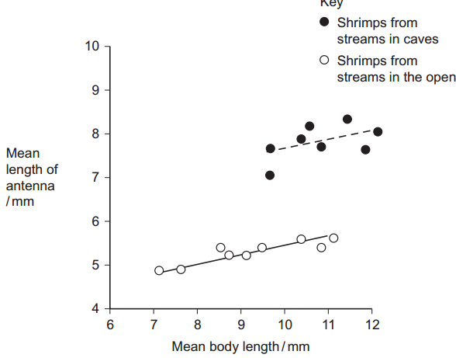**What does the information in the graph suggest about the body lengths of shrimps living in caves and living in the open?**

Qualitative statement about - difference in size/ difference in variation/ overlap in size; Quantitative statement about- difference in size/ difference in variation/ overlap in size; Supported by relevant two sets of figures from graph;;

**Do the data in the graph support the conclusion that shrimps with longer bodies have longer antennae? Give the reason for your answer.**

(No) for same body length, antenna are longer/antenna are shorter/some with longer body have short antennae/some with shorter body length have longer antennae; OR (Yes) positive correlation in open/in cave;

**Other biologists investigated the genetic diversity of these shrimps. Figure 4 shows some of the data they collected.**

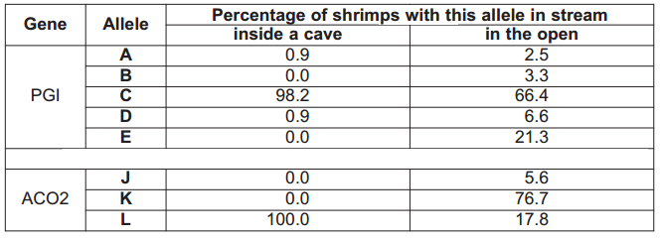**The biologists concluded that the shrimps in the open had a higher genetic diversity than those in the cave. Explain how the data in Figure 4 support this conclusion.**

More alleles of each gene/shrimps in open have all the alleles

**The percentage of shrimps with allele L in the cave is different from the percentage of shrimps with allele L in the open. Use your knowledge of the founder effect to suggest a reason for this difference.**

A small number of shrimps were /went into the cave; All/high proportion of shrimps had allele L; Cave population descended from these/these reproduce

**The biologists who studied these shrimps wanted to know if the shrimps living in the cave were the same species as those living in the open. They used breeding experiments to investigate this. Describe how the biologists should carry out these breeding experiments.**

Cross shrimps from two sites/watch courtship; Breed young together/observe mating; Allow 1 mark for any method of improving quality of results e.g. carry out reciprocal crosses/large number of crosses/isolate beforehand

**The results of breeding experiments would help the biologists to decide whether the shrimps were the same species. Explain how.**

If same species the shrimps would breed, producing fertile young/courtship species specific

1. **Give one feature of starch and explain how this feature enables it to act as a storage substance.**

Helical /spiral/coiled; Compact / description e.g. ‘tightly packed’; Insoluble; Prevents osmosis/uptake of water / does not affect water potential / (starch) does not leave cell; Large molecule / long chain; Does not leave cell

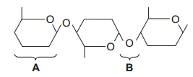

**The diagram shows part of a cellulose molecule.**

**Name part A.**

β/beta Glucose

**Name bond B.**

Glycosidic

**The structure of cellulose is related to its role in plant cell walls. Explain how.**

Long/straight/unbranched chains (of glucose); (Joined by) hydrogen bonds; Form (micro)fibrils/(macro)fibrils; Provide rigidity/strength/support

1. 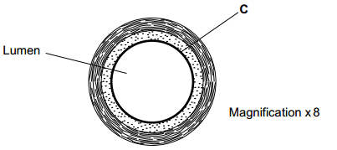**The diagram shows a cross-section of a blood vessel.**

**Name layer C.**

Endothelium/epithelium

**Calculate the actual diameter of the lumen of this blood vessel in millimetres.**

3 to 3.3 (measurement divided by 8)

**The aorta has many elastic fibres in its wall. An arteriole has many muscle fibres in its wall. Explain the importance of elastic fibres in the wall of the aorta.**

Stretches/’expands’ under high pressure/when ventricle contracts / systole; Recoils/’springs back’ under low pressure/when ventricle relaxes / diastole; Smooths blood flow / maintains blood pressure / reduces pressure surges

**Explain the importance of muscle fibres in the wall of an arteriole.**

(Muscle) contracts; (Arteriole) constricts / narrows/alters size of lumen / reduces/regulates blood flow (to capillaries)

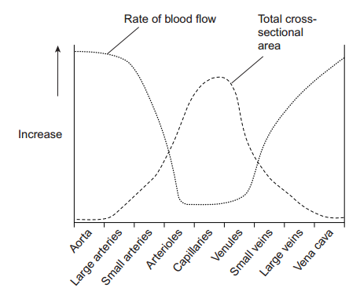**The graph shows the rate of blood flow in different blood vessels. It also shows the total cross-sectional area of these blood vessels.**

**The rate of blood flow decreases from the aorta to the capillaries. Use information from the graph to explain why.**

Large/increase in (total) cross sectional area / friction / resistance

**Efficient exchange of substances in the capillaries is linked to the rate of blood flow. Explain how.**

(More) time for exchange of substances

1. **What name is used for the non-coding sections of a gene?**

Introns

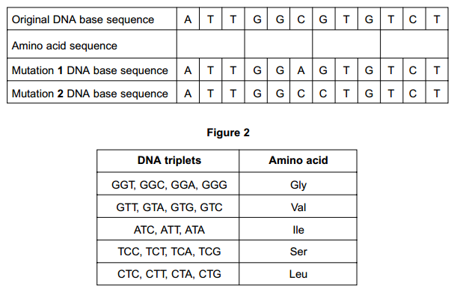**Figure 1 shows a DNA base sequence. It also shows the effect of two mutations on this base sequence. Figure 2 shows DNA triplets that code for different amino acids.**

lle gly val ser

**Complete Figure 1 to show the sequence of amino acids coded for by the original DNA base sequence.**

**Some gene mutations affect the amino acid sequence. Some mutations do not. Use the information from Figure 1 and Figure 2 to explain**

1. **whether mutation 1 affects the amino acid sequence**

Has no effect / same amino acid (sequence) / same primary structure; Glycine named as same amino acid

1. **how mutation 2 could lead to the formation of a non-functional enzyme.**

Leu replaces Val / change in amino acid (sequence)/primary structure; Change in hydrogen/ionic bonds; Alters tertiary structure/active site; Substrate cannot bind / no longer complementary / no enzyme-substrate complexes form

**Gene mutations occur spontaneously. During which part of the cell cycle are gene mutations most likely to occur?**

Interphase/ S/synthesis (phase

**Suggest an explanation for your answer.**

DNA/gene replication/synthesis occurs / longest stage

1. 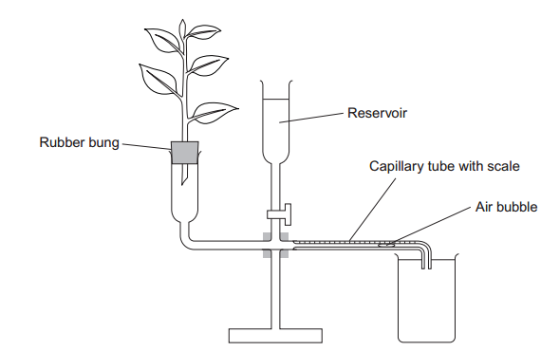**A student investigated the rate of transpiration from a leafy shoot. She used a potometer to measure the rate of water uptake by the shoot. The diagram shows the potometer used by the student.**

**Give one environmental factor that the student should have kept constant during this investigation.**

Light (intensity) / temperature / air movement / humidity

**The student cut the shoot and put it into the potometer under water. Explain why.**

Prevent air entering / continuous water column

**The student wanted to calculate the rate of water uptake by the shoot in cm3 per minute. What measurements did she need to make?**

Distance and time; Radius/diameter/area (of capillary tube);

**The student assumed that water uptake was equivalent to the rate of transpiration. Give two reasons why this might not be a valid assumption.**

(used to provide) turgidity/support/description of; (used in) photosynthesis / (produced in) respiration; Apparatus not sealed/’leaks’;

**The student measured the rate of water uptake three times. Suggest how the reservoir allows repeat measurements to be made.**

Returns bubble (to start)

**Suggest why she made repeat measurements.**

Increases reliability (of results) / anomalous result can be identified

1. 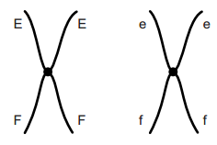**Figure 3 shows a pair of chromosomes at the start of meiosis. The letters represent alleles.**

**What is an allele?**

(Different) form/type/version of a gene / different base sequence of a gene

**Explain the appearance of one of the chromosomes in Figure 3.**

Two/sister chromatids; Due to DNA replication; Joined by a centromere;

**The cell containing this pair of chromosomes divided by meiosis. Figure 4 shows the distribution of chromosomes from this pair in four of the gametes produced**

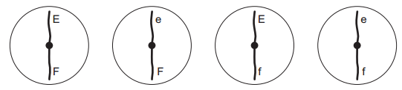

**Some of the gametes formed during meiosis have new combinations of alleles. Explain how the gametes with the combinations of alleles Ef and eF have been produced.**

Crossing over; Exchange (of alleles) between chromatids/chromosomes

**Only a few gametes have the new combination of alleles Ef and eF. Most gametes have the combination of alleles EF and ef. Suggest why only a few gametes have the new combination of alleles, Ef and eF.**

Is infrequent/rare

**Figure 5 shows a cell with six chromosomes.**

**How many different types of gametes could be produced from this cell as a result of different combinations of maternal and paternal chromosomes?**

8

1. **Cytochrome c is a protein found in all eukaryotes. In humans it consists of 102 amino acids. Biologists have compared the amino acid sequence in some other species with that in humans. The table shows amino acids 9 to 13 in the amino acid sequences of cytochrome c from four species.**

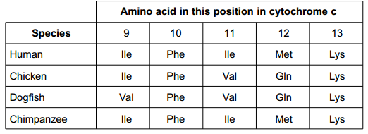

**What do the results suggest about the relationship between humans and the other three species?**

Most closely (related) to chimpanzee / most recent common ancestor; Least (related) to dogfish / least recent common ancestor

**Suggest one advantage of using cytochrome c to determine relationships between species.**

Is present in all eukaryotes

**Comparing the base sequence of a gene provides more information than comparing the amino acid sequence for which the gene codes. Explain why.**

Reference to base triplet/triplet code / more bases than amino acids / longer base sequence than amino acid sequence; Introns/non-coding DNA; Same amino acid may be coded for / DNA code is degenerate

1. 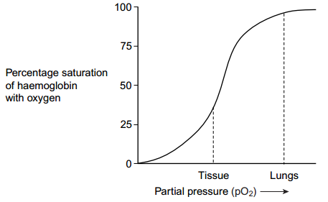**Figure 6 shows the oxygen dissociation curve for human haemoglobin.**

**Use Figure 6 to describe how haemoglobin loads and unloads oxygen in the body.**

Loading/uptake/association of oxygen at high p.O2; In lungs (haemoglobin) is (almost) fully saturated / in lungs haemoglobin has a high affinity for oxygen; Unloads/releases/dissociates oxygen at low p.O2; Unloading linked to higher carbon dioxide concentration

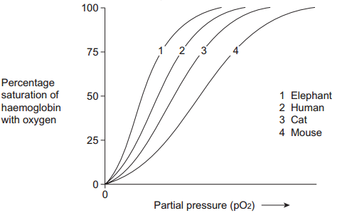**Figure 7 shows oxygen dissociation curves from mammals of different size.**

**Describe the relationship between the size of mammals and the oxygen dissociation curves of their haemoglobins.**

Larger the mammal the more to the left/steeper/’higher’ is the curve / the higher the affinity for oxygen

**Heat from respiration helps mammals to maintain a constant body temperature. Use this information to explain the relationship between the surface area to volume ratio of mammals and the oxygen dissociation curves of their haemoglobins.**

Smaller mammal has greater surface area to volume ratio; Smaller mammal/larger SA:Vol ratio more heat lost (per unit body mass); Smaller mammal/larger SA:Vol ratio has greater rate of respiration/metabolism; Oxygen required for respiration; (Haemoglobin) releases more oxygen / oxygen released more readily / haemoglobin has lower affinity

1. **The number of patients infected with the bacterium MRSA has increased in some hospitals. Scientists have suggested ways to reduce the transmission of MRSA in hospitals. Suggest two ways to reduce the transmission of MRSA in hospitals.**

Isolation / quarantine / ‘kept separate’; Screening/testing (of patients/doctors etc); Sterilisation of wards/equipment / method to improve hygiene

**The minimum inhibitory concentration (MIC) is the lowest concentration of a substance that prevents the growth of a microorganism. When antibiotics are prescribed for treating patients, higher doses than the MIC are recommended. Suggest two reasons why.**

May not all be absorbed; May be broken down /metabolised/excreted quickly; To kill the microorganisms/bacteria; Reference to antibiotic resistance

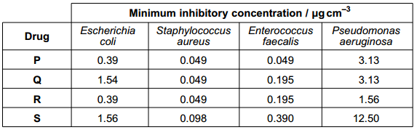**Scientists tested a new group of drugs for their effectiveness against four species of bacteria. The scientists used MICs to compare the effectiveness of four drugs. The results are shown in the table.**

**Which of the four drugs is most effective against Enterococcus faecalis?**

P

**Which of the four drugs is least effective against all the species of bacteria used?**

S

**The effectiveness of these drugs was tested in double-blind trials using human volunteers. In a double-blind trial neither the volunteers nor the scientists know which treatment a particular volunteer is receiving. Suggest two ways in which a double-blind trial improves reliability.**

Prevents bias; Vested interest (of scientists); Prevents ‘placebo’/positive/negative/psychological effects/’demand characteristics’ (in volunteers

**Suggest two factors the scientists should have considered when selecting adult volunteers for this trial.**

Age; Ethnicity; Lifestyle; Body mass; Health; Sex of person

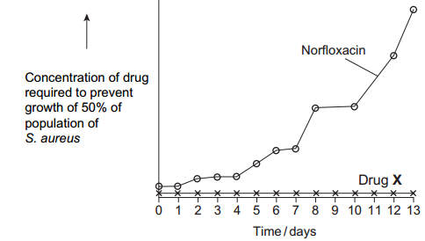**Scientists investigated resistance of the bacterium, S. aureus to the antibiotic Norfloxacin. They grew the bacteria in a medium containing a low concentration of Norfloxacin. The concentration of Norfloxacin that they added killed some of the bacteria. It did not kill all of them. Every 24 hours, they removed a sample of the bacteria from the culture. They tested the sample to find the concentration of Norfloxacin that prevented the growth of 50 % of the bacteria in the sample. The scientists then used the same method to investigate the resistance of S. aureus to a new drug, drug X. The results of both investigations are shown in the graph.**

**Describe the results obtained with Norfloxacin.**

Gradual/slight increase followed by rapid/greater increase

**Use your knowledge of resistance to explain the results obtained with Norfloxacin and drug X.**

No/little resistance shown to drug X; Mutation present (for antibiotic resistance); Gene/allele for (antibiotic) resistance; Bacteria with (antibiotic) resistance survive; Vertical gene transmission; Frequency of gene/allele (for resistance) increases

1. 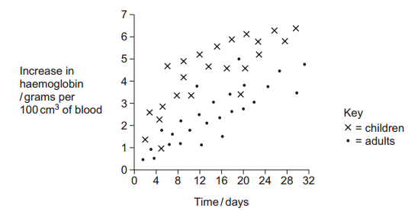**Haemoglobin contains iron. One type of anaemia is caused by a lack of iron. This type of anaemia can be treated by taking tablets containing iron. A number of patients were given a daily dose of 120 mg of iron. Figure 8 shows the effect of this treatment on the increase in the concentration of haemoglobin in their red blood cells.**

**Give one difference in the response of adults and children to this treatment.**

Faster/greater/more effective response in children

**You could use the graph to predict the effect of this treatment on the increase in haemoglobin content of an adult after 40 days. Explain how.**

Use line of best fit; Extrapolate/extend line (and read from graph)

**Haemoglobin has a quaternary structure. Explain what is meant by a quaternary structure.**

More than one polypeptide chain

1. **Pernicious anaemia is another type of anaemia. One method of identifying pernicious anaemia is to measure the diameter of the red blood cells in a sample of blood that has been diluted with an isotonic salt solution. Explain why an isotonic salt solution is used to dilute the blood sample.**

Has same water potential; No (net) water movement / osmosis; Cells will not swell/burst/change size

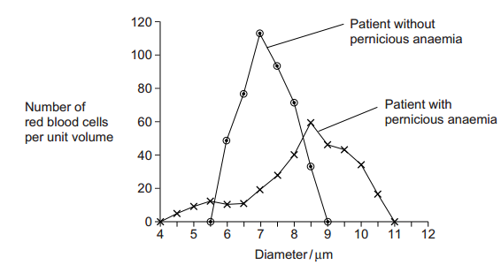**A technician compared the red blood cells in two blood samples of equal volume. One sample was from a patient with pernicious anaemia, the other was from a patient who did not have pernicious anaemia. Figure 9 shows some of the results she obtained.**

**Describe two differences between the blood samples. 1**

Pernicious anaemia (cells) greater range/spread/variation of diameters/widths; Some pernicious anaemia (cells) wider than 9 (µm) / some less than 5.5 (µm) / / without pernicious anaemia none more than 9 (µm) / none less than 5.5 (µm); Pernicious anaemia (cells) peak/most frequent at 8.5 (µm) / peak/most frequent at higher diameter / / without pernicious anaemia peak/most frequent at 7 (µm) /peaks at lower diameter

**Scientists’ analysis of blood proteins has indicated a lack of genetic diversity in populations of some organisms. Describe the processes that lead to a reduction in the genetic diversity of populations of organisms.**

Mark for general principle of - reduced variety/number of different alleles/DNA / reduced gene pool (in new population);

Founder effect; A few individuals from a population become isolated/form colonies:

(Genetic) bottlenecks - (Significant) fall in size of population

Selective breeding / artificial selection; Using organisms with particular alleles/traits/phenotypes/characteristics

1. **Name the process in which cells become adapted for different functions.**

Differentiation/specialisation

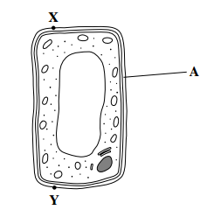**Palisade cells are found in leaves. The diagram shows a palisade cell.**

**Name structure A.**

(cellulose) Cell wall

**The real length of this cell between X and Y is 20 micrometres (µm). By how many times has it been magnified?**

2350 to 2500 (measured length divided by real length)

**Explain one way in which this cell is adapted for photosynthesis.**

Chloroplasts absorb light; Large vacuole pushes chloroplasts to edge (of cell); Thin/permeable (cell) wall to absorb carbon dioxide;

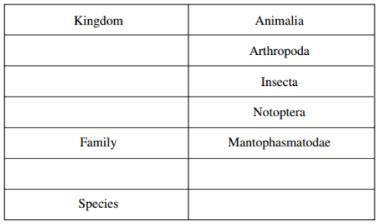**In 2002, biologists identified a new group of insects. They called these insects gladiators. Mantophasma zephyra is one species of gladiator. Complete the table to show how this species is classified.**

**This system of classification consists of a hierarchy. Explain what is meant by a hierarchy.**

Phylum 

Class 

Groups within (larger) groups; No overlap

Order

Mantophasma

Genus

zephyra

**In 2002, very few gladiators were available for identification. Scientists around the world used photographs to establish the relationship of gladiators to other insects. Explain how.**

Comparison of/look for similar features/structures/appearance

1. 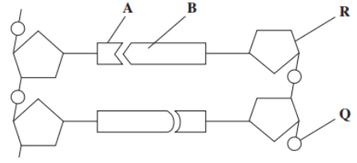**Figure 1 shows a short section of a DNA molecule.**

**Name parts R and Q.**

R = Deoxyribose. Q = Phosphate

**Name the bonds that join A and B.**

Hydrogen (bonds

**Ribonuclease is an enzyme. It is 127 amino acids long. What is the minimum number of DNA bases needed to code for ribonuclease?**

381/384/387

**GTTTACTACTCTTCTTCTTTA is a sequence of DNA bases coding for seven amino acids in the enzyme ribonuclease. The number of each type of amino acid coded for by this sequence of DNA bases is shown in the table.**

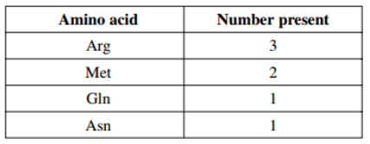 **Use the table and the given sequence to work out the sequence of amino acids in this part of the enzyme. The first one is given to you.**

**Gln** Met Met Arg Arg Arg Asn

**Explain how a change in a sequence of DNA bases could result in a non-functional enzyme.**

Change in (sequence of) amino acids/primary structure; Change in hydrogen/ionic/disulfide bonds; Alters tertiary structure/active site (of enzyme); Substrate cannot bind / no enzyme-substrate complexes form

1. **An increase in respiration in the tissues of a mammal affects the oxygen dissociation curve of haemoglobin. Describe and explain how.**

Increase in/more carbon dioxide; Curve moves to the right/depressed

**There is less oxygen at high altitudes than at sea level. People living at high altitudes have more red blood cells than people living at sea level. Explain the advantage of this to people living at high altitude.**

More haemoglobin; So can load/pick up more oxygen (in the lungs)

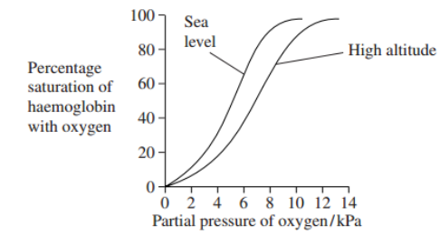**The graph shows oxygen dissociation curves for people living at high altitude and for people living at sea level.**

**Explain the advantage to people living at high altitude of having the oxygen dissociation curve shown in the graph.**

(Haemoglobin) has lower affinity for oxygen / more oxygen released; In/to the cells/ tissues;

1. **A student found the number of stomata per cm2 on the lower surface of a daffodil leaf. He removed a small, thin piece of lower epidermis and mounted it on a microscope slide. He examined the slide using an optical microscope. Explain why it was important that the piece of the epidermis that the student removed was thin.**

Single layer of cells / few layers of cells; So that light that can pass through / cells absorb light

**Suggest how the student could have used his slide to find the number of stomata per cm2.**

Method of determining area of field of view/area seen using microscope; Count number of stomata in field of view; Repeats and calculation of mean

**The stomata on the leaves of pine trees are found in pits below the leaf surface. Explain how this helps to reduce water loss.**

Water vapour accumulates / increased humidity/ reduced air movement (around stomata); Water potential/diffusion gradient reduced;

1. 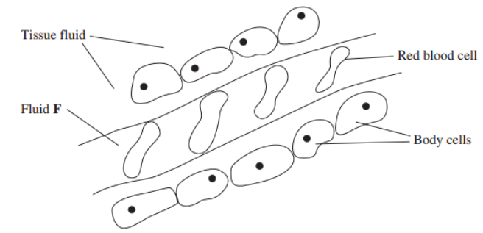**The diagram shows tissue fluid and cells surrounding a capillary**

**Name fluid F.**

(Blood) plasma

**Give one way in which fluid F is different from tissue fluid.**

More/larger proteins / less urea/carbon dioxide / more glucose/amino acids/fatty acids/oxygen/ high(hydrostatic) pressure

**The blood pressure is high at the start of the capillary. Explain how the left ventricle causes the blood to be at high pressure.**

Contracts

**The blood pressure decreases along the length of the capillary. What causes this decrease in pressure?**

Loss of fluid/volume; Friction/resistance (of capillary wall

**In children, some diets may result in a low concentration of protein in fluid F. This can cause the accumulation of tissue fluid. Explain the link between a low concentration of protein in fluid F and the accumulation of tissue fluid.**

Water potential (in capillary) not as low/is higher/less negative / water potential gradient is reduced; More tissue fluid formed (at arteriole end); Less/no water absorbed (into blood capillary); by osmosis; (into blood capillary);

1. 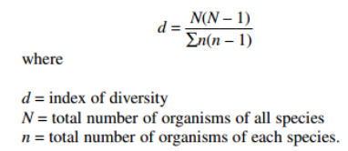**Heath is a community of plants and animals. A student investigated the species diversity of plants in this community. The table shows her results.**

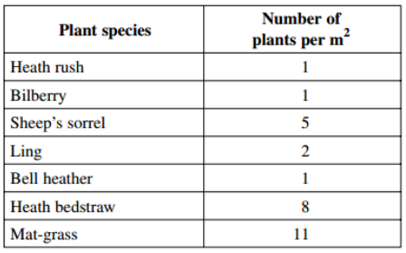

**Use this formula to calculate the index of diversity for the plants on the heath.**

4.3

**Explain why it may be more useful to calculate the index of diversity than to record only the number of species present.**

Measures number of individuals (of each species) and number of species; Some species only present in small number

**The demand for increased food production has led to areas of heath being used to grow wheat. Explain the effect of this on**

1. **the species diversity of plants**

Reduced as one crop/species grown / other species removed; Use of herbicides/weeding/ploughing; Wheat (better) competitor for named factor e.g. light/nutrients

1. **the species diversity of animals.**

(Reduced) as less variety of food sources; (Reduced) as fewer habitats/niches; (Reduced) by pesticides/chemicals

1. **Gas exchange in fish takes place in gills. Explain how two features of gills allow efficient gas exchange.**

Filaments/lamellae provide large surface area; Thin/flattened epithelium/ one/two cell layers so short diffusion pathway (between water and blood); Countercurrent/blood flow maintains concentration/diffusion gradient;

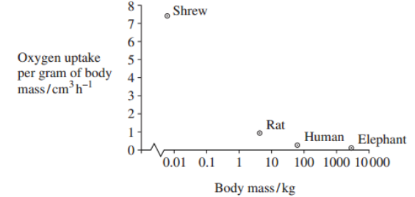**A zoologist investigated the relationship between body mass and rate of oxygen uptake in four species of mammal. The results are shown in the graph.**

**The scale for plotting body mass is a logarithmic scale. Explain why a logarithmic scale was used to plot body mass.**

Large/wide range of values (so can fit on graph);

**Describe the relationship between body mass and oxygen uptake.**

Decrease in uptake with increase in mass / negative correlation

**The zoologist measured oxygen uptake per gram of body mass. Explain why he measured oxygen uptake per gram of body mass.**

Enables comparison; As animals differ in size/mass;

**Heat from respiration helps mammals to maintain a constant body temperature. Use this information to explain the relationship between body mass and oxygen uptake shown in the graph.**

Smaller animals have larger surface area to volume ratio; Lose more heat per gram of tissue; Respire more/faster (relative to body mass); Oxygen used in respiration

1. **Taxol is a drug used to treat cancer. Research scientists investigated the effect of injecting taxol on the growth of tumours in mice. Some of the results are shown in Figure 3.**

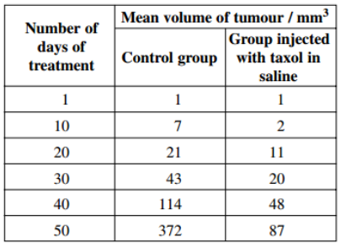 **Suggest how the scientists should have treated the control group.**

Given only saline; Otherwise treated exactly the same way

**Suggest and explain two factors which should be considered when deciding the number of mice to be used in this investigation.**

Ethical consideration, e.g., leads to death/suffering of mice; Large number to improve reliability / reduce sampling error; Number of mice related to cost/space available/animal husbandry

**The scientists measured the volume of the tumours. Explain the advantage of using volume rather than length to measure the growth of tumours.**

Vary in shape / do not grow uniformly

**The scientists concluded that taxol was effective in reducing the growth rate of the tumours over the 50 days of treatment. Use suitable calculations to support this conclusion.**

7.44 and 1.74 7.42 and 1.72 4.28:1 4.31:1 % decrease of 76.6% % decrease of 76.8%

**In cells, taxol disrupts spindle activity. Use this information to explain the results in the group that has been treated with taxol.**

Mitosis; As chromosomes cannot attach (to spindle)/ chromatids cannot separate (on spindle); Cell division/cell cycle slows down

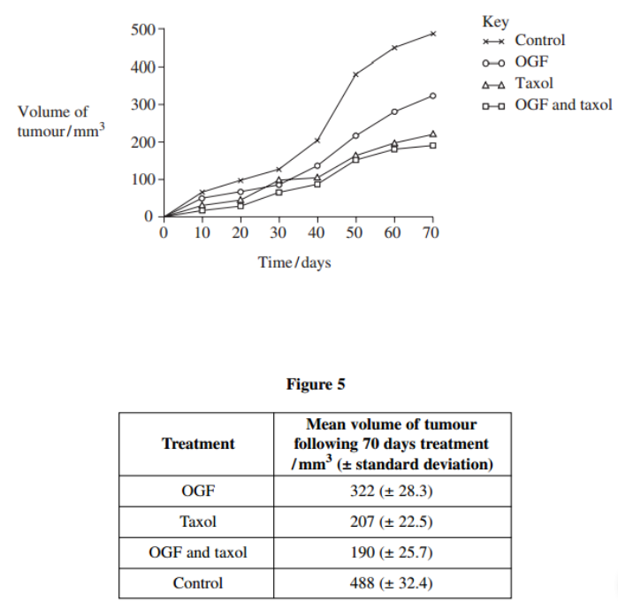**The research scientists then investigated the effect of a drug called OGF on the growth of tumours in mice. OGF and taxol were injected into different mice as separate treatments or as a combined treatment. Figure 4 and Figure 5 show the results from this second investigation.**

**What information does standard deviation give about the volume of the tumours in this investigation?**

(Degree of) spread/variation from the mean;

**Use Figure 4 and Figure 5 to evaluate the effectiveness of the two drugs when they are used separately and as a combined treatment.**

Both chemicals (on their own) slow down growth/are effective; Taxol is more effective than OGF; Combined treatment (seems) most effective; SD overlap for OGF with taxol and taxol (on its own) so not conclusive/could be chance/both treatments could be equally effective

1. **A seahorse is a fish. Mating in seahorses begins with courtship behaviour. After this, the female transfers her unfertilised eggs to the male’s pouch. Most male fish fertilise eggs that have been released into the sea. However, a male seahorse fertilises the eggs while they are inside his pouch. The fertilised eggs stay in the pouch where they develop into young seahorses**

**Give two ways in which courtship behaviour increases the probability of successful mating.**

Recognition of same species; Stimulates release of gametes; Recognition of mate/opposite gender; Indication of sexual maturity/fertility;

**Give one way in which reproduction in seahorses increases the probability of fertilisation**

Internal fertilisation / fertilisation occurs in pouch/limited area

**Give one way in which reproduction in seahorses increases the probability of survival of young seahorses.**

Protection from predators (developing in pouch)

**Scientists investigated the effect of total body length on the selection of a mate in one Australian species of seahorse. The scientists used head length as a measure of total body length. Use the diagram to suggest why the scientists measured head length rather than total body length.**

Less stress caused to seahorse / quicker/more accurate method / body is curved / head is linear;

**Suggest why the scientists were able to use head length as a measure of total body length.**

Head length proportional to body length/or described

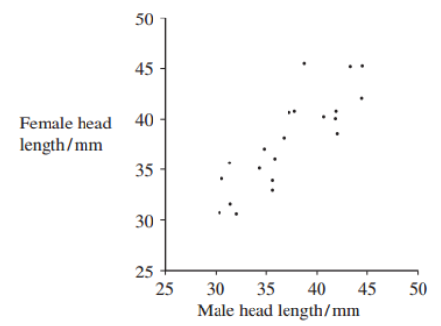**The scientists measured the head lengths of the female and male of a number of pairs. The results are shown in the graph.**

**The scientists concluded that total body length affects the selection of a mate. Explain how the results support this conclusion.**

Positive correlation between head/body lengths of male and female/ female and male with similar head/body lengths pair together

**A female with a head length of 50 mm selected a mate. Explain how you could use the graph to predict the total head length of the mate selected.**

Use line of best fit; And extrapolate/extend line as required

**Scientists studied two species of North American seahorse. They thought that these two species are closely related. Describe how comparisons of biological molecules in these two species could be used to find out if they are closely related.**

Compare DNA:

* Sequence of bases/nucleotides;
* DNA hybridisation 🡪 Separate DNA strands / break hydrogen bonds; Mix DNA/strands (of different species); Temperature/heat required to separate (hybrid) strands indicates relationship;
* Compare same/named protein; Sequence of amino acids /primary structure;
* Immunological evidence –Inject (seahorse) protein/serum into animal; (Obtain) antibodies/serum; Add protein/serum/plasma from other (seahorse) species; Amount of precipitate indicates relationship