DNA TECHNOLOGY SUMMARY NOTES

The process of using DNA technology to make certain proteins is as follows:
- Isolation of the DNA fragments that have the gene for the desired protein
- Insertion of the DNA fragment into a vector
- Transformation of DNA to a suitable host
- Identify the host cells that have taken up the gene
- Growth/cloning of the population of host cells

Producing DNA fragments
= getting a copy of the DNA fragment containing the gene we want

- Using reverse transcriptase
Reverse transcriptase is an enzyme that catalyses the process of producing DNA from RNA

PROCESS:
- A host cell that already produces the desired protein is selected
- These cells will have a lot of the relevant mRNA.
- Reverse transcriptase can be used to make DNA from the mRNA already present
- Complementary (cDNA) is then produced from complementary nucleotides to that of mRNA
- DNA polymerase then builds up the complementary DNA strand to that of the cDNA to form a double helix

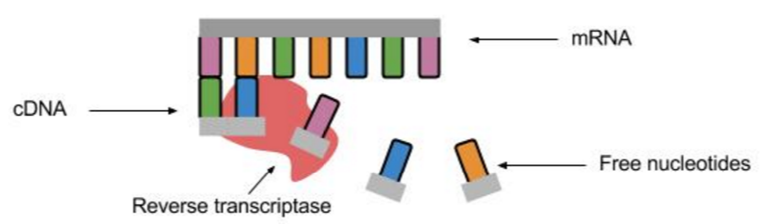

- Using restriction endonuclease
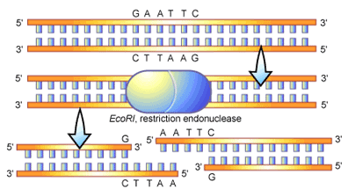
Restriction endonuclease are enzymes that cut a double stranded segment of DNA at a specific “recognition sequence”

- They can cut either in a straight line to form blunt ends, or in a staggered fashion, forming “sticky ends” (which have exposed unpaired nucleotides)

A recognition sequence is a 6 base palindrome sequence

Using the same restriction endonuclease = fragments will have complementary stick ends so we can form recombinant DNA by combining DNA from different organisms.

CLONING THE DESIRED GENE

This can be done in two ways
- In vivo – transferring fragments to a vector (host cell)
- In vitro – using polymerase chain reactions

- IN VIVO CLONING
= cloning INSIDE a living organism by transferring fragments into host cells using vectors and replicating the host cells containing the fragments.

The importance of “sticky ends”
Using the same restriction endonuclease to cut DNA and to cut the vector (e.g. the plasmid) means both will have complementary sticky ends so can be joined together using DNA ligase

- Insertion of DNA fragment into a vector
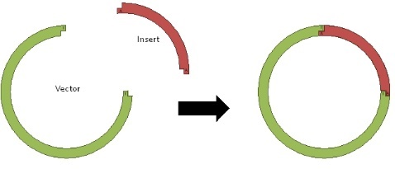
- Plasmids often contain the gene for antibiotic resistance
- Restriction endonuclease can be used on one of these antibiotic resistance genes to break the plasmid loop
- The same restriction endonuclease is used to cut the DNA into fragments so the sticky ends will be complementary
- DNA ligase can be used to join the recombinant DNA permanently

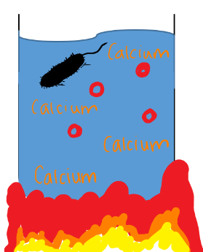

- Introduction of DNA to host cells
- Transformation – mixing plasmids and bacterial cells in a medium containing calcium ions and increasing the temperature to cause bacterial cells to become more permeable to plasmids

- Gene markers

Not all of the bacteria cells will however take up the recombinant DNA. This is due the plasmid sometimes closing up again before the DNA fragment is incorporated so we need to identify those that have were gene markers…

Antibiotic resistant markers

- Treat all the bacteria with ampicillin
- Those that survive will be either (a) those taken up the plasmid with the fragment or (b) those taken up the plasmid but not the one with the fragment
- Use replica plating;
- Place the cells on agar plates and grow colonies of bacteria
- A sample of each colony is placed on the EXACT SAME POSITION on a different plate that contained tetracycline
- The colonies killed on this second plate will have taken up the fragment as the gene resistant to tetracycline will have been disrupted by taking up the fragment.
- Using their exact position, we can find those in this position on the first plate have incorporated the vector.
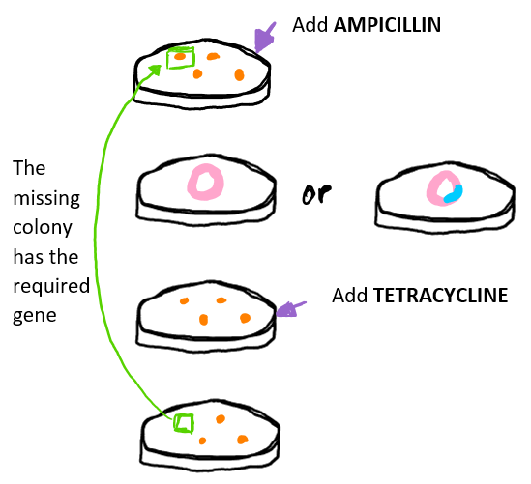

Fluorescent markers
The gene GFP produces a green fluorescent protein
The gene to be cloned is placed in the centre of the GFP gene and hence the GFP gene no longer works.
The bacteria that have taken up the plasmid will be those that do not fluoresce

Enzyme markers
The gene lactase turns a particular substrate blue.
By placing the desired gene in the middle of the lactase gene, those bacteria that successfully take up the modified plasmid will not have the ability to change the substrates colour

In vivo advantages | In vivo disadvantages
Useful in introducing a gene to another organism – The use of plasmids can be used to introduce genes into other organisms | Takes a long time
It is more accurate – mutations during in vivo cloning are rare. Errors during in vitro are multiplied in subsequent cycles | Fragment has to be isolated from other cell components
Only specific genes are copied – since the gene is cut out, only the required piece of DNA is copied | Fragment has to be isolated from other cell components
Produces useful G.M bacteria - modified bacteria can be used to make useful proteins | Fragment has to be isolated from other cell components
Little risk of contamination – The restriction endonuclease cuts at a specific point producing the complementary sticky ends. Contaminant DNA cannot enter the plasmid | Fragment has to be isolated from other cell components

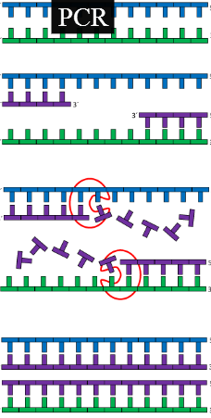
- IN VITRO CLONING

Polymerase chain reaction (PCR)

- DNA fragments, primers and DNA polymerase are placed in the vessel of a thermocycler
- The temperature is increased to 95oC to separate the DNA strands
- The mixture is the cooled 55oC to cause primers to anneal to their complementary bases at the end of the DNA strand to provide a starting sequence for DNA polymerase
- The temperature is raised to 72oC for DNA polymerase to work and join up nucleotides starting at the primer and finishing at the end of the DNA molecule

In vitro advantages | In vitro disadvantages
Very rapid – just small amount of DNA can be copied very quickly in to billions of copies. This can save time in forensic investigations | Requires a very pure sample as errors would be copied in subsequent cycles
Does not require living cells – No complex culturing techniques required, save time and effort
Only copies the DNA fragments of interest

Use of recombinant DNA technology

- Genetic modification
Altering the genetic makeup of organisms by giving them recombinant DNA

BENEFITS TO HUMANS:
- Increasing the yield from animals or plant crop
- Creating more nutrient rich food
- Making crops resistant to disease, pests, herbicides and environmental changes
- Producing vaccines and medicines
- Industrial processes

Examples of GM microorganisms
- Antibiotics – improvements have been made bacteria that increase the quality of antibiotics and the rate at which they’re made

- Hormones – Incorporating the human gene for insulin into bacteria to make the insulin much more affective as it is not rejected by the immune system

- Enzymes – many enzymes which are used in the food such as protease to tenderise meat, amylase to break down starch during beer production and lipase to improve the flavour of certain cheeses

Examples of genetically modified plants
- GM tomatoes – a gene that produces a complementary mRNA molecule to the mRNA that causes tomatoes to soften is added to the tomato DNA. The two mRNA stands are complementary so they combine and thus the corresponding protein/enzyme that causes softening is not produced as it cannot be translated.

- Pest resistant crops – some crops can be modified so that they produce a toxin harmful to pest that feed on it.

- Plants that produce plastics – possible source of plastics in the future

Examples of genetically modified animals
- Disease resistant animals

- Fast growing hormones for animals to be used as food

- Milk producing animals making proteins for medicine – e.g. Anti-thrombin is a protein that slows blood clotting, inserting into a goats fertilized egg the gene for this protein alongside the genes for proteins found in goats milk causes goats to the produce the anti-thrombin gene in their milk which can be used in medicine

BENEFITS of genetic engineering | PROBLEMS with genetic engineering
Crop can be made to withstand extreme conditions so they can be grown more variedly | May irreversibly damage the delicate balance of a habitat
Crops can be made to help prevent disease | Reduce essential genetic diversity
Animals can be made to cheaply produce hormones, drugs or enzymes | Economic consequences if western world can grow their own crops that before they would have had to have gotten from poorer countries
Microorganisms can be made to break up oil and help pollution | Selecting one race over another

Gene therapy

Gene therapy = replacing defective genes with those cloned from a healthy individual

- Cystic fibrosis

SYMPTOMS:
- Mucus congestion in lungs = greater risk of infection since mucus traps pathogens which are not removed
- Less efficient gas exchange
- Thick mucus accumulates in pancreatic ducts = prevents enzymes produced by the pancreas reaching the duodenum = fibrous cysts

- Accumulation of mucus in sperm ducts may cause infertility It is caused by a deletion mutation on recessive allele that causes the loss of an amino acid in a protein.
- The gene that is lost would have been used for transporting chloride ions OUT of epithelial cells which would make water go out too!
- Since less water leaves epithelial cells, their mucus is thick and difficult to move.

Treatment of cystic fibrosis using gene therapy

- Gene replacement - replacing a defective gene with a normal gene

- Gene supplementation - adding copies of the healthy gene alongside the defective gene. The copies are dominant alleles and so the recessive allele which is defective has little affect

- Germ-line gene therapy - replacing the defective gene whilst inside the fertilised egg. All daughter cell will have the healthy gene.

- Somatic-cell gene therapy - targets only the affected tissues. Since the cells are constantly dying and are needed to be replaced, the treatment is not permanent and must be repeated.

Delivering clones of the desired gene into epithelial cells:

Using a harmless virus
Adenoviruses cause respiratory diseases by injecting their DNA into epithelial cells so can be used as vectors!

PROCESS:
- The virus is made harmless by interfering with a gene involved in their replication
- It is grown in epithelial cells in a lab along with plasmids that have the normal desired gene
- The gene becomes incorporated into the DNA of the virus
- The virus is taken up through the nostrils of a patient
- The adenovirus then injects DNA into the epithelial cells of the lungs alongside the normal gene.

Wrapping the gene in lipid molecules
“Wrapping" genes in lipid molecules so they can then pass through the phospholipid membrane

PROCESS:
- The normal gene is isolated from healthy human tissue and are inserted into a plasmid that is then taken up by a bacterial cell.
- Gene markers are used to indemnify the bacteria with the healthy gene
- The bacterial cells then multiply and so clone the plasmid with the gene
- The plasmid is isolated from the bacteria and wrapped in a lipid soluble molecule forming a liposome
- The liposomes with the gene are sprayed into the nostrils of patients and are drawn down into the lungs
- The liposome then enters the epithelial cells of the lungs causing the correct protein to be made

The previous two methods are sometimes not effective because:
- Adenoviruses may cause infection
- Patients may develop immunity
- The liposome aerosols may not be fine enough to pass through the bronchi
- Even when the gene is supplied to the epithelial cells, the protein is not always expressed.

2. Severe combined immunodeficiency
Sufferers do not show an immune response and have a defective gene that cannot produce the ADA enzyme that would destroy toxins that kill white blood cells

TREATMENT USING GENE THERAPY:
The healthy ADA gene is isolated from human tissue using restriction endonuclease and inserted into a retrovirus
The virus is grown in a lab so the gene is copied
The virus is mixed with the patients T cells
The virus injects DNA into the T cells by the virus, thus providing the genetic code to make the enzyme.

ADVANTAGES OF GENE THERAPY | DISADVANTAGES OF GENE THERAPY
Prolongs lives and gives a better quality of life | Somatic therapy is only short lived
Germ-line therapy allows carriers to have a “normal” baby | Genes are not always expressed
 | Hard to treat diseases caused by multiple genes
 | Ethical issues

Locating and sequencing genes
How can we locate genes to see if a person’s DNA contained a mutated gene?:
DNA probes
A DNA probe = a small section of DNA that has an identifiable label attached to it

The probes are normally either radioactively labelled or are fluorescently labelled

HOW THEY IDENTIFY GENES:
- The probe will be made of a complementary nucleotide sequence to the gene we want to identify
- The DNA being tested will have its strands separated
- The strands are mixed with the probe, which will bind to specific part of the strand – DNA hybridisation
- The site the probe binds to is identified by the radioactivity or florescent that it emits.

DNA sequencing
Identifying the sequence of bases in the gene that is being located

The sanger method = using modified (terminator) nucleotides that cannot bind to one another and thus terminate the synthesis of the DNA strand

PROCESS:
- Set up 4 test tubes with;
- single stranded fragments of the DNA to be studied (acting as a template for the synthesis of another strand)
- normal free nucleotides
- terminator nucleotides – a different base being in each of the test tubes (e.g. tube 1 has adenine, tube 2 has guanine…)
- primer that’s labelled with a DNA probe
- DNA polymerase
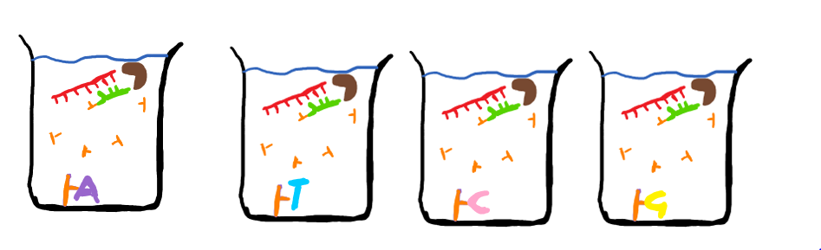

WHAT WILL WE GET OUT OF THE TEST TUBES?:
- In each test tube we will have different DNA fragments →all the complementary DNA strands in tube 1 will end in adenine, tube 2 with thymine, tube 3 with cytosine and tube 4 with guanine (these fragments can be identified using the primer that is labelled with a DNA probe)

How can we find out the possible sequences when the process is over?? (using Adenine as an example)
If we know the sequence of the unknown DNA strand is
C C G T C T A G C A C T C A A G C T C T
then the complementary strand formed in the test tube will have the sequence:
G G C A G A T C G T G A G T T C G A G A

However, there is several possible outcomes depending on where the adenine terminator binds e.g:
- GGCA
- GGCAGA
- GGCAGATCGTGA
- GGCAGATCGTGAGTTCGA
- GGCAGATCGTGAGTTCGAGA

- Each fragment will also be of VARYING LENGTH since whether the normal nucleotide or the terminator nucleotide is the one that binds is random and depending on where the terminator nucleotide binds, DNA synthesis will be terminated either earlier or later = different lengths!

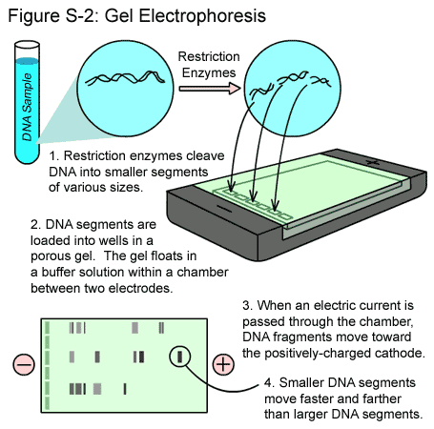
- Gel electrophoresis
Separating out the different lengths

- Place DNA fragments at one end of an agar gel (at the ‘origin’)
- Apply a voltage across it
- The gel has resistance = smaller fragments will move faster and further towards the positive electrode at the end than larger ones
- A photographic film is placed over the agar gel
- The radioactive label will cause the film to change colour where the particular fragment is situated on the gel

INTERPRETING THE RESULTS:
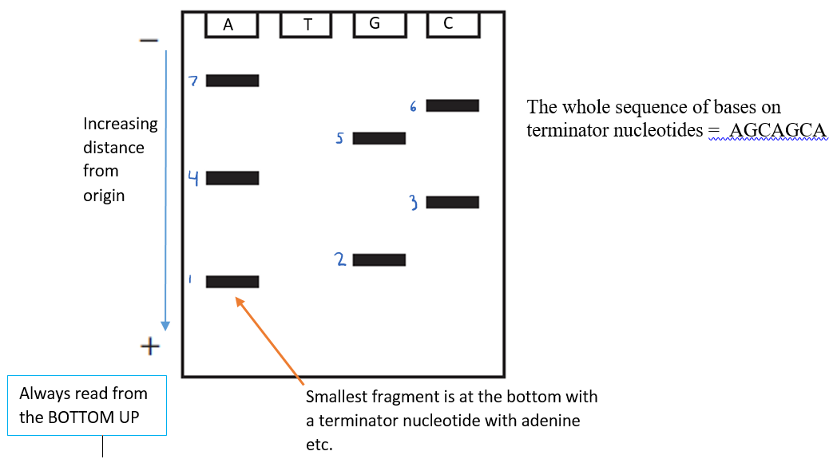
Terminator…

HOWEVER…. Gel electrophoresis will only be used for relatively short fragments of DNA, genes must therefore normally be cut first by restriction endonuclease. This is called restriction mapping

Restriction mapping
It breaks DNA into manageable sizes for analysis!

It also helps to find the position of restriction sites on plasmids by cutting DNA at various different recognition sites using restriction endonucleases and then separating the fragments by gel electrophoresis. Based on the resulting sizes of the DNA fragment, the positions of the sites can be inferred.

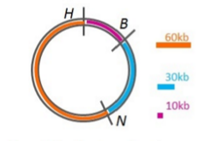
- Restriction endonucleases cut a plasmid in two places.
- This means the length of one fragment will depend on the length of the other (the sum of the individual fragments should equal the original fragment size)
- The distance between restriction enzyme sites can be determined by the patterns of fragments that are. In this way, information about the structure of an unknown piece of DNA can be obtained.

EXAMPLE:
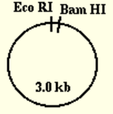

- You have a plasmid that is 3kb which contains the restriction enzymes EcoRI and BamHI

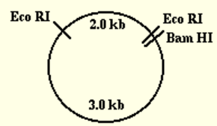

- You insert a gene that is 2kb long, but you want to find more about the insert.

- You digest the plasmid (the one with the insert) with one of the restriction enzymes, e.g. BamHI and there will be two possible outcomes:
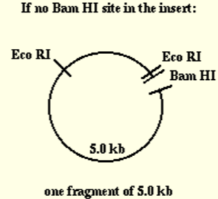

- there is no BamHI sites in the insert = when later running gel electrophoresis you will then only see one DNA fragment that is 5 kb long (3kb from the plasmid and 2kb from the insert) because there will only be one cut in the plasmid loop

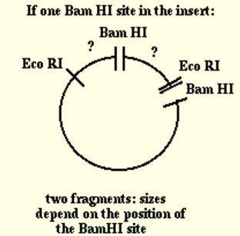

- there is a BamHI site in the insert = when later running gel electrophoresis you will see 2 DNA fragments as the enzyme will cut the circular plasmid in 2 places (in the plasmid BamHI site and in the insert’s BamHI site).
One fragment will be the plasmid with some of the insert still attached and the other will just be the insert.
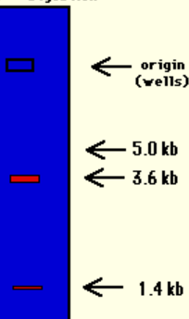
You can find where in the insert the BamHI site is by comparing the sizes of the 2 fragments (using electrophoresis)




- If we find there is a site in the insert, this graph from gel electrophoresis shows us exactly where the site is in relation to one end of the insert.
The 2 fragments have been separated out and are found to be 3.6kb and 1.4kb

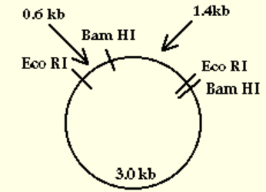
- we now know the BamHI site is 1.4kb away from the right hand side of the insert. We have “mapped” the BamHI site.

Automation of DNA sequencing and restriction mapping
Most DNA sequencing and restriction mapping is carried out by machines

- Fluorescently labelled dyes are used by computerised with each base having a different colour
- DNA synthesis is carried out in a tube and speeded up using PCR cycles
- Electrophoreses is carried out in narrow capillary tube
- Results are scanned by lasers and interpreted by computers

GENETIC SCREENING
Determining the probability of a couple having offspring with a genetic condition

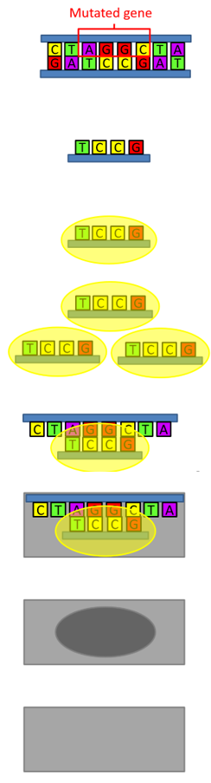
There are 8 main stages:
- DNA sequencing is used to determine the nucleotide sequence on the mutated gene

- A fragment with a complementary sequence of bases to the mutant gene is produced

- The fragment is turned into a DNA probe by radioactively labelling it

- PCR is used to create copies of the probe

- Many different probes are attached to a glass slide at different spots

- Single stranded DNA from the patient is washed over the glass slide and if it has the mutated gene, the probe will bind to complementary bases

- Using an x-ray film, the DNA fragments with the probe attached will be exposed

- If complementary fragments are not produced, the probe will not be taken up and the x-ray film will not be exposed

GENETIC SCREENING AND CANCER:
Gene screening can be used to detect oncogenes
When both alleles of the oncogene in an individual have mutated, a cancer may form.
Some people already have one mutated oncogene that they have inherited and so are at greater risk of developing cancer

Genetic Counselling
Examines family history of certain diseases
- A counsellor can advise a couple on the what the emotion, economically, medical and social issues that arise from having offspring that suffer from a certain genetic condition

Genetic fingerprinting
Diagnostic tool to compare DNA based on the fact that the number of times introns repeat themselves in their genome is unique to individuals.

- The repetitive sequences contained in introns are called core sequences
- In every individual the length and patterns of the core sequences is unique (except in identical twins)
- The more closely related two individuals, the more similarities between core sequences

PROCESS:

- Extraction
DNA is extracted from sample cells and copied using PCR

- Digestion
Specific restriction endonucleases are chosen that will cut between but not within the core sequences (so they’re not altered)

- Separation
- Gel electrophoresis is used to separate the fragments by size
- The gel is immersed in alkali to separate the double strands of DNA
- Each single strand is transferred by southern blotting onto a nylon membrane by laying the membrane over the gel and placing absorbent paper on top. The liquid containing the DNA is soaked up by capillary action which transfers the DNA fragments to the nylon membrane in exactly the same position as they were in the gel
- Ultraviolet light then fixes the DNA to the membrane

- Hybridisation
DNA probes complementary to the core sequences are added. They bind to the DNA under specific conditions (temp, pH and light).
The various probes bind to different core sequences to label the different fragments

- Development
X – Ray film is put over the nylon membrane.
The radiation from the probes allows the position of the fragments after electrophoresis to be seen.
The pattern of the bands is unique to every individual (except identical twins)

Summary

Extraction – DNA is extracted from the sample

Digestion – Restriction endonuclease cuts the DNA into fragments

Separation – Fragments are separated using gel electrophoresis
The fragments are then transferred from the gel to a nylon membrane by southern blotting

Hybridisation – DNA probes are used to label the fragments by binding to complementary core sequences

Development – Membrane with radioactively labelled DNA is added to x – ray film
Which reveals dark bands corresponding to the position of DNA fragments after gel electrophoresis.
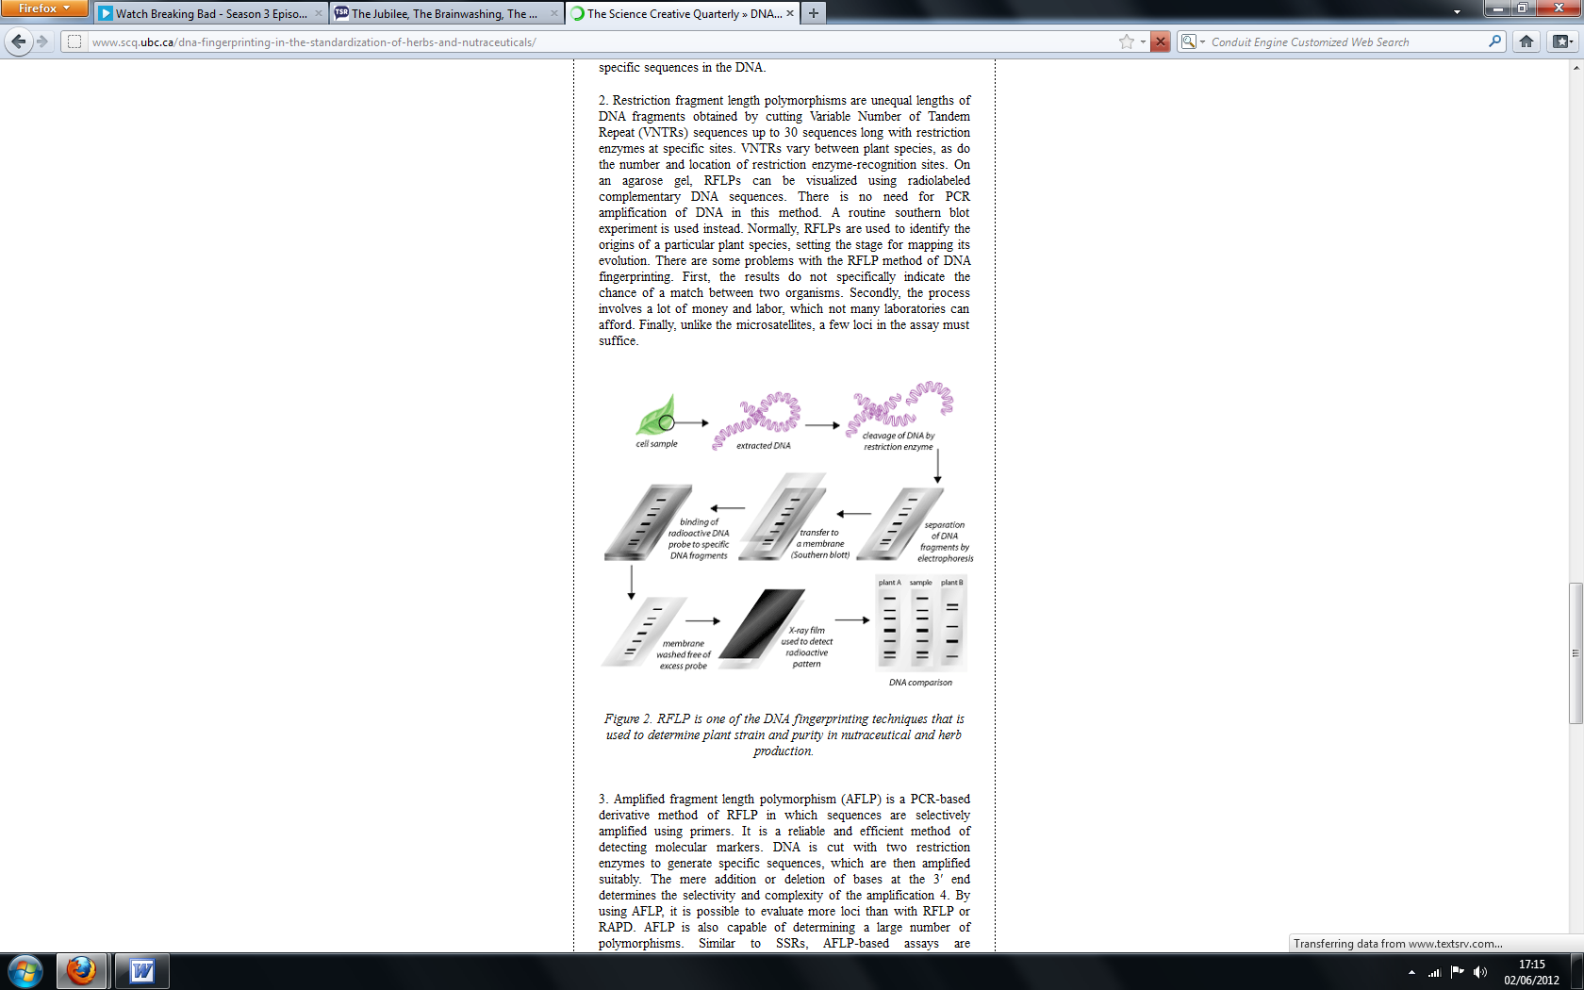

Uses of DNA fingerprinting

- PATERNITY TESTING - Since half the DNA of an individual comes from their mother and the other half from their father, each band on a DNA fingerprint should be found on either the mother or father’s DNA fingerprint
- GENETIC DIVERSITY – a population with similar bands has low diversity
- FORENSIC SCIENCE
- MEDICAL DIAGNOSIS
- ANIMAL BREEDING – prevent breeding closely related animals

