RESPONSE TO STIMULI – end of topic questions
- The human body-louse is an insect which lives and feeds on the surface of the skin. A louse was placed on a chamber, half of which was kept at 35C and half at 30C. the diagram shows the pattern of movement of the louse.
- Name the type of behavioural response shown by the body-louse in this investigation.
Kinesis (or thermokinesis) as it is showing random movements and it involves a non-directional stimulus and response.

- Suggest and explain an advantage of this behaviour to the human body-louse.
It stays longer in warmer areas (35C) and tends to leave cooler areas so that it will stay in favourable conditions and remain near food source (on the host)

- A gardener accidentally prinks her finger on a thorn. She quickly pulls the finger away. This reaction results from a simple reflex arc involving three neurones
- The diagram shows part of the pathway involved in this reaction

- Complete the diagram to show the rest of the reflex arc. Label the 3 neurones and the effector
- (i) what is a reflex?
A rapid response to a stimulus which is automatic/involuntary
- Explain the important of reflex actions
It avoids damage to tissues by helping an organism survive by responding to its environment. It has a role in homeostasis, posture, balance, escaping predators, finding food and mating.

- The graph shows the results of a sequence of treatments to investigate the control of heart rate by the autonomic nervous system
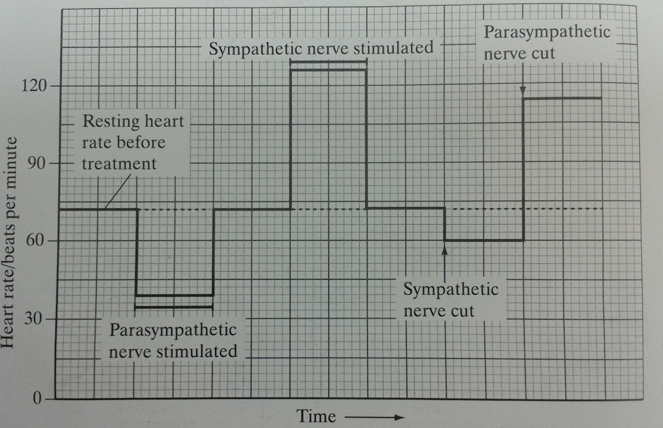
- Explain what the results of cutting the sympathetic and parasympathetic nerves demonstrate about the control of resting heart rate
heart rate controlled by both divisions. The parasympathetic reduces heart rate and the sympathetic increases heart rate. parasympathetic is most active so there will be a larger change in heart rate when parasympathetic is cut;

- What does the graph suggest about how a change in heart rate occurs when a person exercises?
Heart rate increased by sympathetic and decreased by parasympathetic and there is a change in activity of both

- (a) explain how a Pacinian corpuscle produces a generator potential in response to a specific stimulus
pressure deforms and stretches the membrane of sodium ion channels so that their gates open and sodium ions can enter, causing depolarisation (change in membrane potential)

(b) explain how stimulation of chemoreceptors during exercise results in a change in heart rate.
increase in carbon dioxide from respiration causes a decrease in blood pH as detected by chemoreceptors in carotid, aortic bodies and the medulla. More impulses are sent to the cardiac centre / medulla and more of these impulses travel along the sympathetic nerve to SAN increasing heart rate.

- The diagram shows a section through a human eye. The graph shows the distribution of rods and cones in the retina of the human eye

- Use the diagram and graph to explain why;
- No image is perceived when rays of light strike the retina at the point marked P
It is the blind spot, no rods or cone cells are at point P

- Most details is perceived when rays of light strike the part of the retina labelled Q
The maximum number of cones is at Q and each cone has a connection with one bipolar cell so the brain will receive separate sets of impulses from each stimulated cone.

- Rod cells allow us to see objects in dim light. Explain how the connections of rod cells to neurones in the retina make this possible.
Several rods have connections with one bipolar cell so the summation of generator potential exceeds the threshold whereas individual generator potentials would not exceed this.

