GENETIC END OF TOPIC QUESTIONS
- (a) Explain what is meant by a recessive allele
only expressed in phenotype if homozygous

(b) explain what is meant by co-dominant alleles
both expressed in phenotype, if both present

(c) chickens homozygous for black feathers (F^{B} F^{B}) were crossed with chickens homozygous for white feathers (F^{W} F^{W}). these colours are determined by alleles of a single gene. All the F₁ offspring had blue feathers
When the blue feathered F₁ chickens were crossed with each other, there were black-feathered, white-feathered and blue-feathered chickens in the F₂ offspring.
- Draw a genetic diagram to explain how the F₁ and F₂ phenotypes were produced.
F₁ genotype = F^{B} F^{W}
F₁ gametes = F^{B} and F^{W}
F₁ genotypes = F^{B} F^{B} F^{W} F^{W} F^{B} F^{W}
- The number of black-feathered, white-feathered and blue-feathered chickens in the F₂ offspring was counted. The observed ration of black : white : blue was similar to the ratio expected from theory but not the same. Explain why observed ratios are not often the same as expected ratios.
chance related to mating. random fusion of gametes. small sample size. differential mortality

- The Old Order Amish of Lancaster Country, Pennsylvania, are an isolated human population. Marriages occurs almost exclusively within the population. Nearly all can trace their ancestry back to a small group of people who settled in the area in the 18th century. Microcephaly is a condition which occurs in this population with a frequency of 1 in every 480 births. It is caused by a recessive allele of a single gene. Sufferers usually die within 6 months of birth.
- The incidence of microcephaly in this population is very high compared to non-isolated populations. Suggest 2 reasons for this high incidence.
Genetic. reproductive isolation. small gene pool. Inbreeding. small founder population. common ancestor(s). high probability of mating with person having recessive allele. high probability of having two recessive alleles
- (i) a student used the hardy-weinberg equation to estimate the percentage of parents who are heterozygous for microcephaly in this population. What answer should the student have obtained?
8.8%

(ii) the answer from the question above is likely to be lower than the actual percentage of parents heterozygous for microcephaly in this population. Why?
all homozygous recessive die. none with condition survive to become adults. selective disadvantage

- The Hawaiian Islands are 3000km from the nearest continent. The islands were formed relatively recently by volcanic activity. They have patches of forest separated by wide lava flows. Due to high mountains, the climate varies greatly over short distances. 500 species of fruitfly are found in Hawaii
- Explain how the large number of fruitfly species might have evolved in Hawaii
geographical isolation of fruit flies. no interbreeding / gene flow. range of habitats / environmental conditions. different selection pressures in separate populations. Mutation. variation among fruit flies. some more suited to environment than others / differential survival. beneficial allele passed on. populations unable to produce fertile offspring / reproductively isolated

- There are 21,833 species of insects in Britain but only 6,500 in Hawaii. Britain however has 32 species of Drosophila (fruitfly) but Hawaii has 500. Suggest an evolutionary explanation for the difference in the number of species of Drosophila.
Hawaiian islands isolated / Britain less isolated. few colonising species. more environments / niches / habitats available. less competition. better adapted. British 0.15%, Hawaiian 7.70% / higher proportion of insects in Hawaii. rapid evolution of species of Drosophila

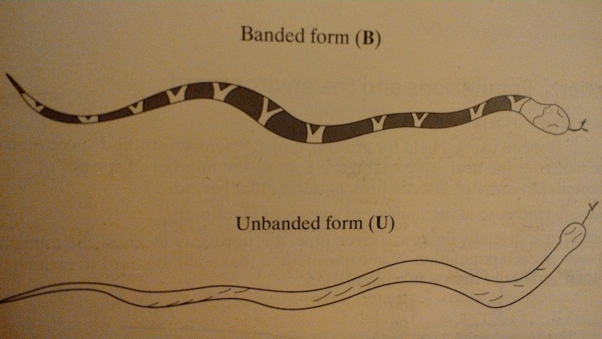
- A species of snake breeds on the shore of a very large lake and on the shore of an isolated island in the lake. There are 2 forms, a branded form (B) and an unbranded form (U). these are shown below.

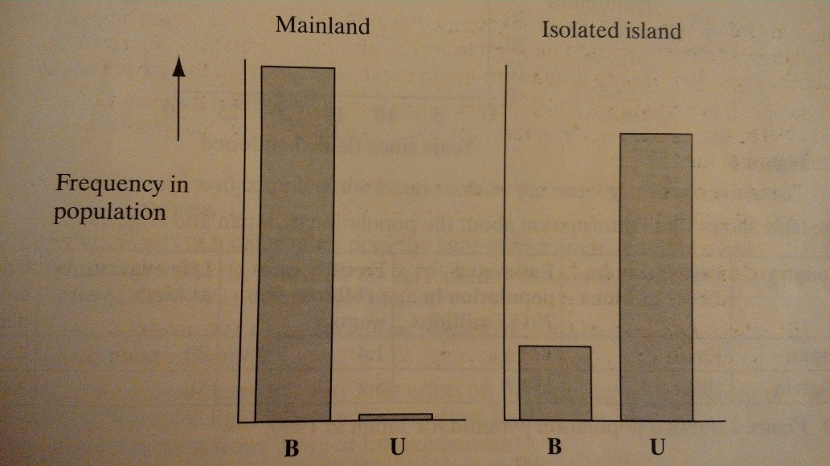
The frequency of the phenotypes was investigated in the two areas. The results are shown below

- The snakes are preyed upon by birds. Explain how natural selection may have produced the differences in frequency shown in the bar charts.
variation due to mutation. different environments / selection pressures. camouflage / selection by predation. survive to reproduce / pass on advantageous alleles. change in allele frequency in the next generation. no gene flow between populations;

- On the island, branded snakes have remained at approximately the same frequency for many generations. Suggest 2 explanations for this.
back mutation. migration of banded snakes from mainland. banded could be recessive so still get occasional homozygotes / heterozygous advantage. stabilising selection. selection pressure stays the same;

