ENERGY END OF TOPIC QUESTIONS

- Below is a pyramid for an ecosystem.
- Suggest suitable units for the measurement of energy transfer in this pyramid of energy
kJ m⁻² yr⁻¹

(i) calculate the percentage of energy transferred form primary consumers to tertiary consumers
0.64%
(ii) give 2 reasons why the percentage of energy transferred between consumers is generally low.
energy is transferred to the environment as heat energy from respiration. muscle contraction. Is lost in faeces, food not eaten. excretion

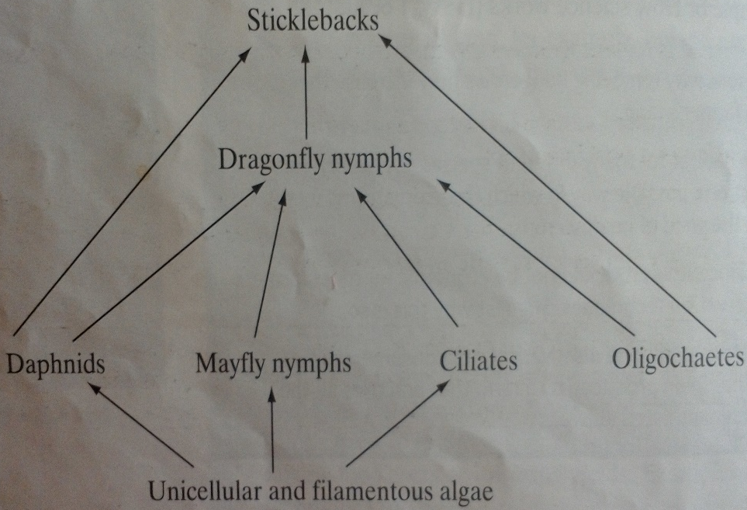
- Below is a simplified food web in an aquatic ecosystem
- In this food web, which organisms feed as tertiary consumers?
stickleback and dragonfly nymph

- The biomass of organisms in an ecosystem can change during the year. In this aquatic ecosystem, the biomass of primary consumers is temporarily greater than that of the producers during the early summer.

- Draw the pyramids of biomass in early summer and autumn for this ecosystem. Name the trophic levels.

SUMMER autumn

- Suggest suitable units to represent biomass in these pyramids.
kg m⁻²

- Explain why food chains rarely have more than five trophic levels
some energy lost at each stage in the food chain. transfer of energy not 100% efficient. Energy lost as heat in respiration. only a limited amount of energy is available so at each stage less is available for next stage. little energy left at top of food chain

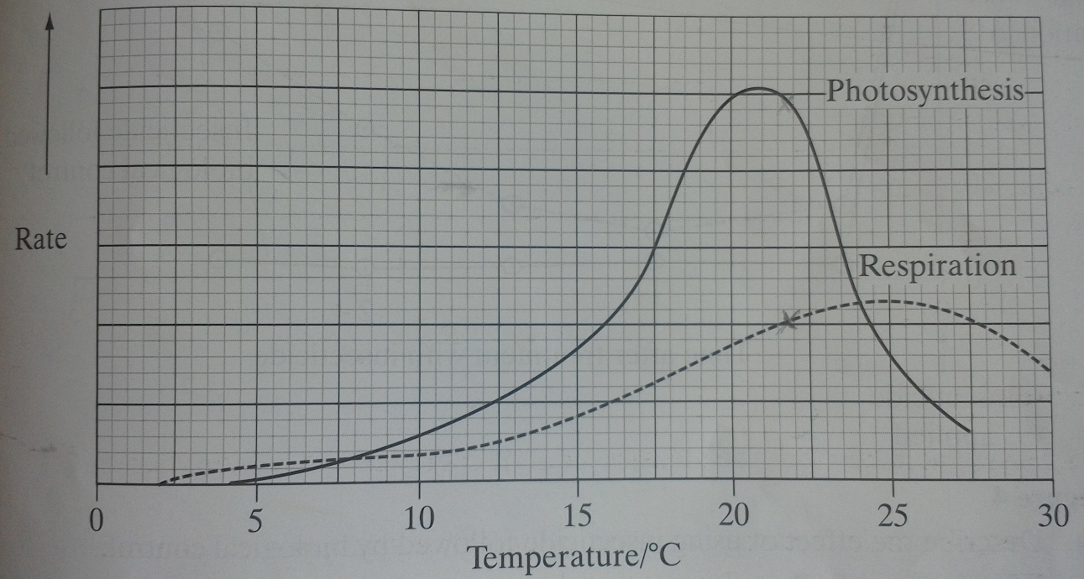
- Potato plants originate form the Andes mountains in South America. They are adapted for survival in a cool climate. The potatoes we eat are food storage organs, called tubers, and are produced on underground stems. The graph shows the rate of photosynthesis and respiration for one variety of potato plant.
- Between which temperatures is there a net gain in energy by the potato plant?
8 to 24C (net productivity = gross productivity – respiratory losses)

- When this variety was grown in a hot climate, with a mean daytime temperature of 23.5C, it failed to produce tubers. Use the graph to explain why no tubers were produced.
Storage is tubers can only occur when net productivity is high. Photosynthesis rate only just above respiration rate. Little gain in biomass as the net loss in biomass due to night-time respiration. No excess production for storage in tubers.

- Suggest what causes the rate of photosynthesis to decrease at temperatures above 21C.
Optimum for enzymes exceeded so enzymes denatured and the Light independent reaction disrupted

- Purple loosestrife is a plant which grows in Europe. It was introduced into the USA where it became a pest.
- Suggest why purple loosestrife became a pest when it was introduced into the USA, but is not a pest in Europe.
no competition in US. no organisms to eat it or pathogens to infect it in US. environment more favourable e.g. temperature / water availability. more reproduction

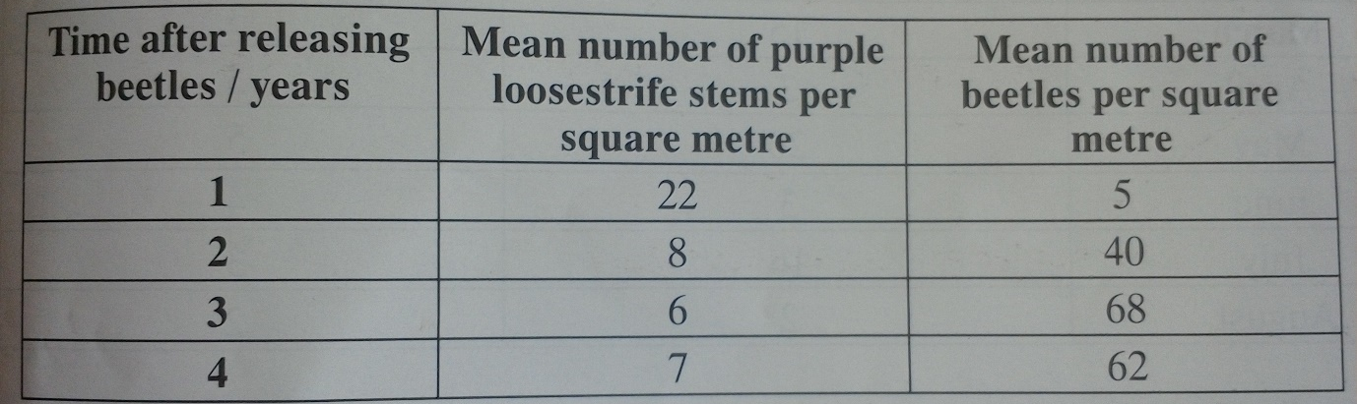
- A European beetle was tested to see whether it could be used for the biological control of purple loosestrife in the USA. In an investigation beetles were released in an area where purple loosestrife was a pest. The table shows some of the results.
Are the beetles effective in controlling purple loosestrife? Give evidence from the table.
yes because reduces and stays low OR no because reduces but does not get rid of plants completely

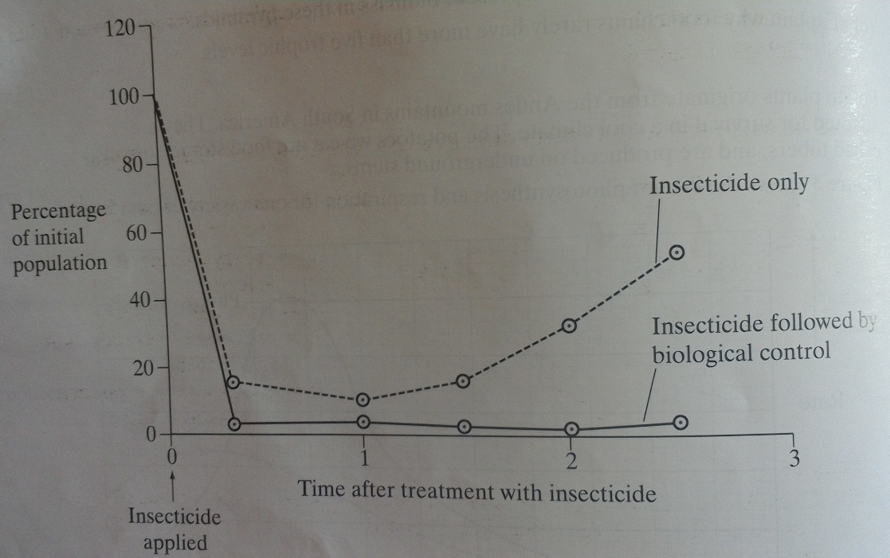
- Fire-ants are a serious pest in parts of the USA. An investigation was carried out to find the best way to control the fire-ant population. The graph shows their results.

- Describe the effect of using insecticide followed by biological control
number of fire-ants falls rapidly. most killed (95%) within six months. then population remains low

- Explain the change in fire-ant population over the period when they were treated with insecticide alone.
most fire-ants killed. some survive because some are resistant and because the insecticide does not affect all stages of life cycle or does not reach all individuals (for example underneath leaf) survivors reproduce because of reduced competition or greater availability of food

- Give the advantages and disadvantages of using biological control.
specific to one pest. only needs one application as it reproduces. It keeps population low. the pests do not develop resistance. does not leave chemical residues in environment. can be used in organic farming. does not get rid of pest completely. may become a pest itself. slow acting / takes time to reduce pest population

- Insecticides are pests which kill insects.
- A low concentration of insecticide was sprayed on the leaves of rose plants to kill greenfly which were feeding on the plants. Ladybirds eat greenfly. 1 month after spraying, the concentration of insecticide in the tissues of ladybirds was found to be higher than the concentration sprayed on the roses. Suggest why
greenflies take in insecticide from roses. ladybirds eat large numbers of greenflies. bioaccumulation occurs and the insecticide cannot be excreted so remains in the body and is not broken down

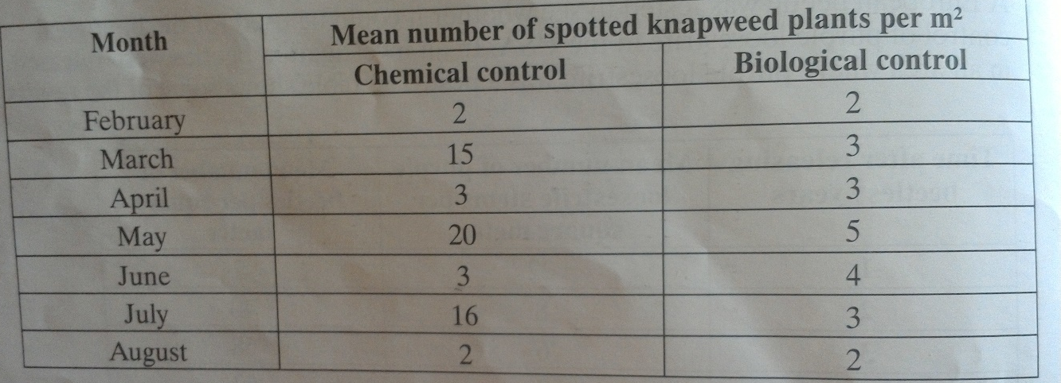
- Spotted knapweed is a common weed in the USA. 2 methods, chemical and biological control, have been used to reduce the numbers of spotted knapweed. The table shows the results of an investigation comparing the effectiveness of these 2 methods.
- Describe the pattern of plants resulting from the use of:
Chemical control – numbers fluctuate throughout year
Biological control – numbers fairly constant throughout year

- Explain how chemical controls leads to the changes in the number of spotted knapweed plants from March to June
number of plants drops because of spraying / reapplication, then rises because insecticide washed away / new plants grow
- Explain why the spotted knapweed plants were never completely eliminated when using;
- Chemical control – some plants or parts of plants not sprayed or the spray washes off before it has effect. plant may be resistant to spray
- Biological control – because the biological control agent never eats all plants as weeds diminish so do control agents.

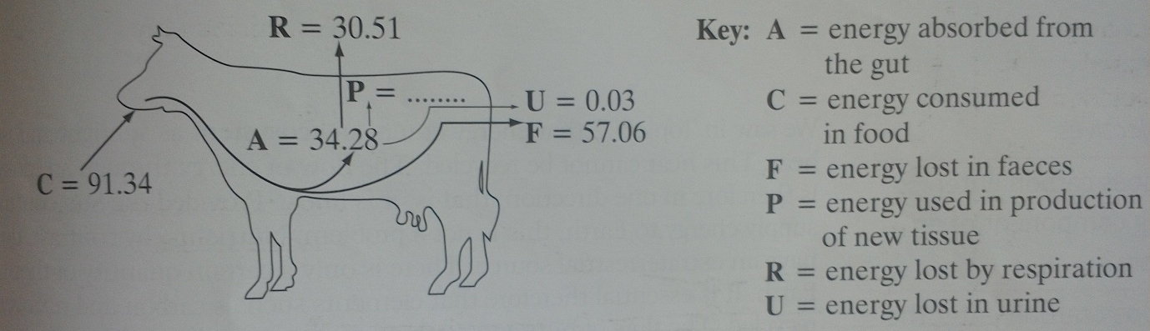
- the diagram shows the transfer of energy through a cow. The figures are in Kjx10⁶year⁻¹
- (i) complete the following equation for the energy used in the production of new tissue. Use only the letters C,F,R and U.
P= C – R – U - F
(ii) calculate the value of P in Kjx10⁶year⁻¹
3.74 Kjx10⁶year⁻¹

- It has been estimated that an area of 8100m² of grassland is needed to keep one cow. The productivity of grass is 21,135 Kjm²year⁻¹ . What percentage of the energy in the grass is used in the production of new tissue in one cow?
3.74 x 10⁶ x 100 = 2.18
21135 x 8100

- keeping cattle indoors, in barns, leads to a higher efficiency of energy transfer. Why?
Less energy lost as heat or in maintaining body temperature or in movement

- a food chain in an oak woodland is shown below
ORGANISM; oak tree aphid hoverfly great tit parasitic mite
TROPHIC LEVEL; A B C D E

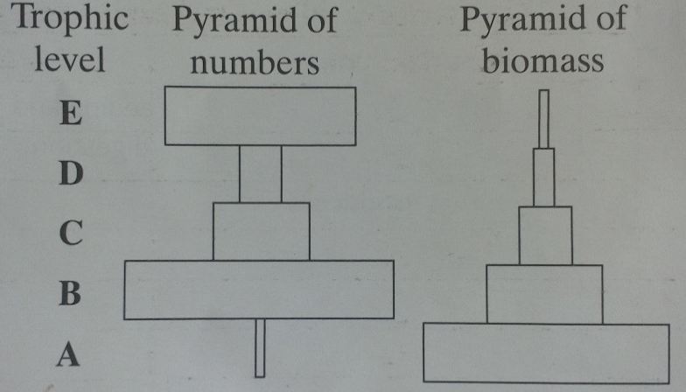
The pyramid of numbers and pyramid of biomass representing this food chain is shown below
- not all the light energy entering the leaves of the oak tree is used in photosynthesis. Why?
light is wrong colour, frequency or wavelength. Light does not strike chlorophyll molecule. there is another limiting factor

- Give 2 ways in which energy is lost between trophic levels A and B
energy is lost in respiration. small amount is lost as heat. lost to decomposers. lost in excretion. leaf fall/death and decay. part of oak tree not eaten or not digested

- Explain the difference between the shapes of the two pyramids at trophic levels D and E.
each bird has several parasitic mites but total mass or energy of mites is less than that of one bird

