RESPIRATION EXAM STYLE QUESTIONS

1. 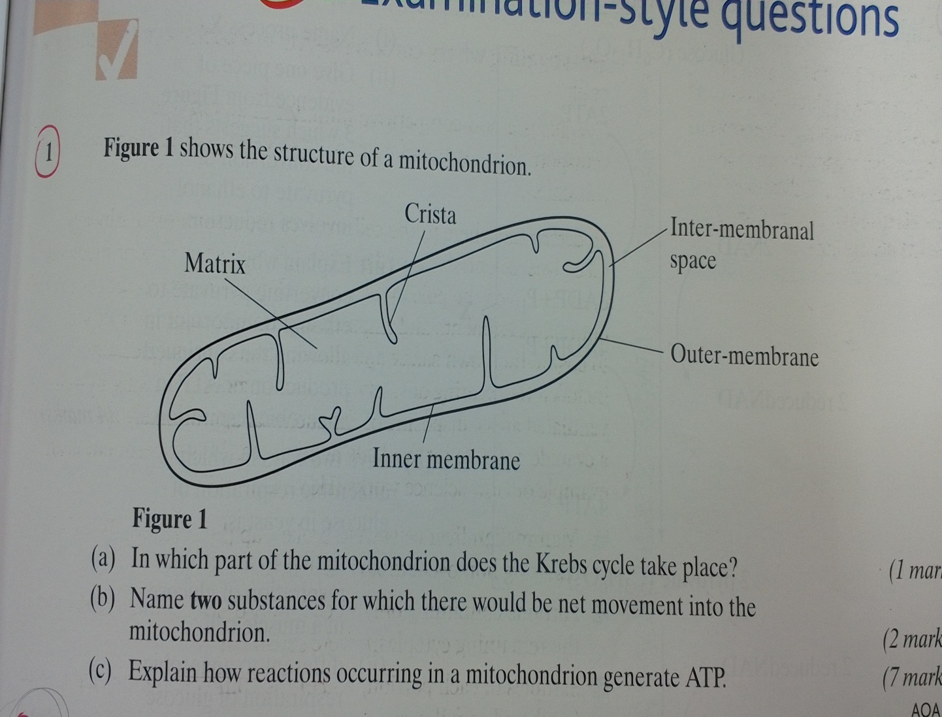**Figure 1 shows the structure of a mitochondrion**
2. **In which part of the mitochondria does the krebs cycle take place?**

Matrix

1. **Name 2 substances for which there would be net movement into the mitochondrion**

Pyruvate, ADP, inorganic phosphate, reduced NAD from glycolysis, oxygen, fatty acids

1. **Explain how reactions occurring in a mitochondrion generate ATP**

oxidation of pyruvate. production of reduced NAD and reduced FAD in the matrix of mitochondria. electrons are passed to electron transport chain (used in oxidative phosphorylation) on the cristae. ATP is produced through substrate level phosphorylation.

1. 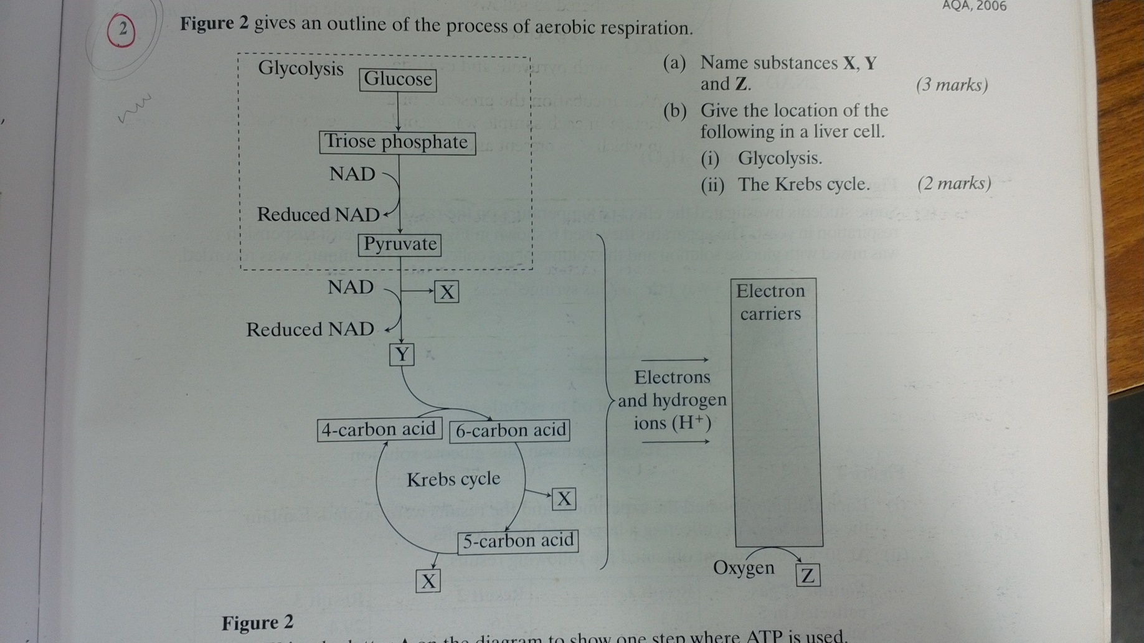**Figure 2 gives an outline of the process of aerobic respiration.**
2. **Name substances X, Y and Z**

**A**

X = carbon dioxide

Y=acetylcoenzyme A

**B**

Z=water

1. **Give the location of the following in a liver cell;**
2. **Glycolysis -** cytoplasm

**B**

1. **The krebs cycle -** mitochondrion
2. **(i) write the letter A on the diagram to show one step where ATP is used**

**(ii**) **write the letter B on the diagram to show one step where ATP is produced**

**B**

1. **Human skeletal muscle can respire both aerobically and anaerobically. Describe what happens to pyruvate in anaerobic conditions and explain why anaerobic respiration is advantageous to human skeletal muscle.**

forms lactate using of reduced NAD. regenerates NAD so it can be re-used to oxidise more respiratory substrate to allow glycolysis to continue and release energy when oxygen in short supply

1. **The main stages in anaerobic respiration in yeast are shown in figure 3.**
2. 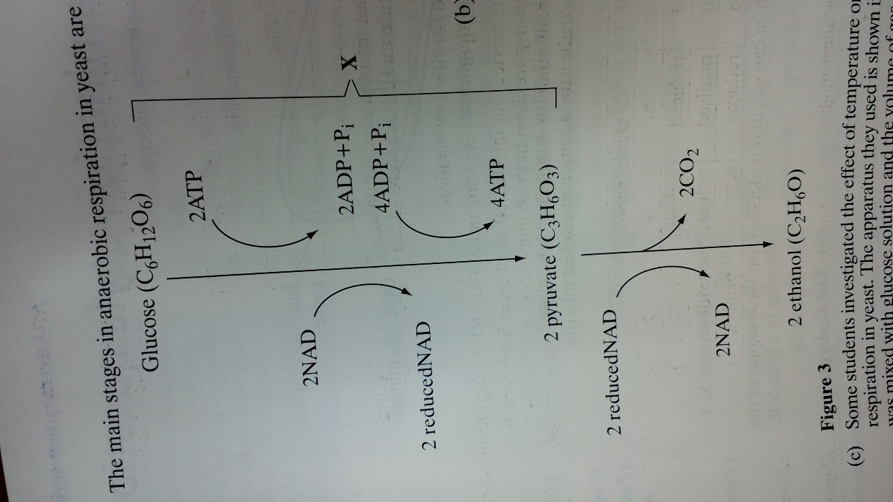**Name process X**

Glycolysis

1. **Give one piece of evidence which suggests that the conversation of pyruvate to ethanol involves reduction**

Reduced NAD is oxidised by donating electrons / hydrogen to pyruvate

1. **Explain why converting pyruvate to ethanol is important in allowing the continued production of ATP in anaerobic respiration**

It allows NAD to be re-formed so glycolysis can proceed so more glucose can be converted to pyruvate

1. **Give 2 ways in which anaerobic respiration of glucose in yeast is;**
2. **Similar to anaerobic respiration of glucose in a muscle cell**

ATP and pyruvate is formed. Involved NAD. Involves glycolysis. It’s a two stage process

1. **Different to anaerobic respiration of glucose in a muscle cell**

ethanol formed by yeast, lactate by muscle cell. CO2 released by yeast but not by muscle cell

1. 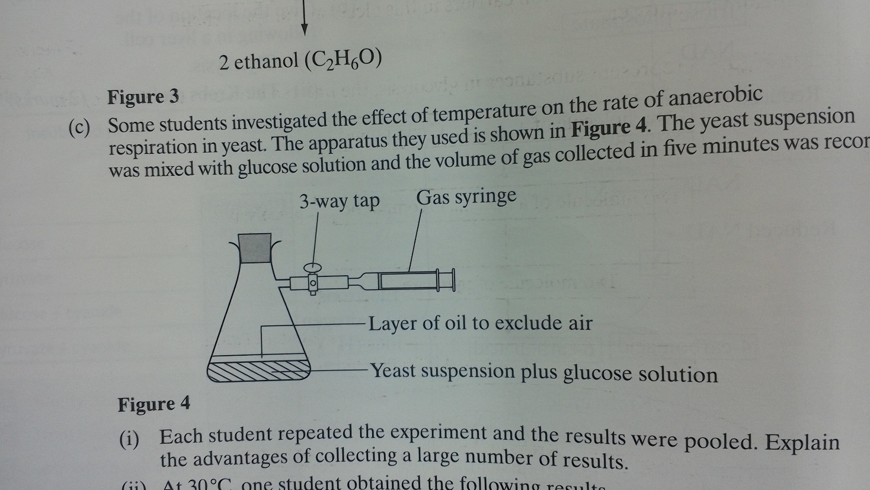**Some students investigated the effect of temperature on the rate of anaerobic respiration in yeast. The apparatus used is shown below. The yeast suspension was mixed with glucose solution and the volume of gas collected in 5 minutes was recorded.**
2. **Each student repeated the experiment and the results were pooled. Explain the advantages of collecting a large number of results.**

allows anomalies to be identified so increases reliability (of means / results); allows use of statistical test

1. 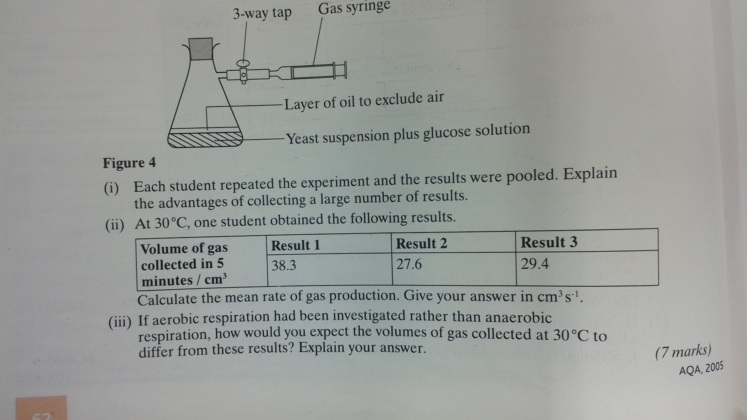**At 30C, one student obtained the following results**

**Calculate the mean rate of gas production. Give your answer in $cm^{3}s^{-1}$**

31.8

1. **If aerobic respiration had been investigated rather than anaerobic respiration, how would you expect the volumes of gas collected at 30C to differ from these results?**

volumes less due to aerobic respiration of glucose so volume CO2 given off= volume of O2 taken in

1. 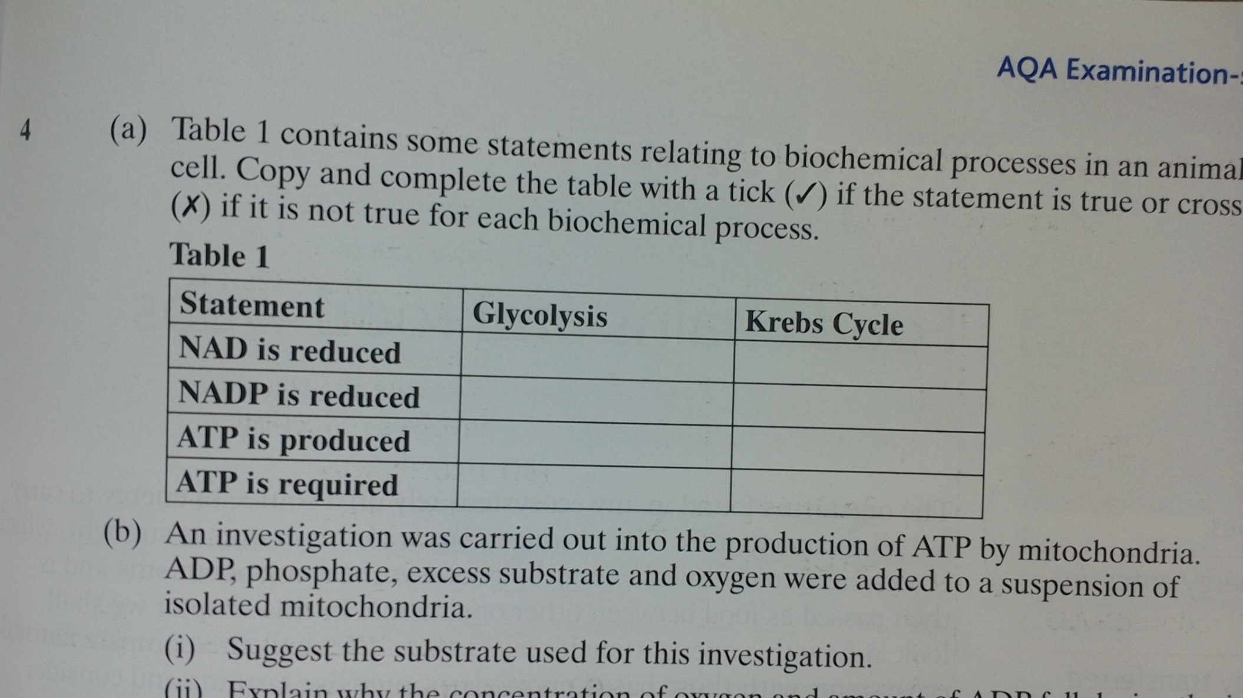**(a) Table 1 contains some statements relating to biochemical processes in an animal cell. Place ticks below if the statement is true or a cross if it is false.**



x



x



x



**(b) an investigation was carried out into the production of ADP by mitochondria. ADP, phosphate, excess substrate and oxygen were added to a suspension of isolated mitochondria.**

**(i) suggest the substrate used for this investigation**

pyruvate

**(ii) explain why the concentration of oxygen and amount of ADP fell during this investigation**

ADP and phosphate forms ATP; oxygen used to form water as the terminal acceptor

1. 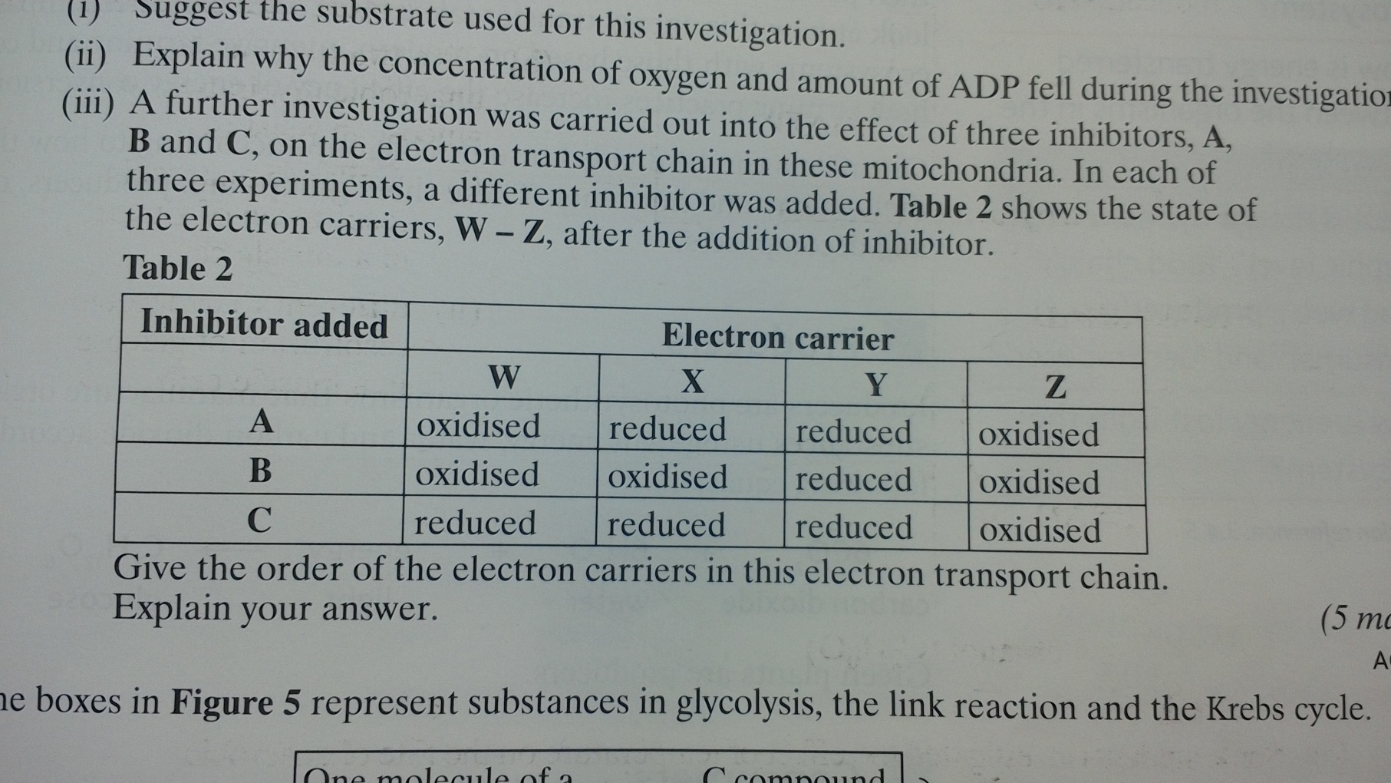**A further investigation was carried out into the effect of 3 inhibitors -A, B and C – on the electron transport chain in these mitochondria. In each of three experiments, a different inhibitor was added. Table 2 shows the state of the electron carries, W to Z, after the addition of an inhibitor.**

**give the order of the electron carriers in this electron transport chain. Explain your answer.**

Y X W Z; order of carriers linked to sequence of reduction - reduced carriers cannot pass on electrons when inhibited

1. 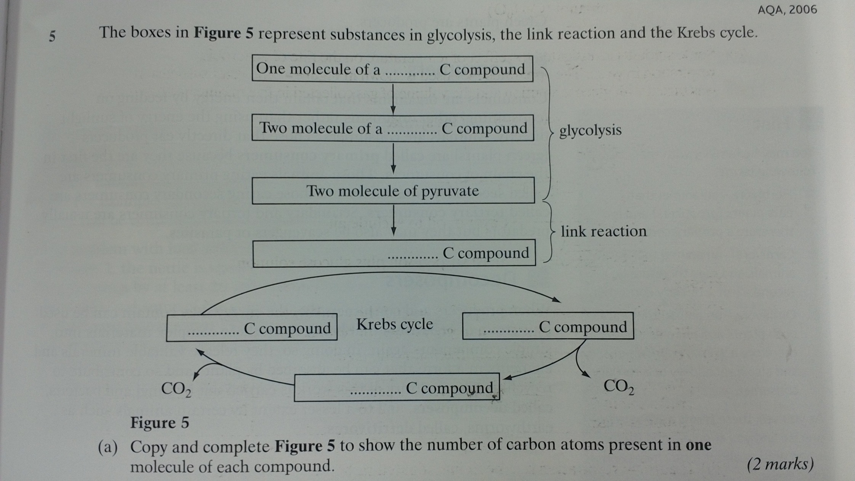**The boxes in figure 5 represent substances in glycolysis, the link reaction and the krebs cycle**

**6**

**3**

**2**

**4**

**5**

**6**

1. **Add to the diagram the number of carbon atoms present in one molecule of each compound**
2. **Other substances are produced in the krebs cycle in addition to the carob compounds shown in figure 5. Name 3 of these other products.**

Reduced NAD. Reduced FAD. ATP