PHOTOSYNTHESIS END OF TOPIC QUESTIONS
- (a) figure 1 summarises some of the light-dependant reactions of photosynthesis.
- Use figure 1 to describe what happens to a molecule of chlorophyll in photosystem II when it absorbs a photon of light
chlorophyll electron gains energy and becomes excited so is raised to higher energy level. The chlorophyll molecule loses electron and becomes positively charged

- Molecules of ATP are formed as electrons are transferred from photosystem II to photosystem I. explain how this is possible
energy lost by electrons is used to form ATP from ADP and Pi

(b) reduced NADP produced during the light-dependant reactions of photosynthesis is used in the light-independent reactions, explain how.
reduction of GP to triose phosphate

- (a) describe how NADP is reduced in the light-independent reaction.
Electrons from chlorophyll / photolysis
(b) in an investigation of the light-independent reaction, the amounts of GP and RuBP in photosynthesising cells were measured under different environmental conditions. Figure 2 shows the effect of reducing the Co2 concentration on the amounts of GP and RuBP in photosynthesising cells.

- explain why there is twice the amount of GP as RuBP when the Co2 concentration is high
RuBP combines with carbon dioxide to produce 2 × GP

(ii) explain the rise in the amount of RuBP after the Co2 concentration is reduced
less used to combine with carbon dioxide to form GP

(c) figure 3 shows the results of an experiment in which photosynthesising cells were kept in the light and then in darkness

- In the environment the cells were supplied with radioactively labelled ¹⁴Co2. Explain why the Co2 used was radioactively labelled
allows detection of products and carbon compounds

- Explain how lack of light caused the amount of radioactively labelled GP to rise
ATP and reduced NADP is not formed. GP is not being used to form RuBP

- Explain what caused the amount of radioactively labelled glucose to decrease after the light was switched off
used in respiration or for the formation of starch / cellulose

- Figure 4 shows the absorption of different wavelengths of light by 3 photosynthetic pigments in a red seaweed
- Describe what the graph shows about the properties of chlorophyll a
pigment does not absorb (reflects) green or yellow or orange. pigment absorbs blue or violet or red

- Describe the part played by chlorophyll in photosynthesis.
light energy is absorbed by chlorophyll which raises the energy level of electrons (excites them) and then ATP is formed
- the red seaweed lives under water at a depth of 2 meters. Suggest an advantage to the red seaweed of having other pigments in addition to chlorophyll a.
more wavelengths or colours absorbed so more efficient photosynthesis can occur at low light intensities OR more efficient photosynthesis can occur when some wavelengths are not present

- Different wavelengths of light are used to illuminate a tube containing a suspension of photosynthetic algal cells. The percentage of lights absorbed and the rate of photosynthesis are measured using the apparatus shown below
- the light meter is calibrated to read 100% using a glass tube containing water but no algal cells. Explain how the percentage of light absorbed by the algal cells is calculated
blank reading minus light meter reading (%)

- what measurements should be taken to determine the rate of photosynthesis
oxygen produced per unit time and the change in oxygen concentration per unit time

- (i) apart from temperature and Ph, give 1 factor that should be kept constant during the investigation
light intensity / type of glass / carbon dioxide concentration / concentration of algae

- a buffer is used to maintain a constant Ph. Explain why the Ph of the suspension would increase during photosynthesis in the absence of a buffer.
decrease in carbon dioxide / hydrogencarbonate ions (Carbon dioxide dissolves to give carbonic acid, so less carbon dioxide would reduce acidity and cause an increase in pH.)

- Explain why temperature has little influence on the absorption of light by photosynthetic organisms
light-dependent reaction absorbs light so is a physical reaction and therefore there is no direct enzyme involvement
- Figure 6 summaries the pathways involved in photosynthesis.

- Name molecule Z
Reduced NADP

- Under some conditions oxygen reacts with RuBP to give GP and phosphoglycolate. This reaction is summarised in the equation.
RuBP + oxygem GP + phosphoglycolate
Phosphoglycolate takes no part in the light-independent reaction
- Give the number of carbon atoms in one molecule of phosphoglycolate
2

- The production of phosphoglycolate could lead to a reduction in the rate of photosynthesis. Explain how.
less GP being reduced to TP so less RuBP regenerated and less carbon dioxide taken up

- An investigation was carried out on the effect of temperature and oxygen concentration on the rate of photosynthesis in leaves. The results are shown in figure 7.
Describe and explain the effect of oxygen concentration on the rate of photosynthesis.
higher levels of oxygen reduce photosynthetic rate with a greater effect at higher temperatures. Higher concentration more RuBP combines with oxygen (instead of carbon dioxide) and a greater chance of binding with the active site of the enzyme

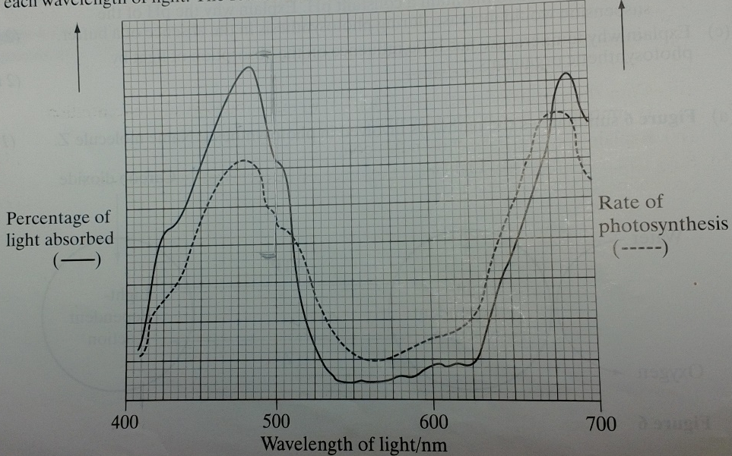
- The percentage of light absorbed by an aquatic plant was measured when it was exposed to different wavelengths. The rate of photosynthesis was also measured at each wavelength of light. The results are shown in figure 8.
- Describe and explain the relationship between light absorption and the rate of photosynthesis for the wavelengths of light between 410nm and 500nm
the more light absorbed, the greater the rate of photosynthesis as light provides the energy for the light- dependent reactions and the production of reduced NADP which is also needed in the light-independent reaction
- Give one dependant variable you could measure in order to determine the rate of photosynthesis in an aquatic plant
count the number of oxygen bubbles / measure the volume of oxygen produced / measure the change in pH / carbon dioxide / hydrogen carbonate ions

- Use figure 8 to identify the range of wavelengths of light that would be green in colour. Give reasons for your answer.
530–630 nm. limited absorption of light / (green) plants reflect green light / limited photosynthesis at these wavelengths of light

- A suspension of chloroplasts was isolated from an aquatic plant and a reagent was added. The reagent is blue when oxidised and is colourless when reduced
- The suspension of chloroplasts in blue reagent was exposed to sunlight. The blue colour disappeared. Use your knowledge of the light-dependant reactions to explain why.
chlorophyll excited to form reduced NADP. The reduced NADP changes the dye colour

- Another suspension of chloroplasts was set up as before. Small quantities of ADP and phosphate ions were added and then the tube was exposed to light. The blue colour disappeared more quickly. Why?
ADP and phosphate needed to produce ATP. ATP is a product of the light-dependent reaction and ADP levels are a limiting factor
- Figure 9 shows the effect of different conditions on the rate of photosynthesis in wheat
- (i) name the factor which is limiting photosynthesis at M
Light intensity
- give a reason for your answer
X
as light intensity increases, so does the rate of photosynthesis

- mark ‘X’ on the graph at the point where Co2 concentration is limiting photosynthesis
- explain why you have chosen this point
higher CO2 level shows higher rate of photosynthesis

- suggest how Co2 concentration could be increased in a glasshouse.
add manure / compost / decaying organic material / CO2 cylinders

