ECOLOGY – END OF CHAPTER QUESTIONS
- An ecosystem can be described as a dynamic system involving interaction of biotic and abiotic components. Within an ecosystem populations of organisms occupy ecological niches.
- Explain what is mean by the following terms:
- Population - a group of organisms of the same species living in the same habitat or area

- Ecological niche - The niche of an organism refers to its biotic role (what it feeds on and what may feed on it) and its abiotic role (where it lives in the habitat in terms of the abiotic conditions it requires).

- Figure 1 shows the ranges of mean animal temperatures and precipitation (water falling as rain or snow) for 6 types of ecosystem.
Arctic tundra is considered to be an extreme environment whereas tropical forest is physically less hostile to living organisms.

- Explain how the information in the diagram supports this view
A ‘physically hostile environment’ will have unfavourable abiotic conditions. Temperature and rainfall is favourable (high) in the tropical forest and unfavourable (low) in Arctic tundra

- Describe and explain the difference in the effect of abiotic factors on the diversity of organisms in the tundra and in tropical forest.
Few species can survive in ecosystems where the abiotic factors are unfavourable. Diversity of organisms is usually low in arctic tundra and high in tropical forest. Abiotic factors dominate distribution and diversity in arctic so have little effect in the tropical forest

- The mark-release-recapture technique may be used to estimate population size.
- Give the assumptions that must be made when using this technique
Mixes fully and randomly in population. marking is not toxic and does not wear off. No migration, emigration or immigration. No change in population size between samples. Life span is longer than time between release and recapture. no births or deaths. Organisms not trap-happy or trap shy
- In estimating the size of a ladybird population, 70 ladybirds were trapped, marked and released. A week later, a second sample was captured. In this second sample, 27 were marked and 13 were not marked.
- Calculate the estimated size of the population
104

- Explain why it is important that the samples contain as many ladybirds as possible.
large sample more representative of population

- (a) in a demographic transition, give one factor that might cause:
- An increase in the birth rate
more people survive to reproductive age. better pre-natal care and health care of mother. better nutrition of mother
- A decrease in the death rate.
better nutrition. better sanitation. Widespread introduction of health care. better post-natal care. vaccination programmes

- Births, deaths and migration affect population growth. Figure 2 shows the effects of these factors on a human population between 1960 and 2000. During this period the death rate was almost constant.
- From the information given, what does the graph show about the changes in birth rate between 1960 and 1980?
birth rate decreasing as the death rate is constant but births minus deaths are falling

- Describe the effect of immigration and emigration on the growth of this population between 1960 and 2000.
reduces population growth until 1990 as more net emigration. increases population growth from 1990 as more net immigration

- (a) the population pyramids in figure 3 show the age distribution in 2 countries in 2000
- Describe the pattern of age distribution in each country
A – high proportion of young, low proportion of older people
B – approximately same proportion of all age groups

- The population size of the 2 countries is about the same. In which country is the population growing more rapidly?
a large base to pyramid with high proportion of young (high birth rate)

(b) what information is required in order to calculate the growth rate of a population?
birth rate and death rate and emigration and immigration

- Tree and canyon lizards in desert areas in Texas. Both species eat insects. In an investigation the population of both species of lizard were measures over a 4 year period in:
- Controlled areas, both species lived
- Experimental areas, from which one of the species had been removed
The results for tree lizards are shown in figure 4 and the results for canyon lizards are shown in figure 5.

- Name the type of interaction being studies in the control areas.
interspecific competition
- Describe how the population density of each lizard species is affected by the presence of the other. Give evidence from the graphs.
- Tree lizard - population declines as experimental area has higher number than control areas. When both species are together the number of tree lizards declines

- Canyon lizard - population not affected as number is similar in both areas. The number of canyon lizards remains similar in both the control and experimental areas

- The investigators concluded that, during the 4 year period, an abiotic factor had a greater effect on the canyon lizards then the tree lizards. What evidence from the graphs supports this conclusion?
large population fluctuation (decrease and increase for canyon lizard) in Figure 2. There is a far greater fluctuation in the number of canyon lizards during the four years compared to canyon lizards.

- Adult tree lizards were found to have shorter lives in experimental areas than in control areas. Use figure 4 to suggest an explanation for this.
more intraspecific competition due to a higher density. The increase in population density in the experimental area would cause increased intraspecific competition for food and other resources.

- Scientists used a line transect to find the distribution of the 3 species of Ranunculus (buttercup) in a field. The field consists of a series of ridges and furrows. Figure 6 shows the distribution of the species of Ranunculus along the line transect.
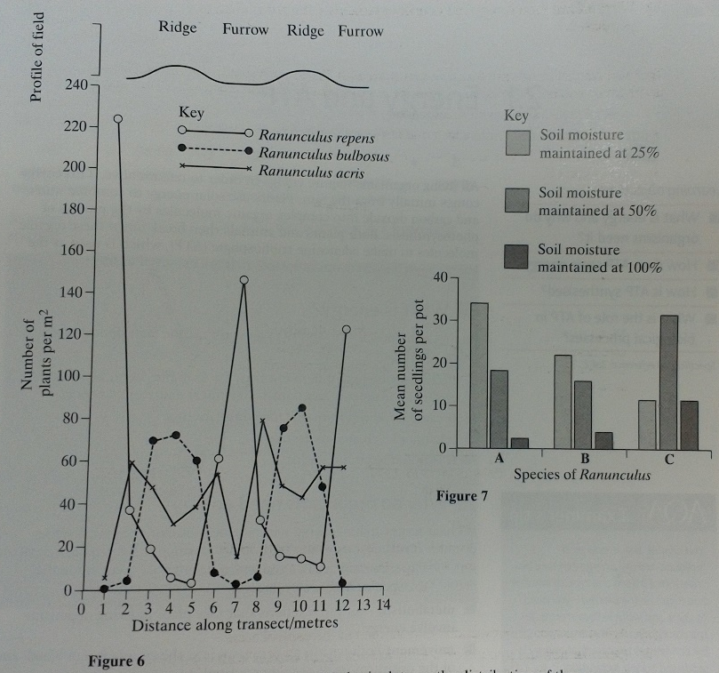
- Describe how you would use a transect to obtain the data on the distribution of Ranunculus species as shown in figure 6
quadrat placed along a line at 1 metre regular intervals and count number and calculate per m2

- Other than soil moisture, give 1 abiotic factor and explain how it could lead to the abundance of ‘Ranunculus reopens’ in the furrows of this field
pH - linked to nutrient availability and enzyme activity. Nutrients - effect growth e.g nitrate and its effect on protein synthesis. Light - adapted to lower light availability for photosynthesis. Temperature and enzyme activity.
- The scientists then investigated the effect of soil moisture on seed germination of the 3 species of Ranunculus. They plantedseeds of species A in 3 sets of pots. The soil in one set of poets was maintained at 25% water content, the soil in the second set was maintained at 50% water content and the soil in the third set was maintained at 100% water content. They repeated this with seeds of species B and species C. four weeks later, they recorded the mean number of seedlings in the pots in each set. Their results are shown in figure 7.
- Suggest 2 factors which should be controlled during this investigation
number of seeds. amount of nutrients. pH. Temperature. Light. carbon dioxide. size of pots. spacing of seeds
- Use information from figure 6 and 7 to identify each species of Ranunculus A-C
A = Ranunculus bulbosus. B = Ranunculus acris. C = Ranunculus repens

- Describe how you could determine whether 2 Ranunculus plants belong to the same species.
breed together to produce of fertile offspring if they’re the same species or if not use of DNA fingerprinting.

