DNA TECHNOLOGY end of topic questions
- The polymerase chain reaction is a process which can be carried out in a lab to replicate DNA. The diagram shows the main stages involved in the PCR.

- Explain why DNA is heated to 95C
To break the hydrogen bonds and separate the two strands

- What is the role of;
- A primer in this process
To enable replication to start

- DNA polymerase
Join DNA nucleotides

- (i) how many DNA molecules will have been produced from one molecule of DNA after 6 complete cycles
64

(ii) suggest one use of the PCR
Replication of DNA from crime scene – tissue sampling – DNA sequencing – gene cloning

- Give two ways in which the PCR differs from the process of transcription
Transcription uses RNA polymerase – RNA nucleotides includes uracil – one template strand – start and stop codons

- (a) plasmids are often used as vectors in genetic engineering
- What is the role of a vector?
To transfer genes from one organism to another

- Describe the role of restriction endonucleases in the formation of plasmids that contain donor DNA
Cut open the plasmid, cut the donor DNA to remove the gene and open the length of DNA. Cut the donor DNA and plasmid with the same enzyme. Sticky ends will be formed with bases exposed and these can pair on complementary strands.

- Describe the role of DNA ligase in the production of plasmids containing donor DNA
Annealing / splicing

(b) there are many different restriction endonucleases. Each type cuts the DNA of a plasmid at a specific base sequence called a restriction site. The diagram below shows the position of four restriction sites, J, K, L and M, for four different enzymes on a single plasmid. The distances between these sites is measured in kilobases of DNA

The plasmid was cut using only two restriction endonucleases. The resulting fragments were separated by gel electrophoresis. The positions of the fragments are shown below.
- Which of the restriction sites were cut?
L and M

- Explain your answer.
Fragments 64 and 26 kilobases obtained

- Gene therapy is used to treat the genetic disorder, ADA deficiency. Affected individuals are unable to produce the enzyme adenosine deminase (ADA). Without this enzyme, T lymphocytes, a type of white blood cell, cannot provide immunity to infection. Below shows the processes involved in the treatment of ADA deficiency by gene therapy.
- What is meant by gene therapy?
Introduction of a healthy gene to replace the defective gene

- Individuals who have been treated by this method of gene therapy do not pass on the ADA gene to their children. Why?
Reproductive cells do not contain the ADA allele

- T lymphocytes are produced in the bone marrow. A bone marrow transplant from a genetically matched donor can provide a permanent cure for ADA deficiency.
- Suggest why bone marrow for a transplant is obtained from a genetically matched donor.
To prevent rejection or an immune response

- Explain why treatment of ADA deficiency by gene therapy must be repeated at regular intervals, whereas a single bone marrow transplant can provide a permanent cure.
T lymphocytes have a limited life span and so die off and do not reproduce. Bone marrow provides continual supply of T lymphocytes/ADA gene

- One technique used to determine the sequence of nucleotides in a sample of DNA is the Sanger procedure. This requires four sequencing reactions to be carried out at the same time. The sequencing reactions occur in four separate tubes. Each tube contains;
- A large quantity of the sample DNA
- A large quantity of the four nucleotides containing thymine, cytosine, guanine and adenine
- DNA polymerase
- Radioactive primers
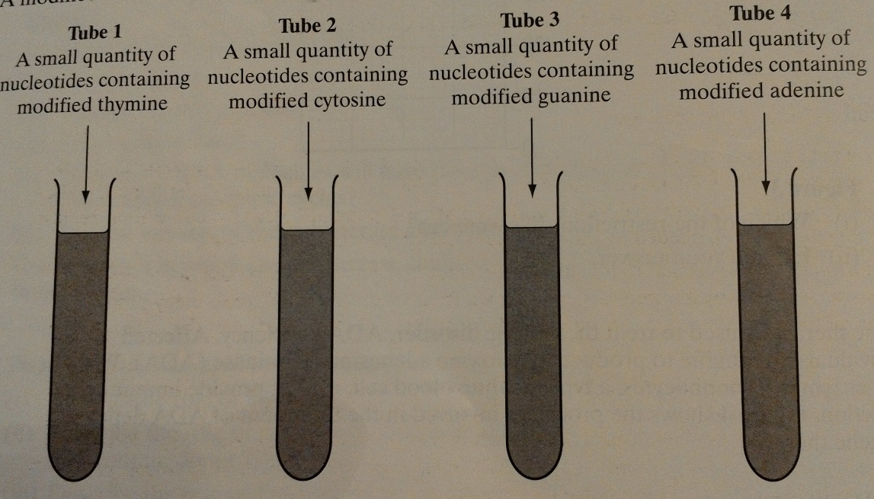
A modified nucleotide is also added to each tube, as shown below

- A large quantity of the DNA sample is required for this procedure. Name the reaction used to amplify small amounts of DNA into quantities large enough for this procedure.
Polymerase chain reaction

- Explain the reason for adding each of the following to the tubes.
- DNA polymerase – joins nucleotides together
- Primers – enables replication to start

- (i) when a modified nucleotide is used to form a complementary DNA strand, the sequencing reaction is terminated. Suggest how this sequencing reaction is terminated
Modified nucleotide does not form bonds or react with other nucleotides as it does not ‘fir’ the DNA polymerase/ enzyme active site

(ii) a sample of DNA analysed by this technique had the following nucleotide base sequence
T G G T C A C G A
Give the base sequence of the shortest DNA fragment which would be produced in tube 2
AC
- A different sample of DNA was then analysed. The DNA fragment from the four tubes were separated in a gel by electrophoresis and analysed by autoradiography. Below shows the banding pattern produced.

- Explain why the DNA fragments move different distances in the gel
Different lengths, sizes, mass
- What makes the DNA fragments visible on the autoradiograph?
Radioactive primer

- Use the banding pattern to determine the sequence of nucleotides in this sample of DNA
GAAGTXTCAG

- Read the following passage;
The giant panda is one of the rarest animals in the world and is considered to be on the brink of extinction in the wild. Giant pandas have been kept and bred in zoos with the hope that they could be released in to the wild. One worry is that small populations, like those in zoos, reduce the genetic variation needed to allow species to adapt to changing situations
Unfortunately, pandas find it difficult to reproduce in captivity. Fertilization of the females in guaranteed only by insemination with semen from several males. With so many potential fathers, the true paternity of the cubs is not clear. It is important to identify the fathers to maintain genetic variation.
Panda faeces can be collected in the wild. The faeces contain DNA from the panda, from the bamboo on which they feed and bacteria. The DNA is subjected to the polymerase chain reaction. The primers used only attach to the panda DNA. The resulting DNA is subjected to genetic fingerprinting. This can help us count the number of individuals in the wild because it allows us to identify individual pandas.
- Describe how genetic fingerprinting may be carried out on a sample of panda DNA
DNA is cute using restriction enzymes. Electrophoresis separates according to length. Southern blotting transfers to a nylon membrane. They are made single stranded and a radioactive of fluorescent probe is added. Autoradiography is used is radioactivity was used.
- (i) explain how genetic fingerprinting allows scientists to identify the father of a particular panda
All bands in cub which don’t come from mother must be in the fathers DNA fingerprint

(ii) when pandas are bred in zoos, it is important to ensure only unrelated pandas breed. Suggest how genetic fingerprinting might be used to do this.
Select pairs with dissimilar DNA fingerprints

- (i) suggest why panda DNA is found in faeces
Cells from the panda, such as gut cells or blood cells, are in the faeces

(ii) explain why the PCR is carried out on the DNA from the faeces
To increase the amount of DNA as only a small amount is present.

- Explain why the primers used in the PCR will bind to panda DNA, but not to DNA from bacteria or bamboo
DNA/primer has a specific base sequence that is complementary

- DNA from wild pandas could also be obtained from blood samples. Suggest two advantages of using faeces, rather than blood samples, to obtain DNA from pandas.
Taking samples from animals causes stress. Injury to animal. Difficult to fins animals. Pandas can be dangerous or a threat to humans

