FEEDBACK MECHANISMS end of chapter questions
- The graph shows the effect on increasing the environmental temperature on metabolic rate of a small mammal
- Suggest one way of measuring the metabolic rate
The uptake of oxygen or the production of carbon dioxide

- The mammal maintained a constant core temperature as the environmental temperature increased from 5C to 40C. name the type of mechanism involved in restoring physiological systems to their original level
Negative feedback

- Use your knowledge of thermoregulation to explain;
- The change in metabolic rate of the mammal when the environmental temperature increases from 5 to 40C
Higher metabolism at low temperatures and metabolism/respiration releases heat so more heat loss at low temperatures
- The increase in metabolic rate after 40C
Lack of thermoregulatory control at high temperatures / positive feedback. Increase in temperatures increases respiration due to increasing enzyme activity.

- The graph shows the changes in concentration of the hormones responsible for controlling the menstrual cycle.

- Which curve, A, B, C or D shows changes in the concentration of;
- FSH - C
- LH - B

- Explain how the release of FSH is controlled by negative feedback
FSH stimulates the release of oestrogen and oestrogen initially inhibits FSH secretion

- Using the graph, give one example of how positive feedback is involved in the secretion of hormone C
Increase in oestrogen concentration after 10 days. Stimulates rise in hormone C

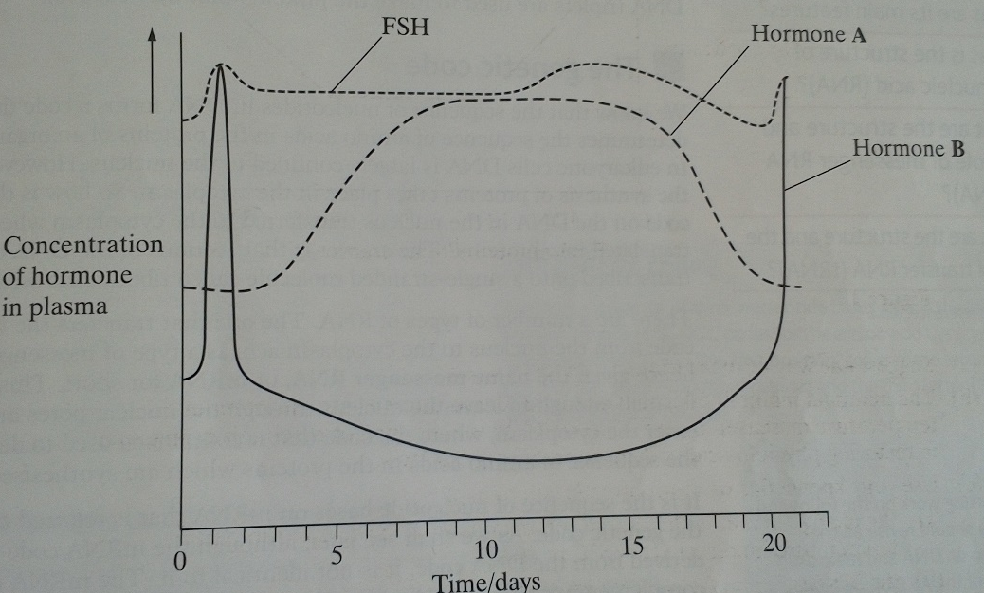
- The menstrual cycle in humans is controlled by hormones. The equivalent cycle in cows is controlled by the same hormones. The graph changes in the concentration of some of these hormones in a cow.

- (i) name hormone A. explain your answer
Progesterone – as it rises after ovulation and falls at the end of cycle

(ii) name hormone B. explain your answer
LH as it shows a sharp peak

- Scientists can clone cows. To do this they need to collect eggs from a cow. Using the graph, suggest two time periods in which the scientist should attempt to collect eggs. Give an explanation.
Between days 2 and 24, just after ovulation. OR between days 0 and 1 or days 20 to 21, when ripe eggs are present/at ovulation

