HOMEOSTASIS – end of topic questions
- (a) (i) what is meant by homeostasis?
maintaining a constant internal environment

(ii) giving one example, explain why homeostasis is important in mammals
Keeping temperature and Ph optimum for enzymes – water potential and blood glucose osmotic effect on cells

(b) (i) cross-channel swimmers experience a large decrease in external temperature when they enter the water. Describe the processes involved in thermoregulation in response to this large decrease in external temperature.
hypothalamus contains the thermoregulatory centre and has receptors which detect temperature changes of blood by receiving impulses from receptors in skin and nerve impulses transmitted from hypothalamus. This results in vasoconstriction, less blood to skin, shivering to generate heat via respiration, release of thyroxine / adrenaline, increase in metabolic rate. This is all maintained by negative feedback (referencing to hairs being raised is not relevant as the response is occurring in water)

(ii) a person swimming in cold water may not be able to maintain their core body temperature and will begin to suffer from hypothermia. Explain why a tall, thin swimmer is more likely to suffer from hypothermia than a short, stout swimmer of the same body mass.
Larger surface area to volume ratio– less insulation so more heat loss by conduction (as it is occurring in water)

- Mammals are endotherms; reptiles are ectotherms
- Explain two advantages of endothermy over ectothermy
Endotherms are less affected by changes in the external temperature and can maintain and optimum temperature for metabolic reactions and enzymes optimum temperature. They’re more independent of environment so are better able to survive in different environments.

- The graph shows how the rates of metabolic heat generation and evaporative heat loss in a reptile change with environmental temperature. Each plot is the mean of several values. The vertical bars show the standard deviation.
- Explain why it is more useful to show the standard deviation rather than the range of values
The range just shows the highest and lowest whereas the standard deviation shows the spread of majority. Extreme values give a false impression of variation and the standard deviation is less affected by extreme values.

- Explain why the values for metabolic heat generation are given per gram of body mass
It allows comparison of animals with different masses. Increased mass means increased heat generation as they will have more cells generating heat from metabolic reactions.

- Describe the relationship between metabolic heat generation and evaporative heat loss shown in the graph
both increase proportionally up to 25°C then heat generation increases faster

- Use the graph to explain why these reptiles often seek shade when the environmental temperature rises above 25C
Body with overheat in very hot environments as it will generate more heat than they can lose and there will be no physiological cooling mechanism

- The graph below shows the relationship between metabolic heat generation and evaporative heat loss in a small mammal
How is the relationship between heat generation and evaporative heat loss in a mammal different from that in a reptile?
The relationship is inverse/equivalent – as the mammal obtains heat from its environment it reduces heat generation from metabolic reactions. Heat loss via evaporation increases as a cooling mechanism

- Suggest an explanation for the change in the slope of the graph for evaporative heat loss at the point marked X
Sweating increases/panting

- Explain how the change in metabolic heat generation in a small mammal is bought about as environmental temperature rises
reduced metabolic rate – reduced energy released from respiration – reduced thyroxine secretion – reduced activity of brown fat cells – reduced physical activity

- (a) describe the role of insulin in the control of blood glucose concentration
An increase in blood sugar leads to more insulin being secreted and it will bind to specific receptors on liver or muscle cells which activates carrier proteins leading to more glucose entering cells. Glucose therefore leaves the blood. Insulin activates enzymes in the liver so glucose entering the cell is converted to glycogen (glycogenesis) overall, insulin activated enzymes to convert glucose to glycogen

The chart below shows the pathway by which glycogen is broken down in liver and muscle cells
(b) suggest why it is important that muscle cells do not convert glucose phosphate to glucose
It keeps glucose in muscle cells as glucose phosphate cannot cross cell membranes. Muscle cells need glucose for respiration.

(c) the production of glycogen phosphorylase form an inactive form of the enzyme is triggered by the hormones glucagon and adrenaline, and by calcium ions. Adrenaline is a hormone released when an animal senses danger. This is controlled by the sympathetic nervous system. The diagram shows the receptors for glucagon and adrenaline on liver and muscle cells.

Use the information in the chart and the diagram to suggest how glycogen breakdown in liver and muscle cells is increased when an animal runs away from a predator.
The sympathetic nervous system is activated so adrenaline is releases and binds to receptors on the muscle cell, causing increased glycogen phosphorlase activity. So there’s more glucose phosphate for respiration. Calcium ions enter muscle cells and glycogen is broken down. Blood glucose is lowered as glucose is used by muscles. glucagon is released and binds to receptors on liver cells causing glycogen to be broken down to glucose.

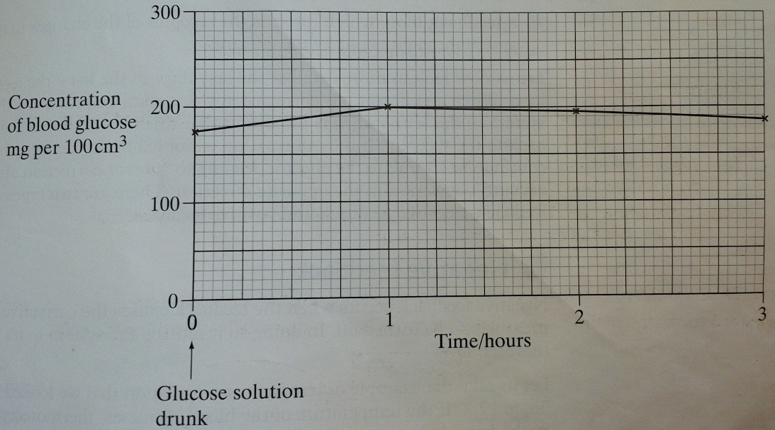
- Some people produce no insulin. As a result, they have diabetes. In an investigation, a man with diabetes drank a glucose solution. The concentration of glucose in his blood was measured at regular intervals and the results are shown below.

- Suggest two reasons why the concentration of glucose decreased after 1 hour even though this man’s blood contained no insulin
Glucose is used in cell respiration as an energy source. Glucose enters the cells and is converted to glycogen. Glucose is excreted in urine.
- The investigation was repeated on a man who did not have diabetes. The concentration of glucose in his blood before drinking the glucose solution was 80mg per 100cm³. Sketch a curve on the graph to show the results you would expect

- The diabetic man adopted a daily routine to stabilise his blood glucose concentration within narrow limits. He ate 3 meals a day; breakfast, a midday meal and an evening meal. He injected insulin once before breakfast and once before the evening meal
The injection he used before breakfast was a mixture of 2 types of insulin. The mixture contained slow-acting insulin and fast-acting insulin
- Explain the advantage of injecting both types of insulin before breakfast
Fast-acting insulin reduces blood glucose from breakfast. Slow-acting insulin reduces blood glucose from other meals before the evening meal so eliminated the need to inject at lunch.

- One day, the man did not eat a midday meal. Suggest one reason why his blood glucose concentration did not fall dangerously low even though he had injected himself with the mixture of insulin before breakfast.
Glucagon is still active and is converted to glucose (glycogenolysis). Insulin injected at breakfast causes cells to take up glucose too slowly for levels to become dangerously low.

