MUSCLES – end of chapter questions

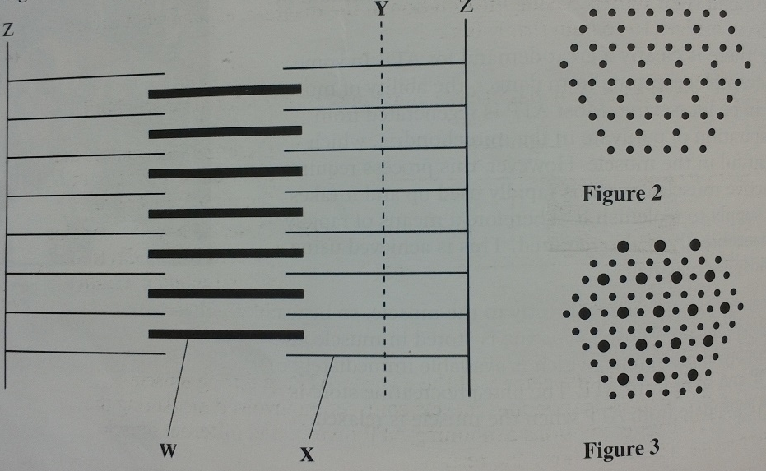
- The diagram shows part of a muscle myofibril

- Name the protein present in the filaments labelled W and X
W = myosin, X = actin

- Figure 2 shows the cut ends of the protein filaments when the myofibril was cut at position Y. figure 3 shows the protein filaments when the myofibril was cut at the same distance from a Z-line at different stages of contraction. Explain why the pattern of protein filaments differs in figure 2 and 3
The myofibril is contracting in figure 3 and relaxing in figure 2. There is movement of actin fibres between myosin fibres.

- Describe the role of calcium ions in the contraction of a myofibril
calcium ions bind to and move tropomyosin to reveal binding sites on the actin which allow the myosin heads to bind to actin to form actinmyosin. This activated ATPase so energy is released from ATP

- The diagram shows the stages in one cycle that results in movement of an actin filament in a muscle myofibril
- Describe how stimulation of a muscle by a nerve impulse starts the cycle shown
Calcium ions bind to and move tropomyosin to reveal the actin binding site so myosin heads can bind to the exposed binding sites to form actomyosin and cross bridges between actin and myosin and to activate ATPase.

- Each cycle requires hydrolysis on one molecule of ATP and moves one actin filament 40nm. During contraction of a muscle sarcomere, a single actin filament moves 0.6 $μ$m. Calculate how many molecules of ATP are required to produce this movement
15 ATP (distance single actin moves divided by distance moved using 1 ATP)

- After death, cross bridges between actin and myosin remain firmly bound resulting in rigor mortis. Using information in the diagram, explain what causes the cross bridges to remain firmly bound.
Respiration stops so no ATP is produced and ATP is needed for the separation of actin and myosin cross bridges

- (a) the diagram shows the banding pattern observed in part of a relaxed muscle fibril
- Describe what causes the different bands seen in the muscle myofibril
The A-band is dark mainly due to myosin filaments. The H-zone only has myosin filaments. The light band has only actin filaments. The darker band has both types of filament.
- Describe how the banding pattern will be different when the muscle fibril is contracted.
The H-zone narrows so the light band narrows and the outer darker regions of the A-band widen (the length of the A-band remains the same as it is determined by the length of the myosin filaments which do no change)

(b) there is an increase in the activity of the enzyme ATPase during muscle contraction. an investigation into muscle contraction involved measuring the activity of ATPase in solutions containing ATP, myosin and different muscle components. The table shows the results.

- Explain the importance of ATPase during muscle contraction
It breaks down ATP, yielding energy which is used to break actomyosin bridges.

- Using your knowledge of muscle contraction, explain the difference in the results between:
A and B – tropomyosin covers binding site on actin so no cross bridges formed and the ATPase activity on the myosin head is reduced
B and C – calcium ions remove tropomyosin and calcium ions increase ATPase activity.

- Skeletal muscle is made of bundles of fibres
- Describe the role of ATP and phosphocreatine in producing contraction of a muscle fibre
ATP allows myosin to detach from actin and ‘re-cocks’ the myosin cross bridge. Phosphocreatine allows the regeneration of ATP under anaerobic conditions as it replenishes phosphate from ATP when the muscle is relaxes to it can release phosphate to join ADP and form ATP

- The table shows some properties of slow and fast muscle fibres.

Endurance athletes, such as marathon runners, nearly always have a high proportion of slow fibres in their muscles. explain the benefit of this.
Sow fibres contract more slowly and provide less powerful contractions over a long period of time. Endurance athletes exercise for long periods and respire aerobically so lactate does not accumulate. Slow fibres are adapted to aerobic respiration as they have many mitochondria (the side of the krebs cycle and electron transport chain) which produce large amounts of ATP and are also resistant to fatigue.

