COORDINATION end of chapter questions

- IAA is a substance that promotes the growth of cells in plants. It is produced in the tips of shoots. The shoots of seedlings grow towards a unidirectional light source as shown in the diagram below.
- Explain the benefit to the seedling of the response shown in the diagram
It grows towards light for photosynthesis (this is an example of phototropism – a response to a directional stimulus that can maintain plants in favourable environments)

Two hypotheses were put forward to explain these response:
Hypothesis 1 – IAA is inactivated by light
Hypothesis 2 – IAA moves laterally away from light
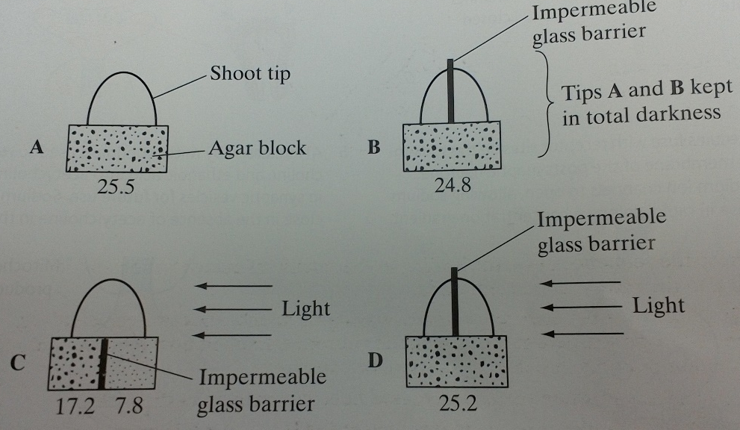
The diagram below shows the results from 4 experiments carried out to test these 2 hypotheses.
The numbers under each agar block represent the amount of IAA (arbitrary units) that has diffused into the block from the shoot tip.

- Suggest one variable which needs to be kept constant in the 4 experiments
Species – size – age of shoot – temperature – time – size of agar block (light intensity is wrong as two of the experiments are carried out in darkness)

(c) give one way in which the results of these experiments provide evidence:
(i) against hypothesis 1 – similar amounts of IAA in light and dark
(ii) in support for hypothesis 2 – C has more IAA on shaded side.
(d) the shoot tip was removed from a seedling and then an agar block containing IAA was placed on the cut end, as shown in the diagram below. Draw showing how the seedling would grow following this treatment.

- Acetylcholine is a neurotransmitter which binds to postsynaptic membranes and stimulates the production of nerve impulses. GABA is another neurotransmitter. It is produced by certain neurones in the brain and spinal cord. GABA binds to postsynaptic membranes and inhibits the production of nerve impulses. The diagram shows a synapse involving three neurones.
- Describe the sequence of events leading to the release of acetylecholine and its binding to the postsynaptic membrane
The action potential arrives and depolarisation occurs. Calcium ions enter the synaptic knob and vesicles containing acetylcholine fuses with the membrane so acetylcholine diffuses across the synaptic cleft and binds to receptors on the post synaptic membrane.

- The binding of GABA to receptors on post synaptic membranes causes negatively charged chloride ions to enter postsynaptic neurones. Explain how this will inhibit transmission of nerve impulses by postsynaptic neurones.
The inside becomes more negatively charged (hyperpolarised) so the stimulation does not reach the threshold level so that action potential is not produced and depolarisation does not occur which reduces the effect of sodium entering

- Epilepsy may result when there is increased neuronal activity in the brain
- One form of epilepsy is due to insufficient GABA. GABA is broken down on the postsynaptic membrane by the enzyme GABA transaminase. Vigabatrin is a drug being used to treat this form of epilepsy. The drug has a similar molecular structure to GABA. Suggest how Vigabatrin may be effective in treating it.
It inhibits the enzyme which breaks down GABA so more GABA is available to inhibit the neurone. It may also bind to GABA receptors and inhibit neuronal activity by stopping chloride ions entering the neurone.

- A different form of epilepsy has been linked to an abnormality in GABA receptors. Suggest and explain how an abnormality in GABA receptors may result in epilepsy.
Receptors have different tertiary structure so the shape may not be complementary and GABA cannot bind. The inhibition of neuronal activity does not occur and chloride ions do not enter.

- The diagram shows the change in the charge across the surface membrane of a non-myelinated axon when an action potential is produced.
- Describe how the change shown occurs when an action potential is produced.
Sodium gates open so there is an increase in the permeability of the axon membrane to sodium so sodium ions enter.

- Explain what causes the conduction of impulses along a non-myelinated axon to be slower than along a myelinated axon
In the non-myelinated neurone, depolarisation occurs along the whole length of the whole membrane
In a myelinated neurone, depolarisation only occurs at nodes of ranvier so impulses ‘jump’ from node to node by salutary conduction.

- (a) describe two ways in which hormonal control differs from nervous control
Nervous system uses electrical impulses, neurones, is localised, short-lived and rapid whereas hormonal control uses chemicals, blood, is widespread, long-lasting and slow.
(b) the resting potential of a neurone is maintained at -70mV. A metabolic poison was applied to a neurone and the change in the resting potential was measured over several hours. The results are shown below.
Explain the change in resting potential that takes place after the application of the metabolic poison.
Respiration stops so no ATP leading to active transport stopping so sodium ions can no longer be pumped out and they continue to diffuse in so that they accumulate inside and the inside becomes less negative. Potassium ions equilibrium is quickly established so potassium ions are no longer pumped in.

- (a) what is a reflex?
A rapid response to a stimulus which is automatic and not under conscious control

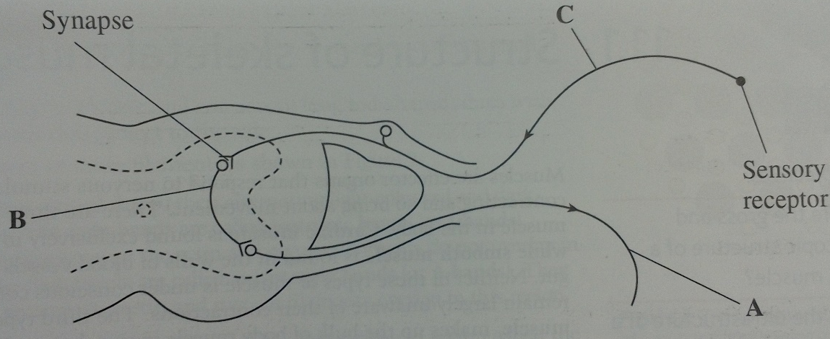
(b) name the types of neurone labelled A,B and C

A – motor
B – relay
C – sensory

- Nervous transmission is delayed at synapses. Explain why
Transmitters are chemicals and not electrical so the process of transmission takes time for the transmitters to diffuse.

- The axon of neurone A is myelinated. The axon of neurone B is non-myelinated. Explain why impulses travel faster along the axon of neurone A.
In Myelinated the impulse jumps from node to node as the action potential/depolarisation only occurs at the nodes.
In non-myelinated the impulse travels the whole length of the axon membrane.

